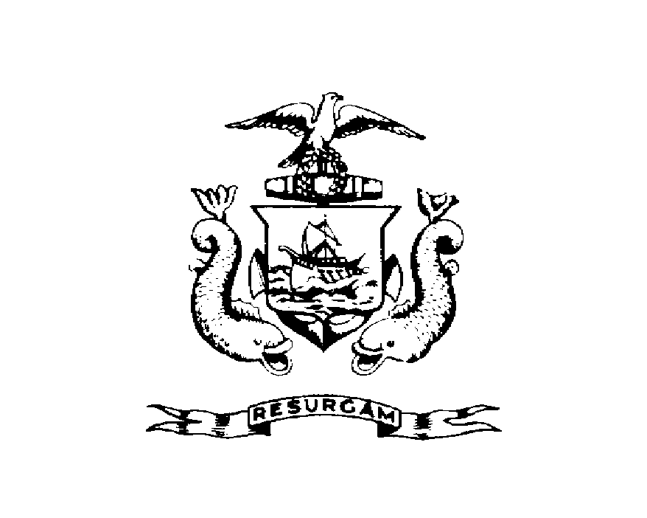
DISPLAY THIS CARD ON PRINCIPAL FRONTAGE OF WORK
CITY OF PORTLAND
CBL CBL: 431 B001001 BUILDING PERMIT # 2011-05-965-SOB
BUILDING PERMIT
This is to certify that ANN & YALE S ARKEL Located At 6 Island St.
has permission for Slope Stabilization (Single Family)
provided that the person or persons, firm or corporation accepting this permit shall comply with all of the provisions of the Statues of Maine and of the Ordinances of the City of Portland regulating the construction, maintenance and use of the buildings and structures, and of the application on file in the department.
Notification of inspection and written permission procured before this building or part thereof is lathed or otherwise closed-in. 48 HOUR NOTICE IS REQUIRED.
A final inspection must be completed by owner before this building or part thereof is occupied. If a certificate of occupancy is required, it must be procured prior to occupancy.

___________________________________________________ _____________________________________10/17/2011
Fire Prevention Officer Code Enforcement Officer / Plan Reviewer
THIS CARD MUST BE POSTED ON THE STREET SIDE OF THE PROPERTY.
PENALTY FOR REMOVING THIS CARD.

