

Memorandum
Planning and Urban Development Department
Planning Division

To: Chair Morrissette and Members of the Portland Planning Board

From: Jean Fraser, Planner

Date: January18, 2013

Re: Ledgewood Drive 16 Lot Subdivision (Old Barn Estates), 1062 Ocean Avenue
TPO Properties, LLC, Tim Donovan

Project #: 2012-584 CBL: 414-A-4 (Part within Town Of Falmouth)

Meeting Date: January 22, 2013

- Introduction

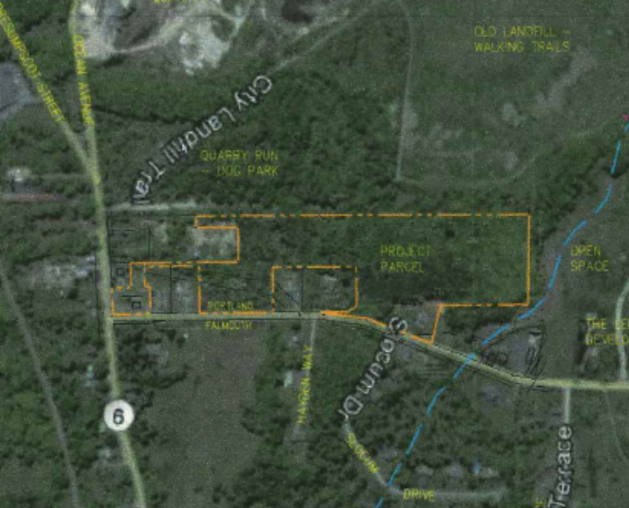
This is a second workshop on the subdivision proposed by Tim Donovan of TPO Properties LLC on land between Ocean Avenue in Portland and Ledgewood Drive in Falmouth. The first workshop was an overview, while this Workshop addresses the details of the proposed drive, stormwater management and treesaves/buffers.

The proposed subdivision comprises:

- 2 existing lots already developed with residential structures (some vacant) (Lots 13 and 14); these are included as required by State Subdivision statutes as they are contiguous and in the same ownership;
- 14 new residential (single family) lots on a proposed new street, 760 linear feet in length with a turnaround at the dead end - proposed to be named Ice Pond Drive;
- 2 other lots called “open space” that are wetland/stormwater detention and to be managed in common by the owners of the 14 new lots.
Extract from applicant’s submission; see also Plan 2

The Planning Board is being requested to review the application under Portland’s Subdivision Ordinance. The required waivers are still under discussion but include sidewalks/curbing, and aspects of street design.

Of the total site of 12.78 acres, just under an acre is located within the Town of Falmouth. Within the Falmouth portion of the subdivision, the proposals show part of the new drive, the intersection with Ledgewood Drive (a Falmouth street), most of the stormwater management area, and one house lot.

Under Maine State Law 30-MRSA Section 4403 there is a requirement for joint meetings between the Planning Boards of Portland and Falmouth where a project crosses municipal boundaries, unless the respective reviewing authorities waive this requirement in writing. Falmouth voted on August 7, 2012 to waive this requirement and the Portland Planning Board voted similarly on October 9th, 2012.

A total of 63 notices were sent out to neighbors and interested parties within Portland, and the public notice appeared in the January 14th and 15th, 2013 editions of the Portland Press-Herald.

- PROJECT DATA

DATA | Existing home at 1062 Ocean Avenue  (Lot #14) | Proposed new 12 lot contiguous subdivision  (lots #1 to #12) | Lot #13 | Lots #15 and #16  (Open Space)
Location | Within Portland and fronts on Ocean Avenue | Within Portland and no existing street access | Within Falmouth and fronting on Ledgewood Drive, Falmouth | Lot #15: Falmouth  Lot #16; Portland
Existing Zoning | R-3 | R-3 | R-3 | R-3
Existing Use | Single family (non-conforming) | Vacant/undeveloped | Single family | Vacant/undeveloped
Proposed Use |  | Single family lots | Reconfigured lot, new drive & stormwater management | Lot #15: Stormwater management/open space  Lot #16; Wetlands (retained)
Areas | .58 acre | 7.53 acres | .91 acre | 3.76 acres
No of Lots | 1 | 12 | 1 | 2
Lot sizes | 25,265 sq ft | Range from 20,000 sq ft to 54, 800 sq ft | 22,480 sq ft | Lot #15: 11,700 sq ft  Lot #16; 152,100 sq ft
Proposed new road (dead end) | none | Approx. 760 linear ft | Retains existing drive onto Ledgewood | Lot #15 abuts new road
Area of existing wetland | See Sweet Associates Wetland Delineation note (Attachment B)
Area of wetlands proposed to be filled | Not indicated; some for access to Lot #2
Total Disturbed Area | Not confirmed
Existing impervious | none
Proposed impervious | 5000 sq ft assumed for purpose of stormwater calculations

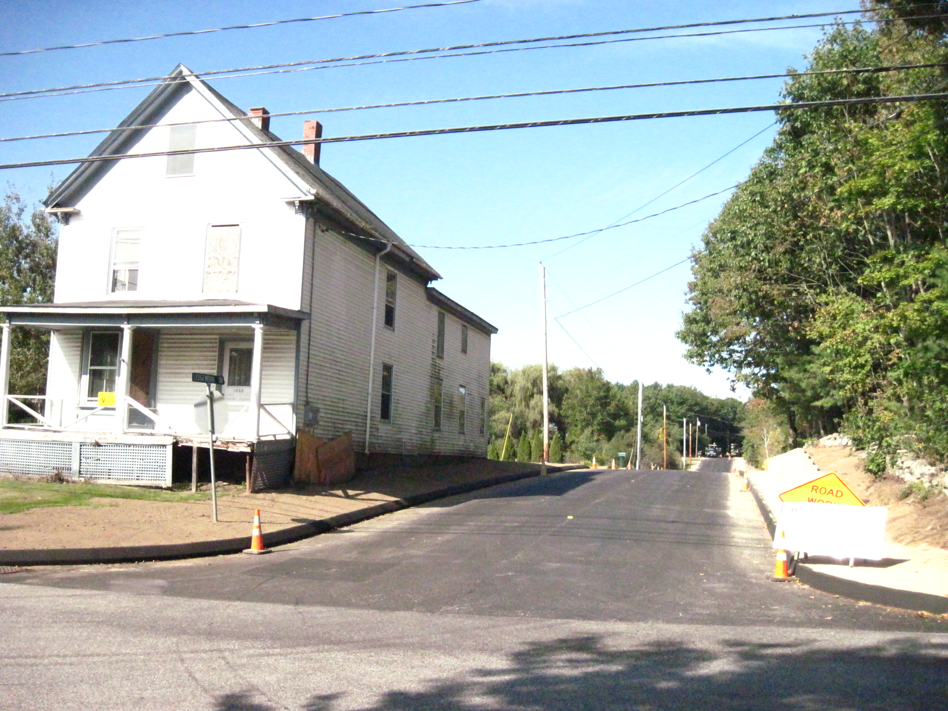
- EXISTING CONDITIONS (see Survey in Attachment Plan 1)

The site includes an existing (vacant) house at 1062 Ocean Avenue (Lot #14) which is not contiguous with the rest of the subdivision but is required to be included under Maine State Subdivision Law (see photo right). The subdivision also inlcudes an existing home on Lot #13, owned by the applicant and leased/occupied.

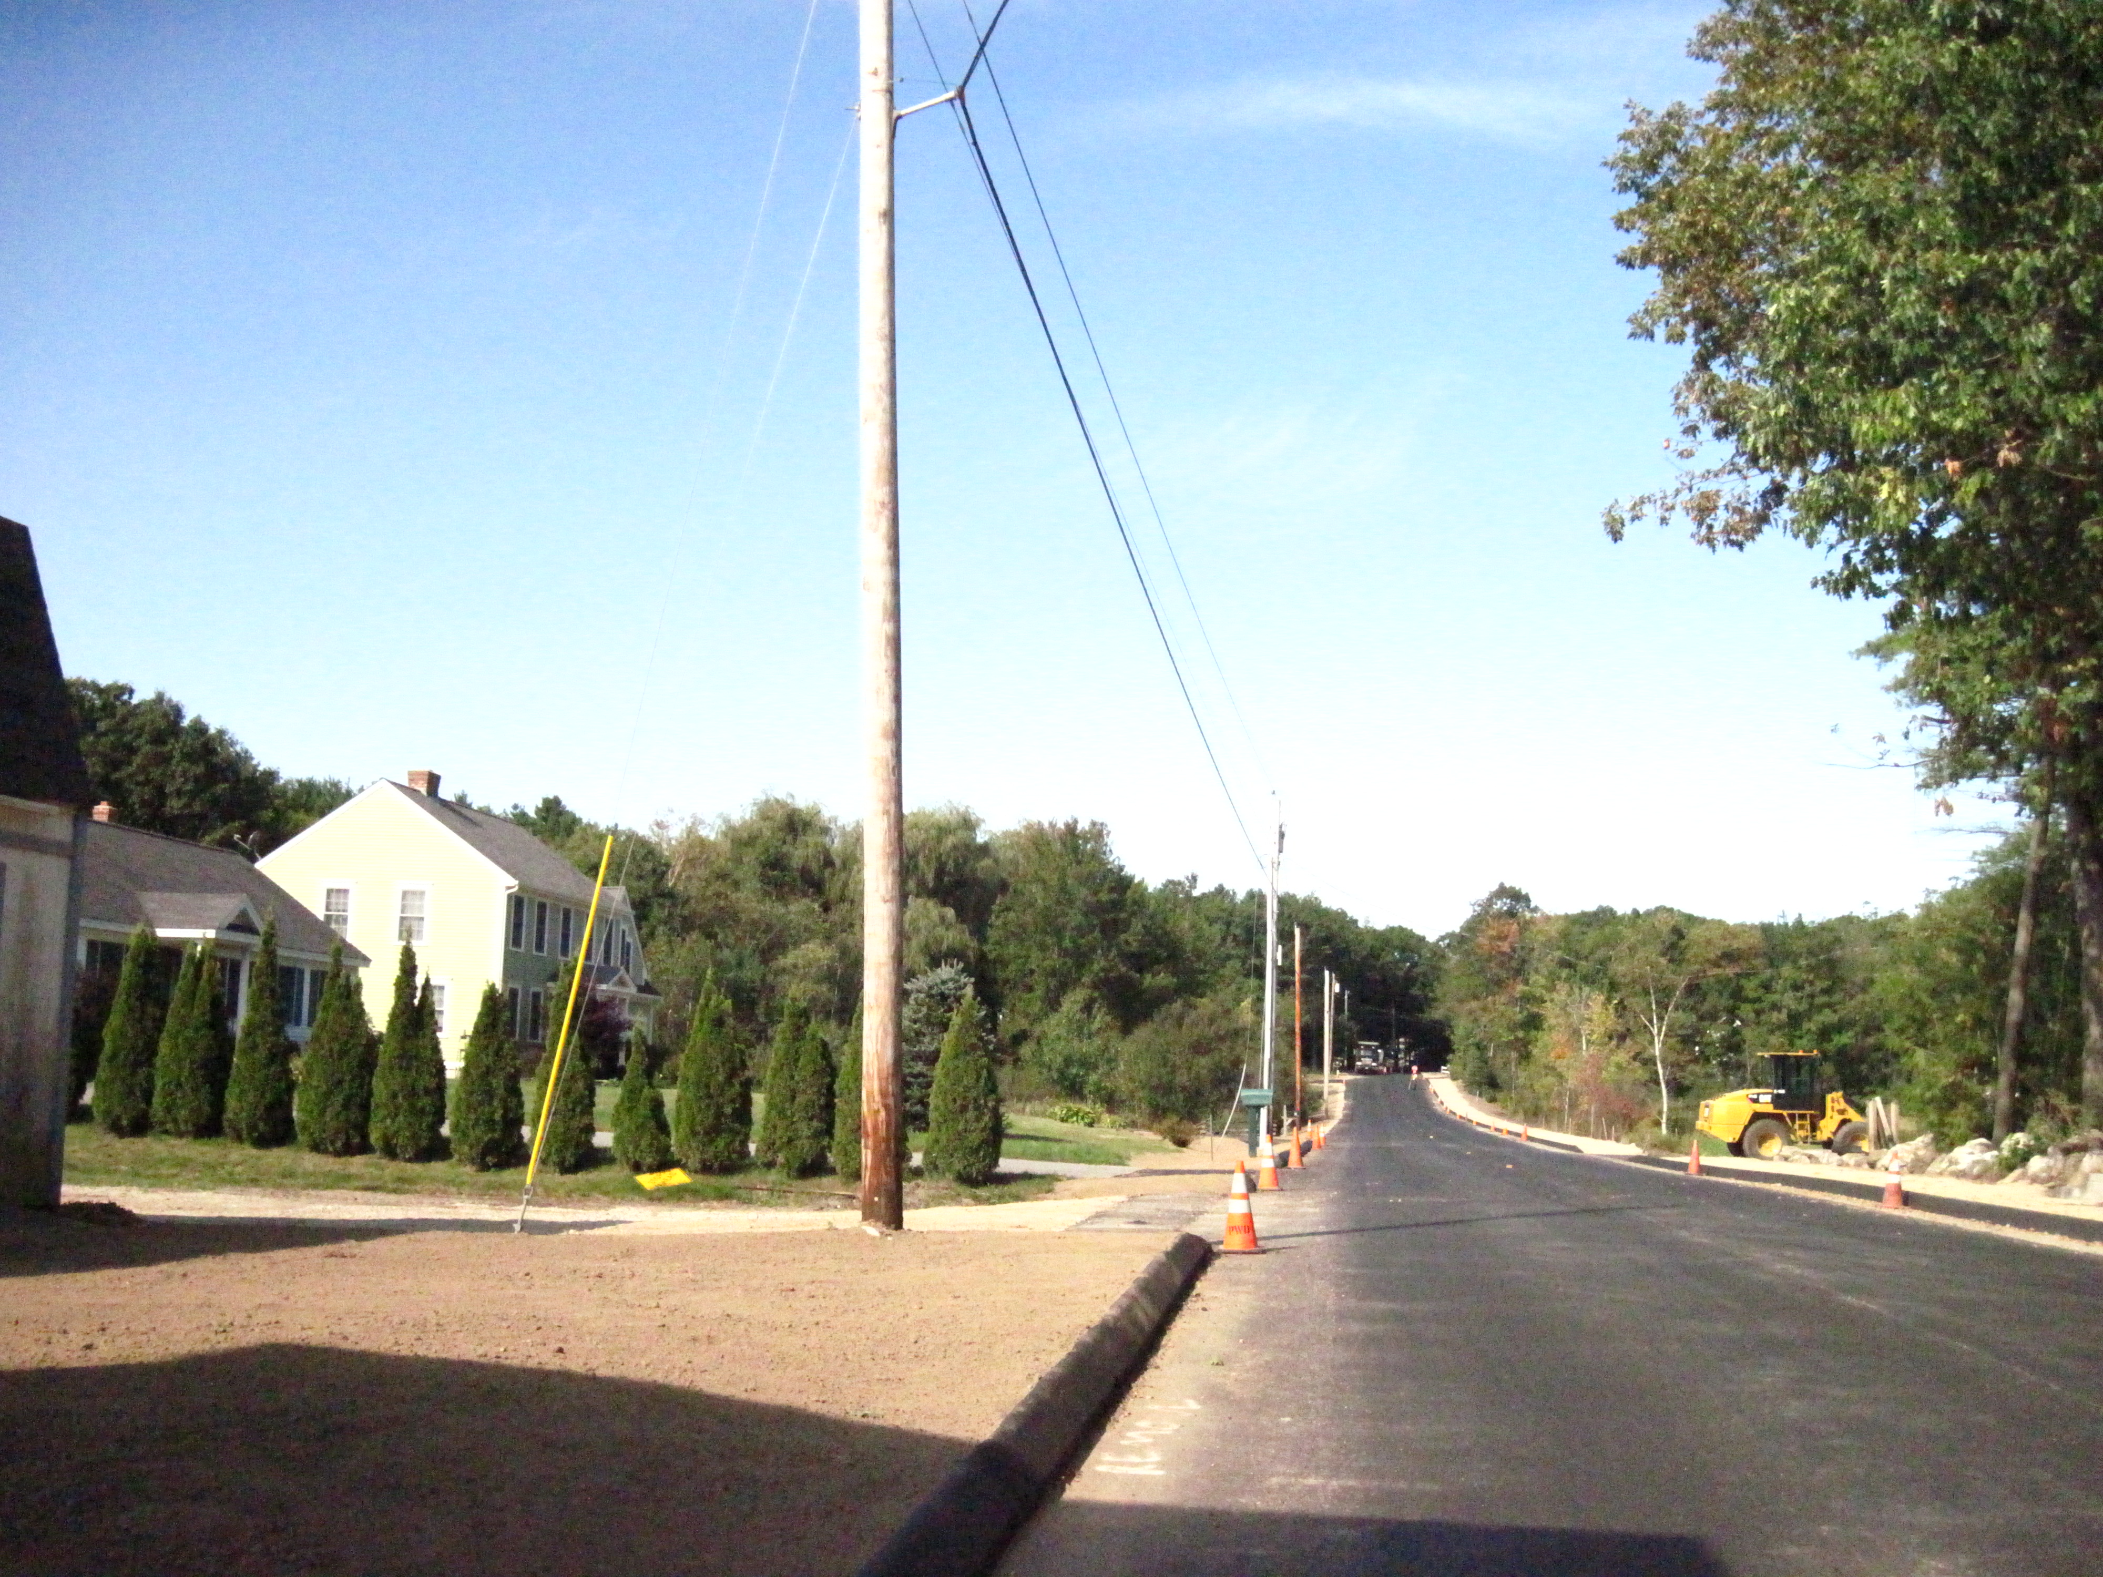
To the west is open space owned by the Falmouth Land Trust and understood to be dedicated conservation land with public access and trails that link into the Portland owned open space (Quarry Run Dog Park and former landfill areas) to the west and south of the proposed
subdivision.

To the east is land in other ownerships except that there is a 50 foot wide easement connecting the bulk of the subdivision site to Ocean Avenue. The contiguous backland parcel is bounded on the north by six existing houses that front onto Ledgewood Drive, of which four are owned by other parties (see photo lower left).

The main new subdivision site is largely composed of wetland and trees, and the MDEP have confirmed there is an intermittent stream traversing the central part of the main parcel (Attachment B and Plans 5,6 and 7). Abutting homes on Ledgewood

A sidewalk on the north side (opposite the development site), and curbs on both sides, of Ledgewood Drive have recently been constructed by Falmouth, though it is understood there are no immediate plans for similar improvements in Ocean Ave/Middle Road.
- PROPOSED DEVELOPMENT

The applicant has submitted comprehensive application with a full plan set and background information such as the Stormwater Report and Sidewalk/Curbing Waiver requests (Attachments G-K & Plans 1 to 16).

The focus of this review has been the new access drive (Ice Pond Drive) lined with 12 single family house lots ranging from .46 to 1.26 acres, and associated detailed proposals for septic systems, drainage, tree/wetland and other protection and buffers. The proposed new subdivision is located at the western end of the parcel to avoid disturbing the wetland areas and has been reduced (from the pre-application proposals) by one lot to minimize impacts on the intermittent stream.

The applicant has confirmed that the existing structure and garage on the isolated Lot #14 at the eastern end in Portland (corner of Ocean and Ledgewood) is intended to be demolished and a new structure built at some time in the future (Attachment B, updated by Attachment G). It would be subject to subdivision requirements (eg sidewalks) even if the detailed site plan is submitted in the future. Lot #13 is reconfigured.

The two other lots (#15 and #16) are wetlands (Lot #16) or primarily stormwater treatment areas (#15) and have been left as undeveloped lots called “open space” and proposed to be managed by a homeowners association.

The proposed access drive has been named Ice Pond Drive and totals 760 linear feet, starting in Falmouth on Ledgewood Drive located opposite Slocum Drive. About 100 feet of the proposed street is in Falmouth, and staff understand that the applicant will convey the fee in this section of the street to Portland and that the entire street (up to the intersection with Ledgewood Drive) will become an accepted street in the City of Portland.

The proposed new lots will be served by a water main in Ledgewood Drive and will each have a private septic system because the nearest sewers are too far away to tie into. The lots must be at least 20,000 sq ft to meet the requirements for a private septic system.

A detailed stormwater management plan has been submitted (Attachment K) which outlines a system with two grassed underdrained soil filters and the use of vegetated “no disturb” buffers for stormwater treatment to address the impacts of the full buildout of the subdivision.

The applicant is proposing a curbed sidewalk and esplanade on one side of the proposed access drive, which stops short of the boundary by 63 feet and does not extend along the frontages of Lots #8 and #9. This section (across the rest of Lot #9) is proposed to be a gravel walkway connecting the sidewalk to the Falmouth Land Trust public open space at the end of the street. The other side of the new street would be a vegetated swale with no curb nor sidewalk. The applicant has submitted waiver requests for this sidewalk and curbing and for sidewalks on Ledgewood and Ocean Avenue (Attachment J).

The applicant has indicated that they would work with the Falmouth Land Trust to ensure the public access connection through the Falmouth land to the Portland open space to the south of the site.

- STATE LAW REGARDING JOINT MEETINGS WHERE PROJECT CROSSES MUNICIPAL BOUNDARIES

The proposal requires review and approval from both Falmouth and Portland and ideally there would be one Subdivision Plat signed by both Boards. Under 30-MRSA Section 4403, Para 1-A the project requires all meetings of the relevant Boards to be held jointly unless both Boards have agreed, in writing, to waive this requirement.

Since the bulk of the project is located within Portland, the applicants requested a waiver from the Falmouth Planning Board first and held a “pre-application sketch plan review” discussion regarding the proposals on August 7, 2012. The Falmouth Planning Board voted to grant the applicant’s request to waive the joint meeting and hearing requirement under 30-MRSA Section 4403, as confirmed by the letter in Attachment 1a. However, the Falmouth Planning Board was concerned about several issues and requested their planners to coordinate with Portland planners to ensure these issues were addressed.

The Portland Planning Board also voted on October 9th, 2012 to waive the joint meeting requirement with the proviso that the option for requesting a joint meeting remains available in the event there are issues that arise in the future that require joint consideration and resolution.

It should be noted that as required by Maine law, Portland and Falmouth Planning Board’s both need to approve this proposal. Consequently, both staffs are coordinating on this review. The Falmouth Senior Planner (Ethan Croce) has already outlined the key concerns of the Falmouth Board (see minutes of the Falmouth 8.7.2012 meeting in Attachment 1b, and the e-mail from the Ethan Croce which summarizes the Falmouth Board concerns, Attachment 1c):

- Concern re stormwater/drainage impacts to Falmouth properties and to Ledgewood Drive;
- Need for traffic safety/capacity analysis for the intersections related to Ledgewood Drive (including the Middle Road and Allen Ave intersections);
- Need for pedestrian connectivity to the adjacent Land Trust and/or Dog Park properties.

The City departments have met to consider the issues, including re emergency response, as posed by the new street and the implications of Lot #13 being located within Falmouth; these are summarized in a staff e-mail in Attachment 8.

- STAFF REVIEW

        - ZONING ASSESSMENT

The proposed subdivision is within the R-3 Residential Zone.

Marge Schmuckal, Zoning Administrator, provided comments for the first Workshop (Attachment 7) which have been largely addressed in this submission. Her comments on the current submissions are (Attachment 10):

I have not seen a requested delineation of the AE Flood Zone as requested in my 9/21/2012 comments. I still am requesting to see that delineation.

I am also noting that Ice Pond Road is not meeting the requirements of 14-403 which requires streets to be put in from where ever pavement ends to the end of the lot(s) being developed. Ice Pond Road stops short approximately 65" from the end of both properties lot #8 & lot #9. The proposed City Street needs to be extended to the end of the lots being developed.

The applicant has provided Flood Zone information in Attachment I and a Zoning comment update will be provided at the workshop.

B. SUBDIVISION STANDARDS

14-496. Subdivision Plat Requirements

The draft Subdivision Plat is included as Plans 5 and 6. The graphic presentation is generally acceptable, but a number of notes will need to be added to clarify the status of the new street and its ownership, limitations on lots (tree zones; setbacks etc), responsibilities for maintaining common features/systems, etc.

Lot #14 has been shown and described as remaining in its existing condition but would need to meet any subdivision requirements (Attachment G and Plan Set). If those requirements are not shown on the plat at this time, there would need to be a note to this effect and the plat would need to incorporate any future development.
14-497. Subdivision General Requirements (a) Review Criteria

Water, Air Pollution and Soil Erosion

Plans, notes and details have been submitted that adequately address standards for the new road and other infrastructure (Attachment 11). A letter confirming adequate water supply has not been submitted.

Traffic

Traffic impact on surrounding intersections

The applicant submitted a Traffic Assessment (Attachment B, as updated in Attachment H) which projects 140 daily vehicle trips from the proposed subdivision access drive to/from Ledgewood Drive (70 enter, 70 exit) and reviewed safety data for Ledgewood Drive. It was updated to address Falmouth Planning Board concerns about the impacts on the operation of nearby intersections and concludes that the impact on the capacity and level of service on the nearest intersections is minimal. The City’s Traffic Engineering reviewer finds this evaluation acceptable (Attachment 12).

Proposed subdivision street

The proposal includes a new street, 760 linear feet, that starts in Falmouth at an intersection with Ledgewood Drive and dead ends with a turnaround near the Falmouth boundary to the west. The intersection is located opposite Slocum Drive and includes a crosswalk to the north side of Ledgewood Drive to Slocum Drive and to an existing sidewalk along Ledgewood Drive.

The access drive has been designed to meet City of Portland standards with a paved travel way of 28 feet in width. The standard in Falmouth is 24 feet and although the Falmouth Board has indicated it would defer to the Portland standard since it is anticipated to be a Portland street (Attachment 1b). The applicant did ask at a pre-application meeting whether a 24 foot wide road could be approved, but the Fire Department has indicated that 28 feet is needed for emergency access.

The Traffic Engineering Reviewer is concerned at the radii size where the new road joins ledgewood Drive and had requested the applicant provide an “auto-turn” analysis at the driveway entrance using both a passenger car and a single-unit truck to support the proposed radii size (Attachment 12).

The proposed new street stops 63 feet short of site boundary and dos not run along the full frontage of Lots 8 and 9. Lot #9 has both a turnaround and a maintenance access drive for the stormwater system in the front yard (Plan 7). Staff recommend that the street be extended across the entire frontage (to meet zoning requirements and to allow the sidewalk to be paved - as discussed in other sections of this memo) and to combine the turnaround with the maintenance access near the site boundary (Attachment 13).

The proposed street does not include street lighting in accordance with the City’s Technical Standards. The applicant considers (attachment G, item 21) that the exiting street light on theother side of ledgewood at the new intersection is adequate at that end of the new drive. One other light is proposed near the turnaround near the dead end of the new drive. DPS are considering this requested waiver from the city standards.

The Concept Plan previously presented to the Board showed Lot #13 having a new driveway onto the proposed subdivision street. After discussions with staff of both municipalities and a review of the sight distances for the existing driveway, the applicant has decided to leave Lot #13 as existing and with its existing address as it is located within Falmouth and the home is occupied. This is acceptable to Portland staff (Attachment 12).

It should be noted that the proposal has been discussed with the Fire Department, DPS trash collection, snowplow and addressing staff, and is acceptable. The 12 lot part of the subdivision will be the only new addresses and they will all be in Portland.

Connectivity

The applicant has confirmed (Attachments G) that they are would create a pedestrian/trail connection linking the subdivision sidewalk to trails within the Falmouth Land Trust public open space; this would achieve a link into the Portland Open Space (Dog Park). Some evidence that this proposal is feasible and supported/financed should be submitted for the hearing review. The applicant should also confirm whether he will be making a financial commitment to ensure this is achieved.

The applicant has proposed a crosswalk across Ledgewood Drive from the proposed sidewalk to the existing sidewalk on Ledgewood. The Traffic Engineering Reviewer has requested crosswalk warning signs be installed (Attachment 12).

Sanitary Sewer/Soils

The proposed new subdivision of 12 lots will have private septic systems, and the lot sizes appear to meet the required minimum lot size (20,000 sq ft). The Plan 7 shows the disposal field locations as located by Sweet Associates of Falmouth as they are limited by shallow ledge and shallow water table. Two locations are shown on Lot #4 and the applicant has noted that the one in wetland and stream setback is preferred (Attachment G).

Staff consider that the septic system leach fields should not encroach within the wetlands/stream setback as shown for Lots #3 and #4 and have requested a determination on this from MDEP (Attachment 11).

Storm water

A detailed Stormwater Management Report has been submitted (Attachment K) which outlines a system with two grassed underdrained soil filters and the use of vegetated “no disturb” buffers for stormwater treatment. The supporting calculations assume the full buildout of the subdivision, including homes (5000 sq ft impervious).

There are a number of concerns regarding the Report as set out in the comments from the Peer Engineering Reviewer David Senus in Attachment 11, which refer to technical issues regarding the system design as well as the need for protective and maintenance easements. Such easements would also need to be identified more clearly on the Subdivision Plat.

Scenic Beauty

Street trees

The applicant has provided a narrative explaining the approach to street trees in Attachment G item 20. Staff suggest that the 2 trees/lot standard should apply only to the 14 residential lots (ie excluding the two open space lots) which would mean a requirement of 28 trees. The proposals show 30 trees but these are evenly spaced and don’t strictly result in 2 trees on each lot. Lots #13 and #14 have no proposed street trees.

The City Arborist is concerned about the plant list shown on Plan 7 and includes recommendations in his comments (Attachment 9.)

Treesaves

The narrative in Attachment G item 6 describes the basis for proposing treesaves and notes that all of Lot #16 is a treesave area and that the stormwater buffer areas will also preserve trees.

The plans (Plans 6 and 7) show a 25 feet wide treesave zone along the south side of the seven lots # 2 through #8 which abut the City’s open space. This area is largely red oaks and maple trees. These treesave areas would provide screening between the home lots and the public park and will need a specific note on the Subdivision Plat and in the deeds which clarifies that these a essentially “no disturb” areas.

The City Arborist has identified steps that need to be taken to ensure adequate protection of the treesave areas (Attachment 9). He has also recommended additional buffer planting (trees) for Lots #10, #11, #12 and #13 along the rear property line, as they do not have any treesave areas identified (Attachment 9). The stormwater buffer may be adequate as suggested by the applicant (Attachment G) and this requires further discussion.

Vegetated buffers and wetland buffers

“Stormwater No Disturb buffers” are shown on Plan 7 and reviewers have noted that these should be delineated on the ground in some way and that leach fields should not be located with these buffers (Attachment 11).

Open Space

The proposed subdivision includes a total of 163,800 sq ft of open space. The largest area is 152, 100 sq ft and made up primarily of wetlands, adjacent to properties with existing homes and to the City’s open space to the south. A separate small area (11,700 sq ft) of identified open space is located within Falmouth along Ledgewood Drive and is co-located with the larger of the two proposed “stormwater management areas”. These have been identified as Lots #16 and #15 respectively and the applicant has indicated a homeowners association will be formed to own and maintain these lots.

The maintenance and management of these open space areas will be the responsibility of a homeowners association, as confirmed in Attachment G item 12. The applicant is preparing the homeowners’ association documents but these have not been submitted at this time.

Financial Capability

This has not yet been submitted.

Wetlands

The Subdivision ordinance standard reads:

14-497 a 11. Whenever situated, in whole or in part, within the watershed of any pond or lake or within two hundred fifty (250) feet of any wetland, great pond or river as defined in Title 38, chapter 3, subchapter I, article 2-B, will not adversely affect the quality of such body of water or unreasonably affect the shoreline of such body of water;

The parcel contains extensive wetlands and an intermittent stream, as confirmed in an MDEP field report and Wetland Delineation Note (no plan) in Attachment B. Most of the wetland is within Lot #16 which is not proposed to be developed.

A 75 foot setback from the wetlands is required and has largely been met with the exception of the leach field locations on Lots #3 and #4 which was discussed above. A NRPA permit is required for the access drive to the home on Lot #2 and the extent of wetland filling has not yet been identified.

The Subdivision Plat will need to include notes to address the Peer Engineer and DPS comments, including the placement of markers to identify the location of wetland setbacks (Attachments 11 and 13).

14-498. Technical and Design Standards

This section of the Subdivision Ordinance includes a number of provisions that the applicant will need to consider carefully as the final plans are being developed. The open space and connectivity requirements have been mentioned previously; three others of particular relevance are:

Sidewalk Requirements

14-498 8a. Sidewalks and curbs: Sidewalks shall be constructed on each side of each street in accordance with article III of chapter 25. Sidewalks to be used by pedestrians are to be so located as to minimize contacts with normal automotive traffic, with preference given to interior walks away from streets in common open space in block interiors.

The applicant has submitted a waiver request (Attachment J, as amplified in Attachment G item 15) for:
- Sidewalks and curbing on the south side of the proposed new subdivision street
- Sidewalks and curbing on the south side of Ledgewood Drive where the site abuts
- Sidewalks and curbing on the west side of Ocean Avenue along the frontage of Lot #14.

DPs have commented that they may be willing to waive the sidewalk only on south side of the proposed new subdivision street in view of the stormwater swale proposed long that side. The interaction of sidewalks, curbing and stormwater management needs further discussion. The gravel section shown near the site boundary is not acceptable, and as suggested under Traffic staff suggest the street and sidewalk be extended to join the proposed trail connection at the property boundary.

The Traffic Engineering Review has commented (Attachment 12) that a sidewalk along Ledgewood Drive should not be required. It is noted that this road is within and maintained by Falmouth and there is a new sidewalk on the other side. Staff are still reviewing the other waiver request.

Street names

In accordance with 14-498 (d) Street and subdivision names the applicant has chosen names for the new street and for the 12 lot subdivision that are acceptable to the City of Portland; they need to be approved by the Planning Board as part of the Subdivision Plat approval.

Underground Utilities

The Subdivision ordinance 14-498 also requires that all utility lines shall be placed underground unless otherwise approved by the Planning Board. The submitted Plan 9 suggests this is part of the proposal but clarification is requested.

VII NEIGHBORHOOD MEETING AND PUBLIC COMMENTS

A neighborhood meeting has been held and the Certification is included in Attachment L.

viii nEXT STEPS

- Revise the Stormwater system to address the Engineering review comments
- Revise new street to extend and modify turnaround location, extend paved sidewalk and address other detailed comments, and resolve street lighting
- Revise the Subdivision Plans to include easements and other notes
- Address Zoning Administrator comments
- Address City Arborist comments and resolve re buffer planting on northern lots
- Determine Lot #14 requirements and notes
- Confirm wetland filling and NRPA permit
- Resolve sidewalk and curbing waivers
- Clarify re underground utilities
- Provide auto-turn” information on radii
- Clarify with MDEP whether septic system leach fields can be located in stream/wetland setback areas
- Submit draft homeowners association documents
- Submit evidence that the connection to trails in Falmouth is supported, feasible and committed
- Submit letter of financial capability and from PWD and utilities

(Attachments next page)

ATTACHMENTS:

Attachments to First Memorandum
  - Documents re Falmouth Planning Board and State law requirements
    - Letter from Ethan Croce, Senior planner, Town of Falmouth 9.13.2012
    - Minutes of Falmouth Planning Board of August 7, 2012
    - E-mail from Ethan Croce confirming Falmouth Planning Board concerns 9.18.2012
  - City Arborist (Jeff Tarling) comments 9.13.2012
  - Transportation Engineering (Tom Errico) comments 9.14.2012
  - Peer Engineering Review comments (David Senus) 9.20.2012
  - DPS (David Margolis-Pineo) comments 9.21.2012
  - Fire Department (Chris Pirone) comments 9.21.2012
  - Zoning Administrator (Marge Schmuckal) comments 9.21.2012

Attachments to Second Memorandum re detailed submissions
  - Staff e-mail re issues of joint concern to Portland and Falmouth
  - City Arborist comments 1.9.2013
  - Zoning Administrator comments 1.16.2013
  - Peer Engineering Review comments 1.16.2013
  - Traffic Engineering Review comments 1.17.2013
  - DPS comments 1.17.2013

Applicant’s Submittal
- Application dated 8.28.2012 (does not include data sheet)
- Letter from Land Design Solutions (Peter Biegel) incl Wetland Delineation & MDEP Field Report 8.22.2012
- Right, Title and Interest information
- Letter from Land Design Solutions (Peter Biegel) w/ Info on Landscaping & Trail Connection, dated 9.13.2012
- Neighborhood Meeting Invitation dated 9.14.2012
- Stormwater Management Information Letter from Land Design Solutions (Tom Saucier, PE) dated 9.18.2012

For second PB Workshop
- Letter from Land Design Solutions (Peter Biegel) responding to Workshop comments 1.1.2013 (atts below)
- Traffic Assessment, Eaton Traffic Engineering 1.1.2013
- Flood Maps
- Sidewalk and Curb Waiver Request with map 1.2.2013
- Stormwater Management Report January 2013
- Neighborhood Meeting Certification

Plans
      - Survey
      - Aerial photo with parcels annotated
      - Sketch Plan

Plans for second PB Workshop
      - Cover sheet (Old Barn Estates)
      - Subdivision Plan #1
      - Subdivision Plan #2
      - Lot Development and Landscape Plan
      - Grading, Drainage and Erosion Control Plan
      - Profiles (new street)
      - Erosion and Sedimentation Notes and Details
      - Site Details
      - Site Details
      - Site Details
      - Pre-Development Drainage Plan
      - Off-Site Subcatchment Plan
      - Post Development Drainage Plan

