

DRAFT- WORK IN PROGRESS AS OF 9.20.2012

Memorandum
Department of Planning and Urban Development
Planning Division

TO: Chair Morrissette and Members of the Portland Planning Board

FROM: Jean Fraser, Planner

DATE: Prepared: September 21, 2012
Presented: September 24, 2012

RE: LEDGEWOOD DRIVE 14 Lot SUBDIVISION
Preliminary Review

Address: 1062 Ocean Avenue CBL: 414-A-4 (part within Town of Falmouth)

Project ID: 2012-584
Applicant: TPO Properties, LLC , Tim Donovan

- Introduction

Tim Donovan is proposing a 14-lot subdivision on land between Ocean Avenue in Portland and Ledgewood Drive in Falmouth. The site includes an existing (vacant) house at 1062 Ocean Avenue which is not contiguous with the rest of the subdivision but but is required to be included under Maine State Subdivision Law (Lot #14). There is also an existing home on part of the land where it meets Ledgewood Drive (incorporated into Lot #13).

The Planning Board is being requested to review the application under Portland’s Subdivision Ordinance.

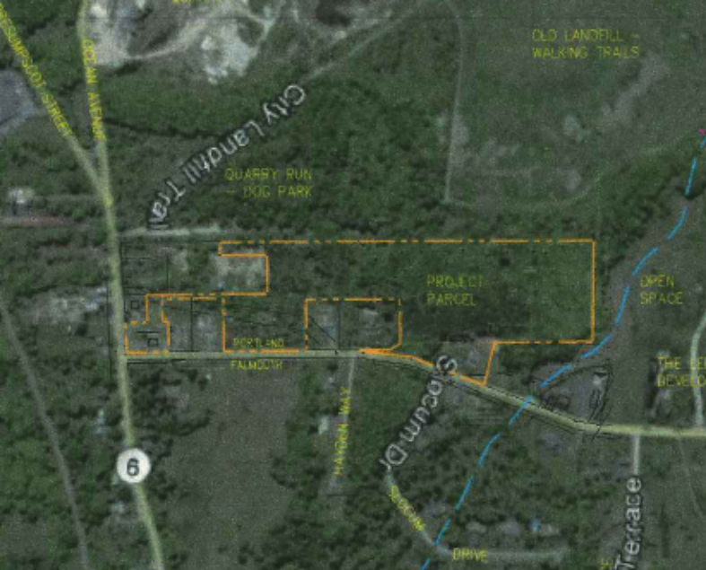
Of the total site of 12.78 acres, just under an acre is located within the Town of Falmouth. Within this land within Falmouth the proposals show part of the new drive, the intersection with Ledgewood Drive (a Falmouth street), most of the stormwater management area, and one house lot.

Under Maine State Law 30-MRSA Section 4403 there is a requirement for joint meetings between the Planning Boards of Portland and Falmouth where a project crosses municipal boundaries, unless the respective reviewing authorities waive this requirement in writing. Falmouth voted on August 7, 2012 to waive this requirement and the Portland Planning Board needs to vote (at a Hearing) whether to also waive this requirement.

Extract from applicant’s submission; larger version in Att. Plan 2

A total of 63 notices were sent out to neighbors and interested parties within Portland, and the public notice appeared in the XXX and XXX, 2012 editions of the Portland Press-Herald.
- PROJECT DATA

DATA | Existing home at 1062 Ocean Avenue  (Lot #14) | Proposed new 13 lot contiguous subdivision  with part in Falmouth  (Lots#1 to #13) |  | Totals  for new 13 lot contiguous subdivision
Location | Within Portland and fronts on Portland street | Within Portland and no existing street access | Within Falmouth and fronting Falmouth street
Existing Zoning | R-3 | R-3 | R-3 | R-3
Existing Use | Single family (non-conforming) | Vacant/undeveloped | Single family
Proposed Use |  | Single family lots | Reconfigured lot of 22,480 sq ft, new drive & stormwater man.
Areas | .58 acre | 11.29 acres | .91 acre | 12.78 acres
No of Lots | 1 | 12 | 1 plus | 4
Lot sizes | .58 | Range from 20,000 sq ft to 54, 800 sq ft | 22,480 sq ft | 4
Street Frontage | Information not submitted - but meets zoning minimum requirement
Total Disturbed Area | Information not submitted
Existing impervious
Proposed impervious
Proposed new (dead end) road | none | Approx. 570 linear ft | Approx. 100 linear ft & intersection w/ Ledgewood | Approx. 670 linear ft
Area of existing wetland | Information not submitted; understood that plan of wetland delineation not available  from Sweet Associates Wetland Delineation note (see Attachment B)
Area of wetlands proposed to be filled
Proposed open space |  | 152,100 sq ft  (mostly weltand) | 11,700 sq ft within Falmouth adj Ledgewood | 163,800 sq ft

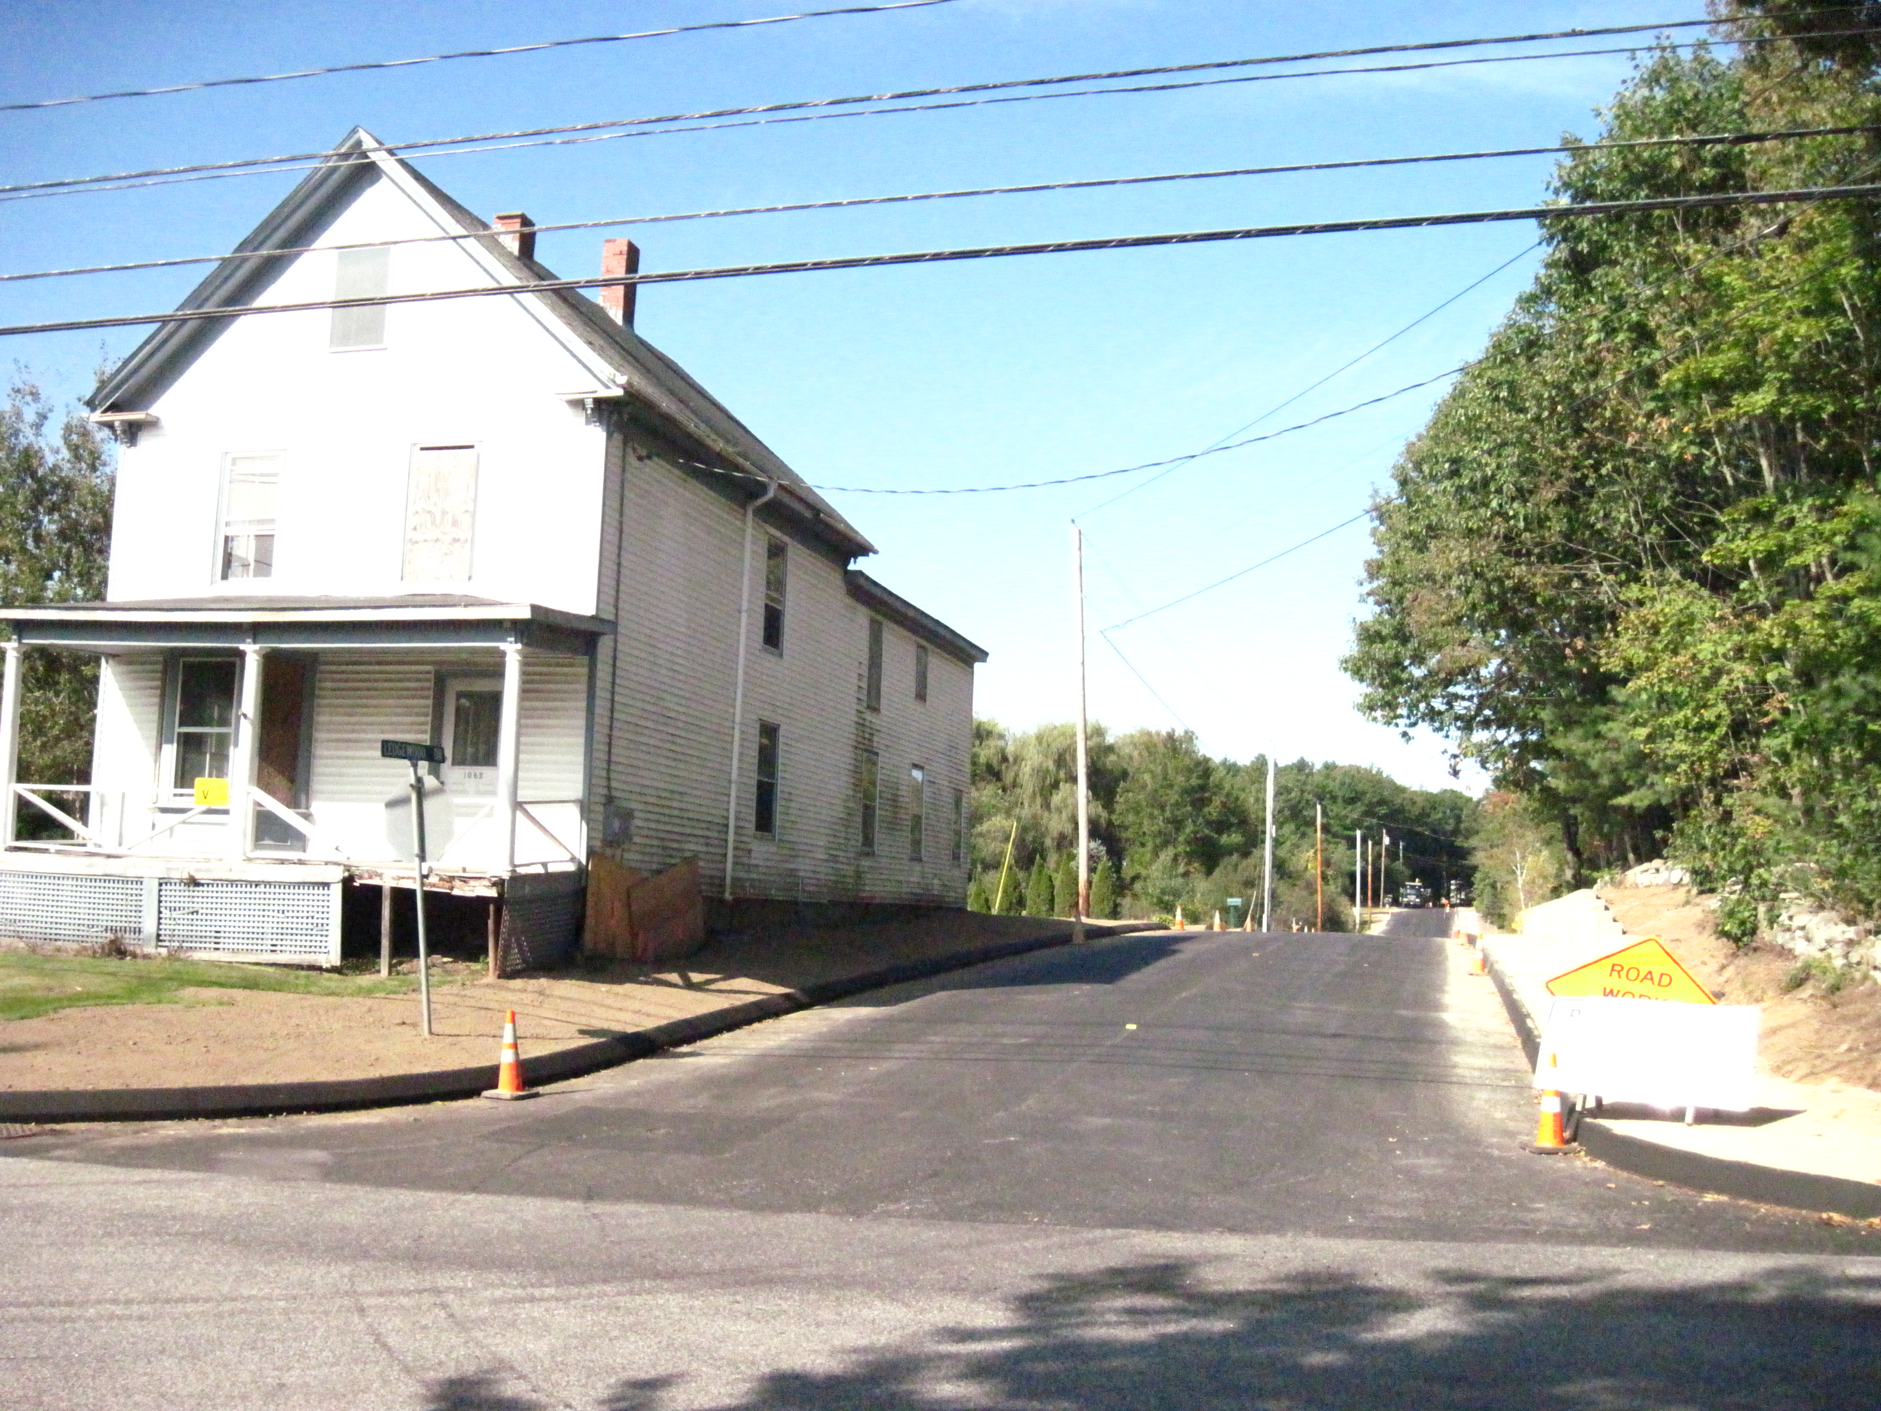
- EXISTING CONDITIONS (see Survey in Attachment Plan 1)

The Lot #14 comprises the existing vacant home at the corner of Ocean Avenue and Ledgewood Drive. See photo right.

The contiguous backland parcel is bounded on the north by six existing houses that front onto Ledgewood Drive, of which four are owned by other parties (see photo lower left).

To the west is open space owned by the Falmouth land Trust and understood to be dedicated conservation land with public access and trails that link into the Portland owned open space (Quarry Run Dog Park and forma landfill areas) to the west and south of the proposed subdivision. To the east is land in other ownerships except that there is a 50 foot wide easement connecting the bulk of the subdivision site to Ocean Avenue.
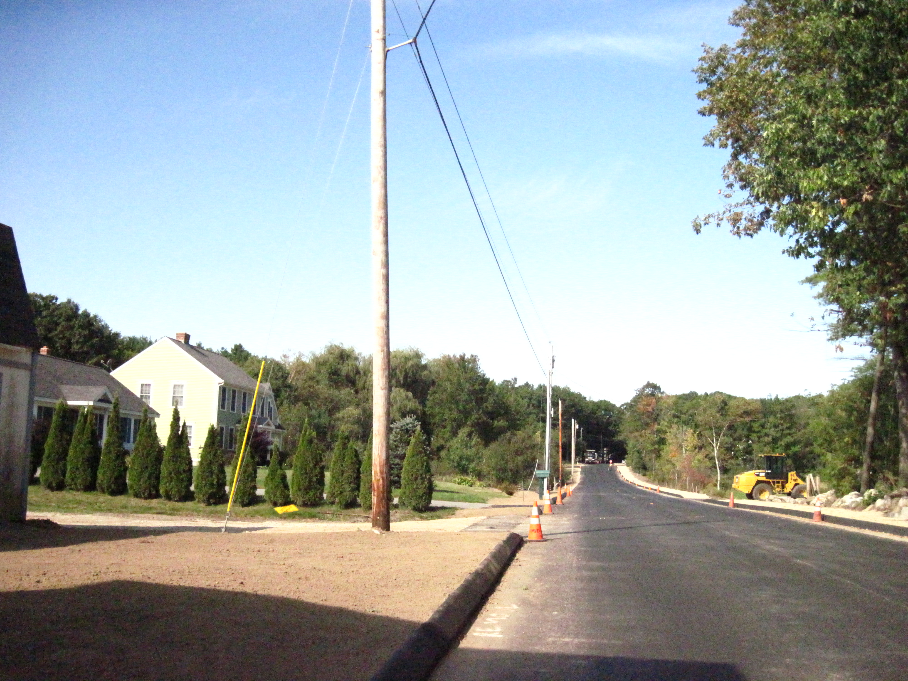
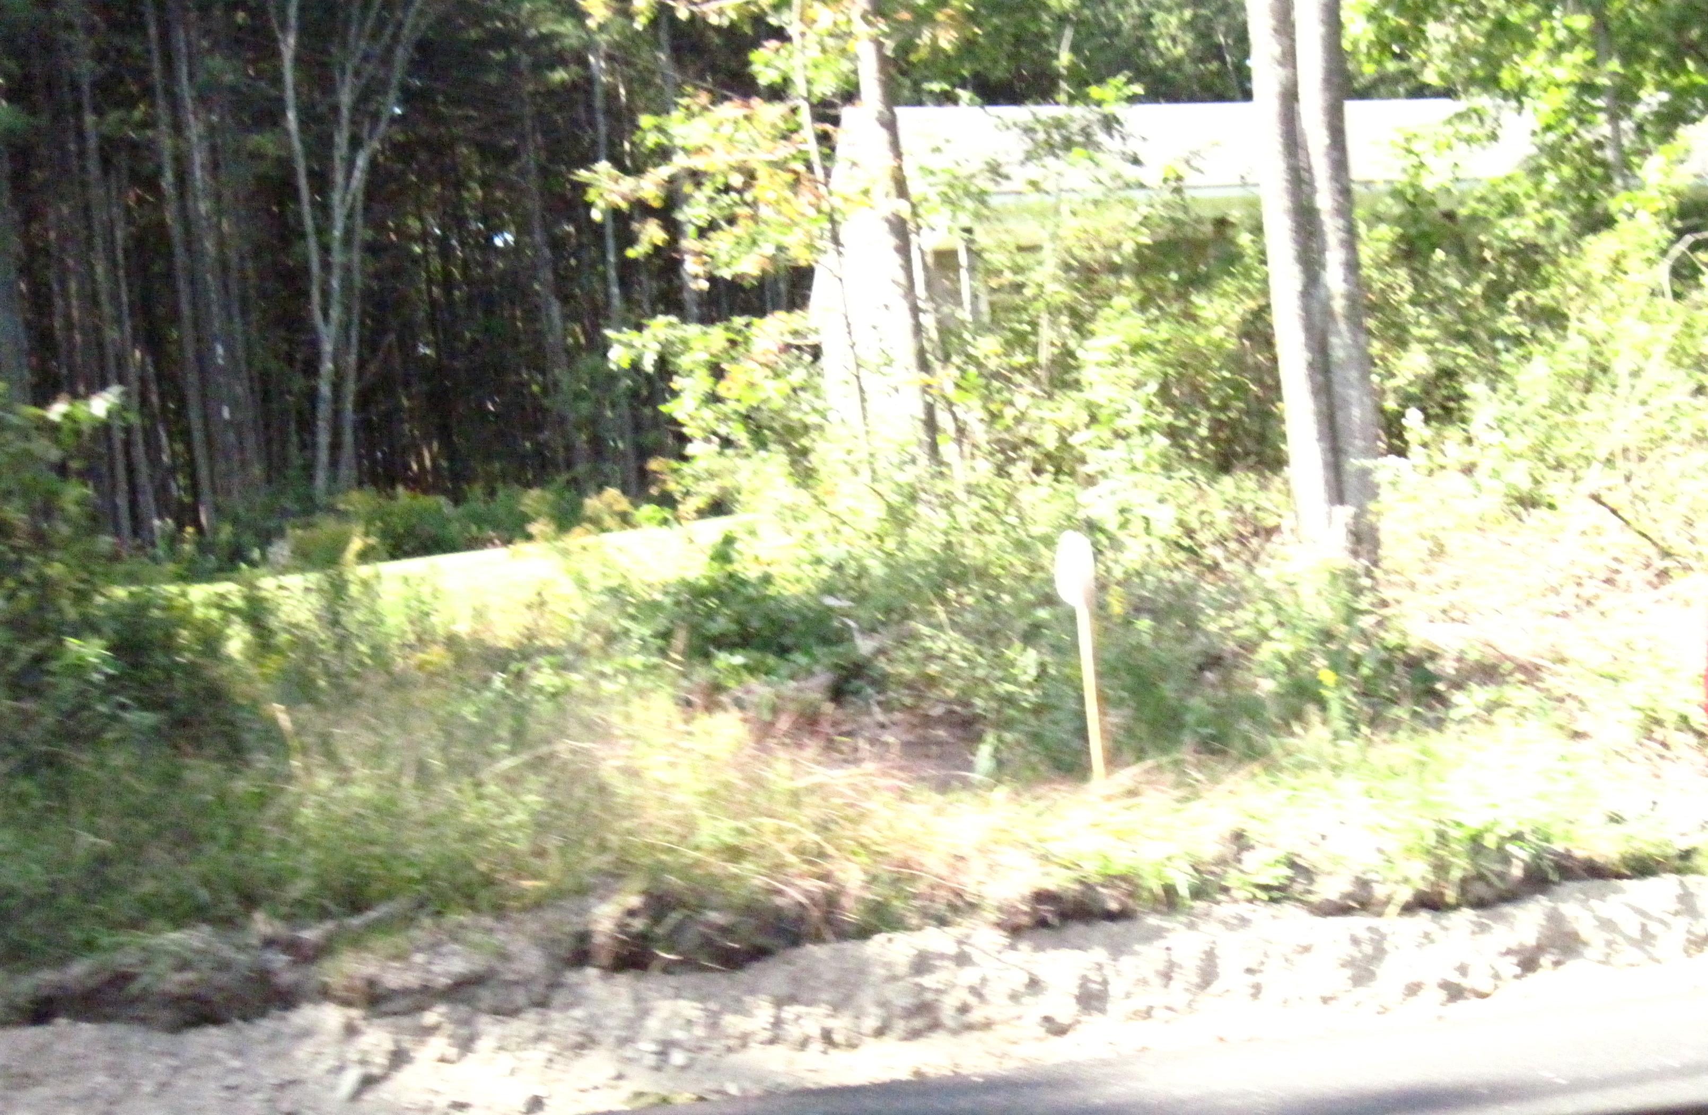

Homes on Ledgewood at Ocean Ave end, not in subdivision- Existing home on Lot #13, fronting Ledgewood and
but wetland area is immediately beyond them on left opposite Slocum Drive (photos constrained by road work)
The main new subdivision site is largely composed of wetland and trees, and the MDEP have confirmed there is an intermittent stream traversing the central part of the main parcel (Attachment B).

Curbs on both sides of Ledgewood Drive, and a sidewalk along the north side, were under construction by Falmouth at the time this Memo was prepared.

- PROPOSED DEVELOPMENT

The applicant has submitted a preliminary application with a sketch plan (Attachments 1 and Plan 3) and requested a preliminary review prior to developing the details of the subdivision. The applicant has already presented the project in “concept” form to the Falmouth Planning Board in association with their request for a waiver from the requirement for joint meetings (see section V below).

The applicant has confirmed that the existing structure and garage on the isolated Lot #14 at the eastern end in Portland (corner of Ocean and Ledgewood) is intended to be demolished and a new structure built at some time in the future (Attachment B). This work is not part of the main subdivision project, but this lot is included in the review as it was originally owned in conjunction with part of the land in the proposed subdivision area, and under State law it must be included in the review.

The proposed new subdivision (Lots #1 to 13) is located at the western end of the parcel to avoid the wetland areas and has been reduced (from the pre-application proposals) by one lot to minimize impacts on the intermittent stream.

A new drive totaling almost 700 linear feet is proposed to provide access to the new lots, with its entrance onto Ledgewood Drive (in Falmouth) located opposite Slocum Drive, and a crosswalk incorporated within the proposal to link to the sidewalk on the north side (currently under construction). Most of the drive (approximately 600 feet) is located within the City of Portland, with the last 100 feet and intersection with Ledgewood in Falmouth.

During the pre-application meetings with Portland staff and the “concept plan” discussions with Falmouth it has been assumed that the City of Portland would accept this street in due course as a public right of way and be responsible for plowing and trash collection. If this becomes a Portland street it raises a number of issues, which are discussed in detail in section V.

The proposed new lots will be served by a water main in Ledgewood Drive and will each have a private septic system because the nearest sewers are too far away to tie into. The lots must be at least 20,000 sq ft to meet the requirements for a private septic system.

A detailed stormwater anlaysis has not been undertaken as this is a preliminary review, but the proposals indicate two areas where stormwater management systems could be located.

The subdivision also includes substantial areas of “Open Space” which generally comprise the wetland/intermittent stream areas and areas designated for stormwater management. Future management and maintenance of these areas has not been discussed.

The applicant is proposing a sidewalk and esplanade on one side of the proposed access drive, with the sidewalk linking into the Falmouth public open space at the dead end of the street. The applicant has indicated that they would work with the Falmouth Land Trust to ensure the sidewalk is linked to trails that connect to the Portland open space to the south of the site.

The applicant has requested a waiver (though not yet submitted an analysis in relation to the Portland waiver criteria) for the sidewalk on the other side of the access drive (Attachment B).

- STATE LAW REGARDING JOINT MEETINGS WHERE PROJECT CROSSES MUNICIPAL BOUNDARIES

The proposal requires review and approval from both Falmouth and Portland and ideally there would be one Subdivision Plat signed by both Boards. Under 30-MRSA Section 4403, Para 1-A the project requires all meetings of the relevant Boards to be held jointly unless both Boards have agreed, in writing, to waive this requirement.

Since the bulk of the project is located within Portland, the applicants requested a waiver from the Falmouth Planning Board first and held a “pre-application sketch plan review” discussion regarding the proposals on August 7, 2012.

The Falmouth Planning Board voted to grant the applicant’s request to waive the joint meeting and hearing requirement under 30-MRSA Section 4403, as confirmed by the letter in Attachment 1a. However, the Falmouth Planning Board was concerned about several issues and requested their planners to coordinate with Portland planners to ensure these issues were addressed.

The Portland Planning Board needs to formally confirm that it is also willing to waive the joint meeting requirement and so the Board will be requested to vote on this waiver at the October 7th Planning Board hearing. A draft letter will be prepared by Corporation Counsel (incorporating any Board comments) if the Board indicates at this Workshop that it desires to waive the joint meeting requirement. In view of the number of Falmouth Board concerns and the range of legal and operational issues resulting from the location of the municipal boundary (re latter, see Section II Project Data), Staff recommends that the Board waive the joint meeting requirement with the proviso that the option for requesting a joint meeting remains available in the event there are issues that arise in the future that require joint consideration and resolution.

It should be noted that as required by Maine law, Portland and Falmouth Planning Board’s both need to approve this proposal. Consequently, both staffs are coordinating on this review. The Falmouth Senior Planner (Ethan Croce) has already outlined the key concerns of the Falmouth Board (see minutes of the Falmouth 8.7.2012 meeting in Attachment 1b, and the e-mail from the Ethan Croce which summarizes the Falmouth Board concerns, Attachment 1c):

- Concern re stormwater/drainage impacts to Falmouth properties and to Ledgewood Drive;
- Need for traffic safety/capacity analysis for the intersections related to Ledgewood Drive (including the Middle Road and Allen Ave intersections);
- Need for pedestrian connectivity to the adjacent Land Trust and/or Dog Park properties.

Portland staff has also already identified the following concerns regarding, the location of the Falmouth/Portland boundary:

- The need to convey the fee ownership for the proposed ROW (now within Falmouth) to Portland;
- Which authority should pick up trash and provide emergency response to Lot #13 which is in Falmouth and already addressed in Falmouth as its drive is currently on Ledgewood, but is proposed to have its drive relocated onto the new access drive; (assuming the other 12 lots in Portland are provided with all services, including plowing, by Portland)
- Which authority should be the “back up” (ie in event of default by the Homeowners Association, which would have responsibility and be liable for costs) to the maintenance agreement for the stormwater management system and open space, some of which will be in Portland and some in Falmouth.

- STAFF REVIEW

        - ZONING ASSESSMENT

The proposed subdivision is within the R-3 Residential Zone.

Marge Schmuckal, Zoning Administrator, reviewed the proposals and XXXX [comments awaited]

B. SUBDIVISION STANDARDS

14-496. Subdivision Plat Requirements

The ordinance requirements would need to be met in the final submissions.

14-497. Subdivision General Requirements (a) Review Criteria

Water, Air Pollution and Soil Erosion

This will be reviewed at the final plan stage when additional information is available.

Traffic

The proposals include a new access drive that starts in Falmouth at a new intersection with Ledgewood Drive and dead ends with a hammerhead near the Falmouth boundary to the west. The intersection is located opposite Slocum Drive and includes a crosswalk to the north side of Ledgewood Drive to Slocum Drive and to an existing sidewalk along Ledgewood Drive (currently under construction).

The access drive has been designed to meet City of Portland standards with a paved travel way of 28 feet in width. The standard in Falmouth is 24 feet and although the Falmouth Board has indicated it would defer to the Portland standard since it is anticipated to be a Portland street (Attachment 1b), the question of whether a 24 foot wide travel way might be more appropriate has been raised.

The applicant submitted a Traffic Assessment (Attachment B) which projects 140 daily vehicle trips from the proposed subdivision access drive to/from Ledgewood Drive (70 enter, 70 exit) and reviewed safety data for Ledgewood Drive.

The City’s Transportation Engineering Reviewer Tom Errico has commented (Attachment 3) :

- Based upon the scope of the project a traffic study or Traffic Movement Permit is not required.
- The applicant shall conduct a sidewalk waiver analysis for their proposed subdivision road (a sidewalk is proposed on one side only) and for the corner property at the Ocean Avenue/Middle Road/Ledgewood Drive intersection (only the frontage that is located in Portland).
- Acceptable sight distance will be provided at the proposed driveway location on Ledgewood Drive.

Tom Errico has not identified the need for further traffic impact information although the Falmouth Planning Board have requested capacity and safety analysis of the traffic implications for the two nearest intersections. Further discussions with Falmouth staff are taking place and this issue will be updated at the Planning Board Workshop.

Connectivity

The proposed subdivision parcel includes a 50 foot wide easement (see Plan 1 Survey) that connects the proposed 13 lot subdivision to Ocean Avenue along the south side of the parcel, which potentially would allow a vehicular or pedestrian access from the subdivision to Ocean Avenue. The Subdivision Ordinance (14-498) includes the following:

- The proposed street layout shall be coordinated with the street system of the surrounding areas. All streets must provide for the continuation or appropriate projection of streets in surrounding areas and provide means of ingress and egress for surrounding acreage tracts.

- When connecting streets within residential neighborhoods, new streets shall contribute to a neighborhood street system characterized by a network of interconnected streets, which minimizes through-traffic in residential neighborhoods. The layout of subdivision lots, streets, and pedestrian ways shall promote multiple paths of travel to get to destinations within and between neighborhoods by foot and bicycle, as well as auto.

- The interconnection of new and existing streets is further subject to the following provisions to minimize and mitigate through-traffic in residential neighborhoods: [provisions to address traffic volumes and speed eg traffic calming]

Staff do not consider that a connection here (ie to Ocean Avenue) would be of particular benefit to the subdivision nor help achieve improved access, while links to the adjacent Portland open space (south and southwest of the site- see Plan 2) are recommended.

The applicant has indicated (Attachment D and Plan 3) that they would create a connection linking the sidewalk at the hammerhead of the new drive to trails within the Falmouth public open space; this would achieve a link into the Portland open space (Dog Park). A direct link from the proposed open space in the subdivision near Lot#2 into the Portland open space is technically a possibility, but would be require public trails between house lots both within and outside the proposed subdivision. It is noted that the Falmouth Planning Board indicated they would like to see connectivity with the Dog Park.

Sanitary Sewer/Soils

The proposed new subdivision of 13 lots will have private septic systems, and the lot size meets the minimum of 20,000 sq ft required.

Storm water

The Sketch Plan (Attachment Plan 3) identifies two areas as “stormwater management areas”; one within Lot #9 in Portland but near the western Falmouth boundary, and one adjacent to the beginning of the access drive within Falmouth (adjacent Ledgewood Drive). Staff requested further information on how the stormwater management system might be designed and received further information in Attachment F.

The Site Plan ordinance for Preliminary Plans requires a “preliminary design of proposed stormwater management system...” and the submissions indicate that stormwater treatment is likely to be underdrained grass filters in the “stormwater management areas” and that flooding standards may be met with dry detention basin in these same areas. The stormwater analysis and final stormwater management plan would need to be part of the final site plan submissions.

The City’s Peer Engineering Review (Attachment 4) is general at this stage because the stormwater analysis has not yet been submitted. However, the reviewer has noted:

- A stormwater management plan has not been submitted as part of this preliminary application. Woodard & Curran will perform a detailed review of the stormwater management plan when it is submitted as part of the final application. We request that the Applicant evaluate and provide comment on any anticipated impacts to abutting properties associated with stormwater runoff from the project (change in rate or volume of stormwater runoff).
- The Stormwater Management Plan should include a stormwater inspection and maintenance plan developed in accordance with and in reference to MaineDEP Chapter 500 guidelines and Chapter 32 of the City of Portland Code of Ordinances.
- It appears the proposed project is adjacent to several natural resources (i.e., wetlands, stream). As noted, one on-site freshwater wetland will require a 75-foot setback; however, at this time, the plans do not appear to note this wetland setback.

Scenic Beauty

The ordinance requires a Preliminary Plan submission to include a “Preliminary Landscape Plan …” and staff have advised the applicant that tree saves are generally sought for subdivisions in forested areas (as based on the comments of the City Arborist in Attachment 2).

The applicant has submitted further information on landscaping in Attachment D and also confirmed that the question of treesaves will be addressed at the Planning Board Workshop.

When a more detailed landscape and treesave plan is prepared for the final submission, the subdivision requirement for two street-trees per lot would also need to be addressed. Treesaves should address the need for buffering between lots, both within the subdivision and between the subdivision and the surrounding existing homes.

The proposed subdivision includes 163,800 sq ft of open space, mostly located adjacent to abutting properties with existing homes, and to the City’s open space to the south. The maintence and management of these areas needs to be clarified in the context of the Subdivision Ordinance (14-498) (quoted below):

(i) Public open space:

1. In all subdivisions open space may be provided for parks, recreational and other public areas. Where no public open space or recreational areas exist in close proximity to the subdivision, or where a lack of such areas in the subdivision would require its disapproval under section 14-497(a), general requirements, the Planning Board may require provision of land for park or recreational purposes. Such lands may be designated for public or private ownership in accordance with the conditions stated in this section, subject to the approval of the Planning Board.

If a tract or parcel is designed or intended to be owned and used in common for recreational or other public or semipublic purposes and such intent is so designated on the subdivision plat, appropriate documents in form approved by the corporation counsel shall be submitted to the Planning Board. Such documents shall clearly:

a. Set forth the nature of the permanent organization under which common ownership is to be established, including its purpose; how it shall be governed and administered; the provisions made for permanent care and maintenance of the common property for its share of the cost of administering and maintaining such common property;

b. Set forth the extent of common interest held by the owner of each individual parcel in the tract held in common with others.

Financial Capability

The applicant has not submitted a letter confirming financial capability.

Wetlands

The parcel contains extensive wetlands and an intermittent stream, as confirmed in an MDEP field report and Wetland Delineation Note (no plan) in Attachment B. The areas of wetlands within the site are shown in Plan 3, and the applicant has revised the layout to minimize impacts on the wetlands and stream. The wetlands on Plan 3 are not cross referenced to the wetlands described in the MDEP comments, so the location of required setbacks and impacts and potential fill are not clear. The final submissions should include details of the wetland areas; the relevant setbacks; potential areas of fill/bridging and evidence of the receipt of MDEP permits.

The Subdivision ordinance standard reads:

14-497 a 11. Whenever situated, in whole or in part, within the watershed of any pond or lake or within two hundred fifty (250) feet of any wetland, great pond or river as defined in Title 38, chapter 3, subchapter I, article 2-B, will not adversely affect the quality of such body of water or unreasonably affect the shoreline of such body of water;

14-498. Technical and Design Standards

Sidewalk Requirements

This section of the Subdivision Ordinance includes a number of provisions that the applicant will need to consider carefully as the final plans are being developed. The open space and connectivity requirements have been mentioned previsously; two others of particular relevance are:

14-498 8a. Sidewalks and curbs:

- Sidewalks shall be constructed on each side of each street in accordance with article III of chapter 25. Sidewalks to be used by pedestrians are to be so located as to minimize contacts with normal automotive traffic, with preference given to interior walks away from streets in common open space in block interiors.

The Transportation Engineer has commented (Attachment 3) that the applicant needs to address the sidewalk waiver criteria both in respect of the access drive (13 lot new subdivision) and in respect of Lot #14 at the corner of Ocean Avenue and Ledgewood Drive (where a sidewalk exists on Ledgewood but not on Ocean).

14-498 (d) Street and subdivision names:

1. Street names for all subdivisions shall appear on the subdivision plat and be subject to approval by the Planning Board.

  - Subdivision names for plats shall be subject to approval by the Planning Board and not duplicate the name of any plat already recorded.

In view of the complexities of emergency access (where the new Portland street will be off of an existing Falmouth street and one lot is located in Falmouth but willhave adrive ontot he new subdivision drive, it is suggested these issues shouldbe resolved early in the review process.

VII NEXT STEPS

- Resolve addressing and 911 issues
- Confirm connectivity proposals
- Submit Stormwater analysis and Management Plan
- Submit Landscape Plan to include treesaves and buffering to neighboring properties
- Clarify maintenance and management of open space and stormwater systems
- Submit letter of financial capability
- Submit further information on wetland and stream impacts and mitigation
- Submit sidewalk waiver addressing sidewalk waiver criteria
- Submit additional traffic information as determined at the PB Workshop
- Submit Neighborhood Meeting Certificate
- Submit draft Subdivision Plat

ATTACHMENTS:

Attachments to Memorandum
  - Documents re Falmouth Planning Board and State law requirements
    - Letter from Ethan Croce
    - Minutes of Falmouth Planning Board of August 7, 2012
    - E-mail from IEthan Croce confirming Falmouth Planning Board main concerns
  - City Arborist comments 9.13.2012
  - Transportaion Engineering (Tom Errico) comments 9.14.2012
  - Peer Engineering Review comments (David Senus) 9.20.2012
  - DPS comment
  - Zoning Administrator comments

Applicant’s Submittal
- Application dated 8.28.2012 (does not include data sheet)
- Cover letters from Land Design Solutions (Peter Biegel) with supporting information incl Wetland Delineation letter and MDEP Field Report, dated 8.22.2012
- Right, Title and Interest information
- Letter from Land Design Solutions (Peter Biegel) with Additional Information on Landscaping and Trail Connection, dated 9.13.2012
- Neighborhood Meeting Invitation dated 9.14.2012
- Stormwater Management Information Letter from Land Design Solutions (Tom Saucier, PE) dated 9.18.2012

Plans
      - Survey
      - Aerial photo with parcels annotated
      - Sketch Plan

