
PLANNING BOARD REPORT
PORTLAND, MAINE

Old Barn Estates 16 Lot Subdivision
1062 Ocean Avenue (Ledgewood Drive)

Level III Subdivision Review

Tim O’Donovan, TPO Properties LLC, Applicant

Project ID #2012-584 CBL: 414-A-4 (Part within Town Of Falmouth)

Submitted to:  Portland Planning Board:  Public Hearing Date: February 26th, 2013 | Prepared by: Jean Fraser  Date: February 22nd, 2013  Planning Board Report Number: #13-13

- Introduction
Tim O’Donovan of TPO Properties LLC proposes a 16 lot subdivision on land between Ocean Avenue in Portland and Ledgewood Drive in Falmouth. Of the total site of 12.78 acres, just under an acre is located within the Town of Falmouth. Within the Falmouth portion of the subdivision, the proposals show part of the new drive, the intersection with Ledgewood Drive (a Falmouth street), part of the stormwater management area, and one house lot.
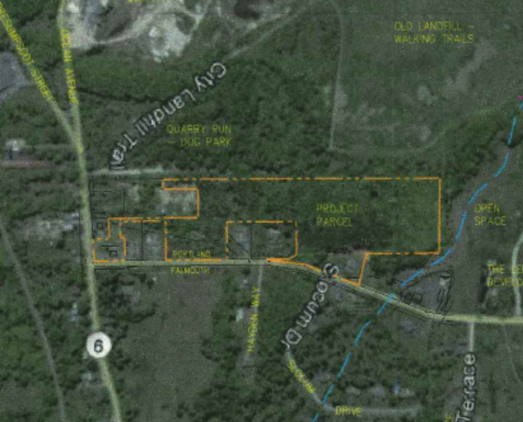
The proposed subdivision comprises (see Plan 7):

- 2 existing lots already developed with residential structures (some vacant) (Lots 13 and 14); these are included as required by State Subdivision statutes as they are contiguous and in the same ownership;
- 14 new residential (single family) lots on a proposed new street, 760 linear feet in length with a turnaround at the dead end - proposed to be named Ice Pond Drive;
- 2 other lots called “open space” that are wetland/stormwater detention and to be managed in common by the owners of the 14 new lots.

Required reviews: The proposal is being reviewed by the Planning Board under the Land Use Code provision 14-497 (Subdivisions).

Under Maine State Law 30-MRSA Section 4403 there is a requirement for joint meetings between the Planning Boards of Portland and Falmouth where a project crosses municipal boundaries, unless the respective reviewing authorities waive this requirement in writing. Falmouth voted on August 7, 2012 to waive this requirement and the Portland Planning Board voted similarly on October 9th, 2012 (Att. 1.b)

The applicant has asked for waivers as listed below (Att. K) :

Requested Waiver | Standard and any waiver provisions
Sidewalk Waiver: for sidewalks along one side of the new street (Ice Pond Drive), along the frontage of Lot #14 (existing lot) and along Ledgewood Drive (Lots # 13 existing lot and #15 open space) as 2 criteria met in each case. | Land Use Ordinance Section 14-506 (b) Sidewalks sets out 6 criteria for waiving the installation of sidewalks, of which 2 must be met.
Curbing Waiver: for curbing along the south side of the proposed subdivision street; as criteria 1, 4 and 5 are met. | Land Use Ordinance Section 14-506 (b) Curbing sets out 5 criteria for waiving the requirement for curbing, of which 2 must be met.
Streetlighting waiver: for approx. 5- 6 street lights along the new street except at ends, to be consistent with nearby developments and to maintain the rural character of the area | Technical Manual Section 10.2.1 requires street lights (14 ft Town and country pole and .4 min foot candle full cut off light) to be a maximum of 120 feet apart on one side of the new street (sidewalk side)
- PROJECT DATA

DATA | Proposed new 12 lot contiguous subdivision  (lots #1 to #12) | Existing home on Ledgewood Drive  (Lot #13) | Existing home at 1062 Ocean Avenue  (Lot #14) | Open Space  ( Lots #15 and #16)
Location | Within Portland and frontage on proposed subdiv street | Within Falmouth - retain existing frontage on Ledgewood Drive | Within Portland and frontage on Ocean Avenue | Lot #15: Falmouth  Lot #16; Portland
Existing Zoning | R-3 | RAm (Falmouth) | R-3 | R-3
Existing Use | Vacant/undeveloped | Single family | Single family  (non-conforming) | Vacant/undeveloped
Proposed Use | Single family lots | Single family  Reconfigured lot | Single family  (retain existing garage but new home) | Lot #15: Stormwater management area  Lot #16; Open Space (undisturbed wetlands)
Areas | 7.53 acres | .91 acre | .58 acre | 3.76 acres
No of Lots | 12 | 1 | 1 | 2
Lot sizes | Range from 20,118 sq ft to 54, 824 sq ft | 22,378 sq ft | 25,427 sq ft | Lot #15: 11,369 sq ft  Lot #16; 152,082 sq ft
Proposed new road (dead end) | Approx 760 linear ft | Retains existing frontage and drive on Ledgewood | No frontage | Lot #15 abuts new street and Ledgewood Drive
Area of existing wetland | 7,958 sq ft | None | None | Lot #16: 103,533 sq ft
Area of wetlands proposed to be filled | Lot #2 driveway stream crossing: approx. 1,220 sq ft | None | None | None
Total Disturbed Area | Approx. 239,070 sq ft (assumes 15,000 sq ft per lot) | Approx 3,345 sq ft | Approx 18,860 sq ft | Lot #15: approx. 7,875 sq ft
Existing impervious | None | Approx 3,350 sq ft | Approx 5,092 sq ft | None
Proposed impervious | Lots: Approx 60,000 sq ft  Street & sidewalk: Approx 28,870 sq ft | Approx 3,350 sq ft | Approx 4,570 sq ft | None
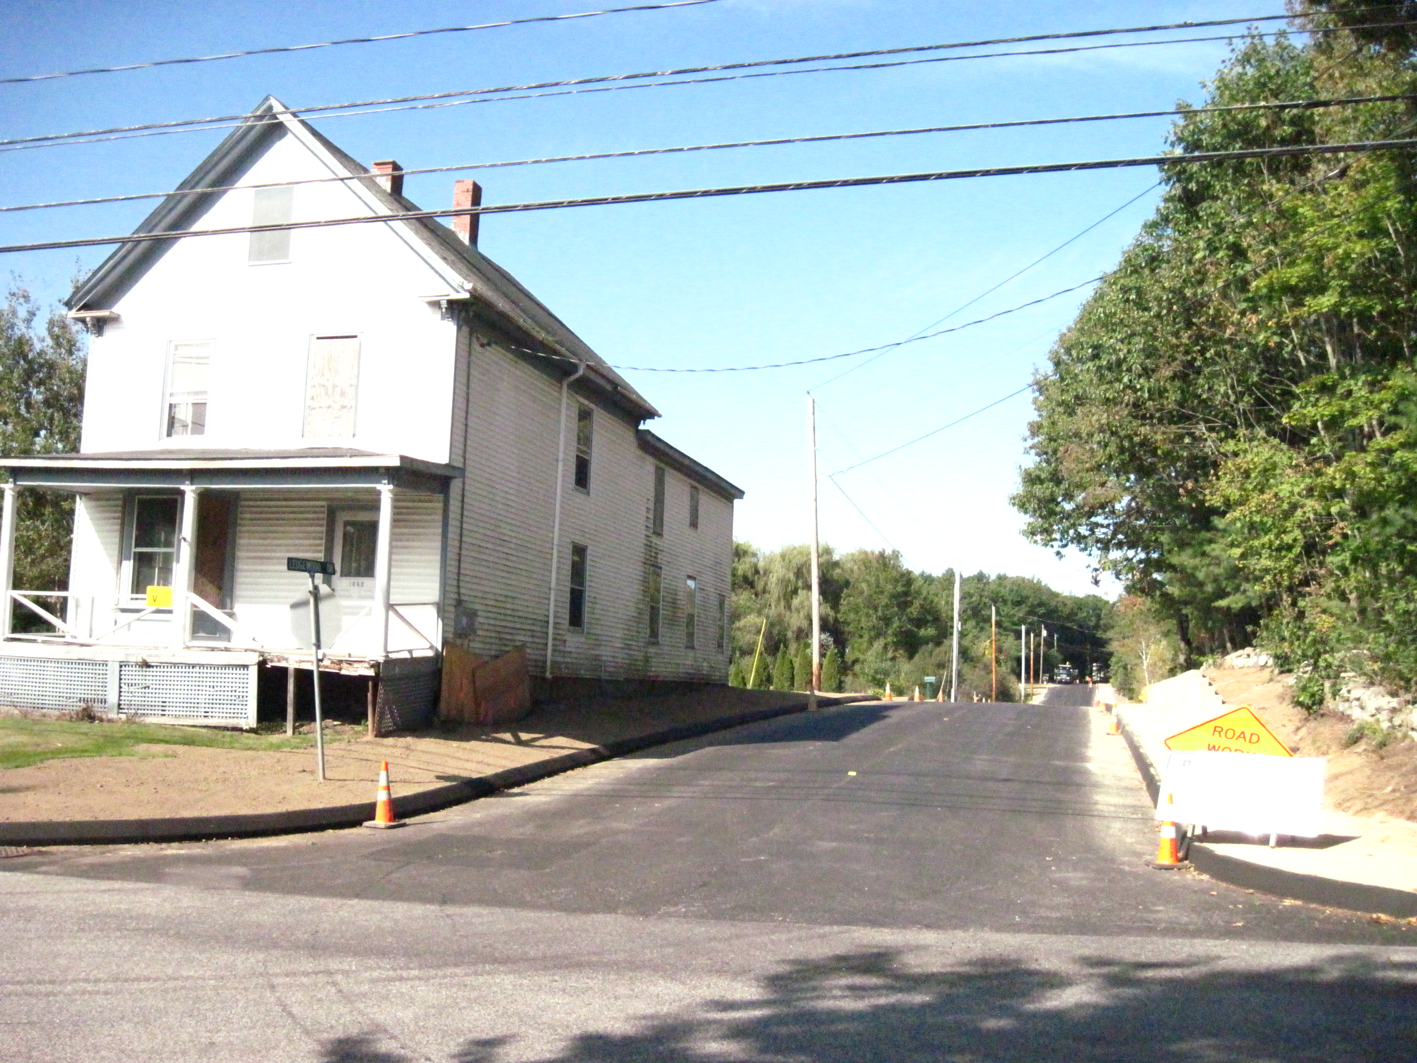
- EXISTING CONDITIONS (see Survey in Attachment Plan 1)

The site includes an existing (vacant) house at 1062 Ocean Avenue (Lot #14 -see photo right) which is linked by a narrow strip of land to the rest of the subdivision (all originally in same ownership). This lot is required to be included under Maine State Subdivision Law. The subdivision also includes an existing home on Lot #13, owned by the applicant and leased/occupied.

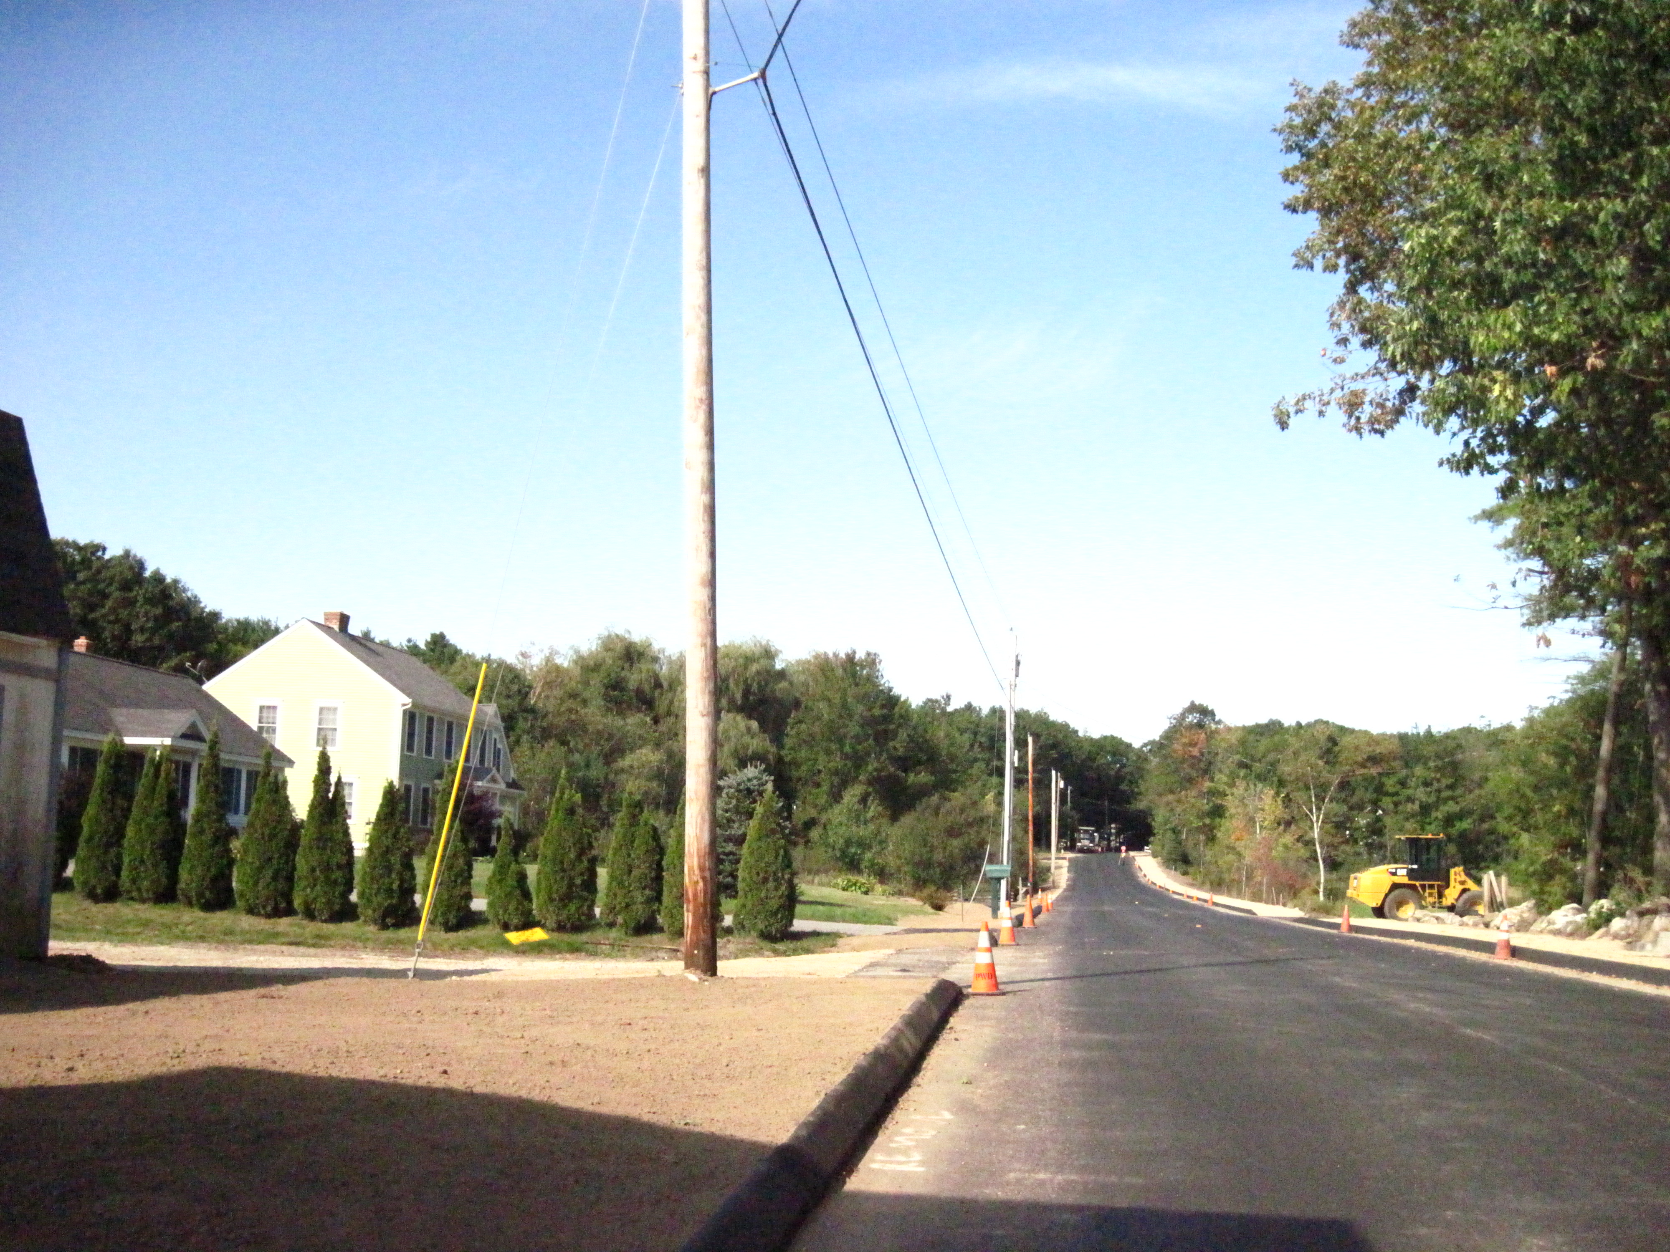
To the west is open space owned by the Falmouth Land Trust and dedicated conservation land with public access and trails that link into the Portland owned open space (Quarry Run Dog Park and former landfill areas) to the west and south of the proposed subdivision.

To the east is land in other ownerships except that there is a 50 foot wide easement connecting the bulk of the subdivision site to Ocean Avenue. The contiguous backland parcel is bounded on the north by six existing houses that front onto Ledgewood Drive, of which four are owned by other parties (see photo lower left).

The main new subdivision site is largely composed of wetland and trees, and the MDEP have confirmed there is an intermittent stream traversing the central part of the main parcel (Attachment B and Plans 5,6 and 7).

Ledgewood Drive is located within Falmouth and has a recently constructed sidewalk on the north side (opposite the development site) with curbs on both sides. It is understood there are no immediate plans for similar improvements in Ocean Ave/Middle Road.

- PROPOSED DEVELOPMENT
The applicant has submitted comprehensive application with a full plan set and background information such as the Stormwater Report and Sidewalk/Curbing Waiver requests (Attachments A-P & Plans 1 to 18).

The site is constrained by extensive existing wetlands and ledge, and the proposed new 12-lot subdivision is located at the western end of the parcel to avoid disturbing the wetland areas. The prevalence of ledge has constrained the location of the septic systems and resulted in some minor impacts to the stormwater buffers.

The proposal is to construct a new access drive of approximately 760 linear feet (Ice Pond Drive) lined with 12 single family house lots ranging from .46 to 1.26 acres, and to construct the associated drainage for the street and for the potential impervious surfaces of the house lots. In order to calculate the required stormwater measures and identify treesaves, the applicant has also developed detailed proposals for septic systems, tree/wetland protection and stormwater buffers.

The four other lots are proposed to be (see Plans 6 and 7):
- Lot #13: Existing house and drive onto Ledgewood Drive to remain, with lot reconfigured.
- Lot #14 at 1062 Ocean Ave: Plat in Plan 6 shows closing of 3 curb-cuts and revised driveway from Ocean Ave, demolition of existing non-conforming house, with a new house location to meet zoning setbacks and the existing garage to be retained;
- Lot #15: open space lot, primarily to provide stormwater retention and filtration;
- Lot #16: open space lot on common ownership to retain and protect existing wetlands.

The proposed access drive has been named Ice Pond Drive and starts in Falmouth on Ledgewood Drive located opposite Slocum Drive. About 100 feet of the proposed street is in Falmouth, and staff understand that the applicant will convey the fee in this section of the street to Portland and that the entire street (up to the intersection with Ledgewood Drive) will become an accepted street in the City of Portland.

The proposed new lots will be served by a water main in Ledgewood Drive and will each have a private septic system because the nearest sewers are too far away to tie into. The lots must be at least 20,000 sq ft to meet the requirements for a private septic system.

The proposed stormwater management plan (Attachment L.1) outlines a system with two grassed underdrained soil filters and the use of vegetated “no disturb” buffers for stormwater treatment to address the impacts of the full buildout of the subdivision.

The proposed access drive stops short of the site boundary by 63 feet and does not extend along the full frontages of Lots #8 and #9 to avoid impacts on the wetland buffer and the potential for connectivity does not exist as the adjoining property is held as conservation land by the Falmouth Land Trust. The applicant is proposing a gravel walkway connecting the sidewalk to the adjoining Falmouth Land Trust public open space/trails at the municipal boundary. The south side of the new street would be a vegetated swale with no curb nor sidewalk; the north side would include a curbed sidewalk and esplanade. The applicant has submitted waiver requests for sidewalk and curbing on one side of Ice Pond Drive and for sidewalks on Ledgewood and Ocean Avenue (Attachment K).

The applicant has been working with the Falmouth Land Trust to develop a public trail through the Falmouth land to the Portland open space to the south of the site, and this will also incorporate the walkway within the site, from the end of the ROW to the Falmouth boundary; a proposal has recently been agreed (Att. N).

- PUBLIC COMMENT AND WORKSHOP SUMMARY
A total of 63 notices were sent out to neighbors and interested parties within Portland, and the public notice appeared in the February 18th and 19th, 2013 editions of the Portland Press-Herald. A neighborhood meeting was held on 9.27.2013 and the Certification is included in Attachment E. No written public comments have been received on this project.

Two Planning Board workshops and a brief hearing have been held on this project:
- September 24, 2012 workshop: Consideration of concept proposals and clarification of information required.

- October 9, 2012 hearing: Voted to confirm that the Portland Planning Board agreed to waive the joint meeting requirement (see below)

- January 22, 2012 workshop: Consideration of detailed proposals with general support subject to resolution of some technical stormwater issues and documentation.

- STATE LAW REGARDING JOINT MEETINGS WHERE PROJECT CROSSES MUNICIPAL BOUNDARIES
The proposal requires review and approval from both Falmouth and Portland and ideally there will be one Subdivision Plat signed by both Boards. Under 30-MRSA Section 4403, Para 1-A the project requires all meetings of the relevant Boards to be held jointly unless both Boards have agreed, in writing, to waive this requirement.

The Falmouth Planning Board voted in August, 2012 to grant the applicant’s request to waive the joint meeting and hearing requirement under 30-MRSA Section 4403, as confirmed by the letter in Attachment 1a. However, the Falmouth Planning Board was concerned about several issues and requested their planners to coordinate with Portland planners to ensure these issues were addressed.

The Portland Planning Board voted on October 9th, 2012 to waive the joint meeting requirement with the proviso that the option for requesting a joint meeting remains available in the event there are issues that arise in the future that require joint consideration and resolution (Att. 1.b).

It should be noted that as required by Maine law, Portland and Falmouth Planning Boards both need to approve this proposal. Both Boards have reviewed the project twice, and the comments of the Falmouth Board at their 2.5.2013 review meeting are attached at Att. 2 along with some Falmouth staff comments that have been been addressed by the applicant. The Falmouth Planning Board were concerned about traffic impacts, stormwater and drainage impacts and trail connectivity and the plans were revised to address these concerns while also addressing Portland requirements.

- STAFF REVIEW

        - ZONING ASSESSMENT
The proposed subdivision is within the R-3 Residential Zone.

Marge Schmuckal, Zoning Administrator, requested and received further information regarding the flood zone delineation (Att. I) and also was concerned that “Ice Pond Road is not meeting the requirements of 14-403 which requires streets to be put in from where ever pavement ends to the end of the lot(s) being developed. Ice Pond Road stops short approximately 65" from the end of both properties lot #8 & lot #9. The proposed City Street needs to be extended to the end of the lots being developed.” (Att. 8)

After discussions with Corporation Counsel, staff determined that in this case it would be possible to end the ROW where the paved street ends and include the land between the ROW and the Falmouth boundary in Lots #8 and 9. A public access easement of 20 feet (with the gravel walkway within this area) would extend from the ROW sidewalk within the site to the off-site trail network within the Falmouth Land Trust area to ensure public access connectivity (see Connectivity below for further discussion). This would avoid the 14-403 requirement for the developers of lots #8 and #9 to pave along the entirety of their frontage and encroach into the wetland buffer.

The Planning Board has the authority under 14-506 (a) to approve the proposal with this arrangement based on the unique circumstances where the subdivision street must dead-end to avoid encroaching on the wetland buffer near the Falmouth municipal boundary, and with Falmouth Land Trust Conservation land abutting at that location.

Sec. 14-506. Modifications.

(a) Except for the requirements set forth in sections 14-498 and 14-499 pertaining to the provision and construction of curbs and sidewalks, the Planning Board if it finds that extraordinary conditions exist or that undue hardship may result from strict compliance with these regulations may vary the regulations so that substantial justice may be done and the public interest secured; provided that such variation will not have the effect of nullifying the intent and purpose of the land development plan and the regulations of this article.
B. SUBDIVISION STANDARDS

14-496. Subdivision Plat Requirements

The draft Subdivision Plat is included as Plans 5 and 6. The graphic presentation is generally acceptable subject to some survey information notations/corrections (Att. 6), but a number of revisions will need to be made to address the following issues:

- To show and identify all easements, including for drainage, stormwater maintenance and public access;
- That the Town of Falmouth is not accepting Ice Pond Drive as a public street and shall have no obligation to repair, maintain, or plow Ice Pond Drive;
- That between the date that the new street is completed for practical purposes and the formal, legal acceptance of the street by the City of Portland, there shall be a pedestrian easement along it to allow the public to access the trail system that starts at the dead end of the street;
- Lot #14 - revise curb-cut radii and add note re sidewalk contribution and staff support for corner clearance and driveway spacing waivers;
- Final arrangements for material and maintenance of walkway between ROW and Falmouth boundary at west end of 12 lot subdivision;
- Reference to Stormwater Management Plan and associated requirements;
- Clarification that City of Portland/Town of Falmouth are not responsible for maintenance of stormwater facilities in Lot #15 and Lot #9, but will have access easements and rights;
- Clearer identification of treesave/stormwater/wetland buffer marker/sign locations and wording;
- Document MDEP permits as necessary;
- Clearer requirement re septic system locations;
- Approved waivers.

The applicant submitted the draft Homeowner Association bylaws in early February and the City’s Corporation Counsel made some minor edits which are incorporated in the draft bylaws in Att. P. The bylaws discuss the maintenance of the stormwater system, trees and the easement area between the ROW and the Falmouth boundary and are generally acceptable (Att 10), subject to revisions to address the Falmouth concerns regarding interim maintenance and plowing of the new street (Att 2).

Subdivision Review: 14-497. Subdivision General Requirements (a) Review Criteria

- Will not result in undue water or air pollution.
- Has sufficient water available for the reasonably foreseeable needs of the subdivision;
- Will not cause unreasonable burden on an existing water supply; and
- Will not cause unreasonable soil erosion or reduction in the capacity of the land to hold water so that a dangerous or unhealthy condition may result;

Plans, notes and details have been submitted that adequately address standards for the new road and other infrastructure (Plans 1-18). A letter confirming adequate water supply has been submitted (Att J.11).

- Will not cause unreasonable highway or public road congestion or unsafe conditions with respect to use of the highway or public roads existing or proposed;

Traffic impact on surrounding intersections

The applicant submitted a Traffic Assessment (Attachment B, as updated in Attachment H) which projects 140 daily vehicle trips from the proposed subdivision access drive to/from Ledgewood Drive (70 enter, 70 exit) and reviewed safety data for Ledgewood Drive. It was updated to address Falmouth Planning Board concerns about the impacts on the operation of nearby intersections and concludes that the impact on the capacity and level of service on the nearest intersections is minimal. The City’s Traffic Engineering reviewer finds this evaluation acceptable (Att. 4).

Proposed subdivision street

The proposal includes a new street of 760 linear feet that starts in Falmouth at the intersection with Ledgewood Drive and dead ends with a turnaround near the Falmouth boundary to the west. The intersection is located opposite Slocum Drive and includes a crosswalk to the north side of Ledgewood Drive to Slocum Drive and to an existing sidewalk along Ledgewood Drive.

The access drive has been designed to meet City of Portland standards with a paved travel way of 28 feet in width. The standard in Falmouth is 24 feet and although the Falmouth Board has indicated it would defer to the Portland standard since it is anticipated to be a Portland street (Attachment 2.h). The applicant did ask at a pre-application meeting whether a 24 foot wide road could be approved, but the Fire Department has indicated that 28 feet is needed for emergency access.

Both Portland and Falmouth Traffic and Public Services staff have approved the design and radii size at the intersection of the new street (Ice Pond Drive) with Ledgewood Drive in Falmouth (Atts 2, 4, 6 and 7).

The proposed new street and ROW stops 63 feet short of site boundary and three boulders have been shown across the end (20 feet away) to stop cars but allow for snow storage. Lots #8 and #9 will own the land around the end of the dead-end and Lot #9 will have three areas designated for use by third parties;
- A public access walkway (linking the ROW sidewalk to the trail system in the abutting Falmouth Land Trust open space;
- ROW turnaround;
- Maintenance access drive for the stormwater system located in the rear yard (Plan 9).

The proposed street does not include street lighting in accordance with the City’s Technical Standards. The applicant has requested a waiver (Att K.3) as they consider the rural character should be maintained and that the existing street light on Ledgewood, and the proposed new light near the turnaround, are adequate for safety (see discussion of waivers below).

The Concept Plan previously presented to the Board showed Lot #13 having a new driveway onto the proposed subdivision street. After discussions with staff of both municipalities and a review of the sight distances for the existing driveway, the applicant has decided to leave Lot #13 as existing and with its existing address as it is located within Falmouth and the home is occupied. This is acceptable to Portland staff (Att. 4).

It should be noted that the proposal has been discussed with the Fire Department, DPS trash collection, snowplow and addressing staff, and is acceptable. The 12 lot part of the subdivision will be the only new addresses and they will all be in Portland.

Connectivity

The applicant has confirmed that they, in conjunction with the Falmouth Land Trust and Portland Trails, would (1) create a pedestrian/trail connection linking the subdivision sidewalk to trails within the Falmouth Land Trust public open space which link into the Portland Open Space (Dog Park); and (2) Contribute to the creation of a trail within the Falmouth Land Trust open space that facilitates this link; and (3) make financial contributions to both the trail creation and future stewardship (Att N, letter of 2.20.2013 signed by both parties).

It is understood that the Falmouth Land Trust would take responsibility for the section within the site as well as the trails on their land so that the design, signage and maintenance etc would be integrated. The financial commitment and the final details of the materials/steps and maintenance agreements are the subject of a potential condition, and the Plats and Homeowners Association Documents would need to be revised to be consistent with this agreement.

The trail connection between the ROW sidewalk and the Falmouth boundary would be located within a 20 foot public access easement, which would be subject to review and approval by Corporation Counsel, DPS, and the Planning Authority prior to the release of the subdivision plat (included in potential condition iv.). It should be noted that the Falmouth Planning Board sought a trail connection at this location.

In view of the possible situation of the street being constructed but not yet accepted by the City of Portland, the applicant is being requested to provide a temporary pedestrian access easement along the street from the Ledgewood Drive ROW to the easement across lots # 8 and #9 so that public access to the Falmouth Land Trust trails is ensured as soon as the street is constructed. The Town of Falmouth (Att 2.) have requested that the Homeowner’s Association documents clarify that during this interim period the Homeowner’s Association is responsible for repair, maintenance, plowing etc.

The applicant has proposed a crosswalk across Ledgewood Drive from the proposed sidewalk to the existing sidewalk on Ledgewood. The Traffic Engineering Reviewer has requested crosswalk warning signs be installed (Attachment 4) but the final plans do not address this request. A potential condition of approval has been included to require the appropriate crosswalk signage.

Lot #14 access

The applicant has shown an indicative layout for the existing lot #14 (corner Ledgewood and Ocean) that closes 3 curb-cuts and creates a new driveway onto Ocean Avenue. Att.J – pg 2 sets out the reasons for the new curb cut being proposed for Ocean Avenue. The Traffic Engineering Reviewer has commented:

The applicant is proposing a driveway for Lot 14 on Ocean Avenue. While I would prefer to have the driveway located on the minor street, or Ledgewood Drive, I find the proposed driveway location to be acceptable given the location and orientation of the existing garage/barn structure that is to remain on-site. I would note that the City does not provide radii at single-family driveways and the plans should be revised to reflect this. Lastly waivers from the City’s Technical Standards are required as it relates to corner clearance and driveway spacing. I support these waivers given site conditions (Att. 4).

A potential condition of approval documents the status of Lot #14 so that when a single family building permit is reviewed, its conformance with the subdivision can be assessed.

(6) Will provide for adequate sanitary waste and storm water disposal and will not cause an unreasonable burden on municipal services if they are utilized;

A wastewater capacity letter is not required as the new 12 lot subdivision will have private septic systems, and the lot sizes meet the required minimum lot size (20,000 sq ft). The Plan 7 shows the disposal field locations as located by Sweet Associates of Falmouth as they are limited by shallow ledge and shallow water table.

The septic system leach fields unavoidably encroach within the wetlands/stream setback as shown on Plan 8. The applicant has confirmed that the State Wastewater Rules do allow these to be within wetland setbacks without further MDEP approvals.

Storm water

The Stormwater Management Report has been revised and submitted (Attachment L.1) to address review comments (Att. 5) and Falmouth Planning staff and Board comments (Att. 2). The system comprises two grassed underdrained soil filters and the use of vegetated “no disturb” buffers for stormwater treatment. The supporting calculations assume the full buildout of the subdivision, including homes (5000 sq ft impervious).

The septic systems also impact the stormwater buffers as the areas around the septic systems need some regrading as shown in Plan 8. The applicant has discussed this with staff and it was agreed that the note 16 and proposed revegetation as shown on Plan 7 confirms that the identified areas of clearance will replanted after the septic system is installed and this is acceptable to reviewers (Att. 5).

The Peer Engineering Reviewer has confirmed that his concerns have been addressed, except for the final language for the maintenance easements and deeds (Att. 5). Draft deed wording was submitted (Att.O) but reviewers suggest that the language should more closely follow MDEP guidance.

The underdrained filter facilities on Lots #9 and #15 are proposed to be maintained by the Homeowner’s Association. The drainage facilities in the new street would ultimately be the responsibility of the City of Portland once the street was accepted. It is understood that the Falmouth engineer requested a drainage maintenance easement at the east end of the site as shown on the Plat (Plan 6). Such easements are included in the potential condition requiring the submission, review and approval of a number of easements, and they also need to be identified/referenced more clearly on the Subdivision Plat.

(7) Will not cause an unreasonable burden on the ability of the city to dispose of solid waste and sewage if municipal services are to be utilized;

See above.

(8) Will not have an undue adverse effect on the scenic or natural beauty of the area, aesthetics, historic sites, significant wildlife habitat identified by the department of inland fisheries and wildlife or by the city, or rare and irreplaceable natural areas or any public rights for physical or visual access to the shoreline.

Street trees

The applicant has provided a narrative explaining the approach to street trees in Attachment G item 20. Staff suggest that the 2 trees/lot standard should apply only to the 14 residential lots (ie excluding the two open space lots) which would mean a requirement of 28 trees. The proposals show 30 trees but these are evenly spaced and don’t strictly result in 2 trees on each lot. Lots #13 and #14 have no proposed street trees.

The City Arborist had requested revisions to the plant list (Att. 3) and the applicant has revised Plan 7 accordingly. The comments of the City Arborist will be circulated at the Planning Board hearing.

Treesaves

The narrative in Attachment G item 6 describes the basis for proposing treesaves and notes that all of Lot #16 is a treesave area and that the stormwater buffer areas will also preserve trees.

The plans (Plans 6 and 7) show a 25 feet wide treesave zone along the south side of the seven lots # 2 through #8 which abut the City’s open space. This area is largely red oaks and maple trees. These treesave areas would provide screening between the home lots and the public park. On the north side the stormwater buffer areas will effectively preserve trees and the applicant has added buffer planting as recommended by the City Arborist (Att. 3)

The stormwater “No Disturb buffers” are also shown on Plans 6 & 7 and augment the treesave areas. Staff recommended that markers and signs be installed to delineate the edge of the “no disturb/treesave” areas nearest to the homes to ensure their protection. The applicant has indicated signs and rebar markers on Plans 6 and 7, but reviewers consider that these need to be more clearly called out, described and located on both plans (Att. 5).

Open Space

The proposed subdivision includes a total of approximately 163,400 sq ft of open space. The largest area is 152, 082 sq ft and made up primarily of wetlands, adjacent to properties with existing homes and to the City’s open space to the south. A separate small area (11,369 sq ft) of identified open space is located within Falmouth along Ledgewood Drive and is co-located with the larger of the two proposed “stormwater management areas”. These have been identified as Lots #16 and #15 respectively and the applicant has addressed the question of maintenance in the Homeowners Association Bylaws (Att. P.)

(9) Is in conformance with the land development plan or its successor;

The project is compatible with Comprehensive Plan housing goals and policies.

(10) The subdivider has adequate financial and technical capacity to meet the standards of this section;

The applicant has submitted a letter dated 1.11.2013 from Bath Savings Institution (Att. J10).

(11 (Whenever situated, in whole or in part, within the watershed of any pond or lake or within two hundred fifty (250) feet of any wetland, great pond or river as defined in Title 38, chapter 3, subchapter I, article 2-B, will not adversely affect the quality of such body of water or unreasonably affect the shoreline of such body of water;
(12) Will not, alone or in conjunction with existing activities, adversely affect the quality or quantity of groundwater;
(13) Is or is not in a flood-prone area, based on the Federal Emergency Management Agency's Flood Boundary and Floodway Maps and Flood Insurance Rate Maps, and information presented by the applicant.
(14) All potential wetlands within the proposed subdivision shall be identified on any maps submitted as part of the application, regardless of the size of those wetlands.
(15) Any river, stream or brook within or abutting the proposed subdivision shall be identified on any maps submitted as part of the application.

The parcel contains extensive wetlands and an intermittent stream, as confirmed in an MDEP field report and Wetland Delineation Note (no plan) in Attachment B. Most of the wetland is within Lot #16 which is not proposed to be developed.

A 75 foot setback from the wetlands is required and has largely been met with the exception of the leach field locations on Lots #3 and #4, which are allowable as discussed above. A NRPA permit is required for the small amount of filling (1220 sq ft) required for the access drive to the home on Lot #2 and this has been submitted in Att. M. A potential condition of approval requires evidence of MDEP approval, as recommended by DPS (Att. 9).

The applicant has confirmed that the wetland buffer will be delineated on the ground in the same way as the treesaves and stormwater buffers (Att. J), and these similarly need to be shown more clearly on the Subdivision Plat and Lot Development Plan, as incorporated in the potential condition of approval # vi.

14-498. Technical and Design Standards

This section of the Subdivision Ordinance includes a number of provisions that the applicant will need to consider carefully as the final plans are being developed. The open space and connectivity requirements have been mentioned previously; three others of particular relevance are:

Sidewalk and Curbing Requirements

14-498 8a. Sidewalks and curbs: Sidewalks shall be constructed on each side of each street in accordance with article III of chapter 25. Sidewalks to be used by pedestrians are to be so located as to minimize contacts with normal automotive traffic, with preference given to interior walks away from streets in common open space in block interiors.

The applicant has submitted a waiver request (Attachment J, as amplified in Attachment K. 1 and K.2) for:
- Sidewalks and curbing on the south side of the proposed new subdivision street
- Sidewalks and curbing on the south side of Ledgewood Drive where the site abuts
- Sidewalks and curbing on the west side of Ocean Avenue along the frontage of Lot #14.

DPS/Traffic engineering reviewer have confirmed they support the first two requests, but would require a contribution of $7500 in lieu of sidewalk/curbing along the Ocean Avenue frontage of the existing lot #14 (which will be redeveloped) (Att 4 and 6).

Street Lighting

The applicant has requested a waiver from the Technical Manual requirements for street lighting in order to maintain the rural character of the area and be consistent with nearby subdivision developments (in Falmouth) (Atts. J and K.3.) The proposal is for one new streetlight near the turnaround at the dead-end, with illumination at the Ledgewood Drive end provided by an existing light on Ledgewood Drive. The Technical Manual Section 10.2.1 requires street lights (14 ft Town and Country pole and .4 min foot candle full cut off light) to be a maximum of 120 feet apart, normally on one side of the new street.
In this case staff consider that the required streetlights should be installed in accordance with the Technical standard (Att. 6). The requirement would be 5-6 streetlights to be installed along the sidewalk side of Ice Pond Drive to illuminate the sidewalk in the winter and at night.

The Falmouth Planning Board indicated support for the applicant’s proposal as it is consistent with other Falmouth subdivisions (Att. 2). If the Board wish to consider a waiver of streetlighting, they may want to consider a partial waiver to allow for greater spacing of the streetlights but retain some illumination to benefit the sidewalk.

Street names
In accordance with 14-498 (d) Street and subdivision names the applicant has chosen Ice pond Drive as the name for the new street and this is acceptable to staff who have checked whether there any other streets of the same name in Portland or Falmouth. The name would be approved by the Planning Board as part of the Subdivision Plat approval.

Underground Utilities
The Subdivision ordinance 14-498 also requires that all utility lines shall be placed underground unless otherwise approved by the Planning Board. The submissions confirm this requirement has been met (Att. 6).

viii STAFF REcommendation
Staff recommends approval to the proposed subdivision subject to the suggested conditions. Staff have liaised with Falmouth planning and engineering staff through-out the review and confirm that there are no areas of potential disagreement.

- PROPOSED MOTIONS
On the basis of the application, plans, reports and other information submitted by the applicant, findings and recommendations contained in Planning Board Report # 13 -13 for the Old Barn Estates subdivision at 1062 Ocean Avenue (Ledgewood Drive) relevant to the Subdivision ordinance and other regulations, and the testimony presented at the Planning Board hearing, the Planning Board finds the following:

Waivers

- Sidewalks

- The Planning Board finds that two of the following criteria do/do not apply, (namely 3 and 6, as per applicant’s request) and therefore waives/does not waive the requirement for a sidewalk along the south side of Ice Pond Drive within the 12 lot new subdivision:

- The Planning Board finds that two of the following criteria do/do not apply, (namely 3 and 6, as per applicant’s request) and therefore waives/does not waive the requirement for a sidewalk along the south side of Ledgewood Drive on Lots #13 and #15:

- The Planning Board finds that two of the following criteria do/do not apply, (namely 1 and 6, as per applicant’s request) and therefore waives/does not waive the requirement for a sidewalk along the frontage of the property at 1062 Ocean Avenue (Lot #14). If this sidewalk is not waived, a contribution of $7500 is required towards an equivalent length of sidewalk and curbing along Ocean Avenue in the vicinity of 1062 Ocean Avenue:

SiDEWALK WAIVER CRITERIA:
- There is no reasonable expectation for pedestrian usage coming from, going to and traversing the site.
- There is no sidewalk in existence or expected within 1000 feet and the construction of sidewalks does not contribute to the development of a pedestrian oriented infrastructure.
- A safe alternative-walking route is reasonably and safely available, for example, by way of a sidewalk on the other side of the street that is lightly traveled.
- The reconstruction of the street is specifically identified and approved in the first or second year of the current capital improvement program or has been funded through an earlier CIP or through other sources.
- The street has been constructed or reconstructed without sidewalks within the last 24 months.
- Strict adherence to the sidewalk requirement would result in the loss of significant site features related to landscaping or topography that are deemed to be of a greater public value.
- Curbing:

The Planning Board finds that two of the following criteria do/do not apply, (namely 1, 4 and 5, as per applicant’s request) and therefore waives/does not waive the requirement for curbing along the south side of Ice Pond Drive within the 12 lot new subdivision:

CURBING WAIVER CRITERIA:
1. The cost to construct the curbing, including any applicable street opening fees, is in excess of 5% of the overall project cost.
2. The reconstruction of the street is specifically identified and approved in the first or second year of the current Capital Improvement Program or has been funded through an earlier CIP or through other sources.
3. The street has been rehabilitated without curbing in the last 60 months.
4. Strict adherence to the curb requirement would result in the loss of significant site features related to landscaping or topography that are deemed to be of a greater public value.
5. Runoff from the development site or within the street does not require curbing for stormwater management.
[In no event shall the waiver have the effect of creating potentially hazardous vehicle and pedestrian conflict or nullifying the intent and purpose and policies of the land development plan relating to transportation and pedestrian infrastructure and the regulations of this article.]

- Streetlighting:

The Planning Board (waives/does not waive) the Technical Standard, Section 10.2.1, to allow a reduction in the number of street lights along the proposed new street Ice Pond Drive to one new pole and light at the “dead end’ of the new street.

Subdivision

That the Planning Board finds that the plan (is/is not) in conformance with the subdivision standards of the land use code, subject to the following conditions of approval:

Potential conditions of approval:

    - That the Subdivision Plat shall be finalized to the satisfaction of the Planning Authority, Department of Public Services and Corporation Counsel and include references to stormwater management, easements, buffer and treesave markers, street trees, Homeowners Association documents, status of Lot #14, septic system locations, and relevant conditions; and

    - That the applicant shall convey the fee interest for the new street to the City of Portland, including the section within the Town of Falmouth, as part of the process for City acceptance of the street; and

    - That the applicant shall submit copies of the required permits from the MDEP prior to the release of the signed Subdivision Plat; and

    - That the following shall be finalized to the satisfaction of the Corporation Counsel, Department of Public Services and the Planning Authority prior to the release of the signed subdivision plat:

- Public access easement for the trail/walkway between the Ice Pond Drive ROW and the Falmouth boundary (Falmouth Land Trust land);
- Stormwater maintenance agreements/easements for Lots #9 and #15; these are Homeowners Association; responsibility but with rights of access for Portland re lot #9 and both municipalities re Lot #15;
- Other easements as indicated on the Plat in Plans 5 and 6;
- Interim public access easement along Ice Pond Drive as soon as practical until it is accepted;
- Homeowner Association Documents;
- Individual lot deed final generic wording, including stormwater language as suggested in the Memo from David Senus of Woodard & Curran dated 2.20.2013.
    - That the applicant shall construct a crosswalk across Ledgewood Drive as shown in the approved plans prior to the first CO for a single family home on Ice Pond Drive, including the installation of crosswalk warning signs complying with the MUTCD; and

    - That the signs and markers, including materials, wording and location, that delineate the location and restrictions of wetland and stormwater buffers and treesave areas be called out on Plans 6 and 7 more clearly and installed as part of the Ice Pond Drive street construction; and

    - The developer/contractor/subcontractor must comply with conditions of the construction stormwater management plan and sediment and erosion control plan based on City standards and state guidelines.

The owner/operator of the approved stormwater management system and all assigns shall comply with the conditions of Chapter 32 Stormwater including Article III, Post Construction Stormwater Management, which specifies the annual inspections and reporting requirements.

A maintenance agreement for the stormwater drainage system, as included in Attachment 1of the approval letter, or in substantially the same form with any changes to be approved by Corporation Counsel, shall be submitted and signed prior to the issuance of a Certificate of Occupancy with a copy to the Department of Public Services.

    - That the applicant shall show evidence that the terms of the agreement with the Falmouth Land Trust dated 2.20.2013 regarding the trail connections have been met in full, and that the details of the trail within the site be submitted to the Planning Authority for review and approval, both prior to the release of the signed Subdivision Plat.

ATTACHMENTS:

  - Documents re Falmouth Planning Board and State law requirements
    - Letter from Ethan Croce, Senior planner, Town of Falmouth 9.13.2012
    - Portland PB letter to Falmouth
  - Falmouth Staff comments on final plans and associated issues
  - City Arborist (Jeff Tarling) comments for hearing not received; 1.9.2013; and 9.13.2012
  - Traffic Engineering (Tom Errico) comments 2.21.2013
  - Peer Engineering Review comments (David Senus) 2.20.2013; 1.16.2012; 9.20.2012
  - DPS (David Margolis-Pineo) comments 2.4.2013; 1.17.2012 9.21.2012
  - Fire Department (Chris Pirone) comments 9.21.2012
  - Zoning Administrator (Marge Schmuckal) comments 2.21.2013; 1.16.2013; 9.21.2012
  - DPS (Doug Roncarati) comments 1.30.2013
  - Corporation Counsel comments 2.14.2013

Applicant’s Submittal
- Application dated 8.28.2012 (does not include data sheet)
- Letter from Land Design Solutions (Peter Biegel) incl Wetland Delineation & MDEP Field Report 8.22.2012
- Right, Title and Interest information
- Letter from Land Design Solutions (Peter Biegel) w/ Info on Landscaping & Trail Connection, dated 9.13.2012
- Neighborhood Meeting Certification 9.30.2012
- Stormwater Management Information Letter from Land Design Solutions (Tom Saucier, PE) dated 9.18.2012
- Letter from Land Design Solutions (Peter Biegel) responding to Workshop comments 1.1.2013 (atts below)
- Traffic Assessment, Eaton Traffic Engineering 1.1.2013
- Flood Maps

Submitted for Hearing
- Letter from Land Design Solutions (Peter Biegel) re revisions, incl revised data sheet, turning radii sketch; financial capability; and Portland Water District capacity letter
- Waiver Requests
  - Sidewalk Request with map 1.2.2013
  - Curb Waiver Request 1.25.2013
  - Street Lighting Waiver Request 2.8.2013
- Stormwater Management Information
  - Stormwater Management Report Rev 1 2.8.2013 (extracts)
  - Peter Biegel responses to review comments 2.20.2013; 2.8.2013; and 2.1.2013
  - Falmouth sign off (Cumberland County Soil & Water Conservation District Engineer)
- NRPA Permit by Rule notification to MDEP 2.4.2013
- Falmouth land Trust letters/plans re proposed off site trail 2.6.2013 and 1.4.2013
- Draft deed language 2.15.2013
- Homeowners Association Bylaws 2.21.2013

Plans
- Survey
- Aerial photo with parcels annotated
- Sketch Plan
- Cover sheet (Old Barn Estates)
- Subdivision Plan #1
- Subdivision Plan #2 (S-101 Rev F)
- Lot Development and Landscape Plan (C-101 Rev D)
- Leach Field Fill Slope Diagram 2.1.2013
- Grading, Drainage and Erosion Control Plan (C-201 Rev D)
- Profiles (new street) (C-202 Rev D)
- Erosion and Sedimentation Notes and Details (C-300 Rev D)
- Site Details (C-301 Rev C)
- Site Details (C-302 Rev D)
- Site Details (C-303 Rev D)
- Site Details (C-304 Rev A)
- Pre-Development Drainage Plan (D-100 Rev C)
- Off-Site Subcatchment Plan (D-101 Rev C)
- Post Development Drainage Plan (D-102 Rev C)

