Inspection Services Department of Urban Development
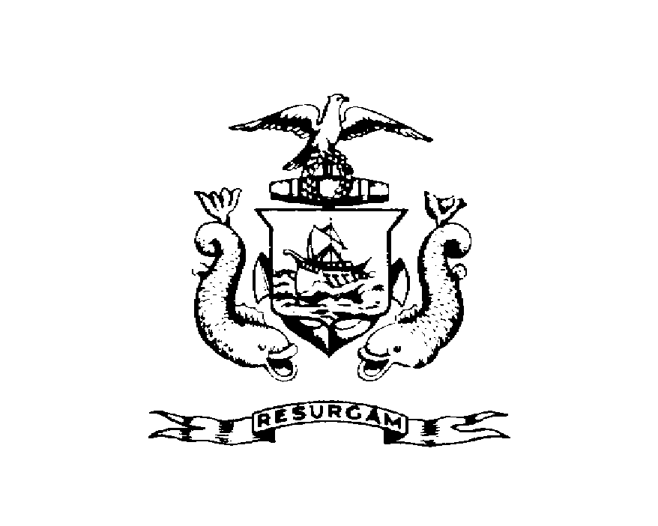
Michael J. Nugent Joseph E. Gray, Jr.
Manager Director

CITY OF PORTLAND

September 2, 1999

Amato’s Enterprises Inc.
1379 Washington Ave
Portland ME 04101

RE: Amato’s
CBL: 401-A-001

Dear Sir/Madam:

A health inspection of your establishment was made on August 31, 1999.

Attached is a copy of the inspection report, if you have not already been provided
with one, which indicated the sanitary condition of your establishment at the time
of inspection was found to be unsatisfactory.

The next inspection of your establishment will be carried out within ten days, at
which time I require that all operational and maintenance practices comply with
the standards set forth in Chapter 11 of the City's Ordinance. If, upon reinspection
your establishment is graded unsatisfactory, the matter will be referred to the City's Corporation Counsel for action pursuant to Section 15.8 of the License Ordinance.
Action may include license suspension or revocation and possible civil penalites pursuant to Section 1-15.

If you have any questions regarding this report, please do not hesitate to
contact this office.

Sincerely,

Tammy Munson
Code Enforcement Officer

