Certificate of Occupancy
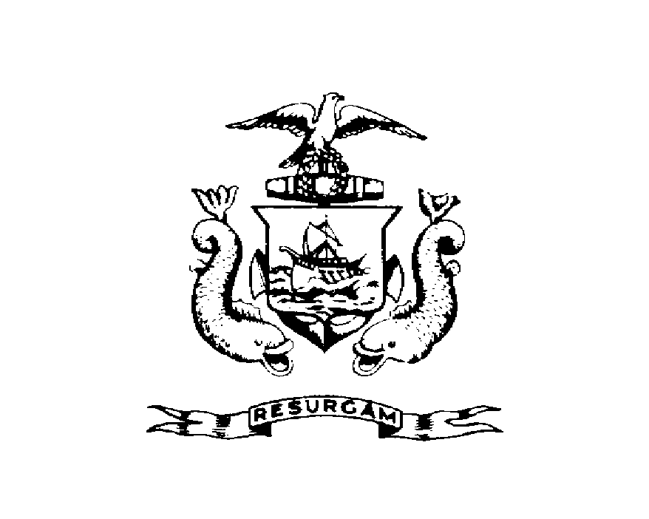
CITY OF PORTLAND, MAINE
Department of Planning and Urban Development Building Inspections Division

Location 20 BALL PARK DRIVE CBL 371-A-031-001
Issued to RICHARD AND CARMELA HOLDEN Date Issued 11-5-2012
This is to certify that the building, premises, or part thereof, at the above location, built-altered-changed as to use under Building Permit NO. , has had a final inspection, has been found to conform substantially to the requirements of the Building Code and the Land Use Code of the City of Portland, and is hereby approved for occupancy or use, limited or otherwise, as indicated below.
PORTION OF BUILDING OR PREMISES APPROVED OCCUPANCY
ENTIRE USE GROUP R-3
SINGLE FAMILY RESIDENCE
TYPE 5-B
IRC 2009 (MUBEC)
Approved:
11-5-2012
(Date) Inspector Inspections Division Director
Notice: This certificate identifies the legal use of the building or premises, and ought to be transferred from owner to owner upon the sale of the property.

