riverside innovation
874 Riverside St.
Portland, Me 04103

MEMORANDUM:

To: Portland Planning Board care of Barbara Barhydt

Date: April 6th, 2018

Re: Performance Based Use Option in the IM Zone, explicitly as it relates to the Level 3 Subdivision and Site Plan Application from Innovative Green Living for 874 Riverside St.

The project is known as riverside innovation.

INTRODUCTION:

riverside innovation will be a series of newly constructed light industrial and live/work buildings grouped around a landscaped plaza at 874 Riverside St. The project will be anchored by a state of the art brewery and will provide a variety of spaces for the small to medium sized business tenant.

This project, located off the peninsula offers all of the ease and convenience of Portland, with easy access to the bus line, onsite parking, neighborhood grocery and a wooded setting.

All of the uses that are being proposed for this project are either expressly permitted or permitted under the performance based option section of the code Section 14-248

This memorandum is specifically about the performance based option as it pertains to Live/Work units on this project.

Performance Based Use Option: Sec. 14-248

Uses not expressly permitted as provided in section 14-247 or expressly prohibited in section 14-249 may be permitted if they meet the following conditions and standards:

- The proposed development is consistent with the purposes of this zone.
- The proposed development is designed and operated so that it will prevent undue adverse environmental impacts, substantial diminution of the value or utility of neighboring structures, or significant hazards to the health or safety of neighboring residents by controlling noise levels, emissions, traffic, lighting, odor and any other potential negative impacts of the proposal.

Live /work is defined as a separate use in the Portland Land Use code and is of a different nature and character than a purely “residential” project and it is not expressly prohibited.
Therefore live/work should be allowed to use the performance option to determine if it meets the remaining criteria of 14-248(a), (b).

SECTION A asks the question, is the proposed
development consistent with the purpose of this
zone?

How is the purpose of a zone defined?

It is usually defined by what is stated, but it is the actual permitted uses that more accurately reflect the purpose of a zone. It is not unusual for the uses in a zone to change over time, but the original stated purpose may not have changed to reflect those new uses.

In the IM the opening paragraph states the following: “that the moderate impact
industrial zones are intended to provide zones in areas of the city in which light and moderate impact industries and transportation-related uses will coexist.”

There is no definition in the code for moderate impact, we substitute low impact for light impact since no definition of light impact is in the code.

The full definition of low impact industrial uses can be found in the definition section and what is notable, is the wide range of permitted uses, which show that the intention of the zone was to provide an area where many different types of business could easily coexist. It is stated that low impact industrial uses are compatible, due to their size and impact with residential and commercial uses .

All three industrial zones have language regarding residential uses in the zone. The IL and ILB refer to that zone as a buffer and will be located adjacent to residential neighborhoods, the IH zone states that it’s uses are incompatible with residential and commercial uses, only the IM states that its uses are compatible with residential and commercial which by inference means within the zone.

An examination of all the permitted uses in the IM Zone reveals that many of the permitted uses in the IM Zone are also found in some of the B Zones.

Of the 27 or so permitted uses in the IM, 19 of them can be found in the B-4 zone, and 18 of
them can be found in the B-2 zone .

When looking at the IM zone through this lens, it becomes clear that the intention of the zone was to be more of a bridge zone, embracing uses that are both low impact industrial as well as commercial and residential.

A survey of uses in the IM zone from Washington Ave to Forest Ave, looking at over 100 properties found the following:

General Business Uses……………………………………33
Offices of Tradesmen……………………………………..12
Residential……………………………………………………..12
Whare-houses………………………………………………….9
Breweries…………………………………………………….....7
Wholesale Operations……………………………………..6
Manufacturing………………………………………………...6
Tech…………………………………………………………………3

What can be understood here is that the majority of the uses are extremely low impact, with very little manufacturing other than beer. It should also be noted that there are 12 residences in this area all coexisting with the other uses as intended.

Although residential uses are explicitly prohibited, there are allowed uses with residential components. The zone currently allows for shelters, prisoner pre-release housing and intermediate care facilities. These are all forms of institutional allowed uses in the IM zone that have a residential/living component to them.

A live-work unit is a space that combines your workspace with your living-quarters. The only definition found in the code was in the B 2-b: What is live/work? Combined living/working spaces including, but not limited to, artist residences with studio space are permitted on the first floor and within the commercial space along the principal street frontage

In this case; this is about combining allowed commercial/industrial uses with a subsidiary residential component. Like the institutional uses with residential components, this project will perform in a similar manner with the allowed commercial/industrial uses; not the prohibited purely residential use traditionally envisioned.

In fact due to the previous allowance of institutional uses with no industrial component which can be interpreted to meet the zones purpose, it could be seen as inconsistent to prohibit an industrial/commercial project with a residential component that is in-line with the IM zone’s purpose.

In the general real estate language; a live/work unit is substantially different than what is regarded as a typical stand alone residential apartment in one major way: A live/work unit allows for uses that would not generally be found in a residential zone.

So the answer to question (a) is yes. Live/Work does meet the intentions of the zone.

SECTION B asks if the proposed use will have any detrimental or negative impacts on the surrounding properties?

The subject property is a vacant lot (2 acres) at 874 Riverside St. The property lies back from Riverside St. and is accessed by a 150’ long driveway with an existing canopy of trees.

This is a very unique piece of property in that it has a wooded setting, it abuts the Portland Trail System and there is stair access down to the Presumpscot River.

The site lends itself to significant landscaping which in itself will be a part of the storm water and soil erosion systems.

There are 6 neighbors whose properties abut the subject land. Three single family parcels, one with a commercial structure attached, one commercial property, one vacant lot used for construction equipment and the Riverside Recycling Facility.

The remaining properties going towards the RivertonTrolley Park contain 6 single family homes and 2 commercial buildings.

The other side of the street is a food wholesale whare-house, an indoor trampoline park, Spurwink, a bowling alley, general offices and a small industrial building with 4 breweries.

This development can only have a positive impact on the neighboring properties and the whole area as well. The actual design and building sizes are much more harmonious with the existing use pattern, this location in the zone is as much residential as it is commercial/industrial, and its proximity to transportation and services make it a natural fit for the neighborhood.

The live work buildings are designed to attract creative entrepreneurs in those industries that Portland is best known for: Beer, Food, Design and Tech.

The opportunity to be in a creative, co-working and co-living environment with your own space can only have a positive effect on tenants and their neighbors, and it is hoped new and creative business ideas come forward.

The benefits to the city: more real estate taxes, job creation, housing creation, and creative use of the land. It is the new comprehensive plan at work.

Live /work meets the criteria of question (b) and will not have any detrimental or negative impacts on the surrounding properties.

CONCLUSION:

In conclusion:
Live /work is defined as a separate use in the Portland Land Use code and is of a different nature and character than a purely “residential” project and it is not expressly prohibited.

It is stated that low impact industrial uses are compatible, due to their size and impact with residential and commercial uses. That implies that those uses were intended to be in the zone.

The IM zone is the only Industrial zone that has the performance based option, which logically would lead one to believe that its intended uses are more expansive than just what has been written so far.

The IM zone is the only Industrial zone that has in its definitions its compatibility with residential and commercial uses as inclusive in the zone.

A live-work unit is a space that combines your workspace with your living-quarters.

Although residential uses are explicitly prohibited, there are allowed uses with residential components. The zone currently allows for shelters, prisoner pre-release housing and intermediate care facilities. These are all forms of institutional allowed uses in the IM zone that have a residential/living component to them.

In fact due to the previous allowance of institutional uses with no industrial component which can be interpreted to meet the zones purpose, it could be seen as inconsistent to prohibit an industrial/commercial project with a residential component that is in-line with the IM zone’s purpose.
Adding a living component to an allowed use will not have a detrimental effect on the surrounding properties and has already proven to be compatible in this area.

The actual design and building sizes are much more harmonious with the existing use pattern, this location in the zone is as much residential as it is commercial/industrial, and its proximity to transportation and services make it a natural fit for the neighborhood.

Therefore live/work is an allowed use.

This project is not only consistent with the new comprehensive plan, but it hits all the major points in the plan and could have been the test case addendum had one been needed. This project will be an asset to the neighborhood and Portland as well.

“Creative and collaborative workspaces are flourishing in the City, providing opportunities to meet the changing needs of the 21st Century workforce. However, sustaining a robust economy calls for Portland to welcome innovation and respond to shifting economic trends. Perhaps the most critical element for the City’s economic future is tapping the nascent energy of current and future entrepreneurs and the many individuals of all skill levels, that contribute to the businesses and organizations that will drive Portland’s economic future.” Portland 2017 Comprehensive Plan.

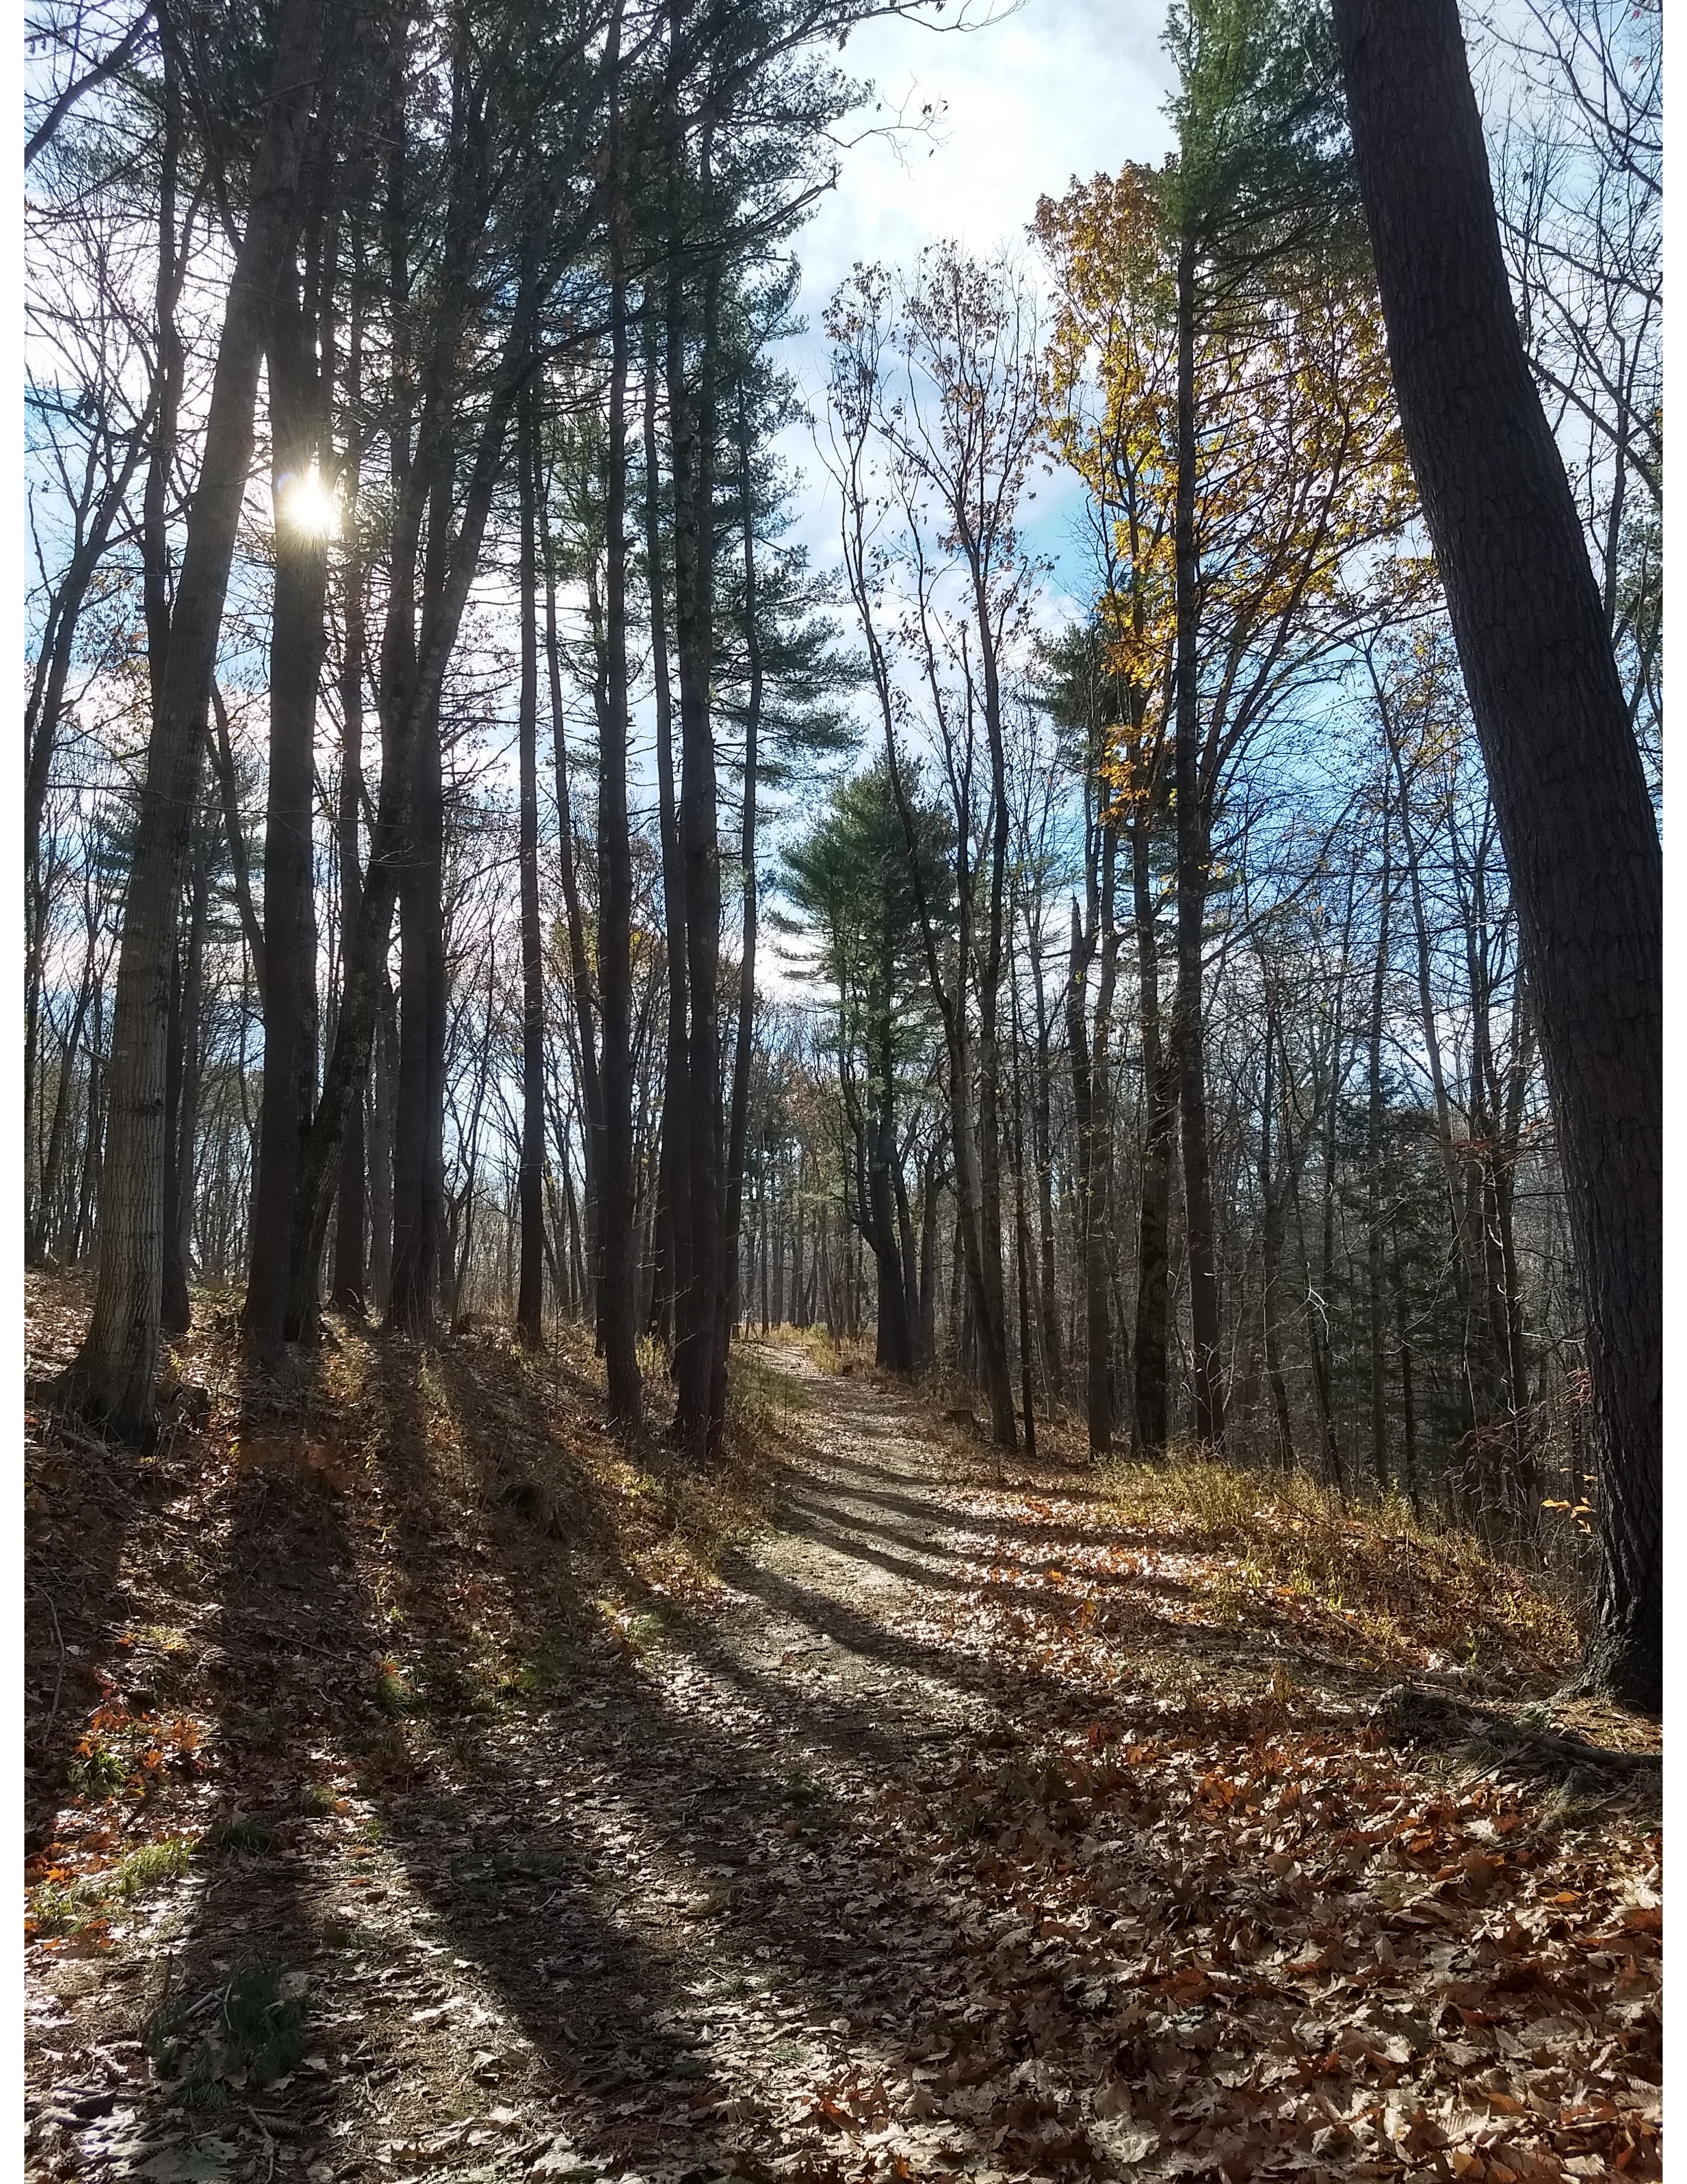

www.riportlandmaine.com riportlandmaine@gmail.com (207)233-3753

