Certificate of Occupancy
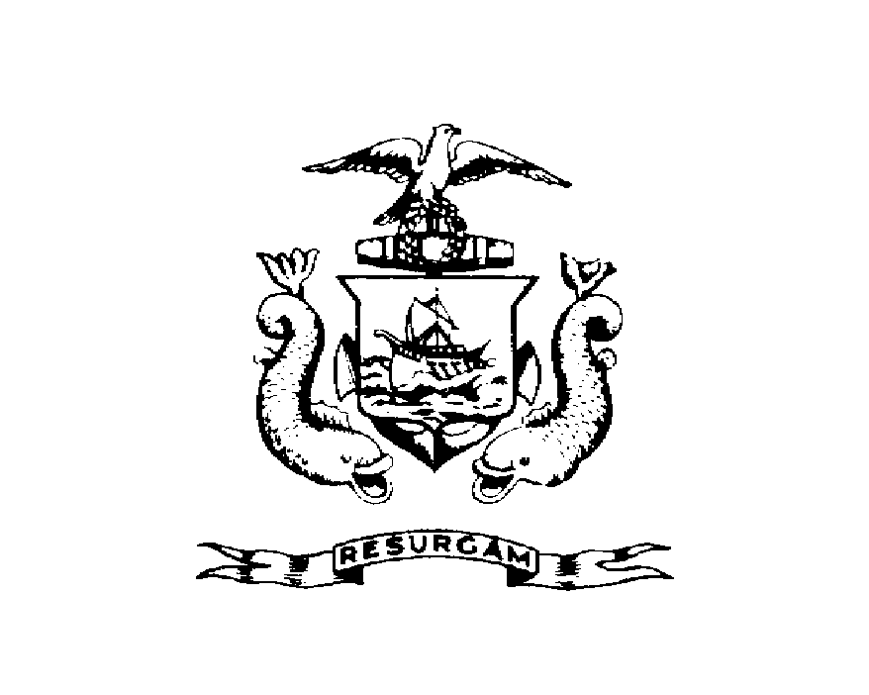CITY OF PORTLAND, MAINE
Department of Planning and Urban Development
Building Inspections Division
Issued to: 50 INDUSTRIAL WAY LLC Location: 50 INDUSTRIAL
Date Issued: Wednesday, March 09, 2011 CBL 326 B009001
This is to certify that the building, premises, or part thereof, at the above location, built-altered-changed as to use under Building Permit No. 2011-01-247-ALTCOMM, has had a final inspection, has been found to conform substantially to the requirements of the Building Code and the Land Use Code of the City of Portland, and is hereby approved for occupancy or use, limited or otherwise, as indicated below.
PORTION OF BUILDING OR PREMISES APPROVED OCCUPANCY
PRODUCTION ROOM #101 IBC 2009 USE GROUP F-2/S-2, TYPE 2B
Limiting Conditions: ELECTRICAL SIGNOFF PRIOR TO STARTUP/DRC APPROVAL PRIOR TO JUNE 1, 2011
Approved:

Inspector Inspections Division Director
Notice: This certificate identifies the legal use of the building or premises, and ought to be transferred from owner to owner upon the sale of the property.

