India Bazaar and Takeout is on Facebook.
To connect with India Bazaar and Takeout, sign up for Facebook today.

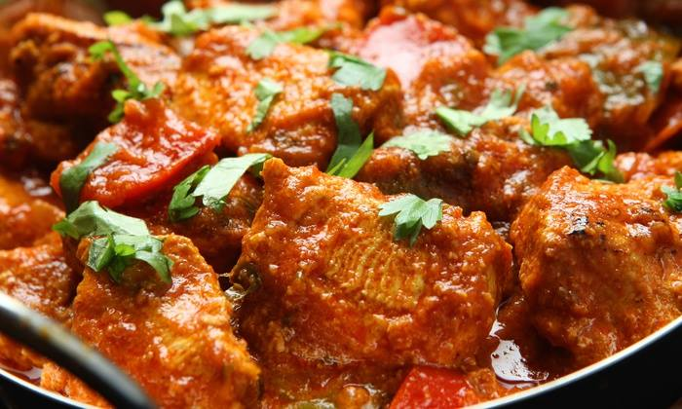

India Bazaar and Takeout
Indian Restaurant
GGrocery open 9am to 9pm daily. Take-out available 11am to 7pm daily.
- Timeline selected:
- Page last updated 07/22/2014
17 likes
1 visit
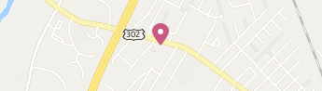

1706 Forest Ave
Portland, Maine

(207) 805-1226

