Portland's India Bazaar and Takeout Closed?
by Adam H. Callaghan Sep 9, 2014

- Share
- Tweet
- Don't miss stories.Don’t Miss Stories-
- Follow Eater Maine
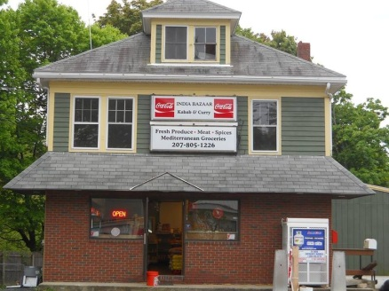

A commenter at Portland Food Map suggests India Bazaar and Takeout at 1706 Forest Avenue is closed: "If they took a vacation they don't seem to have put a note on the door." Calls were not being answered at the time of posting, and the business' Facebook page and menu hasn't been updated since late July. In what little attention the restaurant has received, Meredith Goad wrote an unfavorable review in May, calling the food "underwhelming." Anyone have definitive intel?
- I got take-out there in late July, but have not checked since. –Betsy P.

- I went in early August and they were closed. Thought they were on vacation or renovating, but when I went back in late August I found them definitely closed. – John D.

From Portland Food Map website:
- September 4th, 2014 at 7:13 am Mark Says:
Also: India Bazaar in Riverton looks like it’s closed; if they took a vacation they don’t seem to have put a note on the door. It’s too bad, but the published reviews weren’t positive and although I never tried it, the word of mouth I got (admittedly from people who are neither Indian nor foodies) was that it wasn’t very good and the portions were small for the price.
- September 11th, 2014 at 8:00 pm EllaMinnowPea Says:
Yes, India Bazaar closed last month. And looks like Jan Mee Chinese also closed recently down there on St John — put a sign on the door about renovations two months ago, then never reopened. I think there’s a FOR LEASE sign up now.
- September 11th, 2014 at 8:59 pm Portland Food Map Says:
Thanks for the info EMP. I’ll remove both of them from the Portland Food Map directory.

