As sent

September 21, 2009

Jim Fisher, President
Northeast Civil Solutions, Inc
153 US Route 1
Scarborough, ME 04074

RE: Vance project, 355 Warren Avenue (Tow Lot)
Minor Site Plan (maximum of 70 vehicles to be stored)
Application ID # 2007-0138

Dear Mr. Fisher,

I understand that Mr Vance has indicated, in discussions with MDOT, that he is awaiting a Planning Division decision on the Tow Lot application. Therefore I am writing to clarify the status of this application.

Our records show that the last submission regarding the Tow Lot application was November 2008 and that staff gave engineering and landscape comments at that time which required further revisions to some of the submitted plans. No further submissions have been received since then and City staff has not progressed the review.

The staff comments on the Plans dated 11.4.2008 were sent to you in December 2008 and are summarized below:

- Please address the attached engineering review comments dated November 13, 2008. A complete boundary survey is necessary as no waiver has been granted regarding the survey. Please see our letter dated September 15, 2008, which was confirmed at the meeting with Mr Jaegerman on September 29, 2008;

- The plans need to specify the size and species of the planting; Jeff Tarling, City Arborist would be willing to advise on this (he can be contacted on 874 8462 or JST@portlandmaine.gov).

Also at that time we agreed that the curb cut would be 30 feet wide and centered on the existing access to the tow lot, with the area between the ROW and the tow lot improved with plantings by Mr Vance, as set out in your letter to the MDOT dated November 3, 2008 (copy attached).

Mike Farmer of the City’s Public Services Department (the City’s liaison engineer with the MDOT improvement contract on Warren Avenue) has recently inquired as to whether the residential building at the front of the tow lot site was included in the tow lot application. I have confirmed to him that the Tow Lot Site Plan application did not include proposals for this building. Removal of the addition and re-cladding of the exposed wall would require Site Plan approval.

Mr Vance may amend the Tow Lot application to include changes that have arisen as a result of the need to integrate with the MDOT improvement works along the Tow Lot frontage (such as the demolition of the building addition and re-cladding). I understand the MDOT are seeking an early resolution of all issues in this area as they will be completing their work in the near future; therefore I suggest that you submit the (final) revised plans by October 6, 2009, including any amendments now under consideration, so that staff may expedite this last stage of the Site Plan Review of Mr Vance’s application.

Please ensure that these revised plans:

- Satisfactorily address the 2008 review comments;
- Reflect the agreed proposals relating to the ROW;
- Address the question of the condition of the existing fencing, as mentioned in our letter of September 15, 2008 (see attached photograph); the improvements to the enclosure should be integrated with the final planting and sidewalk proposals; and
- (Optional) Add in any amendment(s) that relate to the MDOT project that are located along the tow lot frontage within the site boundary eg demolition of the building addition and re-cladding.

If you have any questions, please contact me at 874 8728 or by email at jf@portlandmaine.gov.

Sincerely,

[signed]

Jean Fraser
Planner

Attachments:
- Woodard & Curran comments dated November 13, 2008 (as forwarded on 11.21.2008)
- Your letter to MDOT dated November 3, 2009
- Photograph of existing fencing

Cc electronic copies
Alexander Jaegerman, Director, Planning Division
Barbara Barhydt, Development Review Services Manager
Tom Errico, Traffic Reviewing Engineer
David Margolis-Pineo, Deputy City Engineer
Mike Farmer, Project Engineer, Dept. Public Services
Marge Schmuckal, Zoning Administrator
Legal Department
Licensing Department
John Vance, 383 Warren Avenue, Portland ME 04103 (applicant)
Attachment 1
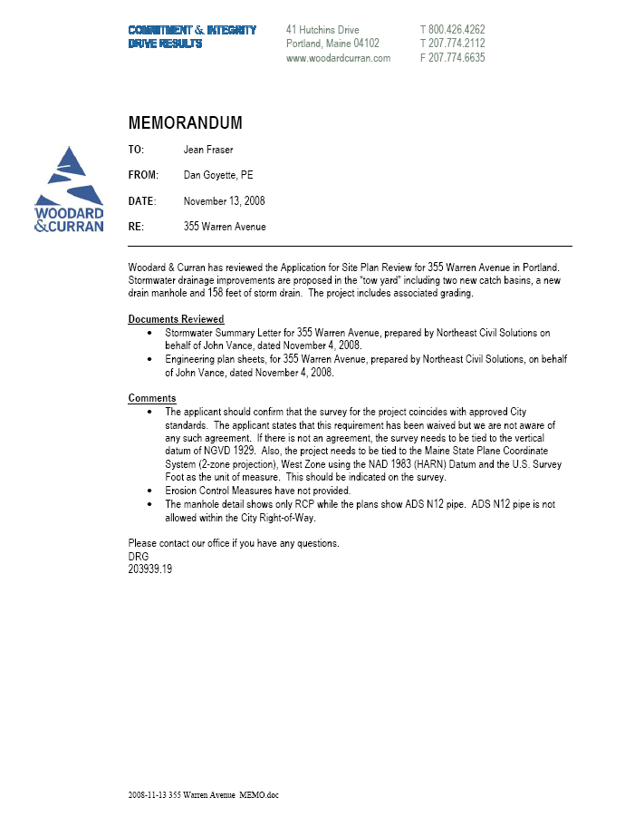

Attachment 2

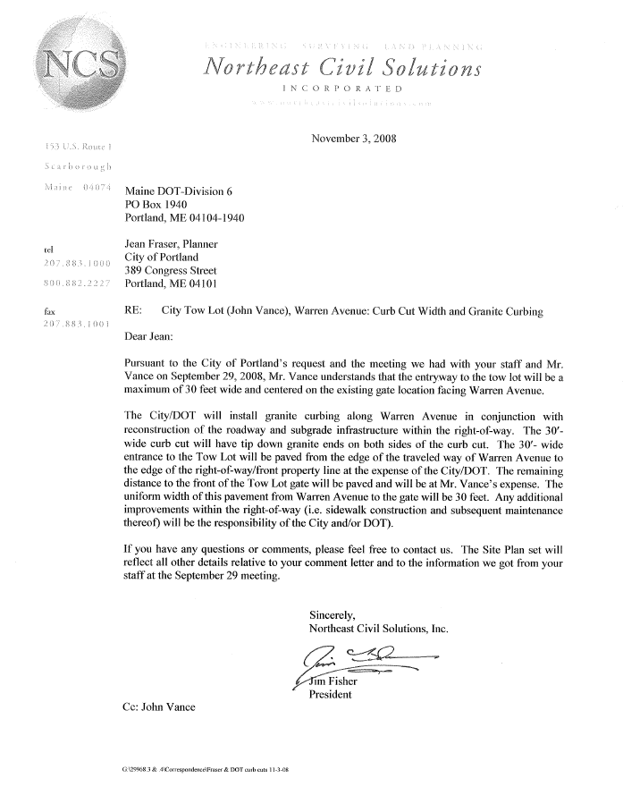
Attachment 3



