

Planning and Urban Development
Penny St. Louis Littell, Director

Planning Division
Alexander Jaegerman, Director

September 15, 2008
[as sent]

Jim Fisher, President
Northeast Civil Solutions, Inc
153 US Route 1
Scarborough, ME 04074

RE: Vance project, 355 Warren Avenue (Tow Lot)
Minor Site Plan (maximum of 70 vehicles to be stored)
Application ID # 2007-0138

Dear Mr. Fisher,

I refer to the letter and attached plans submitted on July 11, 2008.

This proposal is being reviewed as a minor site plan for a proposed tow lot of 13,000 sq ft plus access drive for the storage of up to 70 cars. The tow lot has been termed “proposed” because our records indicate that no previous site plan approval was granted for the recent (our records suggest 2003) improvement works and the use as a tow lot is not grandfathered nor legal. The towing licenses related to the use of this lot for the storage of towed vehicles have previously been renewed by the City based on the guidance provided by the Pubic Safety Committee in 2005/2006 and the requested site plan application which is currently under review.

City reviewers have the following preliminary comments on the site plan application; these confirm previous telephone conversations with yourself and Mr Vance. There may be further comments or requests for additional information after the review of further submitted information or revisions.

- Boundary Survey: I would like to correct the first paragraph of your July 11, 2008 letter. In a conversation on June 13, 2008 you indicated that substantial additional survey work would be required to investigate historic monumentation issues and provide a certified (stamped) Boundary Survey. Both you and Mr Vance suggested that the additional survey work and the level of accuracy it would achieve were not warranted for the small scale of this project. During that discussion I did not state that a certified Boundary Survey would not be required as part of the site plan review; I suggested that I would need to ask for advice on this question and that in the meantime the Existing Conditions Plan could be revised to include Boundary Survey information so that reviewers would have information on which to undertake a preliminary review.

I note the submitted Existing Conditions Plan (July 2008) includes the information normally included in the Boundary Survey and is signed by a registered Surveyor but not stamped.

The City’s requirements are set out in the Ordinance:

14-525 b Contents.
Any final or proposed site plan for a major or minor development shall include:
(1) A standard boundary survey prepared by a registered land surveyor at a scale of not less than one (1) inch to one hundred (100) feet and shall set forth: ….

I have sought advice and understand that the City has generally interpreted “standard” to mean a certified (stamped) Boundary Survey.

The requirement for a stamped survey was included in the letter to Mr Vance on April 19 2006 that outlined the request for a site plan application to be submitted: the text included “…. 2. Submit a detailed site plan application to the City’s Planning Division that includes, at a minimum, (a) proof of right title and interest in the property, such as a deed; (b) a boundary survey, stamped by a professional surveyor; and (c) a site plan, stamped by a professional engineer, that addresses fencing, landscaping, lighting and stormwater treatment.”

We appreciate that the proposals involve minimal development but we note that some are outside of Mr Vance’ property and some (drainage and landscaping) would relate to features in the ROW. Please submit a certified Boundary Survey that meets the first comment contained in the attached Engineering Review Memo (see below).

- Stormwater Management: As requested in my letters of April 18 and June 5, 2008 and requested in the attached Engineering Review Comments dated July 31, 2008, please submit a Storm Water Management Plan that includes an analysis that demonstrates that the proposed drainage system is capable of handling the proposed drainage amounts and patterns. The existing graveled surface has been in place a few years and was installed without site plan approval and therefore the existing condition is not necessarily acceptable. I confirm that storm water treatment is required for this site and would need to meet current City and MDEP requirements.

- Curb Cut and Access: The drive leading to the tow lot should be a maximum of 30 feet wide to comply with the City’s Technical Standards that are applied to all site plan applications. We understand that a 42 foot wide curb cut and access has been designed for this location as part of the MDOT improvements. The proposed 42 wide curb cut is excessive and the City would like this to be reduced to 30 feet to comply with the City’s standards, to be arranged between the City and the MDOT at no additional cost to Mr Vance. Please submit a plan showing the proposals for the entire tow lot project area (which you have confirmed includes the area between the tow lot and the Warren Avenue ROW).

- Landscaping and Screening: We welcome the planting of lilacs along the western boundary (Saville Street) although they appear to be within the paper street (as is the existing fence; see below). We continue to request some screen planting (eg evergreens) along the Warren Avenue frontage and do not agree that this will undermine security of the site since the vehicles are parked so far to the rear of the site. Some of the screen planting could be nearer to Warren Avenue at the edge of the new sidewalk and/or along the new access drive.

- Repair of Fencing: We do not agree that the existing fencing is in a “very viable condition” as evidenced by the attached photograph and request that the fencing be repaired to a good condition. The fencing along Saville Street does not appear to be on your property and there may be a question as to whether it should be relocated.

- Hydrant: the Fire Department requires a fire hydrant in the near vicinity of this project, on either side of Warren Avenue. They have suggested that you and the applicant for 380 Warren Avenue (approved addition to the warehouse at the rear; applicant is Delta Realty Co Inc, 120 Exchange Street, Portland ME 04101) could join together in this provision.

- Surfacing: The proposed retention of the gravel surface within the tow lot area is acceptable subject to the storm water proposals and treatment meeting current standards. The area between the MDOT apron and the tow lot gates should be paved by the applicant to a width no greater than 30 feet and shown on the plans.

- Sidewalks and Curbing: Sidewalks and curbing along the frontage of this site are required under the City’s Ordinance (Section 25-96 as modified by Section 14-506 (b)) as previously noted in discussions with Mr Vance and in my letter of June 5, 2008. In view of the small scale of the proposed development we will not request the applicant to contribute to the City’s part of the costs of the MDOT imminent improvement scheme, which is anticipated to include an access apron plus curbing and sidewalk along the site’s frontage.

Please let me know if you have any questions and/or would like a meeting to clarify any of the above issues; I can be contacted at 874 8728 or by email at jf@portlandmaine.gov.

Sincerely,

[signed]

Jean Fraser
Planner

Attachments:
- Woodard & Curran comments dated July 31, 2008
- Photograph of existing fencing

Cc electronic copies
Penny St. Louis Littell, Director, Planning and Urban Development
Alexander Jaegerman, Director, Planning Division
Barbara Barhydt, Development Review Services Manager
Jim Carmody, Transportation Engineer
Tom Errico, Traffic Reviewing Engineer
Dan Goyette, Engineering Review Engineer
David Margolis-Pineo, Deputy City Engineer
Marge Schmuckal, Zoning Administrator
Captain Greg Cass, Fire Prevention
Legal Department
Licensing Department
Attachment 1

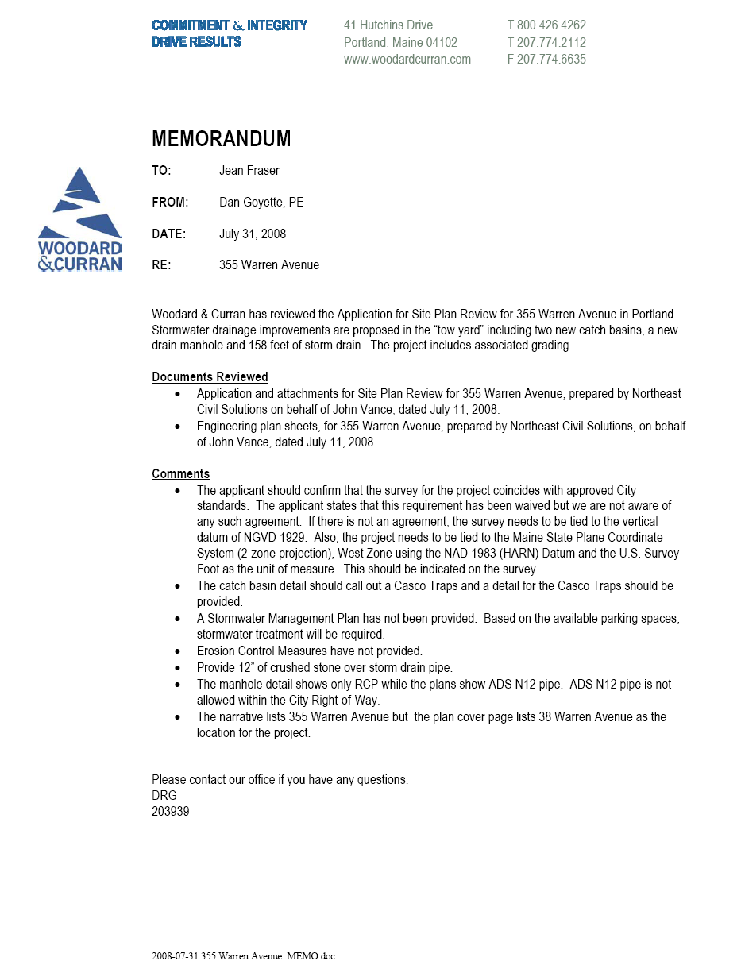

Attachment 2



