

Memorandum
Department of Planning and Development
Planning Division

TO: Stuart O’Brien, Chair and Members of the Portland Planning Board

FROM: Jean Fraser, Planner

DATE: March14th, 2014

RE: Multi-unit Commercial Building
421 Warren Avenue
PH Warren Avenue, LLC, Applicant
Project #: 2014-016 CBL 296-A006001

MEETING DATE: March 18th, 2014

- INTRODUCTION

Steve Bushey of Fay, Spoffard & Thorndike, on behalf of P H Warren Avenue, LLC, has requested a Preliminary Level III Site Plan review for a proposed 28,000 sq ft single story industrial building to create a 7 unit commercial complex with 41 parking spaces. It is proposed to be accessed via an existing drive that currently serves 429 Warren Avenue (also owned by the applicant).

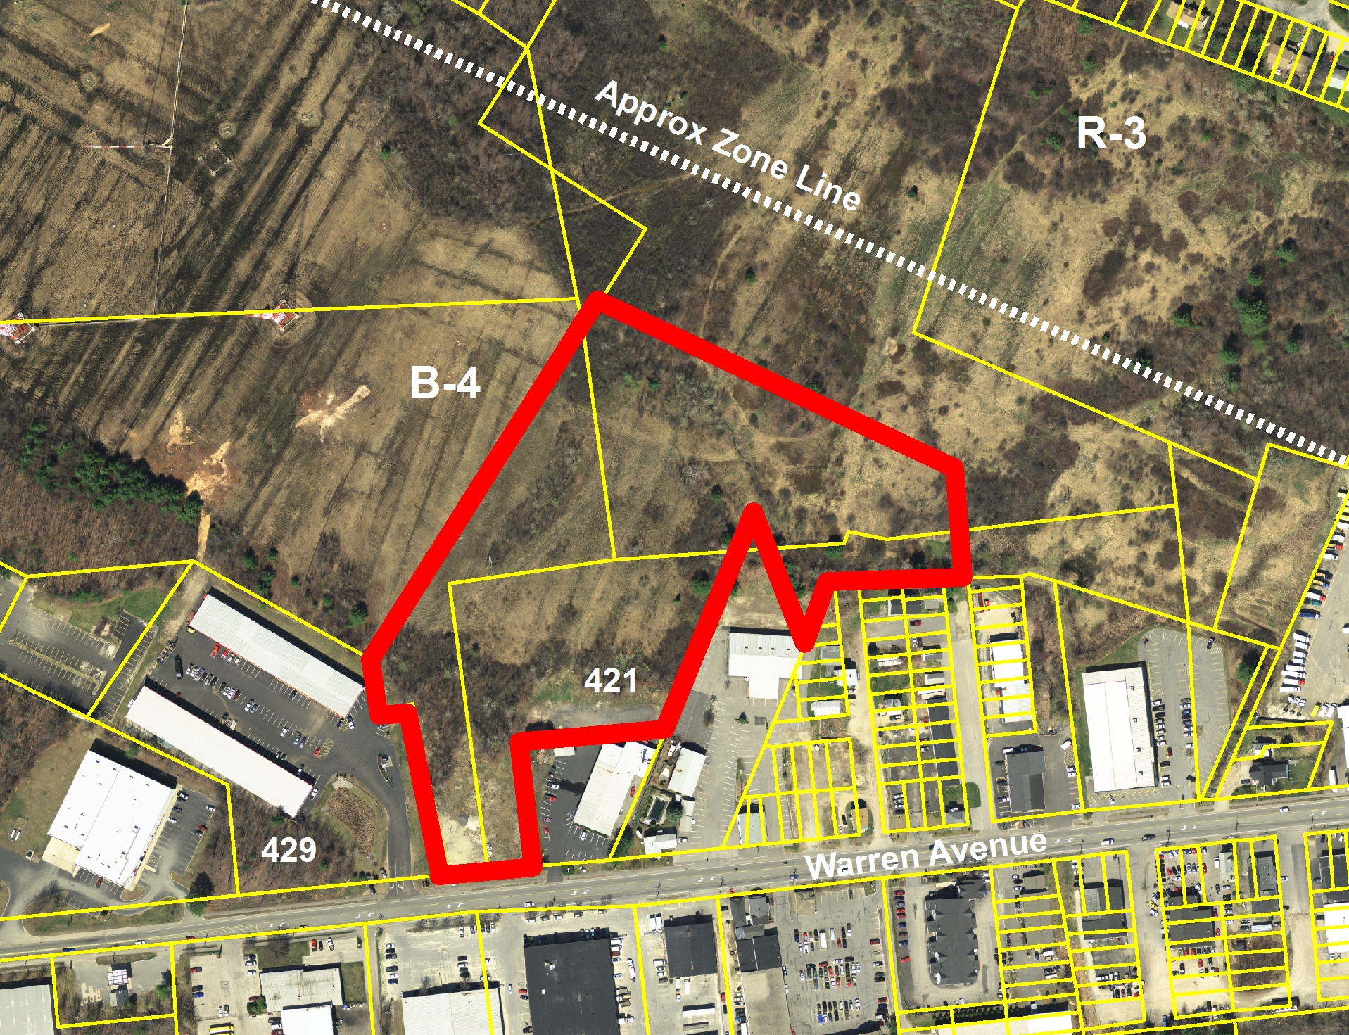
The building is located on a 9.6 acre lot that was formerly part of the 48+ acre site known as “Warren Green”. The applicant has purchased the whole of the “Warren Green” site (see Plan P1 and Attachment 7) and is currently in discussions regarding the possible sale of part or all of the remainder of this larger site to the City to preserve water resources. The applicant also owns the properties abutting both sides of the project on the Warren Avenue frontage.

The proposal does not constitute a subdivision as the 9.6 acre parcel is the first split of the overall “Warren Green” site since at least 2008, and the proposed 7 commercial units do not create a subdivision under State law or City ordinance (as both relate to dwelling units only).

A total of 116 notices of this Workshop were sent to property owners within 500 feet and to interested citizens. The applicant held a public information meeting on March 17, 2014 regarding the associated MDEP application to fill in wetlands on part of the site, which was noticed widely. A Neighborhood Meeting will also be held, date/time to be confirmed. To date the Planning office has not received any public comments

Required reviews: The site plan is being reviewed under the Land Use Code provision 14-526 (Site Plan). The project is located within the Capisic Brook Watershed District and must obtain a Stormwater Permit from the City of Portland (delegated review). The project requires a Natural Resources Protection Act (NRPA) approval from the Maine DEP (Tier III permit for wetland fill).

The waivers required by the project are still under review, but staff suggest that the following would be required for the project as currently designed. The preliminary submission has not addressed the tree preservation ordinance and waivers may be requested in the context of that requirement.

Requested Waiver | Standard and any waiver provisions
Driveway Design: the access driveway into the proposal site is 60 feet in width and exceeds the maximum in order to allow for the large vehicles anticipated to require regular access to the site and to avoid conflict with the existing turning movements and traffic flows on the joint access drive. | Technical Manual Section 1.7.1.4 which specifies a maximum of 36 feet wide for a major commercial driveway. (Note: the driveway is off of a private drive jointly serving the project not directly off of a public street)
Parking Lot and Parking Space Design: The parking aisles are up to 65 feet in width to allow for circulation by large truck vehicles and therefore exceed the maximum width. | Technical Manual Section 1.14 which specifies a maximum of 24 feet for parking aisles.

- PROJECT DATA

DATA | Proposal
Total Site Area | 418,393 sq ft
Existing Zoning | B4
Existing Use | Vacant, flat gravel
Proposed Uses | Commercial units for rent
Proposed structure height | 21 feet
Total Disturbed Area | 110,207 sq ft
Existing impervious areas | 0
Proposed impervious areas | 82,764 sq ft
Increase in impervious area | 82,764 st ft
Existing wetland | 3.5 to 4 acres  (2.1 acres of this is delineated in detail in vicinity of development)
Proposed wetland fill | 25,093 sq ft
Existing building footprint | 0
Proposed building footprint | 28,000 sq ft
Proposed floorspace | 28,000 sq ft
Proposed parking as required by zoning | 41 proposed; 28 required by zoning
Proposed bicycle parking | 4 (4 required by Ordinance)
Estimated Cost of Project: | $1.5 million
Uses in Vicinity: | Mixed commercial along Warren Avenue; undeveloped at rear

- EXISTING CONDITIONS Photo submitted by applicant:
The part of the site nearest to Warren Avenue,
where the new building is proposed, is about half cleared with gravel and the remainder is wetland mixed with vegetation, including many trees. The rear part of the lot (approximately 7 acres) is mostly fingers of wetland which are part of a much larger area of wetland (Attachment 7 shows wetland over the wider “Warren Green” site).

The lot is bounded on the west and east (nearest Warren Avenue) by commercial developments similar to the proposed project and owned by the applicant. The commercial development to the west is 429 Warren Avenue ( 2 buildings totaling about 35,000 sq ft) in the same ownership as the proposal site. It is served by an existing 36 foot wide access drive from Warren Avenue, and this is proposed as a shared access for the new commercial building.

There are bituminous sidewalks along the frontage and a former (now unused) curb cut on the site.

- PROPOSAL
The proposal plans (Plans P3. to P17.) show the layout and physical site work on the southern part of the lot where the new development is proposed, with the building elevations in Plan P18. The development comprises a new single story 70 foot by 400 foot building containing 7 commercial units: 5 units at 3,500 sq ft each; and 2 units of 5,250 sq ft each, to total 28,000 q ft. Each unit will have an overhead door and pedestrian door and initially have an open interior to be leased and modified by small business users.

The 41 parking spaces are largely located near the front of the units with some around the periphery of a large paved area accessed by a 60 foot wide drive onto the joint access drive to Warren Avenue. Drainage will be managed by gravel wetlands, and just over 25,000 sq ft of existing meadow and tree wetland will be filled in to accommodate the development.

The proposals include the provision of three street trees in the Warren Avenue ROW but no other tree planting or reinstatement planting is proposed. Where the new access is created from the joint access drive, a few shrubs and boulders are proposed.

- Staff Review

- Zoning: Comments from Marge Schmuckal, Zoning Administrator, were not received in time for inclusion in this Memorandum.

- Staff Review: Site Plan 14-526 Site Plan Level III Final Plan Requirements

The submitted information for a preliminary plan has addressed most of the relevant Site Plan requirements. The comments below highlight areas where staff consider the Site Plan requirements need to be addressed for the final plan review.

- Transportation

- Impact on Surrounding Street system
The proposed development utilizes an existing access that currently serves the commercial units at 429 (aka 424 Warren) Warren Avenue (understood to be just over 35,000 sq ft warehouse/commercial plus ancillary offices). Tom Errico, the Consultant Traffic Engineer, has requested that the applicant provide a traffic generation estimate for the proposed project as well as for the two existing buildings serviced by the shared driveway, in order to determine whether a Traffic Movement Permit is necessary (Attachment 3).

- Access and circulation, loading and servicing
The access into the new site is proposed to be via a 60 foot wide curb cut from the existing access drive from Warren Avenue that currently serves 429 Warren (two existing warehouse /industrial /commercial buildings) (See Plan P6). The 60 foot wide curb cut opens immediately into an area of pavement that extends about 100 feet out from the new building in the central area, narrowing to 80 feet from the new building at the north and south ends and partially wrapping around the building (over 50,000 sq ft in area). This area provides access to the units by large vehicles, including tractor-trailers, and includes parking around the periphery, although it is not clear why the pavement is around the north end when there are no doors at that location (Plan P18).

The applicant has described the dimensions of these areas as being needed to avoid conflicts with existing turning movements and traffic flows (understood to mean in the joint access drive) and to allow for the occasional movement of tractor –trailers. (Attachment E)

This area requires the infilling of substantial areas of wetland and this concern is discussed below. Tom Errico, the Traffic Engineering reviewer, has questioned the functional necessity for such large areas (Attachment 3):

  - The proposed driveway entrance exceeds City standards and a waiver will be required. The applicant shall provide an Auto-Turn analysis documenting the need for the wide driveway.

  - The aisle widths in the internal parking/circulation area do not meet City standards and a waiver will be required. The applicant shall provide an Auto-Turn analysis documenting the need for the expanded pavement areas.

- Pedestrian Access
Each of the proposed 7 units have a pedestrian entrance from the central paved area which also provides parking spaces (Plan P6). Although the south end of the building is about 50 feet from the existing Warren Avenue sidewalk, the current proposals do not include any pedestrian link from the sidewalk to the building entrances. The Site Plan Ordinance includes a standard that states (14-526 (a) 2. c. (iii):

Continuous internal walkways shall be provided between existing or planned public sidewalks adjacent to the site, transit stops and street crossings and primary building entrances on the site.

Tom Errico has provided the following comments, which need to be addressed as part of the final submissions (Attachment 3):

- A sidewalk connection from the proposed building to Warren Avenue shall be provided.
- An area along the building frontage on the parking area shall be marked such that pedestrians have a direct routing to Warren Avenue.

- Parking Requirements
The proposal includes 41 parking spaces, distributed around the perimeter of the central access area to serve the units. The zoning requirement would be 28 spaces (1 per 1000 sq ft). The applicant has indicated that the total spaces, including 13 above the zoning requirement, are appropriate for the anticipated uses. As with the expanse of pavement, the submission does not include any explanation of the need. The final submissions should include further information to support the scale of the paved area and parking provision.

- Bicycle Parking Requirements
The ordinance standard for this development is 2 bicycle parking spaces for every 10 required vehicle parking spaces, ie 4 bicycle parking spaces. The applicant has provided 4 bicycle [parking spaces in 2 racks, one near Warren Avenue and one near the central two units.

- Snow Storage
The site plan (Plan P6.) does not specifically call out snow storage. The proposed paved area is likely to provide adequate area for snow storage, but the proposed wetland cells, swales and erosion control features abut the paved area and a Snow Storage Plan is required to ensure that these areas are not used for snow storage.

Note: Public Transit Access and TDM requirements do not apply to this project.

- Environmental Quality

1. Landscape Preservation
Preservation of a percentage of large trees within the setbacks is an Ordinance requirement. The proposed building and the extensive paved area surrounding the building result in the loss of most of the existing vegetation, so the final submissions should include an assessment of the trees within the setback and include a “tree save” plan, as confirmed by the City Arborist (Attachment 4).

2. Site Landscaping and Street Trees
The Site Plan (Plan P.6) shows three street trees and a few shrubs and boulders near the new access from the joint drive. The Site Plan requirements for parking areas also apply to the B4 zone and additional planting/replacement planting is required to meet this standard, particularly in view of the likely impact on the existing trees in the northern part of the site. (Attachment 4)

Planting is also needed for the proposed gravel wetlands and staff suggest a separate Landscape Plan for this, along with parking lot landscaping and replacement trees.

3. Stormwater Management
The proposals result in creation of new impervious areas that total 82,764 sq ft, of which the new commercial building accounts for about a third (28,000 sq ft). The need for over 50,0000 sq ft of paved area, which exceeds parking and drive aisle and curb cut standards, is unclear and further information has been requested in the staff comments.

The project also results in the filling of 25,093 sq ft of wetlands and the applicant has applied for a Tier III Permit under NRPA. The site is within the Capisic Pond Impaired Watershed. Again, the need for this scale of wetland fill is not clear in the application and further justification is requested.

The applicant has submitted a preliminary Stormwater Management Report (Attachment F) but the calculations that underpin the Report have been questioned by Dave Senus, the Consulting Engineer reviewer (Attachment 1). The review also notes that some information has not been submitted at this stage as it is a preliminary application (eg gravel wetland and other details, capacity to serve letters, construction management plan, and the Stormwater Inspection and Maintenance manual) and confirms that these would need to be included in the final submissions.

It is also noted that the project is required to comply with the Urban Impaired Stream Standard and the final submittal should present either a fee calculation or a design approach /plans that show how the project will meet this standard.

- Public Infrastructure and Community Safety Standards

- Consistency with City Master Plans
The Department of Public Services (David Margolis-Pineo) has commented (Attachment 2):

Since the curb cut on Warren Ave in front of this project is not proposed to be used, the applicant is requested to close the curb cut. The curbing shall be set in concrete to match the abutting curb work… Warren Ave in this area is currently under a pavement moratorium until October 26, 2014. However as long as the applicant does not encroach the pavement more than two feet from the face of curb, no moratorium repair will be requested if the work is done before this date. A Street Opening Permit will be required.

He has also noted that some corrections/amendments are needed to the submitted survey for the site (Plan P2.). An easement for the use of the joint access should be included in the final submission.

- Public safety
This will be reviewed following the submission of plans showing a pedestrian link to the Warren Avenue sidewalk, and the submission of information regarding the existing lighting near the joint access drive.

- Fire prevention
Comments were not received at the time this Memorandum was prepared.

- Site Design Standards

- Site Lighting
The proposed lighting fixtures are included in Attachment E (at end) and the Photometric Plan is included in Plan P7; both meet the City’s Technical Standards. There are two existing lights (Plan P6) shown near the site entrance and details of these lights should be submitted as part of the final submissions to ensure these also meet Technical Standards.

The pedestrian link to the Warren Avenue sidewalk (as requested above) should have lighting provided along it.

- Construction Management Plan
This has not been included and needs to be part of the final submission.

VI. NEXT STEPS
The proposal appears generally acceptable, subject to further information and final revisions for final plan review, to address a number of issues as identified in the staff comments and in this Memorandum. These are summarized below:
- Provide traffic generation estimate for the existing development at 429 Warren and for the proposal;
- Submit turning templates and other information to explain the need for the curb cut, drive aisle and parking proposals;
- Submit further information to clarify any impacts on the wooded area on this site, as per the tree preservation standards;
- Address issues raised by the Consulting Engineer Reviewer, including regarding the Urban Impaired Stream Standards;
- Revise the proposals to address pedestrian accommodations; snow storage; landscaping; ROW curb cut removal; and extent of paved area;
- Provide capacity letters; submit the easement for joint access; submit Tier III permit;
- Planning Board comments.

ATTACHMENTS:

Staff Review comments and background information
  - Engineering Review (David Senus, Woodard & Curran) comments 3.3.2014
  - DPS (David Margolis-Pineo) comments 3.11.2014
  - Traffic Engineering Review (Tom Errico, T Y Lin), comments 3.13.2014
  - City Arborist (Jeff Tarling) comments 3.13.2014
  - Zoning Administrator (Marge Schmuckal) comments
  - Fire Department (Captain Chris Pirone) comments
  - Wider Warren Green Wetlands Plan (2007) (from rezoning files)

Public comments (none at the time PB Memo completed)

Applicant’s Submittal
- Cover letter
- Application and Fire Code analysis
- Development Description
- RTI and Financial Capability
- Conformity with Standards and Lighting
- (Prelim) Stormwater Management Report

Plans
P1. Boundary Survey Wider Area
P2. Site Boundary survey (C2.0)
P3. Cover sheet
P4. General Notes and Legend
P5. Existing conditions
P6. Site Layout and Utility Plan
P7. Lighting and Photometic
P8. Grading and Drainage
P9. Gravel Wetland #1 Plan
P10. Gravel Wetland #2 Plan
P11. Erosion and Sedimentation Control
P12. Details (C4.3)
P13. Details (C6.0)
P14. Details (C6.1)
P15. Details (C6.2)
P16. Predevelopment Watershed
P17. Post-Development Watershed
P18. Building Elevations

