November 3, 2017

Project Name: | Moran’s Market | Project ID: | 2017-251
Address: | 1576 Forest Avenue | CBL: | 299 D001001
Applicant: | Bernard and Peter Larsen

Dear Bernard and Peter Larsen:

On November 2, 2017, the Planning Authority approved with conditions an administrative authorization application for site improvements at 1576 Forest Avenue, known as Moran’s Market, in order to legalize a fourth residential unit. The decision is based upon the application, documents and plans as submitted. The proposal was reviewed for conformance with the standards of Portland’s Site Plan Ordinance and Technical Manual.

The City estimates that the cost of installing vertical granite curb is approximately $45 per linear foot. All
work in the right-of-way must be done by a contractor licensed by the city and all applicable permits from the Department of Public Works must be obtained prior to start of construction.

SITE PLAN REVIEW
The Planning Authority found that the plan is in conformance with the site plan standards of the Land Use Code, subject to the following conditions of approval that shall be met by the applicant by submitting a revised plan meeting the conditions and the work shall be completed prior to the issuance of a certificate of occupancy:

- Placement of pinned curb stops and/or planters with spacing no farther than 10 feet apart and anchored to the ground and placed a minimum of 6' from the back of curb on the Forest Avenue side of the side, between the two Forest Avenue curb cuts and between the westerly curb cut and Belfort Street as shown below. Exact locations of curb stops may be adjusted based on consultation with Public Works staff in order to allow for safe access to the loading door;

- Permanent installation of approximately 19 linear feet of vertical granite curb from the end of the catch basin curb inlet and matching the top of the curb reveal at the curb ramp tip-down curb stone along Belfort Street at its intersection with Forest Avenue. This curbing shall be installed by a contractor licensed by the Department of Public Works to do such work, as shown below on page two, and the sidewalk shall be regraded to meet Americans with Disabilities Act standards;

- Provision and annual maintenance of painted lines, similar to a crosswalk, across the Forest Avenue curb openings to delineate the parking areas from the public sidewalk. Precise locations of these lines will be determined with consultation from Public Works or Planning division staff; and

- Certificates of Occupancy shall not be issued until the site work is completed or a performance guarantee and inspection fee meeting all of the requirements of the site plan ordinance, or mutually acceptable alternative arrangement, is in place for the work to be completed within one year from the date of this approval.

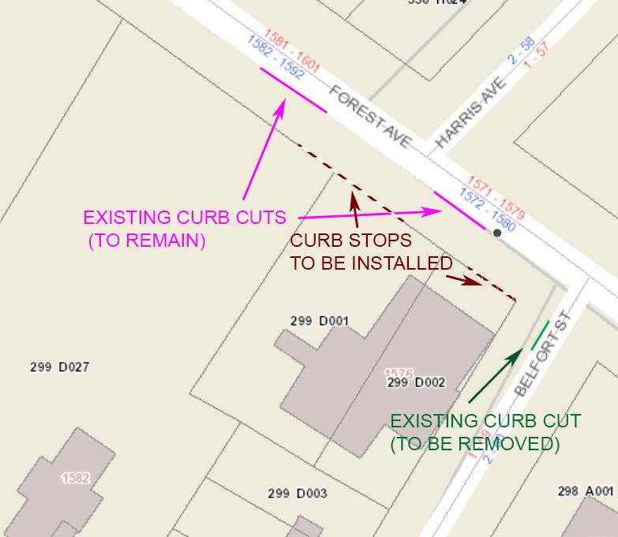

The approval with conditions is based on the submitted plans and the findings related to site plan ordinance and technical manual standards.

STANDARD CO NDITIO NS O F APPRO VAL
Pleas e Note: The following standard conditions of approval and requirements apply to all approved site plans:

- De ve lop Site According to Plan The site shall be developed and maintained as depicted on the site plan and in the written submission of the applicant. Modification of any approved site plan or alteration of a parcel which was the subject of site plan approval after May 20, 1974, shall require the prior approval of a revised site plan by the Planning Board or Planning Authority pursuant to the terms of Chapter 14, Land Use, of the Portland City Code.

- Site Plan Expiration The site plan approval will be deemed to have expired unless work has commenced within one (1) year of the approval or within a time period up to three (3) years from the approval date as agreed upon in writing by the City and the applicant. Requests to extend approvals must be received before the one (1) year expiration date.

- Performance Guarantee and Inspection Fees If a performance guarantee is required as stated in condition 3 above, the a performance guarantee covering the site improvements, and inspection fee

payment of 2.0% of the guarantee amount must be submitted to and approved by the Planning and Urban Development Department and Public Works Department prior to the release of a certificate of occupancy and a street opening permit for the site plan. If you need to make any modifications to the approved plans, you must submit a revised site plan application for staff review and approval.

- De fect Guarantee If a performance guarantee is submitted for this project, then a defect guarantee, consisting of 10% of the performance guarantee, must be posted before the performance guarantee will be released.

- De partment of Public Work s Pe rmits A Street Opening permit and/or an Occupancy permit is required for the proposed work or obstructions will occur within the public right-of-way, such as closing the curb cut, sidewalk , driveway construction, site deliveries and equipment siting. Please contact the Department of Public Works Permit Clerk at 874-8300, ext. 8828. (Only excavators licensed by the City of Portland are eligible.)

The Development Review Coordinator must be notified five (5) working days prior to the date required for final site inspection. The Development Review Coordinator can be reached at the Planning and Urban Development Department at 874-8632. All site plan requirements must be completed and approved by the Development Review Coordinator prior to issuance of a Certificate of Occupancy. Please schedule any property closing with these requirements in mind.

If there are any questions, please contact Barbara Barhydt, Development Review Services Manager at 874- 8699 or Jeremiah Bartlett, Transportation System Engineer, at 874-8891 with the Department of Public Works.

Sincerely,
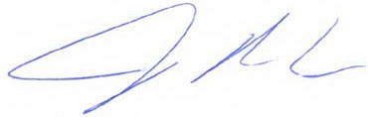
Jeff Levine, Director
Department of Planning and Urban Development

Attachments:
1. Performance Guarantee Packet

Electronic Distribution:
cc: Jeff Levine, AICP, Director of Planning and Urban Development
Stuart G. O’Brien, City Planning Director, Planning and Urban Development
Barbara Barhydt, Development Review Services Manager, Planning and Urban Development Philip DiPierro, DRC, Planning and Urban Development
Mike Russell, Director of Permitting and Inspections
Ann Machado, Zoning Administrator, Permitting and Inspections Jonathan Rioux, Deputy Director, Permitting and Inspections Jeanie Bourke, Plan Reviewer/CEO, Permitting and Inspections Chris Branch, Director of Public Works
Katherine Earley, Engineering Manager, Public Works Keith Gray, Senior Engineer, Public Works
Doug Roncarati, Stormwater Coordinator, Public Works

Jane Ward, Engineering, Public Works
Rhonda Zazzara, Construction Engineering Coordinator, Public Works Jeff Tarling, City Arborist, Public Works
Jeremiah Bartlett, Transportation Systems Engineer, Public Works William Scott, Chief Surveyor, Public Works
Keith Gautreau, Fire Mike Thompson, Fire
Danielle West-Chuhta, Corporation Counsel Jennifer Thompson, Corporation Counsel
Victoria Volent, Housing Program Manager, Housing and Community Development Thomas Errico, P.E., TY Lin Associates
Lauren Swett, P.E., Woodard and Curran Christopher Huff, Assessor

