Inspection Services Department of Urban Development
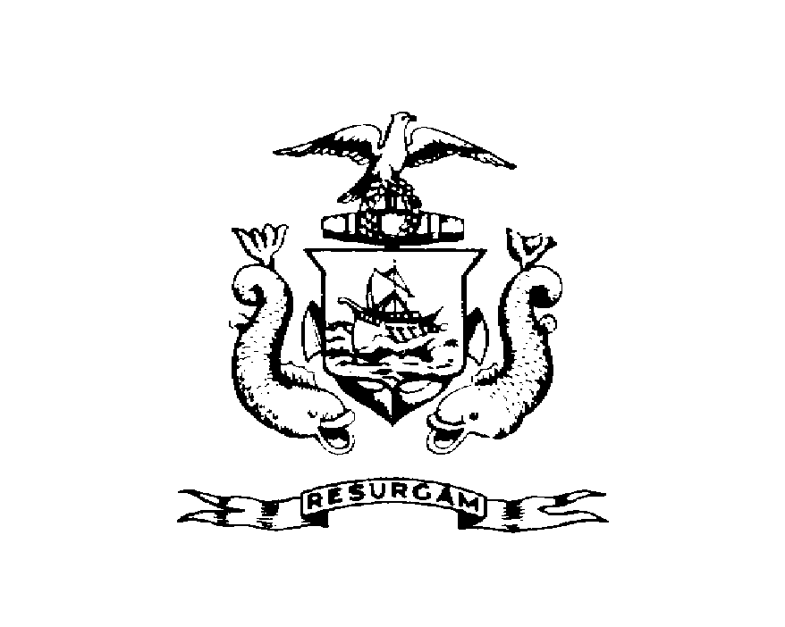
Michael J. Nugent Joseph E. Gray, Jr.
Manager Director

CITY OF PORTLAND

Notice of Violation

June 28, 2001

WM. J Hannigan Jr
27 Commonwealth Drive
Portland, ME

RE: 27 Commonwealth Drive
CBL: 298-D-001

Certified Mail Receipt #7099 3400 0019 5716 1004

Dear Mr. Hannigan:

An evaluation of your property at 27 Commonwealth Drive on June 18, 2001 revealed that the premises fails to comply with Section 14-335(d) of the Land Use Ordinance of the City of Portland.

Five unregistered cars were stored in the yard.

This is a notice of violation pursuant to Sect. 14-335(d) of the Code. All referenced violations shall be corrected within 30 days of the date of this notice. A re-inspection of the premises will occur on July 28, 2001 at which time compliance will be required. Failure to comply will result in this office referring the matter to the City of Portland Corporation Counsel for legal action and possible civil penalties, as provided for in Section 1-15 of the Code.

This constitutes an appealable decision pursuant to Section 14-472 of the Land Use Ordinance. Please feel free to contact me at 874-8697 if you wish to discuss the matter or have any questions.

Sincerely,

Arthur Rowe
Code Enforcement Officer

gg

