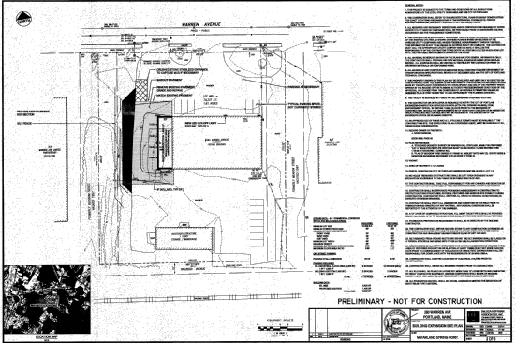
280 Warren Ave- McFarland Spring proposal July 2011 (fuzzy as this is a copy of e-Plan document- clearer pdf being obtained)

