Carol Morissette
Residential Design Studio
via email to carol@resdesstudio.com
August 20, 2015

Re: Request to Extend Lawfully Nonconforming Status at 313 Warren Avenue

Dear Ms. Morissette:

You have requested that, as per Section 14-387 of the Land Use Ordinance, I extend the timeframe for which a lawfully nonconforming residential unit be retained. The building in question is a single family dwelling unit at 313 Warren Avenue. That building is nonconforming with respect to use. Under the default circumstances, if that building was not reoccupied for residential use within two years, the nonconforming use would no longer be permitted. You have requested that timeframe be extended under the clause in that section that permits extending the lawfully nonconforming status for up to an additional five years in a case of foreclosure or similar circumstances. You have specifically requested an extension until May 2016, which would be an extension of 2 years and 11 months, by your records, from the current abandonment date of June 2013.

I have reviewed the materials you provided and authorize an extension of the lawfully nonconforming use for the timeframe you have requested. As required under the ordinance, I find that the “the extension is for good cause and the minimum length considered necessary to resume the legally nonconforming use.” There is every indication that the property had extenuating circumstances related to mortgage transfers and the ultimate acquisition of the mortgage by the Federal Home Loan Mortgage Corporation.

In order to finalize this extension, please forward any backup documentation you have related to the timeframe outlined in your letter, in particular the records showing the transfers of mortgages that strongly imply financing difficulties.

Sincerely,
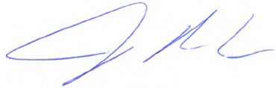
Jeff Levine
Director

cc: Ann Machado, Zoning Administrator

