Memorandum
Planning and Urban Development Department
Planning Division

To: Stuart O’Brien, Chair and Members of the Portland Planning Board
From: Nell Donaldson, Development Review Services Manager
Date: May 15, 2015
Re: Bishop Street Apartments, 72-78 Bishop Street, Avesta 72 Bishop Street, LP
Project #: 2015-060 CBL: 293 C002001
Meeting Date: May 19, 2015

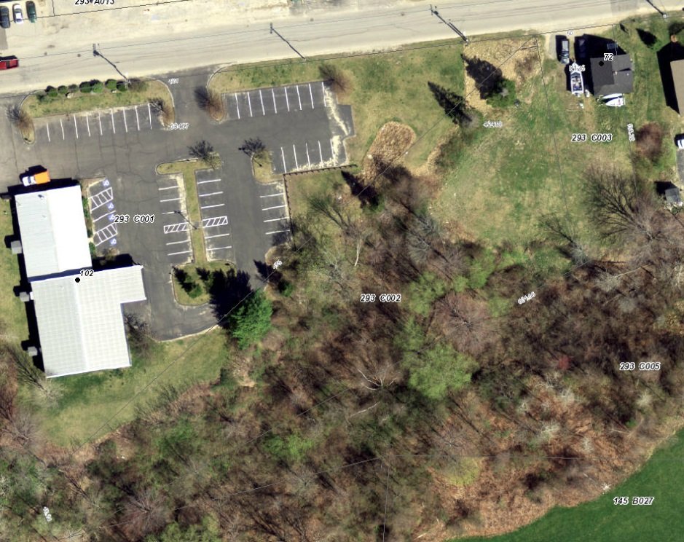
I. INTRODUCTION
Figure 1: 72 Bishop Street, aerial view
Avesta Housing has requested a Level III site plan and subdivision review for a 3-story, 30-unit housing project, the Bishop Street Apartments, proposed for 72 Bishop Street near Morrill’s Corner. The building is designed for chronically homeless individuals around the Housing First approach, and includes a large entry lobby, community kitchen, common seating areas, and a library. A sidewalk connection to Morrill’s Corner, landscaping, 12 spaces of surface parking, and stormwater treatment facilities are included in the proposal. The planning board previously considered the plans for the site, at least in conceptual form, as part of a zoning map amendment application reviewed in the fall of 2014.

Public notice of the planning board workshop appeared in the Portland Press Herald on May 11 and 12, 2015, was posted on the web site, and was sent by mail or e-mail to 60 property owners within 500 feet as well as interested citizens.

Applicant: Brooks More, Avesta 72 Bishop Street, LP
Consultants: Bob Metcalf, Mitchell & Associates; Stephen Bradstreet, Ransom Consulting; Ben Walter, CWS Architects; Owen Haskell

- REQUIRED REVIEWS
Waiver Requests | Applicable Standards
Street trees – To plant 1 street tree, with contribution for remainder to street tree fund | Site Plan Standard, Section 14-526(b)2.b(iii) and Technical Manual, Section 4.6.1. All multi-family development shall provide one street tree per unit. Waiver permitted where site constraints prevent it, with applicant contributing proportionate amount to Tree Fund.  30 units = 30 street trees required
Review | Applicable Standards
Site Plan | Section 14-526
Subdivision | Section 14-497

- PROJECT DATA
Existing Zoning | B-2c
Existing Use | Single-family residential
Proposed Use | Multi-family residential
Proposed Development Program | 30 efficiency units, including common spaces, totaling 21, 374 SF
Parcel Size | 52,383 SF
 | Existing | Proposed | Net Change
Building Footprint | 826 SF | 7,804 SF | 6,978 SF
Building Floor Area | 1,600 SF | 21,347 SF | 19,774 SF
Impervious Surface Area | 1,340 SF | 18,686 SF | 17,346 SF
Parking Spaces (on site) | 2 | 12 | 10
Bicycle Parking Spaces | 0 | 12 | 12
Estimated Cost of Project | $5,586,058

IV. BACKGROUND & EXISTING CONDITIONS
Figure 2: 72 Bishop Street, existing conditions

72-78 Bishop Street lies on the south side of Bishop Street approximately 900 feet west of Morrill’s Corner. The site is presently occupied by a single-family home. Forested wetlands, housing thee headwaters of the Capisic Brook, lie at the rear of the property. An office building and taxi dispatch facility sit to the east of the site, a Masonic Hall to the west, UNE property across the wetlands to the south, and Maine Moped Factory and Portland Collision lie across Bishop Street to the north.

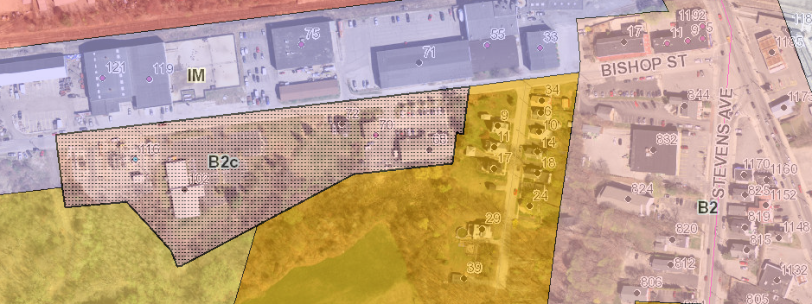
The site and its neighboring properties were recently rezoned from Moderate Impact Industrial (IM) to Business B-2c. An IM zone lies across Bishop Street and a Residential R-5 zone lies at the site’s rear. A single-family residential neighborhood is located approximately 300 feet to the east on Mayfield Street in an R-5 zone.
Figure 3: Existing zoning, 72 Bishop Street

- PROPOSED DEVELOPMENT
The proposal for the Bishop Street Apartments focuses around the development of a three-story, 30-unit building to house formerly homeless individuals, many with significant medical conditions, much in the same vein as Avesta Housing’s two other Housing First projects, Florence House and Logan Place. The proposal is a direct response to a call from the City Council identifying the need for additional permanent housing for homeless individuals in locations beyond the city’s peninsula. The building’s 30 efficiency units would be constructed with shared library, kitchen, meeting, laundry, and interior and exterior social spaces. The main entrance is proposed via a vestibule off Bishop Street, and the plans include a sidewalk connection in the right-of-way east to Morrill’s Corner. 12 parking spaces are proposed, as is landscaping. Stormwater treatment would also be provided on site (Figure 4).

While Avesta would develop the site, provide building maintenance, and serve as the landlord for the eventual tenants of the building, the applicant has stated that they anticipate partnering with Preble Street to provide on-site supportive services. In a memo to the planning board, Preble Street describes a plan to staff 10 full-time employees at the site, including “one coordinator, one supervisor, and one team leader managing seven housing support workers,” and provide a minimum of two staff members “on duty at all times, with as many as four on-site between the hours of 8 a.m. and 8 p.m.” (Attachment M) Based on the Preble Street web site for Logan Place, it is assumed that these staff would not only monitor the building, but support tenants in “developing and enhancing life skills,” “help with…household management, shopping, use of transportation, and meal preparation,” and “facilitate access to community resources, such as health clinics, and mental health and substance abuse services.” The project narrative further states that outside health care providers would likely be engaged “to both address specific health concerns and ensure that residents have access to the health and/or personal care services that medically compromised individuals” often need in their home setting (Attachment D).

PUBLIC COMMENT
Figure 4: Preliminary site plan and Bishop Street elevation
The Planning Division received no public comments on the redevelopment proposal. However, it should be noted that, during the associated zoning map amendment review, a number of neighbors expressed concerns. Neighbors questioned the project’s environmental, traffic, and security impacts, as well as the project’s scale. Light and noise trespass were discussed. Neighbors also expressed concerns regarding the proposed sidewalk connection to Morrill’s Corner, including its implications for existing trees and maintenance.

The applicant has held their required public meeting on the proposal, but minutes have not yet been submitted. Neighborhood meeting minutes will be required as part of the final plan review.

RIGHT, TITLE, & INTEREST
The applicant has provided a deed as evidence of right, title, and interest (Attachment Y).

FINANCIAL & TECHNICAL CAPACITY
The applicant has provided two letters as evidence of Avesta’s technical capacity to develop affordable housing. The applicant has also provided a letter from Gorham Savings Bank expressing an interest in financing the project (Attachment H).

ZONING ANALYSIS
The applicant has submitted a zoning analysis, which notes that the development, as proposed, does not meet two requirements of the B-2c zone (Attachment I). These include the following:

- Front Yard Maximum. The B-2c zone establishes a front yard maximum of 10 feet, which the applicant currently proposes to exceed. At its closest point, the building is planned to sit 18 feet from the property line (Figure 5). The ordinance does provide for an exception, stating that “the Planning Board or Planning Authority may approve a different amount for irregularly shaped lots or lots with frontage less than 40 feet provided this standard is met to the maximum extent practicable” (Section 14-185). During the review of the zoning map amendment related to this site, as a product of similar discussions regarding active street frontages and the associated density bonuses of the B-2 zone, the applicant argued that, due to the shape of the site and the need for a driveway entrance, the building could not be located as close to the street as prescribed by the ordinance to qualify as an “active street frontage.” In a continuation of this argument, the applicant has claimed again in their preliminary site plan submittal that 72 Bishop is an irregularly shaped lot and that they have sited the building as close to the street as possible. The applicant writes,
Figure 5: Bishop Street frontage and setback

“[t]he property is 50 feet wide at the property line and does not offer the ability to locate a 24 foot driveway and the primary building façade towards the street. Because of the low traffic volume entering the site and to allow the building to be as close to the road as possible, the driveway was designed as 20’ wide. The building is located as close as possible to the front property line (18’) to achieve the appearance of an active street front” (Attachment I).

The applicant is requesting that the board approve the project with the proposed deviation from the front yard maximum of the B-2c.

Related to this discussion, the B-2 dimensional requirements also include a provision that, “[w]here setbacks exceed 10 feet, a continuous, attractive, and pedestrian-scaled edge treatment shall be constructed along the street, consisting of street trees spaced at no more than 15 feet on center, approved by City arborist, and a combinations of landscaping no less than 4 feet deep, ornamental brick or stone walls or ornamental fencing” (Section 14-185). The plans do not currently provide such a treatment. Assuming that the board is agreeable to the extension in setback, staff has requested that the applicant address this provision in the final site plan submittal.

- Residential Parking Requirement. Division 20 of the land use ordinance requires one parking space per dwelling unit for residential development in the B-2, B-2b, and B-2c zones. At this ratio, the project would be required to provide 30 parking spaces for the 30 residential units. However, Section 14-332.2(b) of the ordinance also provides an exception for affordable housing, whereby “the planning board may establish a parking requirement for affordable housing units for rent or sale within an eligible project that is less than one parking space per affordable housing unit, regardless of the size of the structure.” The applicant has proposed 12 spaces, less than the 30 required, explaining that the demand calculations were based on Avesta’s experience at Logan Place. The applicant’s traffic engineer, Gorrill-Palmer, writes that the parking demand at Logan Place is generally a product of staff, outside medical providers, and social workers. Given anticipated staffing levels, they calculate a total demand for the Bishop Street site of 11 spaces (Attachment M).

Tom Errico, the city’s traffic engineer, has reviewed this analysis and notes the following,

Gorrill-Palmer has provided a summary of parking needs based primarily on staffing requirements. According to the analysis, 12 parking spaces will be sufficient for demand needs. This demand calculation assumes that none of the proposed tenants will be allowed to have vehicles. In general I find the estimate to be reasonable, but I would suggest that a condition of approval note that if automobile ownership is permitted for residents, the project shall return to the Planning Board for review .

At the time of final review, a condition of approval will be drafted to address this concern.

- SITE PLAN SUBMISSION REQUIREMENTS (Section 14-527) and SUBDIVISION PLAT AND RECORDING PLAT REQUIREMENTS (Section 14-496)
Per the city’s land use ordinance, the following materials should be submitted at time of final review:
- A subdivision plat meeting all plat requirements as noted in 14-496 (including the depiction of any proposed easements); and
- Final plan submittal requirements as noted in 14-527(e) and (f), including:
  - A construction management plan;
  - A boundary survey stamped by a Maine Licensed Professional Surveyor showing all existing easements, including an easement for a stormwater drain which crosses the applicant’s property; and
  - A revised civil set including the following details:
  - Detectable Warning Strip;
  - Catch Basin;
  - Storm Drain Trench; and
  - J-Drain.

- SUBDIVISION REVIEW (Section 14-497(a))
The proposed development has been reviewed by staff for conformance with the relevant review standards of the City of Portland’s subdivision ordinance. Staff comments are below.

1. Water, Air Pollution
Currently, the vast majority of the site is covered in grass or low scrub brush, and drains to the wetlands to the south, which serve as the headwaters of the Capisic Brook, an urban impaired stream. The proposed development would result in an increase of over 17,000 SF in impervious surface, and change drainage patterns on the site. All runoff is proposed to flow through treatment systems which will mitigate for both quality and quantity. David Senus, consulting civil engineer, and David Margolis-Pineo, of the city’s Department of Public Services, have reviewed the stormwater management plans (Attachment N and Plans 10, 11, and 12). Comments are discussed in detail under site plan review below. Given the findings of these reviews, the proposal is not expected to generate undue air or water quality impacts.

2 & 3. Adequacy of Water Supply
The applicant has provided evidence of capacity from the Portland Water District (Attachment G).

4. Soil Erosion
The applicant has provided a soil survey noting that “soils on the site are representative of the urban environment,” including “fill material, relic topsoil and glaciomarine deposits including silty clay.” The geotechnical report recommends excavation of fill material and backfilling with compacted granular borrow below the development site. The project is not expected to cause unreasonable soil erosion or reduction in the capacity of the land to hold water so that a dangerous or unhealthy condition results.

5. Impacts on Existing or Proposed Highways and Public Roads
As noted above, the applicant has provided a traffic analysis, prepared by Gorrill-Palmer Consulting Engineers. Tom Errico, the city’s consulting traffic engineer, has reviewed this traffic study and provided comments, discussed in detail under site plan review below.

6. Sanitary Sewer/Stormwater Disposal
The applicant has submitted a wastewater capacity application to the Department of Public Services (Attachment G). Verification of capacity will be required at the time of final plan. As noted above, a review of the proposed stormwater management system is discussed in detail below.

7. Solid Waste
The applicant has proposed an internal trash and recycling room for residential use and has stated that a private hauler will be contracted for the removal of solid waste. The application states that the “hauler will back into the driveway off of Bishop Street [and]…wheel container units to the truck.” Given this, the development is not anticipated to cause a burden on the city’s system.

8. Scenic Beauty
This proposal is not deemed to have an adverse impact on the scenic beauty of the area.

9. Comprehensive Plan
The applicant has provided a narrative regarding consistency with the city’s comprehensive plan (Attachment K). Consistency with the comprehensive plan is discussed in more detail under site plan review below.

10. Financial and Technical Capacity
As noted above, the applicant has submitted a letter from Gorham Savings Bank indicating the intent to consider project financing (Attachment H). Letters attesting to the proficiency of Avesta Housing have also been provided (Attachment H).

11. Wetland/Water Body Impacts
Altogether, the proposed development would impact 3,105 SF of wetlands. The applicant has made efforts to minimize this impact by siting the building as far from the wetland as possible, proposing limited parking and thus limited pavement, and designing retaining walls rather than grading at the project’s rear. As noted above, the applicant proposes to treat all stormwater proposed to enter these wetlands. This system and wetland impacts are discussed in detail below.

12. Groundwater Impacts
There are no anticipated detrimental impacts to groundwater supplies.

13. Flood-Prone Area
Per the city’s existing flood maps, the development is not proposed in a flood zone.

- SITE PLAN REVIEW (Section 14-526)
The proposed development has been reviewed by staff for conformance with the relevant review standards of the City of Portland’s site plan ordinance. Staff comments are below.

- Transportation Standards
- Impact on Surrounding Street Systems
The applicant has provided trip generation, access, and crash analyses prepared by Tom Gorrill of Gorrill-Palmer Consulting Engineers (Attachment Y). The Gorrill-Palmer study estimates trip generation based on data collected at Logan Place, which is managed by Preble Street in much the same fashion as is anticipated at Bishop Street. Based on the Logan Place data, Gorrill-Palmer estimates a total of 13 AM peak hour and 11 PM peak hour vehicular trip ends to/from the site, mostly as a product of staff. Preble Street has written that all tenants will be afforded bus passes, that Preble Street has an account with Elite Taxi for emergency use, and that many clients will qualify for subsidized paratransit service. Given the low anticipated traffic volumes, no vehicular level of service analysis for area intersections was conducted.

Mr. Errico has reviewed the trip generation estimates and provided the following comments,

I have reviewed the traffic generation estimate prepared by Gorrill-Palmer and concur with the estimate that approximately 13 trips are projected to be generated during the AM peak hour and 11 trips during the PM peak hour. Based upon this level of traffic, I do not expect the project to have a significant impact to traffic safety and operations in the study area. It should be emphasized that while the tenants of the project are not expected to own cars, it is expected that they will be using the proposed sidewalk to gain access to METRO buses at Forest Avenue and general commercial land uses in the area.

The study also pulled crash data from the area, including Morrill’s Corner and the intersection of Bishop Street and Warren Avenue. Of this, Mr. Errico writes,

The crash data provided by the applicant notes that the Morrill’s Corner intersection(s) had significant crashes over the report 2011 to 2013 three-year period. While the Forest Avenue/Stevens Avenue/Bishop Street intersection was not classified as a High Crash Location, it still had 30 reported crashes. The Forest Avenue/Allen Avenue intersection is a High Crash Location and had 53 reported collisions. Given that the project is not generating a significant amount of traffic, I do not expect safety conditions to be exacerbated.

- Access and Circulation
As a corollary to the low vehicular trip generation noted above, the development poses that potential to generate significant pedestrian traffic. In fact, pedestrian access to goods, services, and transit connections at Morrill’s Corner formed a central component of the applicant’s argument for the location of this housing during the associated zone change review. During that review, Mr. Errico noted that, at the time of development, a grade-separated sidewalk would be required between the site and Morrill’s Corner in order to serve pedestrian traffic generated by the site. In response, the applicant has provided preliminary plans for approximately 600 feet of this sidewalk (Plan 8).

The preliminary plans show the sidewalk, with a grassed esplanade, extending east from the site, past Mayfield Street, to the location of an existing sidewalk segment at 12 Bishop Street. However, the current plans do not show a proposed sidewalk connection to the east of the 12 Bishop Street property and all the way to the Stevens Avenue/Forest Avenue intersection at Morrill’s Corner. This outstanding section abuts only one property owner but would replace what now constitutes a single, large curb cut. The city has contacted the property owner in order to discuss a possible design. Mr. Errico writes,

A sidewalk is being constructed on Bishop Street, as identified during the zoning amendment process. I find it to be acceptable although the sidewalk should be extended to the corner at Forest Avenue/Stevens Avenue. I would suggest that the applicant develop a concept plan for review and approval. I can work with the applicant in the development of the plan from a traffic perspective, particularly how it interfaces with the existing parking lot.

Mr. Margolis-Pineo adds,

The applicant has agreed to extend a sidewalk to Forest Avenue. The plans show the sidewalk terminating at the parking lot prior to Forest Ave. It is desirable to have the sidewalk continued through this parking area to Forest Ave. Drive cut location(s) will need to[be] determine[d] with the parking lot owner.

In his review of the plans, Mr. Margolis-Pineo has also noted the need for grading and construction easements associated with this sidewalk. David Senus, the city’s consulting civil engineer, has also documented the need for several related details in the plans,

The Bituminous Sidewalk with Granite Curb – City of Portland detail on Sheet L5 should be modified to comply with the City of Portland Technical Manual.

The Applicant should provide details for proposed sidewalk ramps in accordance with the City of Portland Technical Manual for the Bishop Street Sidewalk Improvements.

On-site pedestrian circulation is proposed via a bituminous walkway from Bishop Street. This walkway wraps around the east and south sides of the proposed building. Vehicular access is proposed via a 20’ curb cut from Bishop Street.

- Public Transit Access
The proposed development is not located along a public transit route. As such, no provisions for transit access are required on the site. The proposed sidewalk to Morrill’s Corner will serve as a pedestrian connection to transit service.

- Parking
As noted under the zoning review above, Division 20 of the land use ordinance requires one parking space/unit for residential development located in the B-2, B-2b, or B-2c zone, but the applicant has requested an exception under the affordable housing provisions of the land use ordinance. Mr. Errico has generally expressed his support. Mr. Errico has also reviewed the parking lot layout and driveway condition and found them acceptable (Attachment I).

The preliminary plans include 6 bicycle racks providing 12 bike parking spaces. One of these is proposed at the building’s front; the other five are at the side or rear. The 12 spaces proposed meet the site plan standard of two spaces/five dwelling units for residential structures.

- Transportation Demand Management
A transportation demand management plan is not required. However, as noted above, the project has been designed to incorporate some transportation demand management strategies, including paratransit services and transit subsidies.
2. Environmental Quality Standards
- Preservation of Significant Natural Features

As noted previously, the Capisic Brook crosses onto the southwestern corner of the site. This segment of the Capisic is often cited by the Department of Public Services as one of the city’s cleanest water resources; the Capisic Brook Watershed Management Plan, which was published in 2012, documents results of a 2003 biological monitoring program on the Capisic Brook which determined that the east tributary of the Capisic, which roughly parallels Bishop Street here, had “a healthy macroinvertebrate community, good water quality, and adequate habitat” and met Class C water quality standards. Doug Roncarati, of the city’s Department of Public Services, has noted that staff from the Maine Department of Environmental Protection have stated that water quality in this segment of the brook has actually improved since the 2003 monitoring program and now meets Class A water quality standards (Attachment 2).

Given this, there are concerns about stream impacts and wetland disturbance on the site. The applicant has made efforts to site the building over 75 feet from the stream, minimize wetland disturbance to just over 3,000 SF (less than the .1 acre threshold for DEP permitting), and develop adequate plans to treat stormwater prior to discharge. In addition to providing comments on the stormwater treatment system, discussed below, Mr. Senus has asked for additional analysis regarding state and federal regulations related to the proposed wetland disturbance,

The Applicant should provide a written summary of their assessment of state and federal wetland regulations relative to the proposed plan (types of wetlands present on the site, setback requirements, acceptable amount of wetland disturbance/fill).

Mr. Margolis-Pineo adds,

This Department has concerns regarding the wetland impacts and encroachment on the stream. We would like to see the wetland delineation line shown on the post-construction site plan to more clearly define the area of impact. A comparison of pre and post wetlands delineation is requested. Please show the limits of temporary construction activity on the wetlands area.

Similarly, it should be noted that a peer review conducted in 2007 by Call of the Wild Consulting and Environmental Services for the Gullivers Field area immediately south of Bishop Street found that that site provides “very significant migratory passerine (songbird) stopover habitat for both the spring and fall migrations. In fact, this area is a premier destination site for spring birding because of the large variety of bird species and numbers.” The review concludes, “this area is a well-documented, important ecological area in Portland that Call of the Wild recommends permanent protection [sic]…” Again, the applicant has made efforts to minimize the impact of the development on the forested area at the property’s rear.

Regarding these natural resources more generally, including existing mature trees which provide habitat on site, Jeff Tarling, the city’s arborist, writes,

The proposed project is wedged into a narrow space with important wetlands that drain into Capisic Brook watershed. Wetland protection and keeping a 'natural feel' to the site is important both from a wildlife aspect and fitting into the surrounding area.

The woodlands near this project ha[ve] been noted for important habitat area. Thus defining the tree clearing limits and work zone is important. I would ask as a condition that Note 10 be straightened to include protection measures that requires the project team vs the general contractor identify, before any clearing or site work to begin, actual work zones and construction fencing for tree saves, wetlands and existing vegetation save areas.
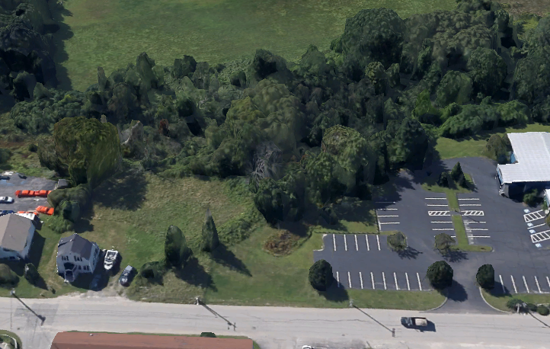
Figure 6: 72 Bishop Street, existing vegetation as seen from the north, with Gullivers Field at rear
- Landscaping and Landscape Preservation
The site is currently forested at rear around the Capisic Brook and associated wetlands (Figure 6). In the preliminary plans, the applicant proposes to preserve a considerable amount of this forested area, including existing vegetation on the eastern and southwestern sides of the site. As noted above, Mr. Tarling has requested that notes regarding protection measures be added to the plan. Planning staff have also requested that the applicant provide documentation as to the plan’s conformance with the landscape preservation standards of the site plan ordinance, which require that 30% of trees 10 inches DBH or greater within setbacks be preserved.

The applicant proposes evergreen plantings along the eastern property line in an effort to buffer the development from nearby single-family residential uses, which arose as an area of concern during the associated zone change request. The applicant has also proposed understory plantings at the rear of the building. The eastern and street-facing facades are proposed with maples, oaks, and cherry trees. Regarding the plant selection, Mr. Tarling has commented,

The landscape plant material selected for the UNE edge should be exclusively native plants to New England. Native plants like Red or White Spruce, Amelanchier, Hop- Hornbeam, Yellow Birch and American Mountain Ash would be preferable. Evergreen trees in this area should be a mix of 5-6', 4-5' trees. (note - the UNE property is already impacted by non-native species & invasive plants)

Staff has also commented on the location of the plantings, requesting that the applicant consider adding or relocating some of the understory plantings to the eastern side of the building, western side of the building, or to the Bishop Street frontage to improve the visual experience from the street. This request relates to the zoning requirement related to a continuous edge treatment. Mr. Tarling writes,

The project currently is wide open visually on the Bishop Street side near the Deering Lodge. Landscape buffering is recommended. This can be on the narrow strip of project land or on Deering Lodge property by agreement. Larger shade trees would be ideal. Planting trees along or within the Bishop Street right of way would be acceptable as well. This would also be a landscape condition.
Also related to the edge treatment along Bishop Street, the applicant has requested a waiver from the street tree provisions of the ordinance, which require that a proposal include street trees at a ratio of one per unit planted in the right-of-way at 30 – 45 feet on center. The site plan ordinance includes language which allows the planting of street trees in the front yard within 10 feet of the property line in cases when site constraints prevent planting in the right-of-way. One of the applicant’s trees falls within this range. Staff has requested that the applicant add a street tree to the west of the driveway entrance within 10 feet. Contributions to the tree fund for the remaining trees will be required.

Staff has also requested that the applicant provide details for the fences and guardrail proposed around the rear parking area.

- Water Quality/Storm Water Management/Erosion Control
The applicant has submitted a stormwater management narrative by Ransom Consulting which describes the plan to treat the stormwater from 17,000 SF of additional impervious surface through the use of paver drain and filtered roof drain systems, both of which would outlet to R-Tanks for storage. These systems would be supplemented by a drain along the western edge of the site. Each of these systems would outlet near the wetlands at rear. Mr. Senus has reviewed the narrative and the associated stormwater plans and has provided the following comments,

In accordance with Section 5 of the City of Portland Technical Manual, a Level III development project is required to submit a stormwater management plan pursuant to the regulations of MaineDEP Chapter 500 Stormwater Management Rules, including conformance with the Basic, General, and Flooding Standards. We offer the following comments:
  - General Standards: The project will result in a net increase in impervious area of approximately 17,382 square feet. As such, the project is required to include stormwater management features for stormwater quality control. The following comments should be addressed:
    - From the HydroCAD model, it appears that the Applicant has proposed to treat a sufficient amount of impervious area with a paver drain system and filter cartridges for roof runoff; however, the area proposed to receive treatment should be identified on a plan and tabulated/calculated to show compliance with the General Standards (95% of new impervious area treated, 80% of new developed area treated).
    - Documentation/calculations should be provided to demonstrate that the proposed porous pavers have been adequately designed per Chapter 7.7 of Volume III of the MaineDEP Stormwater BMP Manual to provide the necessary level of treatment.
    - Details and pollutant removal data should be provided for the proposed filter cartridges and the plans should indicate whether the treatment unit will be located internal to the building; at this time, no provisions for the proposed filter cartridges have been included on the plans.
    - It appears that some roof drainage is directed to a crushed stone drip strip; the Applicant should clarify if this is the proposed treatment method for a portion of the roof runoff.
  - Flooding Standard: The project will result in a net increase in impervious area of approximately 17,382 square feet. As such, the project is required to include stormwater management features to control the rate of stormwater runoff from the site. The Applicant has provided a HydroCAD Report that indicates the peak rate of runoff from the proposed development will not exceed that from existing conditions; however, the following comments should be addressed:
    - It is unclear from the plans how the stormwater management system will be interconnected; it does not appear that the equalizing pipe connecting the two R-Tank systems is shown, and the method of discharging from the outlet control structure is unclear. It is also unclear how the roof drainage crushed stone drip strip will connect to the R-Tank system. Proposed storm drain piping should be clearly labeled with size, material, slopes, and invert elevations and more detail should be provided on the interconnections between the various stormwater management systems on the site.
- The Bishop Street Stormwater Management Narrative prepared by Ransom Consulting, Inc., dated April 10, 2015, refers to Appendices A and B, which include a Post-Construction Stormwater Management Plan and Stormwater BMP Inspection and Maintenance Requirements; however, it does not appear that these appendices have been received at this time. The Stormwater Management Plan should include a stormwater inspection and maintenance plan developed in accordance with and in reference to Manufacturer recommendations for the proposed filter cartridges, MaineDEP Stormwater BMP Manual Maintenance Criteria for Manmade Pervious Surfaces, manufacturer specific requirements for the R-Tanks, and Chapter 32 of the City of Portland Code of Ordinances.
- The R-Tank system does not appear to be lined with a watertight liner. The paver/tank/retaining wall section on L9 proposes a system that would likely not hold or retain water, instead, drainage may daylight through or below the wall system. Additional design detail is necessary to address drainage and water storage behind the retaining wall structure.
- It appears that the Applicant is proposing to daylight the outlet of the Outlet Control Structure. Outlet protection measures should be provided at the discharge location. The Applicant should also clarify whether the proposed J-drain will daylight adjacent to the Outlet Control Structure, or if it is intended to connect to the Outlet Control Structure. The plans should be clarified in this area.
- The Applicant has proposed an NDS 12-inch Square Shallow Catchbasin with flat grate for use as a field inlet; the Applicant should consider utilizing beehive grates for proposed field inlets.

Mr. Senus has also noted that the Capisic Brook qualifies as an urban impaired stream. He writes,

The project is located within the Capisic Brook Watershed, which is identified as an Urban Impaired Stream by the Maine DEP. Section 5 of the City of Portland Technical Manual requires that all development within the Capisic Brook watershed, except single and two family homes, comply with the Urban Impaired Stream Standard pursuant to MaineDEP Chapter 500 Rules. To meet the Urban Impaired Stream Standard, the Applicant must either pay an in-lieu compensation fee or mitigate project impacts by treating, reducing, or eliminating an off-site or on-site pre-development impervious stormwater source. The Applicant has noted that the project will adhere to the Urban Impaired Stream Standard for development; however, it is unclear how the Applicant is proposing to meet the Standard. The Applicant should provide calculations of the in-lieu fee compensation amount or identify mitigation measures in accordance with the Urban Impaired Stream Standard.

On the matter of discharging in to an Urban Impaired Stream, Mr. Margolis-Pineo adds,

All catchbasins capturing stormwater discharging into an urban impaired watershed, the applicant is requested to install four foot diameter catchbasins with three foot sumps.

It should be noted that the applicant has proposed a retaining wall, at some points over 6 feet in height, at the southern and eastern sides of the parking area adjacent to the proposed porous paver strip. This wall will require its own building permit. Mr. Senus also notes,

The Applicant has proposed a porous paver strip along the proposed retaining wall, which exceeds five feet in height. A geotechnical report has been provided that specifies the parameters for the wall design engineer; however, at this time, the geotechnical report does not appear to include an evaluation of the impact of the porous pavement and associated R-Tank storage system on the wall design. The Applicant should clarify whether infiltration from the porous pavers adjacent to the proposed retaining wall and the adjacent, below grade stormwater storage has been evaluated/considered by the geotechnical engineer.

Mr. Margolis-Pineo adds,

The grading plan needs to show the existing stormwater drainage system including drain manholes adjacent and on the applicant’s property. Show all field inlets, rim elevation, pipe size and pipe invert elevations.

3. Public Infrastructure and Community Safety Standards
- Consistency with Related Master Plans
As noted above, the project is generally deemed consistent with related master plans, especially those plans addressing the need for affordable housing. Housing: Sustaining Portland’s Future highlights the need for supportive housing with a goal particularly targeted towards this housing type. The housing plan recommends that the city should “[e]ncourage proposals from developers that will transition homeless families and individuals out of emergency shelters and transitional facilities into permanent housing, including single room occupancy (SRO) units.” In addition, the report of the city’s Homelessness Prevention Task Force, issued in November 2012, includes recommendations designed to address the city’s issues with homelessness, many of which apply here. Among these, the report recommends “a focus on providing appropriate permanent housing and support in the community for individuals, families, and youth as quickly as possible…Meeting this goal will…require constructing three new housing first units consisting of 35 units each and appropriate supports for people who are chronically homeless (4).”

- Public Safety and Fire Prevention
At prior meetings related to the related zone change request, responding to neighborhood concerns, board members requested that the applicant provide information related to the potential security and safety impacts of the proposed development. Board members asked explicitly for police department data related to security around Avesta’s existing Housing First developments. The applicant provided a testimonial from Vernon Malloch of the Portland Police Department regarding Logan Place, stating that “Logan Place has successfully served as a tested model with no significant impact on the surrounding neighborhood” (Attachment S), but the board stressed the importance of additional information.

In response, the Portland Police Department provided an analysis of calls for service at Logan Place between 2005 and 2014 (Attachment T). The analysis includes explanations of the number of calls of various types, including, most prominently, refusing to leave/bothering and behavioral complaints. The memo also addresses drug-, assault-, and weapons-related calls, noting that many of these involved false alarms or repeat violators. The memo states that “few calls [at Logan Place] resulted in police reports or arrests. None of the [calls for service] were for serious crime types,” and concludes that “[w]e can anticipate an increase in police calls for service with development of any otherwise vacant parcel. Housing of the chronically homeless as takes place at Logan Place further increases the likelihood of an increase. Data review suggests there has been no negative impact on the neighborhood from a public safety standpoint. Other reports and studies have shown the population targeted for housing in this model draw significantly more police resources when they are homeless.”

Given the concerns about public safety and security on site, the applicant has generally made efforts to use site design to balance issues regarding natural surveillance and visual impacts to adjacent residential properties, which tend to conflict. In the revised submittal, the applicant should provide additional information related to surveillance of concrete paver seating area at rear, a portion of the site which is not immediately visible from the street or parking area.

With respect to fire prevention, the applicant proposes to provide 6” water service from Bishop Street for the building’s internal sprinkler system. An existing hydrant is located just to the east of the site entrance. Keith Gautreau, of the city’s Fire Prevention Bureau, has reviewed the plans and provided comments requesting fire lane signs and several additional plan notes (Attachment 5). The applicant should address these comments in the final submittal.

- Availability and Capacity of Public Utilities
The applicant has proposed to bring water for both fire suppression and domestic service from a 12” water main in Bishop Street. Sewer will be serviced from an existing 8” line in Bishop Street and natural gas will be supplied from an existing 8” line in Bishop Street. Electrical, telephone, and cable service is proposed from either a pole directly north of the property on the south side of Bishop Street or from a pole to the west. The second of these options would require an easement from the Masonic Lodge. In the final plan set, the applicant should confirm the plan for electrical service, include accommodations for an easement as necessary, and note that electrical/communications service will be underground in accordance with the site plan standards.

Regarding water and sewer capacity, Mr. Senus writes,

The Applicant has requested letters from utilities confirming capacity to serve the proposed development. The Portland Water District confirmed ability to serve the proposed development, but noted that approval of plans will be required prior to construction. A letter documenting approval of the proposed project from the Portland Water District and a letter confirming ability to serve sanitary sewer for the proposed development should be forwarded upon receipt.

4. Site Design Standards
- Massing, Ventilation, and Wind Impact
No comments at this time.

- Shadows
No comments at this time.

- Snow and Ice Loading
The applicant has indicated in their preliminary submittal that they will contract with a private plow company to maintain the driveway and sidewalk in the event of snow. Snow storage is depicted at the southwest edge of the parking lot in the plans. The applicant has stated explicitly that snow will not be placed in the adjacent wetland.

- View Corridors
There are no comments at this time.
- Historic Resources
There are no comments at this time.

- Exterior Lighting
The applicant has provided a cut sheet for a pole-mounted parking area light which depicts a full cutoff fixture. A photometric plan should be submitted at the time of final review. This lighting plan should be sensitive to concerns voiced previously from neighbors to the east regarding light trespass.

- Noise and Vibration
Information on the location of HVAC vents and mechanical equipment should be provided with the final plans.

- Signage and Wayfinding
No signage or wayfinding is proposed at this time.

- Zoning-Related Design Standards
Planning staff reviewed the plans for conformance with the multi-family design standards (Design Manual, Section (i)). Caitlin Cameron, the city’s urban designer, documented the findings of the review, writing,

Standard 1 – The surrounding context tends to be more commercial in use and character. Additionally, the neighboring residential context is most often single-family or other small-scale buildings. Therefore, the multi-family, large-scale building proposed is not the same type of residential project and is therefore not able to have the same character. The project uses a mix of building materials that, in combination with the fenestration, projections, and the varying forms and roof lines, provide positive visual interest as stipulated in the Standard. Staff would like to see the “bay” elements extended to the ground level which currently have an awkward relationship to the façade as floating elements.

Standard 2 – A building in a B-2 zone should contribute to the street wall. However, this property has an usual lot configuration and very little frontage. As such, it is understandably difficult to build to the street. The principal entry is relatively close to the street and provides good visibility.

Standard 3 – The project provides a garden space and screening and landscaping elements as required by the Standard.

Standard 4 – Overall the project has a high level of fenestration to provide resident access to light and air. Storage is provided.

Standard 5 – Parking is well screened and positioned away from the street. However, more detail is requested regarding the height and material of fences around the property – visual and sound screening is desirable between the parking and neighboring property as well as between the outdoor seating area and neighboring property. What will be the landscape treatment at the Northeast face of the building?

Standard 6 – Not Applicable

XIII. NEXT STEPS
- Address staff comments;
- Address additional comments of the Planning Board;
- Prepare final plan submission, including subdivision and site plan submittal requirements as included in 14-496(a) and (b) and 14-527(e) and (f) for review by the Planning Authority and Planning Board; and
- Hold final Planning Board Hearing.

ATTACHMENTS
Planning Board Report Attachments
- Traffic Engineer review (memo from Thomas Errico, 5/13/15)
- Department of Public Services review (memo from David Margolis-Pineo, 5/12/15)
- Civil Engineer review (memo from David Senus, 5/11/15)
- City Arborist review (memo from Jeff Tarling, 5/12/15)
- Fire Prevention Bureau review (memo from Keith Gautreau, 4/27/15)
- Design review (memo from Caitlin Cameron, 4/29/15)

Applicant’s Submittals
- Cover Letter (from Bob Metcalf, Mitchell Associates, 4/10/15)
- Development Review Application, Project Data, and Checklist
- Right, Title, or Interest
- Project Description, Project Data, and Maps
- Abutting Property Owners
- Existing Soils Condition
- Public Utilities
- Technical Capability, Financial Capability, and Letter of Authorization
- Compliance with Applicable Zoning
- Waiver Request
- Consistency with City’s Master Plan and Conformity with Design Standards
- Fire Department Checklist and HVAC Emissions Requirements
- Traffic and Parking Study
- Stormwater Management Plan
- Solid Waste Disposal and Snow Removal
- Light Fixtures
- Construction Management Plan
- Natural Features
- Letter from PDD
- PDD Calls for Service Analysis

PLANS
- Existing Conditions Plan
- Boundary & Topographic Survey
- Layout and Lighting Plan
- Grading, Drainage, and Utilities Plan
- Planting Plan
- Site Details
- Site Details
- Bishop Street Sidewalk Plan
- Erosion & Sedimentation Control Plan
- Stormwater Details
- Pre-Development Stormwater Plan
- Post-Development Stormwater Plan
- First Floor Plan
- Second Floor Plan
- Third Floor Plan
- Roof Plan
- Exterior Elevations

