IMPORTANT NOTICE FROM THE CITY OF PORTLAND PLANNING DIVISION
TO RESIDENTS AND PROPERTY OWNERS IN THE VICINITY OF
34 to 116 Bishop Street
Bishop Street – B-2c and R-5 Zoning Map Amendments; Avesta Housing, Applicant
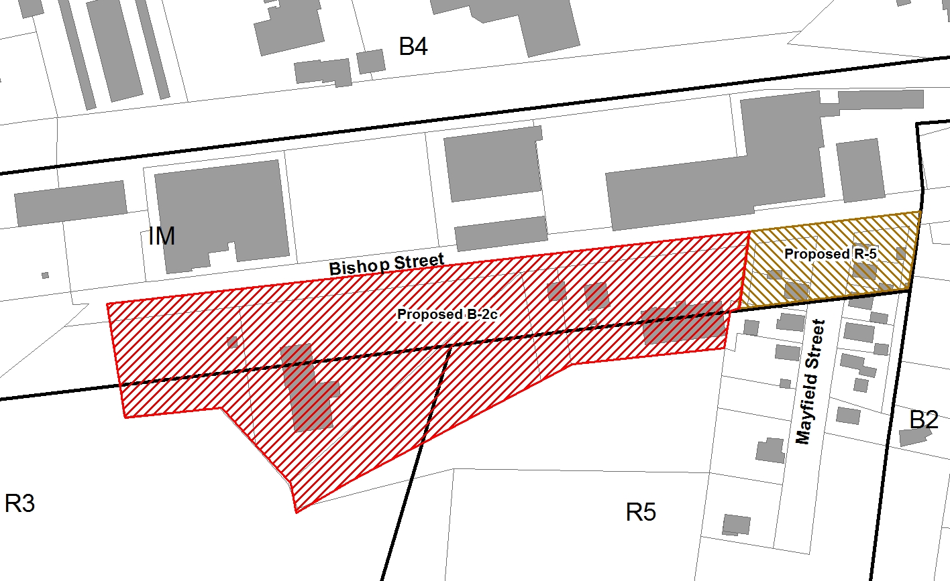
The Planning Board will consider a zoning map amendment to rezone a series of five parcels on the south side of Bishop Street (from 50 to 116 Bishop Street) from Moderate Impact Industrial (IM), Residential (R-3), and Residential (R-5) to Community Business (B-2c). Another six parcels at the intersection of Mayfield Street and Bishop Street (34 Bishop Street and 6 to 11 Mayfield Street) are being considered for rezoning from Moderate Impact Industrial (IM) to Residential (R-5). The proposed map amendments are shown below. The zone change would allow Avesta Housing, the applicant, to develop 30 efficiency apartments at the property at 72 Bishop Street. The public hearing is an opportunity for the applicant to present a plan to the Planning Board in a formal session which is open to the public. Public comments will be taken at this meeting.

WHEN: Tuesday, October 14, 2014
7:00 p.m.
Room 209, 2nd Floor

FOR MORE INFORMATION:
Plans are available in the Portland Planning Division, 4th Floor, City Hall. If you wish to submit written comments, address them to Nell Donaldson, Planner, Planning Division, 4th Floor, 389 Congress Street, Portland, Maine 04101; by phone at (207) 874-8723or e-mail at HCD@portlandmaine.gov To access agenda materials on-line, please visit the following web address on or after the Friday proceeding the meeting date: http://www.portlandmaine.gov/AgendaCenter/

