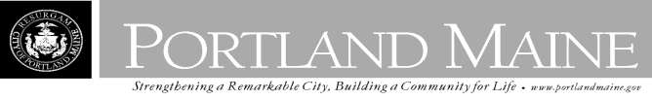
Director of Planning and Urban Development
Jeff Levine

July 30, 2013

1336 FOREST AVE ASSOCIATES
51-A BURNHAM ST PORTLAND, ME 04102

Inspection Services, Director
Tammy M. Munson

CBL: 292 D001001
Located at: 1336 FOREST AVE
Hand Delivery

Dear Mr. Winslow,

POSTING NOTICE

An evaluation of the above-referenced property on 07/30/2013,
revealed that the structure fails to

comply with Section 6-120.1 of the Housing Code of the City of Portland.

Pursuant to Section 6-120.3 (a) & (b), this office declares the dwelling unit is unfit for human habitation. The dwelling and premises at which time the dwelling unit must be totally vacated and secured from vandalism.

Failure to comply will result in this office referring the matter to the City of Portland Corporation Counsel for legal action and possible civil penalties, as provided for in Section 1-15 of the Code in Title 30-A of M.R.S.A ss 4452.

This constitutes an appealable decision pursuant to Section 6-127 of the Code. Please feel free to contact me if you have any questions or would like to discuss this matter further.

Sincerely,

Chuck Fagone
Code Enforcement Officer
(207) 874-8789

