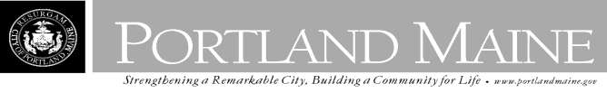
Director of Planning and Urban Development
Jeff Levine

July 18, 2013

WHITE PAUL E JR
113 WARWICK ST PORTLAND, ME 04103

Inspection Services, Director
Tammy M. Munson

CBL: 275 I022001
Located at: 113 WARWICK ST
Certified Mail 7012 0470 0002 1928 5242

Dear Mr. White,

An evaluation of the above-referenced property on
07/17/2013
revealed that the premises fails to

comply with Section 12.79 of the Junk Motor Vehicle Ordinance of the City of Portland. Attached is a list of the vehicles in violation and the Junk Motor Vehicle Ordinance.
This is a Notice of Violation pursuant to Section 12.79 of the Code. All referenced violations shall

be corrected within 30 days of the date of this notice.

A reinspection will occur on 8/16/2013 at which time compliance will be required. Failure to comply will result in this office referring the matter to the City of Portland Corporation Counsel for legal action and possible civil penalties, as provided for in Section 1-15 of the Code and in Title 30-A M.R.S.A. Section 4452. This is an appealable decision pursuant to Section 12.80 of the Municipal Code.

Please feel free to contact me if you wish to discuss this matter, or if you have any questions. Sincerely,

Chuck Fagone
Code Enforcement Officer
(207) 874-8789

