Portland Fire Department,

This letter is in regards to the Ansul R-102 system that was installed at the Egg & I in Portland located at
155 Riverside Street. The system is UL-300 Compliant and conforms to all NFPA 17A requirements. I have attached to the email a copy of our full system inspection report for your records as well. If you have any questions feel free to reach out to me directly.

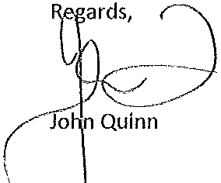

John Quinn I Operations Manager I Cintas Fire Protection
3 Tallwood Drive I Bow NH 03304
I 0. 603.717.7300 I Cell- 603-.300-.23471 F. 603.717.7303 I

(formerly All State Fire Equipment)
3 Tallwood Drtve, Unit 3, Bow, NH 03304
Phone(603) 717 7300 * Fax(603) 717-7303
MA·CR4628
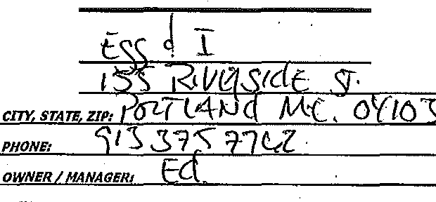oAT£• -3 t 1 () nME:_ _:::Z:_o_a

Pre-Engineered
Kitchen SVstem Inspection Report
A0 lYPE: INSPECTION / RECHARG NOVATION

CUSTOMER: /lAKE IMODEL: A ?'tS'VLL rL (. Cyt_
CYLINDER LASTHTDATE: L0 t z

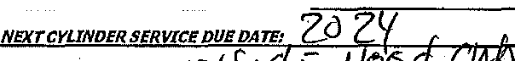ADDRESS:
----

DESCRIPTION

'.E,$..
...

C Yll ND £ R L O rn oll L· c1'

0 N DESCRIPTION YES NO

1. SYSTEM TIED INTO ARE AlARM
2, ALL TAMPER SEALS INTACT
K,C NDER(S) PRESSURE
,;...-,- CK PlACE CARTRIDGE (circle one)

3.CORRECT NOZZLE COVERAGE ,
4.HOOD & DUCT PROPERLY SEA LED I CLEANED ,
17":C'HECK MANUAL PULL STATION /
18. EXHAUST FAN(S) OPERATING /
,

5.OPERATION OF omcnoN UNE
6. CYLINDER RELEASE MECHANIS
19.FAN WARNING SIGN VISIBLE /
"' 20, HOOD FILTERS COMPLIANT

8.NOZZLES CLEANED QTYZQ_ R EPLACED
/,.

22,SYSTEM OPERATIONAL & ARMED
...
,.,

10. NOZZLE CAPS REPlACED QTY_(M)_(R)

12. CHECKED GAS VALVE-. (MECH.) _(ELECT,)
, / 24. EX11NGUISHERS INSPECTED ....

26. POSI·SET ON WHEELED EQUIPMENT /

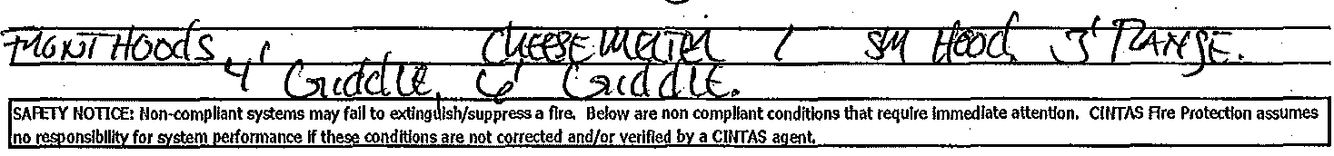14. CYLINDER(S) MOUNTS SECURE 28. QTY. OF FUSIBLE LINKS: 360A s4SOA SOOA

EQUJPMENT{Iefttorlght): '3lf
r&Ktlhdd :.J £,

COMMENTSINON·COMPUANCE (see notes below}: ( } PRE UL·300 COVERAGES APPLY

1

2

3 MATERIAL COST lTiiM 1: LABOR COST nEM 1; MATJ!RIAL COST ITEM 21 lABOR COST ITEM 1; MATERIAL COST ITEM 3: lABOR COST ITEM 1:

Total on site quote:$----- _I accept quoted price please schedule service work to be completed.

Idecline quoted price and take full responslblllty for non-compliance Issues.
M ­

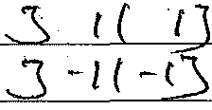CINTAS Fire Protection Agent: Date:

cu.tomer'sAuthorl•ed Agent:'C., c ...:::J
<
\J \:::' D,_s\
Printed Agent's Namei_ ·-·.='C....D:::> =< "='"'-"" ""'·"-'"- """'--=-------

Date:

This report may be required to be foiWarded to your current Insurance provider and/or authority having julisdlction.

