July 24th, 2015

David Latulippe, Manager
Portland Property Holdings, LLC
2 Main Street
Topsham, ME 04086

Project Name: Request for approval to advance site work for the Commercial Development including gas station and convenience store with ATM
Project ID: #2013-086 and #2014-138
CBL: 237-A-012
Address: 2282 Congress Street
Applicant: C J Developers, Inc. and Portland Property Holdings, LLC
Planner: Jean Fraser

Dear David:

Thank you for your letter dated July 12th, 2014 requesting approval to undertake advance site work prior to the receipt of a building permit (copy attached).

On May 14th, 2013, the Portland Planning Board approved with conditions a proposal to construct a commercial development that includes a 3,850 sq. ft. convenience store with an ATM and fuel station (14 filling dispensers plus a future compressed natural gas pump and electric recharging stations), a small farmstand associated with the convenience store, and 26 parking spaces. An amendment application that altered the layout, landscape and stormwater system was approved on November 12th, 2015 and all of the relevant conditions of that approval (copy attached) have been met.

As provided in Section 14-532, this letter serves as the written permission from the Planning Authority to commence site work on this project prior to the issuance of a building permit. The permitted advance site work is limited to the Extent of Work listed below with associated conditions.

Please note that prior to the commencement of any work on site (including tree cutting) the following shall be completed:

- A satisfactory Performance Guarantee shall be posted;
- The Inspection Fee shall be paid;
- The Preconstruction meeting (to include Phil diPierro and Jeff Tarling) shall be held to confirm the limits of work and that the conditions are being met;
- That any blasting be done in accordance with the City's Blasting ordinance, which requires a permit from Fire Department;
- That the number and timing of trucks per day accessing the site during the period of advance site work be advised to the Planning Authority and DPS at least one week in advance, and that traffic control measures be incorporated based on their advice;
- That all requirements related to the Amended Stormwater Management Report (prepared by FST and dated April 2013, updated July 2014), the Long Creek Watershed District standards/requirements, and MDEP Stormwater Discharge approval (and any other relevant permits) shall be met;
- That the contractor is aware of the City’s Ordinances regarding construction activities and hours of work, and the associated Department of Public Services waiver request form re hours of work.

Extent of Work:

- Clearance of the site and Grub, stump and strip a service road, subject to the clearance of trees being only within the existing access area (where there are no existing trees), within the boundaries of the project’s proposed impervious surfaces and in compliance with the approved landscape plan. The “limit of clearance work” shall be clearly marked on the site with construction tape or snow fencing to identify treesaves and trees to be protected during construction (from storage of vehicles or materials), and reviewed by Phil diPierro and Jeff Tarling prior to the start of any site work including the cutting of any trees.
- Fill the southern portion of the site.
- Blasting and cuts and fills in accordance with all requirements of the City’s Blasting Ordinance (attached).

- Installation of the following as per the approved plans:
- Erosion and sedimentation control;
- Site Utilities;
- Stormwater Management system.

Please note that you must obtain any permits that may be required from Public Works for any street openings, and that building permits must be obtained from the Inspections Division prior to the commencement of any construction of any buildings, foundations or structures.

The pre-construction meeting shall be held at the project site with the contractor, development review coordinator, Pubic Service Department representative, City Arborist and owner to review the traffic management measures, erosion and sedimentation controls, and other critical aspects of the work. Please contact Philip DiPierro, Development Review Coordinator at 874-8632 regarding the preconstruction meeting.

If you have any questions, please contact Jean Fraser on 874 8728.

Sincerely,

Jeff Levine, AICP
Director of Planning and Urban Development

Attachments:
- Request letter from David Latulippe, dated July 12th, 2015;
- Site plan approval letter (amendment) 2014
- Blasting ordinance

cc: Steve Bushey and Bo Kennedy, FST (Engineers for applicant)

Electronic cc:
Jeff Levine, AICP, Director of Planning and Urban Development  Barbara Barhydt, Development Review Services Manager  Jean Fraser, Planner  Philip DiPierro, Development Review Coordinator, Planning  Ann Machado, Zoning Administrator, Inspections Division  Tammy Munson, Inspection Division Director  Lannie Dobson, Administration, Inspections Division  Michael Bobinsky, Public Services Director  Katherine Earley, Engineering Services Manager, Public Services  Bill Clark, Project Engineer, Public Services  David Margolis-Pineo, Deputy City Engineer, Public Services  Doug Roncarati, Stormwater Coordinator, Public Services  Greg Vining, Associate Engineer, Public Services | Michelle Sweeney, Associate Engineer  John Low, Associate Engineer, Public Services  Rhonda Zazzara, Field Inspection Coordinator, Public Services  Mike Farmer, Project Engineer, Public Services  Jane Ward, Administration, Public Services  Jeff Tarling, City Arborist, Public Services  Jeremiah Bartlett, Public Services  Keith Gautreau, Fire Department  Danielle West-Chuhta, Corporation Counsel  Thomas Errico, P.E., TY Lin Associates  David Senus, P.E., Woodard and Curran  Rick Blackburn, Assessor’s Department  Approval Letter File

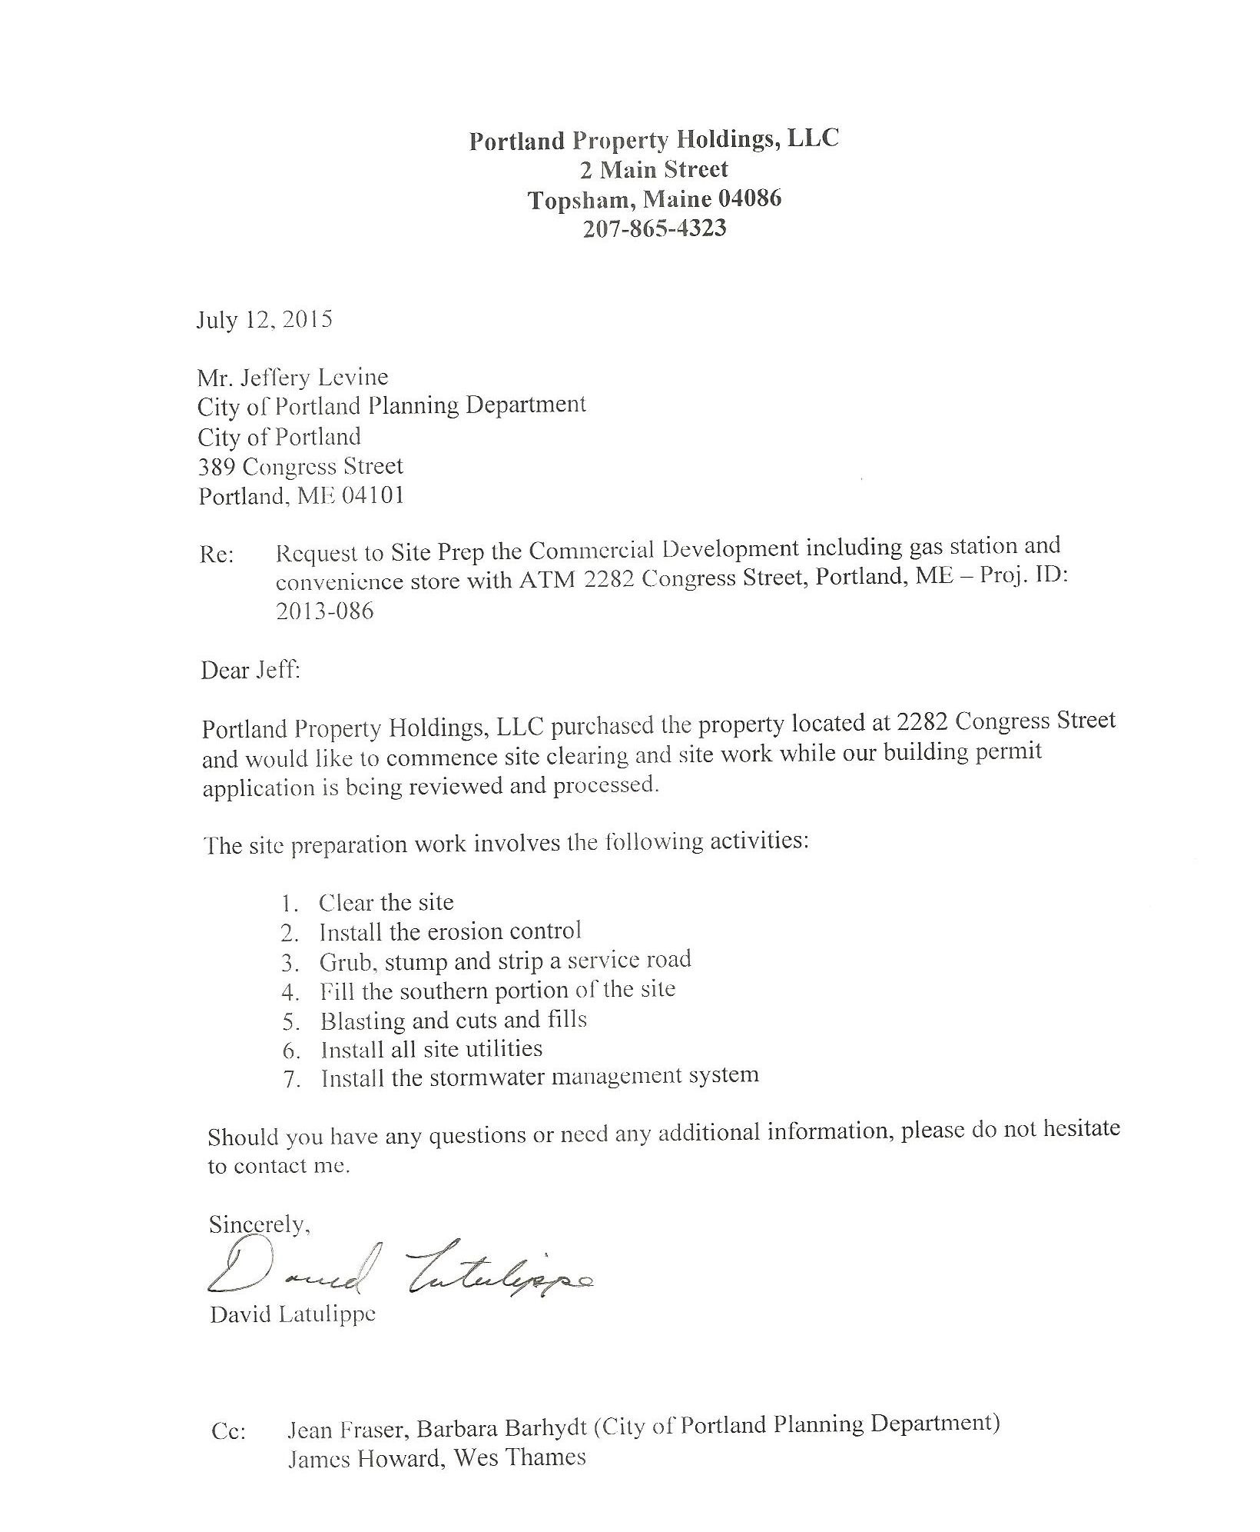
Attachment 1

