AMENDMENT TO CITY CODE
SEC. 14-49 (ZONING TEXT AND MAP AMENDMENT)
RE: CONDITIONAL REZONING FOR PROPERTY
IN THE VICINITY OF 2282 CONGRERSS STREET

ORDERED, that the zoning map and text of the City of Portland, dated December 2000, as amended and on file in the Department of Planning & Development, and incorporated by reference into the Zoning Ordinance by Sec. 14-49 of the Portland City Code, is hereby amended to reflect a conditional rezoning as detailed below.
CONDITIONAL REZONING AGREEMENT
AGREEMENT made this ______ day of ________________, 2013 by CJ DEVELOPERS, INC. of Cumberland County (“CJD”) with a place of business in 35 Primrose Lane, Freeport, Maine, and its successors and assigns.

WITNESSETH:
WHEREAS, CJD is or will be the owner of the property located at 2282 Congress Street, Portland, Maine (The “Property”) more particularly described and shown on the Portland Assessors Map 237, Block A as Lot 12 and in a deed in the Cumberland County Registry of Deeds at Book , Page ; and,
WHEREAS, CJD did request a rezoning of the property located at 2282 Congress Street, in Portland, in order to permit the establishment and operation of a major auto service station, convenience store, restaurant (without a drive thru) and bank (with a drive thru) on 3.24 acres; and,
WHEREAS, in 1999 the City rezoned this property with a Contract Zone (C22) to allow a 4 story hotel development. That development did not proceed and the associated conditional agreement has expired.
WHEREAS, the Property is currently in the IM zone and is difficult to develop for an industrial use because of its limited size, MTA easements and wetland areas; and
WHEREAS, the Property is located in an unique and isolated location with the turnpike on one side, busy streets on two sides, and a developed lot on the other side, which together would limit the loss of industrial land and provide a convenient location for commercial uses to serve the adjoining industrial employment area; and
WHEREAS, the Planning Board of the City of Portland, pursuant to 30-A.M.R.S.A Sec.4352(8), and after notice and hearing and due deliberation thereon, recommended the rezoning of the property as aforesaid, subject, however, to certain conditions; and,
WHEREAS, the CITY by and through its City Council has determined that said rezoning would be pursuant to and consistent with the CITY’S comprehensive land use plan and consistent with the existing and permitted uses within the original zone; and
WHEREAS, the CITY has determined that because of the unusual nature of the proposed development it is necessary or appropriate to impose by agreement the following conditions or restrictions in order to insure that the rezoning is consistent with the CITY’s comprehensive land use plan.
WHEREAS, the City’s Comprehensive Plan seeks to “provide maximum mobility in a balanced transportation system, which encompasses all modes, to support the economic vitality and quality of life of the Portland community.”
WHEREAS, CJD has agreed to enter into this Agreement and the Amendment with its concomitant terms and conditions, which shall hereinafter bind CJD, its successors and assigns; and,
WHEREAS, the Portland City Council has on ___________________, 2013 approved this Agreement in its entirety, by City Council Order No. __________, a true copy of which is attached hereto as Attachment 1 (the “Order”);
NOW, THEREFORE, in consideration of the rezoning of the Property, CJD agrees to be bound by the following terms and conditions:
- The CITY shall amend the Zoning Map of the City of Portland, dated December 2000, as amended and on file in the Department of Planning and Urban Development, and incorporate by reference into the Zoning Ordinance by Sec. 14-49 of the Portland City Code, by adopting conditional IM zone amendment shown below;

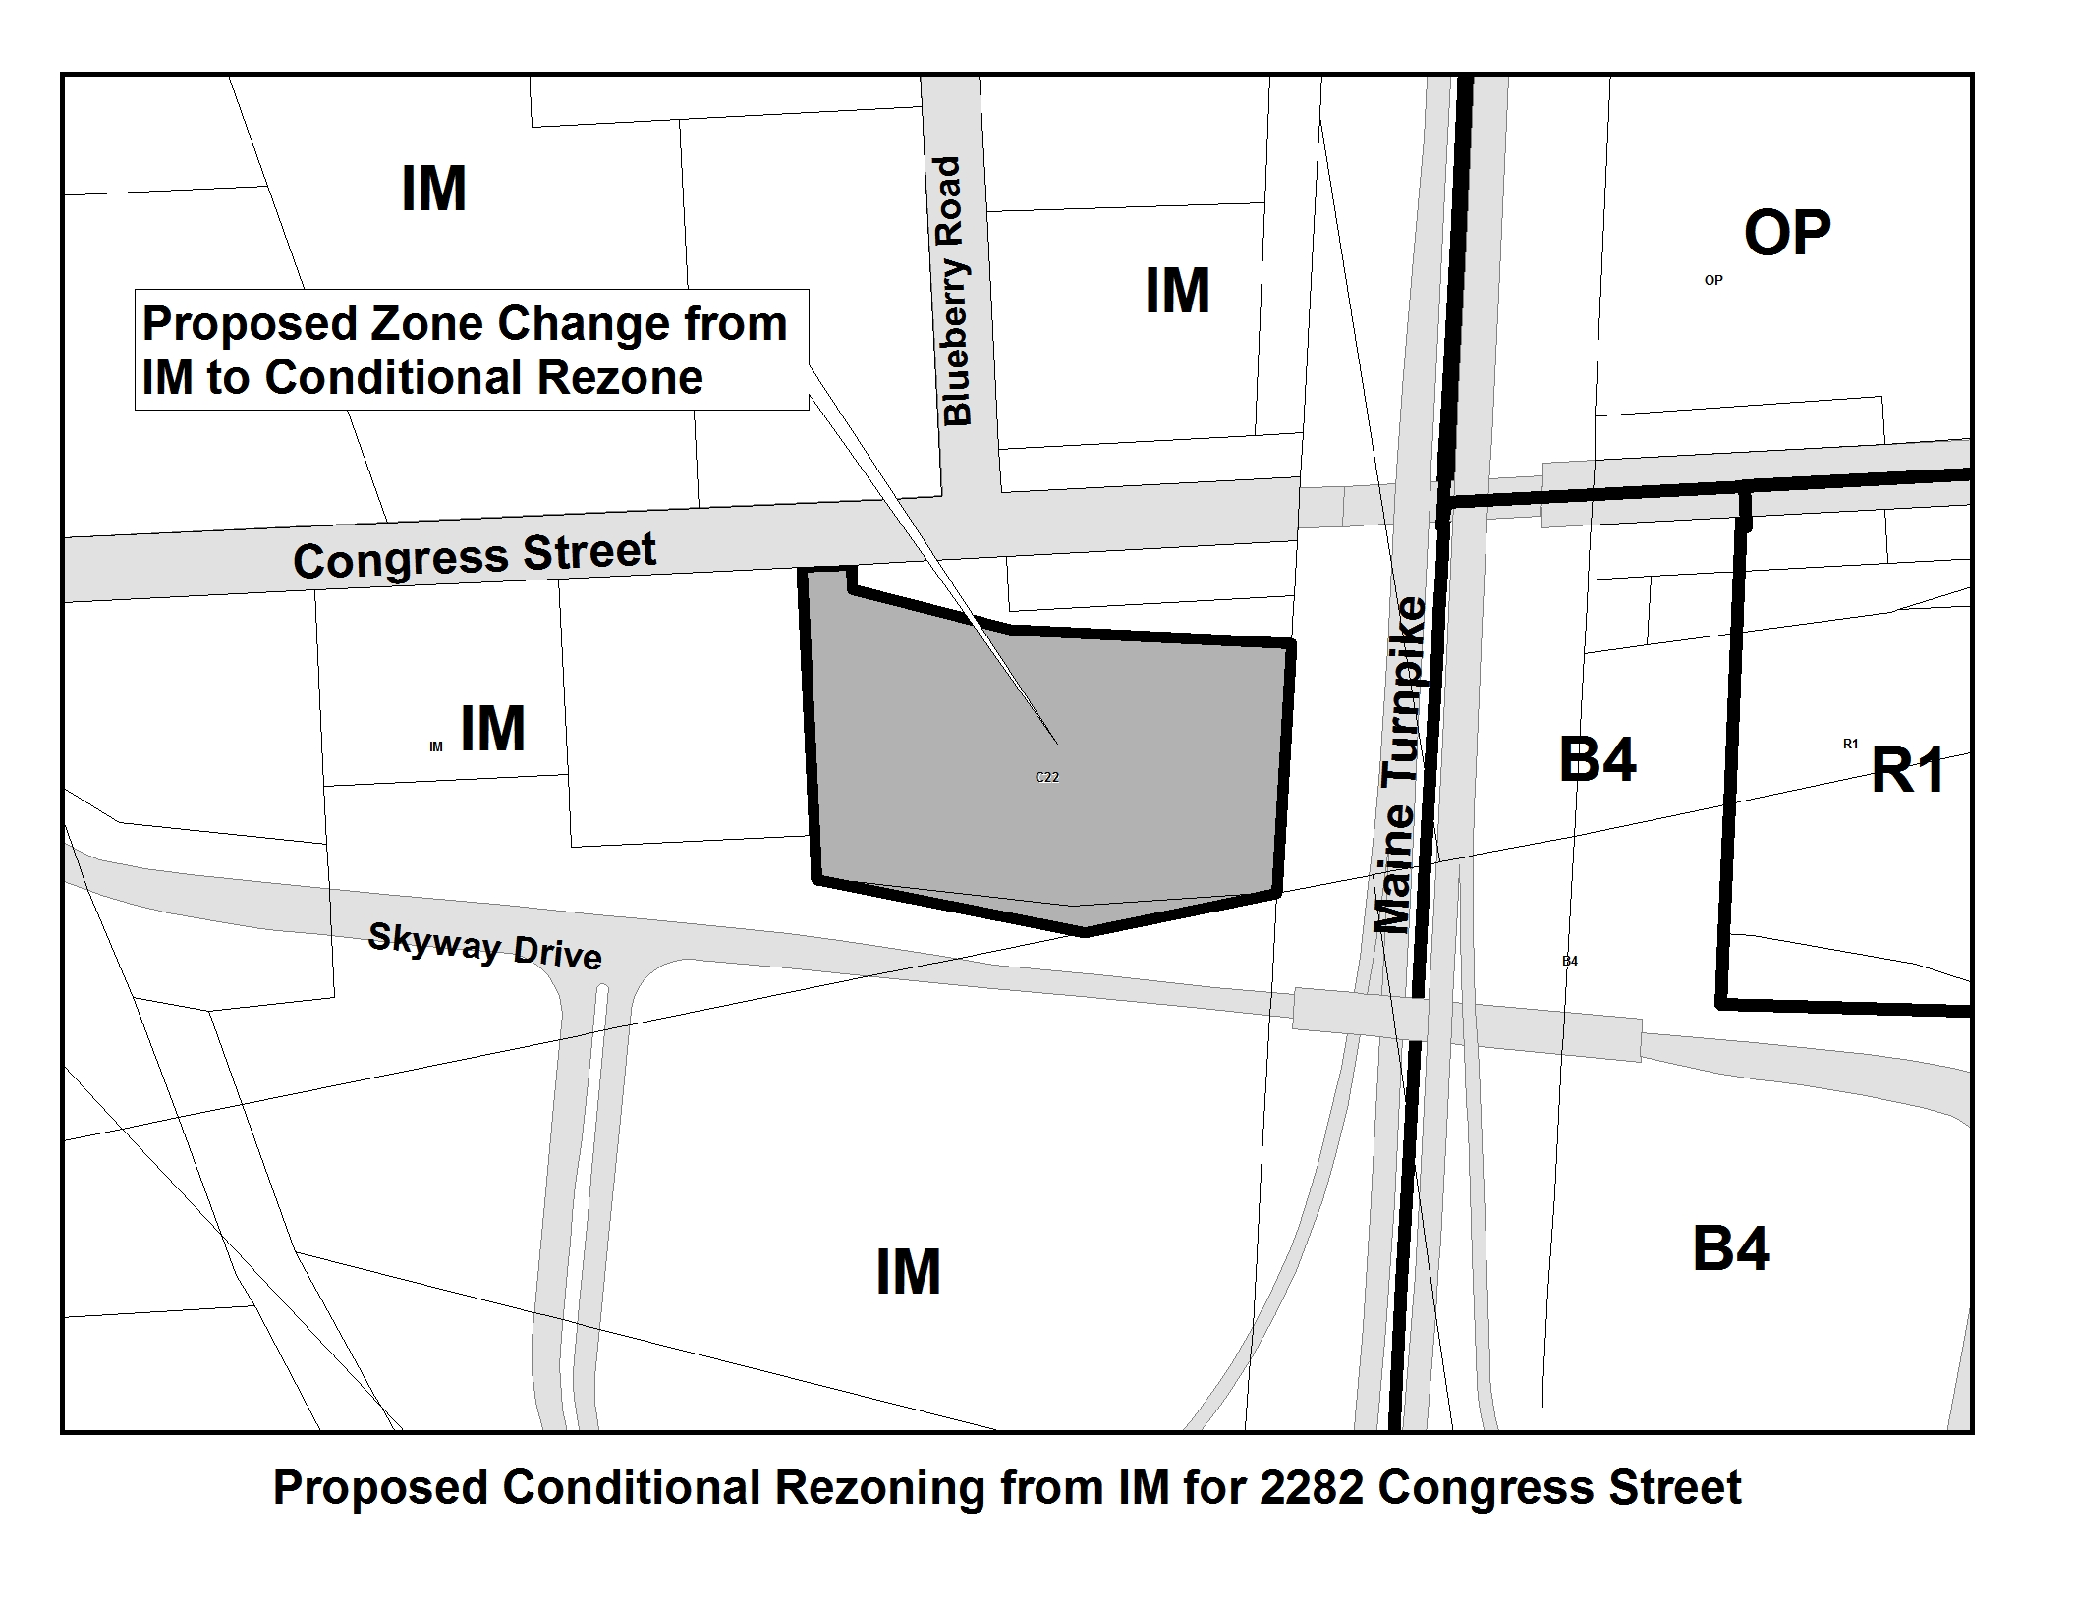

- The property shall be developed substantially in accordance with the conceptual site plan shown on Attachment 2. The site layout plan may be amended, modified or altered with the Portland Planning Board approval in connection with the site plan review process;

- Permitted uses: Those uses allowed in the IM zone. In addition, the Property shall be permitted to be used for the following uses:
- Major auto service station. Natural gas and electricity fuel shall be included in the fuels that the major auto service station is allowed to sell.
- Bank or ATM (with a drive through)
- Convenience Store (without a drive through)
- Restaurant (without a drive through)
- Planning Board Site Plan Approval: The major auto service station, convenience store/restaurant and bank project must obtain final site plan from the Portland Planning Board. Included within any application for such approval are the following requirements:

  - CJD shall submit a traffic study establishing its ability to meet all the traffic safety requirements to the satisfaction of the CITY’s Traffic Engineer, including information on integration of a possible future connection to Skyway Drive; and,

  - CJD shall submit a detailed site plan addressing the bank drive through and associated stacking capacity, landscaping, architecture and protection of pedestrians.

  - CJD shall include Landscape, Architectural and Lighting Plans that achieve a campus like character for the project.

- Community Contribution: shall install a new crosswalk on Congress Street from the project site to the sidewalk on the north side of Congress Street. The crosswalk shall include the following features:

- A pedestrian island in Congress Street. The island shall be raised and include granite curbing. The location, size (width and length) and material shall be determined by the City;

- Rectangle Rapid Flash Beacon warning lights. Three sets of the warnings lights shall be installed (on each side of Congress Street and in the median island);

- The crosswalk and all accessories shall be ADA complaint and include sidewalk ramps and connections to the existing sidewalk;

- Durable pavement markings and supplemental signs; and

- Drainage and pavement improvements, as required by the Planning Authority and/or the Department of Public Services.

This full combination of the above items is above and beyond the usual site plan requirement that would apply to this project for a striped crosswalk as shown in the Conceptual Site Plan in Attachment 2 Plan.

- The provisions of the Agreement, including the permitted major auto service station, restaurant and bank uses, are intended to be supplemental to the uses and requirements of the underlying I-M zone. The project must still adhere to all applicable dimensional requirements, other requirements and performance standards of the IM zone and obtain separate permits for all signage.

- If a building permit has not been pulled within two (2) years of the date of this Agreement, the zone shall revert to I-M; provided that CJD may extend this Agreement by one (1) year at the discretion of the Director of Planning and Urban Development.

The above stated restrictions, provisions and conditions are an essential part of the rezoning, shall run with the subject premises, shall bind CJD, their heirs successors and assigns, as permitted by this Agreement, of said property or any part thereof or interest therein, and any party in possession or occupancy of said property or any part thereof, and shall inure to the benefit of and be enforceable by the CITY, by and through its duly authorized representatives.
If any of the restrictions, provisions, conditions, or portions thereof set forth herein is for any reason held invalid or unconstitutional by any Court of competent jurisdiction, such portion shall be deemed as a separate, distinct and independent provision and such determination shall not affect the validity of the remaining portion hereof.
Except as expressly modified herein, the use and occupancy of the subject premises shall be governed by and comply with the provisions of the Land Use Code of the City of Portland and any applicable amendments thereto or replacement thereof.
In the event that CJD, or any successor, fails to continue to utilize the property in accordance with this Agreement, or in the event of a breach of any condition(s) set forth in this Agreement, the Planning Board and/or the Court, pursuant to among other things, M.R. Civ. P. 80B, shall have the authority to resolve the issue resulting in the breach of this Agreement or the failure to operate. The resolution may include a recommendation to the City Council that the site be rezoned to I-M or any successor zone and that this Agreement be terminated, requiring a cessation of the major auto service station, restaurant and bank use.

WITNESS: CJ DEVELOPERS, INC.

_________________________ By: ______________________
David Latulippe
Its President
STATE OF MAINE
CUMBERLAND, ss. Date: __________________, 2013
Personally appeared the above named David Latulippe, and acknowledged the foregoing instrument to be his free act and deed of CJ Developers, Inc.
Before me,
_____________________________
Notary Public / Attorney at Law

Attachments:
- City Council Order No. 154-12/13
- CONCEPT 3 Plan dated 1.30.2013

