Applicant: Norris Inc.
App Phone #: 207-883-1104 x 1104
Building Name: Nephrology Associates z
Building Address: 1600 Congress St
Occupancy: Health Care
Assembly OL>300, 20 unit apartment building, etc.
Emergency Contact: Nephrology Assoc.
Emergency phone #: 207-774-5222
Date of Application: 2/21/12
Billing Address: 1600 Congress St, STE B
Portland, ME 04102
Comments:

Applicant completes red box and submits with Fire Alarm Permit
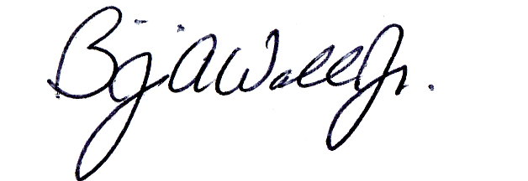Fire Prevention: Approved Denied
1
3 / 21 / 12 _____________________________________________
Date Fire Prevention Officer
Zone 1: Water flow Zone 2: City disconnect – Water Flow .
Zone 3: Pulls and detectors . Zone 4: City disconnect – Pulls and Detectors.
Zone 5: Unassigned Zone 6: Unassigned .
Zone 7: Unassigned Zone 8: AES Tamper switch . .
Modify City Box response to alarm sounding in CAD: YES NO .
2
Fire Alarm: Box #: ______ (discontinue existing supervised box number)
1279

Electrical Division: Approved Denied
Box Type: AES Radio Box / __________________
New Other
3
Test Date: _____/_____/_____ In Service Date: _____/_____/_____ __________________
Fire Alarm Technician
AES
Circuit if applicable:

Fire Alarm: Same Running Assignment As Box: _____
4
Notifications: All Stations Run Books Digitizer Computer Cad Box Test
South Portland ___________________________ ____________________________________
Other Dispatcher
5
Billing: Entered ____________________________________
Financial Officer

