Certificate of Occupancy
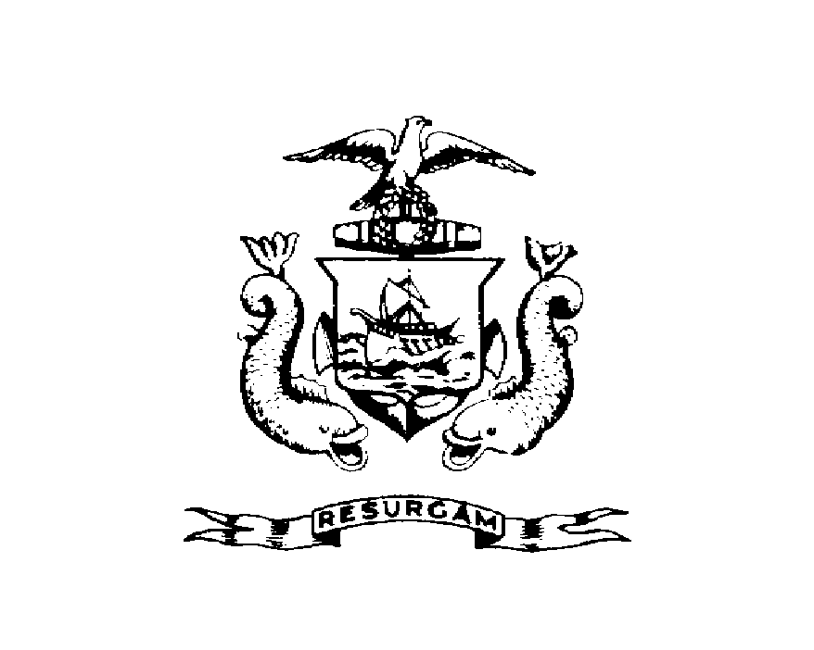
CITY OF PORTLAND, MAINE
Department of Planning and Urban Development Building Inspections Division

Location 1685 CONGRESS ST CBL 219 A013001
Issued to PORTLAND STROUDWATER ASSOCIATES LLC Date Issued September 30, 2011
This is to certify that the building, premises, or part thereof, at the above location, built-altered-changed as to use under Building Permit NO. 2011-06-1439, has had a final inspection, has been found to conform substantially to the requirements of the Building Code and the Land Use Code of the City of Portland, and is hereby approved for occupancy or use, limited or otherwise, as indicated below.
PORTION OF BUILDING OR PREMISES APPROVED OCCUPANCY
2nd Floor – V-Tech Use Group B
Type 5B – IBC 2009
Limiting Conditions:
Approved:
9-30-2011
(Date) Inspector Inspections Division Director
Notice: This certificate identifies the legal use of the building or premises, and ought to be transferred from owner to owner upon the sale of the property.

