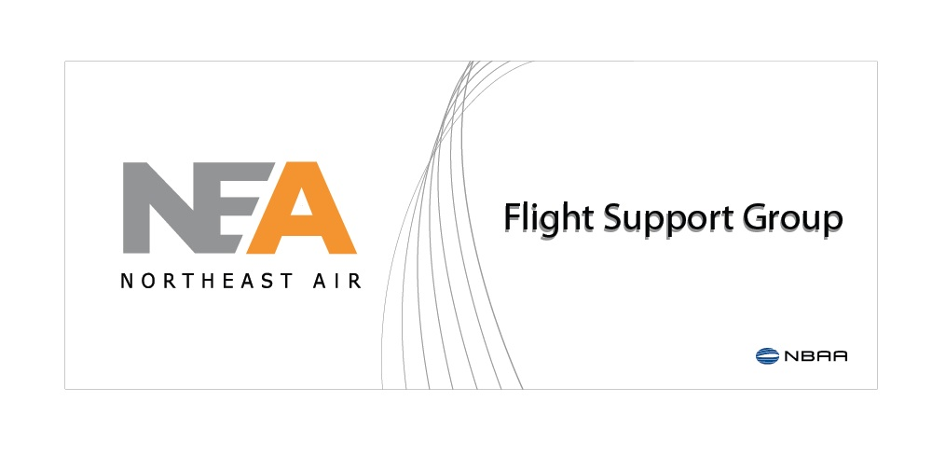

1011 Westbrook Street, Portland, Maine 04102

207-774-6318 • [www.northeastair.com](http://www.northeastair.com)

Ramp Sign – Installation Details

Metal “raceway” base to be constructed and channel letters will attach to race base. Raceway will be designed to include support around lettering to minimize any shifting during wind. Raceway will be bolted into canopy with ice/water shield membrane to cover. Electrical junction box with UL switch at top of canopy for final hook-up.

