**Turner Construction Company                                                                                             Week of 10/11/2010**

**Portland International Jetport Expansion Progress Report**

Viewed best in full screen

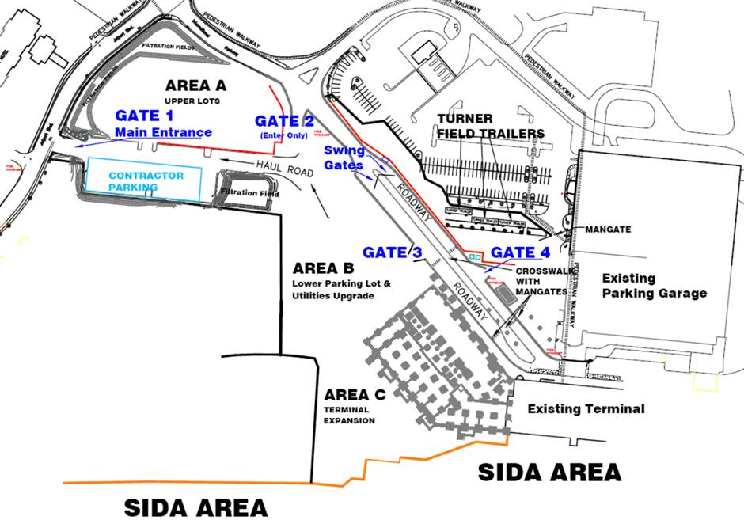

View of Steel Erection for Terminal Expansion

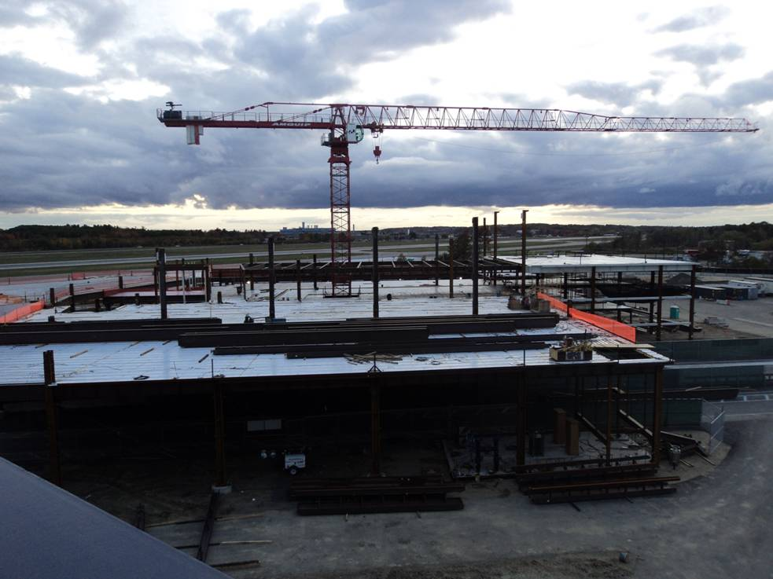

**Level 4**

Steel Erection for Elevator 4 and 5 Framing

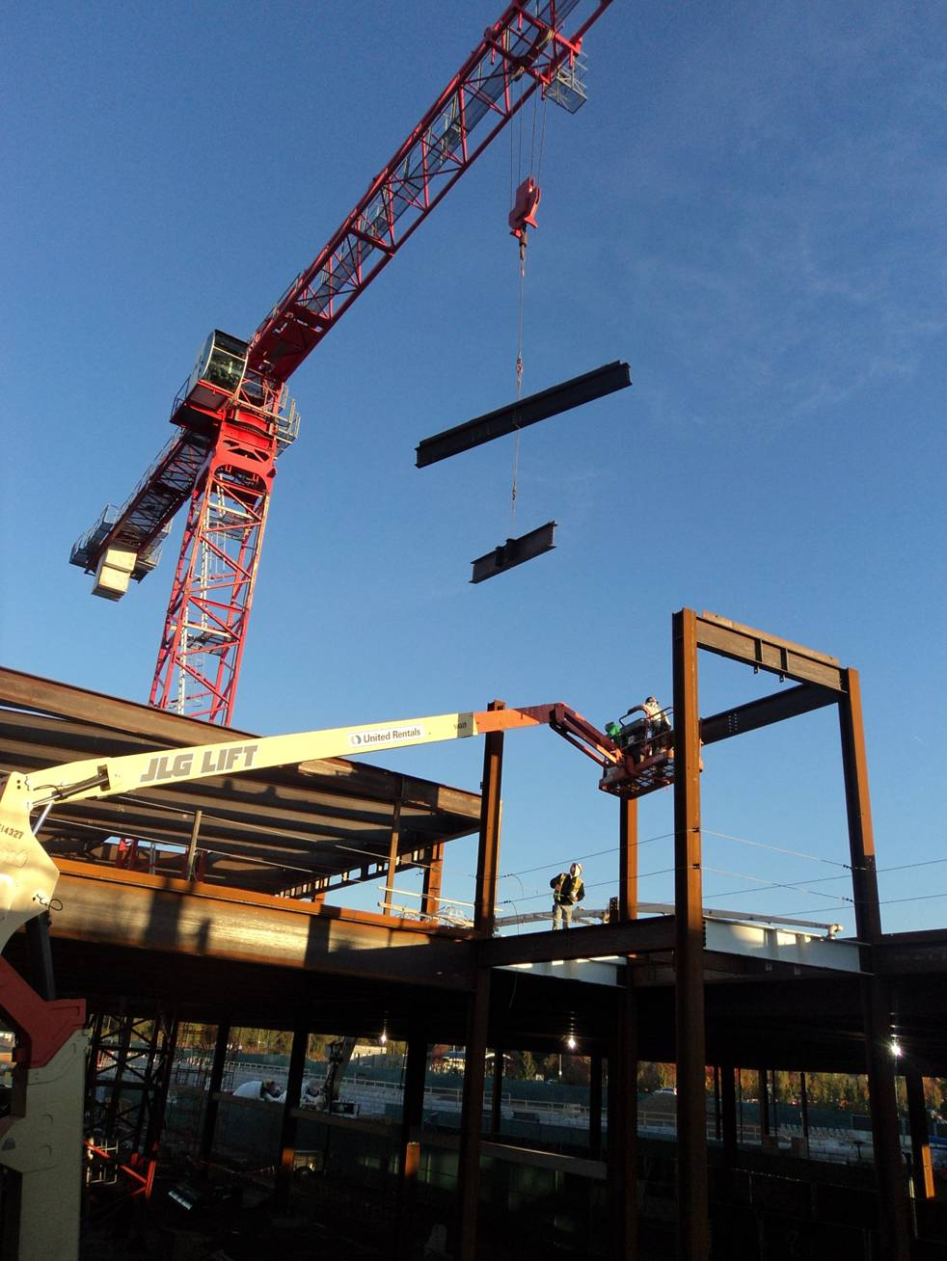

**Level 4**

White Colored Concrete Slab on Deck Placement

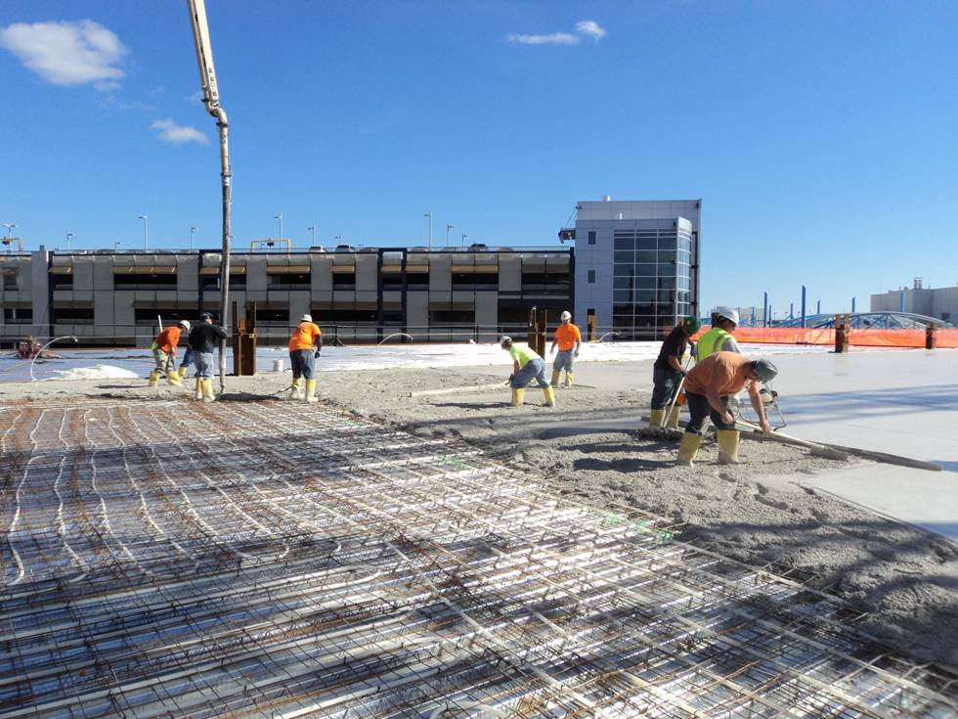

**Level 4**

Finishing for Level 4 Concrete Slab Placement

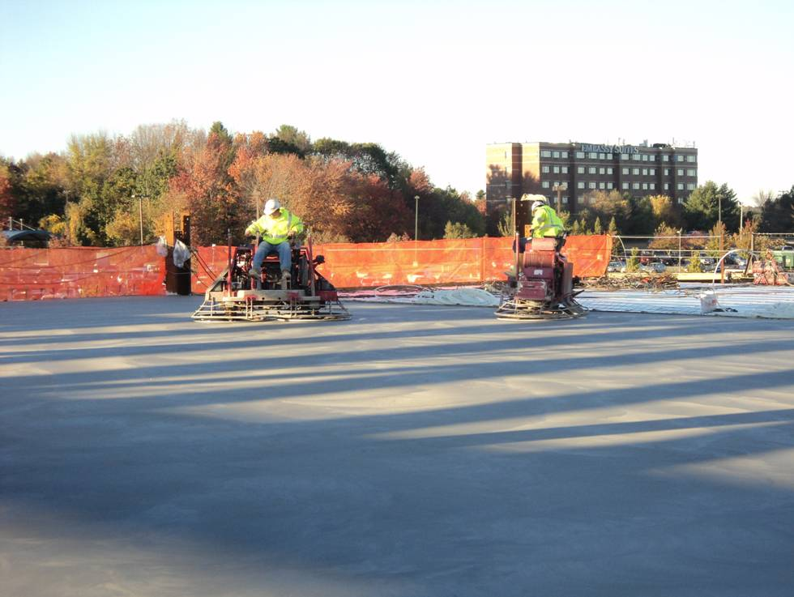

Spray On Fireproofing and Masonry Wall Installation at South Exterior

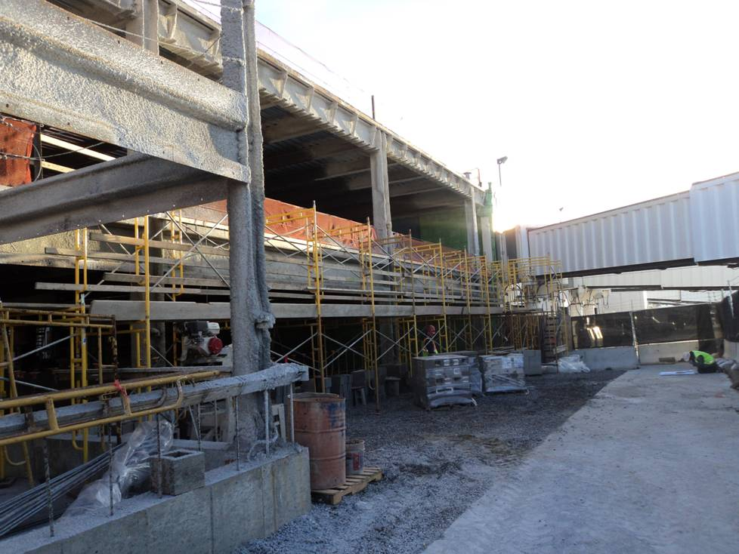

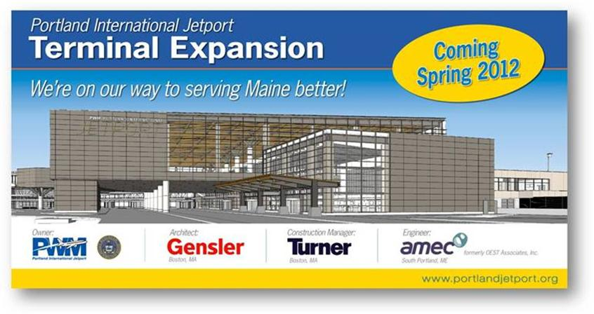

Please let me know of anyone else who would like to be added to the email distribution list.

Thanks and have a great weekend.

Ryan Dixon

Turner Construction

Portland International Airport

23 International Pkwy

Portland, ME 04102

c. 617-590-0872