Helen Donaldson
City of Portland
389 Congress Street
Portland, Maine 04101 April 16, 2016

RE: Residence at 11 Pomeroy Street

Dear Ms. Donaldson:

We write to you on behalf of the Redlon Park Association (the Association) and its members who are residents of Redlon Park Road in Portland. As you know, the Association has long been interested in the zoning for, and construction of, a single family home at 11 Pomeroy Street. That property abuts one or more existing homes in the Association.

The Association took no position with respect to the zoning for, or construction of, a single family home on that site, though we would note that it is an unusually large single family home relative to the size of homes in the neighborhood. However, the Association does note that the zoning in this neighborhood is limited to single family homes. We understand this limitation to mean that the home is for the principal residence of one family and is not intended for any other uses, especially commercial uses.

The Association has reason to believe that the property is being used as a Chabad House (http://www.chabad.org/centers/default_cdo/aid/117638/jewish/Chabad-Lubavitch-of-Maine.htm) which means that religious services are conducted there. We are concerned that the strain on neighborhood resources may become significant, including but not limited to, foot and vehicle traffic. In addition, since the road and driveway were built the amount of still water pooling in the woods from the construction has doubled due to poor drainage. This issue alone should require an inspection by the City. We request that the City of Portland take such steps as may be necessary and advisable to ensure that the use of this property is limited to a dwelling exclusively for use as a single family home.

We are happy to discuss this matter with you or your designate. You may contact me at (240) 752-7143 or at jdemerson@northendgroup.com. If I have not heard from you within ten (10) days of the date of this letter I will call you.

Thank you.

Sincerely,

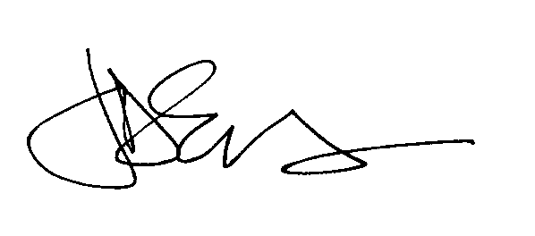

Jeff D. Emerson
Treasurer
Redlon Park Association

cc: Ed Suslovic

