

Memorandum
Department of Planning and Urban Development
Planning Division

TO: Stuart O’Brien, Chair and Members of the Portland Planning Board

FROM: Jean Fraser, Planner

DATE: January 24, 2014

RE: Capisic Pond Enhancement
Capisic Street
City of Portland (Doug Roncarati, DPS), applicant
Project #: 2013-268 CBL 192-C001001

MEETING DATE: January 28, 2014

- Introduction
Woodard & Curran have submitted a Level III Site plan application on behalf of the City of Portland for an enhancement project to the Capisic Pond within the Capisic Pond Park on the north side of Capisic Street.

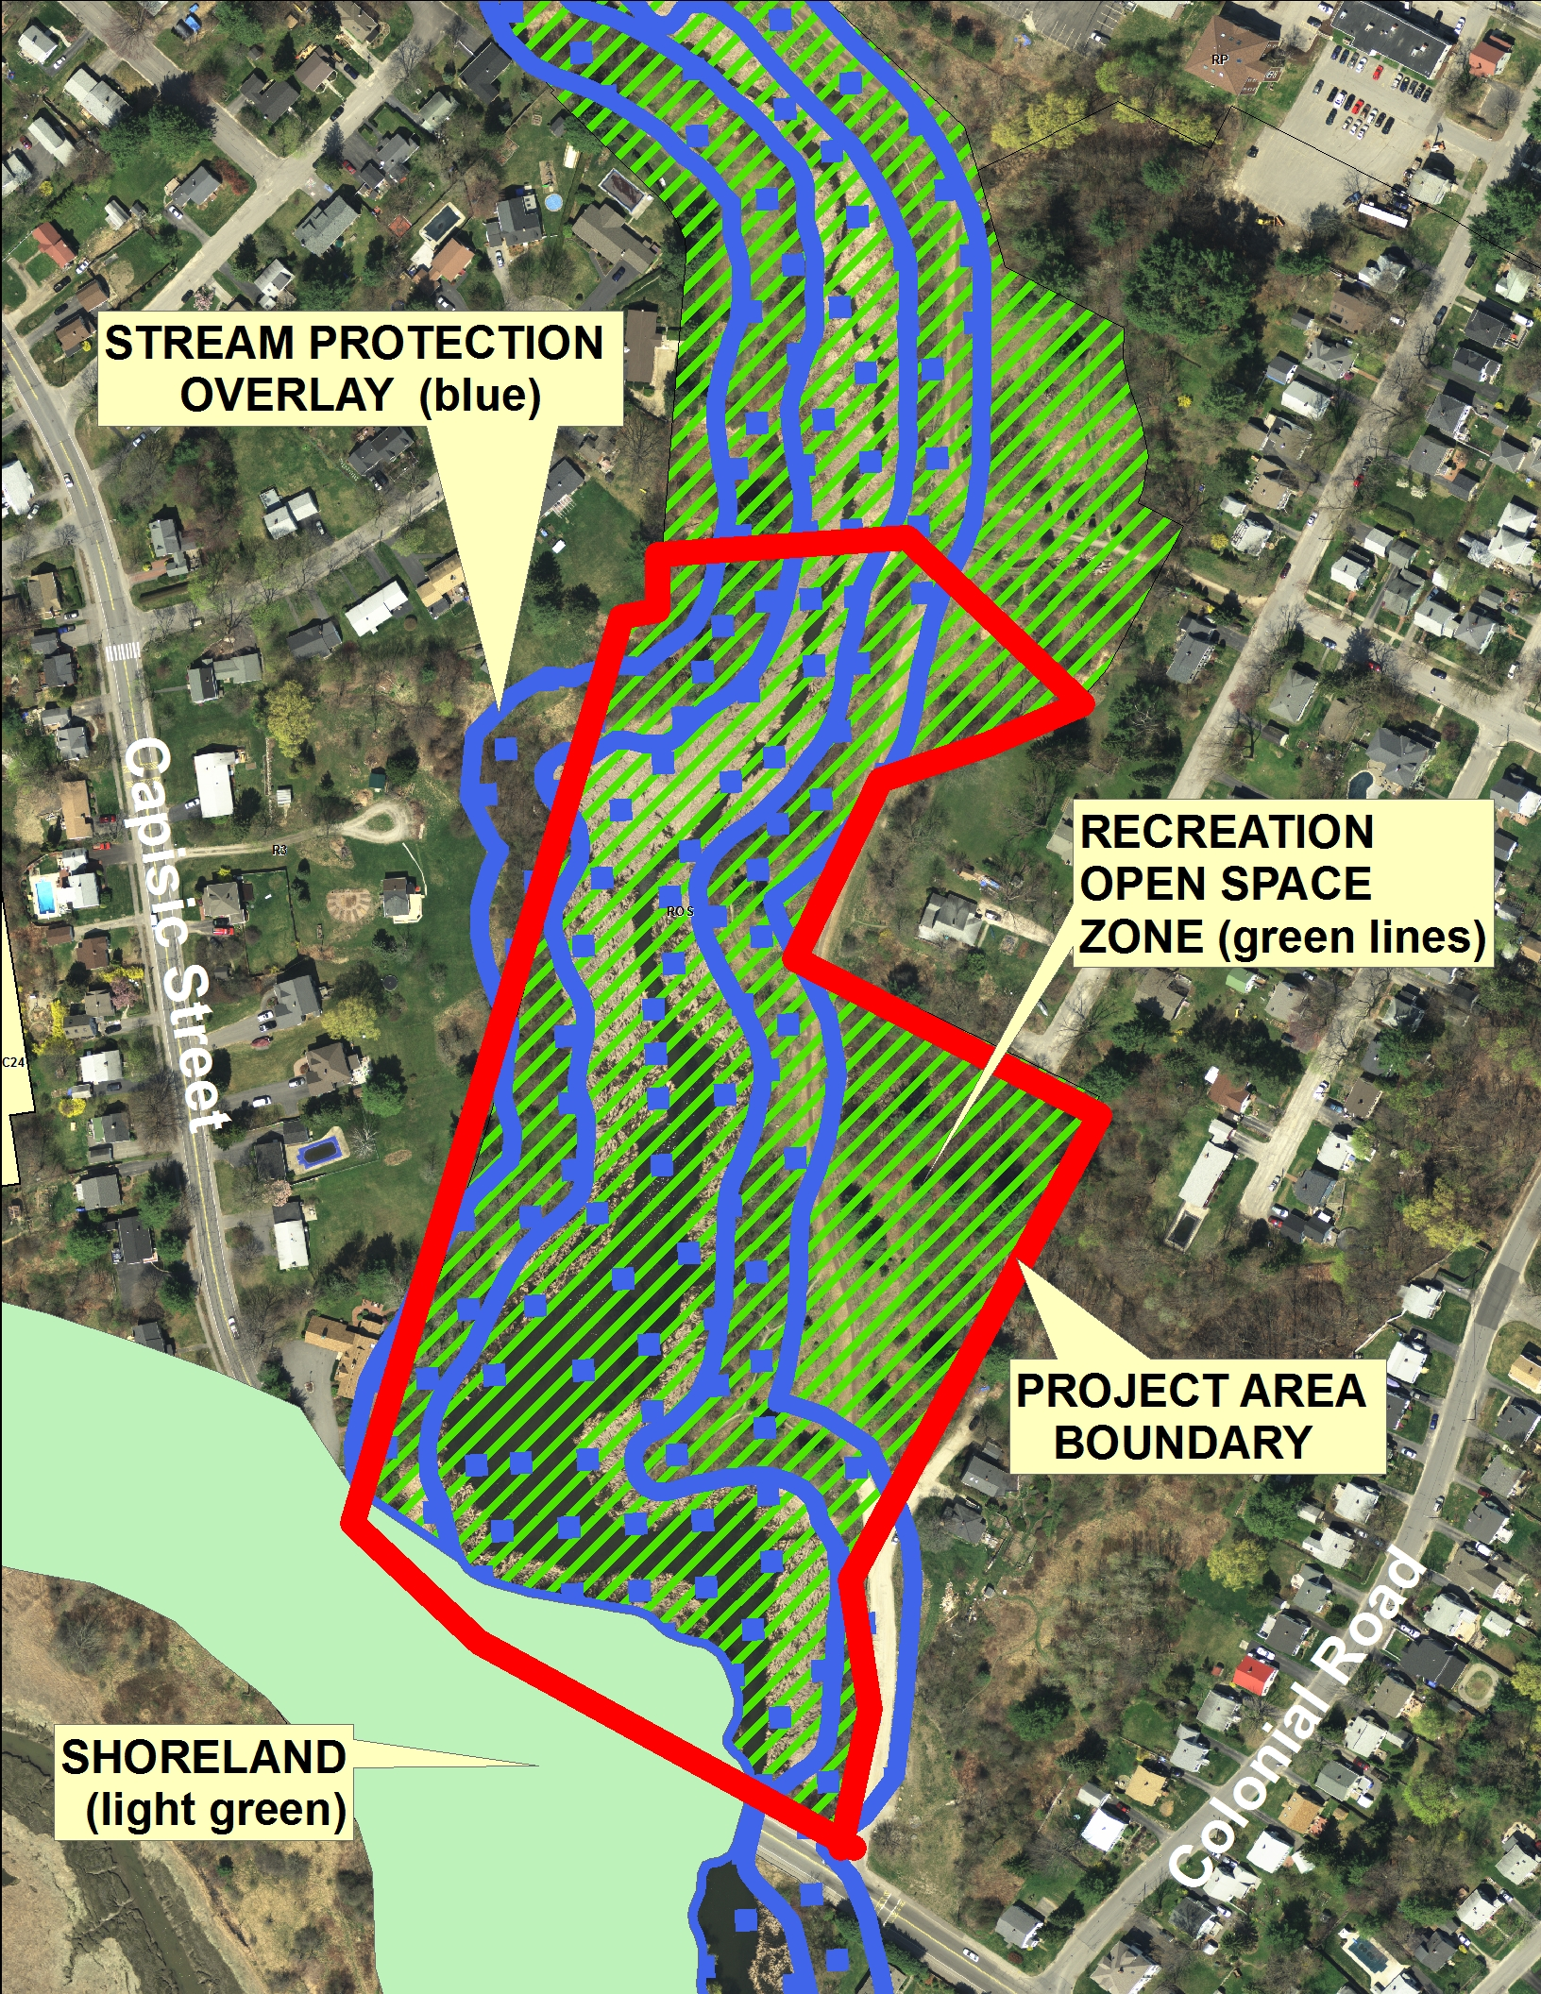
The project involves the removal of cattails and sediments from historically open waters using mechanical excavation methods and then replanting with a diverse range of vegetation that will support a greater diversity of habitat and help maintain the open water area. The area of disturbance is approximately 8 acres.

Overall the project is important to allow the pond to remain classified as a moderate value Inland Waterbird and Waterfowl Habitat by the Maine Department of Inland Fisheries and Wildlife.

The application (Attachment X) describes the background to the project and outlines how the project will enhance the aesthetic, recreational and education opportunities of the park as well as addressing the MDIF&W criteria.

The project is located within the City’s Recreation Open Space Zone and Stream Protection Overlay Zone with a small part also within the Shoreland Overlay Zone. The entire area is within the “AE” Flood Area.

The project is being reviewed as a Level III Site Plan because the scale of the disturbance is over 3 acres and it includes park improvements over 20,000 sq ft . It will also require permitting under NRPA, Army Corps and MDEP due to the impacts on significant Wildlife Habitat and wetlands and scale of disturbance to land.

- Project Data

Area of site: | 784,080 sq ft (18 acres)
Proposed area of disturbance: | 357,300 sq ft (8.2 acres)
Impervious surfaces: | none
Zoning: | ROS; Shoreland; Stream Protection
Land Use: | Public park (Capisic Pond Park)
Estimated Cost of the Project: | $2,090,000

III. Background/Existing conditions
Capisic Pond is the City of Portland’s largest freshwater water body and the surrounding park is well used by area residents and bird watchers. The application (Project Description) explains it is a man made pond created by dams that were first installed in the 1600’s and recent weir modifications.

The pond has become overgrown with invasive cattails which have reduced the open water are afrom about 7.7 acres (1950’s) to about 2 acres. This problem has accelerated over the last 10 years and ow threatens the

III. Proposed Development

Proposals
Construction

IV. Staff Review

- Zoning Assessment
- Site Plan Standards

V. Next Steps

Attachments

