
Memorandum
Planning and Urban Development Department
Planning Division

To: Stuart O’Brien, Chair and Members of the Portland Planning Board
From: Jean Fraser, Planner
Date: May 15th, 2015

Re: Neighborhood Center and Preschool/Daycare

1342 Congress Street

Site Plan and Conditional Use(s)

Jewish Community Alliance of Southern Maine, Applicant

Project #: 2015-058 CBL: 191 B016001

Meeting Date: May 19th, 2015

- Introduction
The Jewish Community Alliance of Southern Maine, as represented by Bradlee Mezquita of Tighe & Bond, has submitted a Level III Site Plan and Conditional Use application for the construction of a single story 19,300 sq ft neighborhood center (defined as a “Place of Assembly”) and preschool/daycare on the site of the existing St Patricks Church next to Westgate Shopping Center and extending back to Lassall Street behind residential properties.
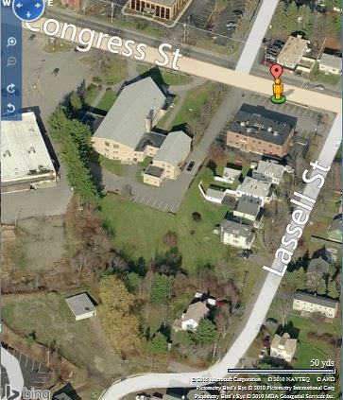
The existing church was closed in 2013 and its removal is a requirement in the terms of the sale (P&S Agreement in Attachment D) from the Roman Catholic Bishop of Portland. It will be demolished and a new building constructed. The existing church is not designated an historic landmark nor is within an historic district, so the demolition is not part of the current review.

The two acre site is located in the R5 residential zone where both “Places of Assembly” and “Day care facilities” are conditional uses, although in this case the Planning Board is the reviewing authority for the “Places of Assembly” aspect of the proposal, and the Zoning Board of Appeals (ZBA) is the reviewing authority for the preschool/day care element of the project. The ZBA is considering the conditional use appeal for the day care use on May 21, 2015, and any issues of concern that are raised at this Workshop (covered by the conditional use standards applicable to the day care) will be brought to the attention of the ZBA at their review.

Required reviews:
Applicant’s Proposal | Applicable Standards
New structure of 19, 300 sq ft | Level III Site Plan
Place of Assembly (Neighborhood Center) of 10,000 sq ft or less | Institutional Conditional Use in the R5 zone [14.118 (b) 3] (Planning Board review)
Day care facilities | Other Conditional Use in the R5 zone [14.118 (c) 3] (Zoning Board of Appeals review)

Requested Waivers: The applicant has requested a waiver for completing a soil survey, as they have undertaken soil borings as part of an earlier environmental assessment. The Traffic Engineering reviewer has advised that a waiver is required for the width of the drive directly from Congress Street (Att 3).
A total of 147 notices of this workshop were sent to property owners within 500 feet and to interested citizens and a notice was published in the May 11th and 12th, 2015 editions of the Portland Press Herald. As of the time of completing this memo, the Planning office has received 2 public comments (Attached as PC1- PC2) and 2 telephone inquiries.

- PROJECT DATA:

SUBJECT | DATA
Existing Zoning | R-5 Residential
Existing Use | Vacant church
Proposed Use | Place of assembly and Day Care (new building)
Parcel Size | 2 acres (91,146 sq ft)
Impervious Surface Area  --Existing  --Proposed  --Net Change | 36,810 sq ft  48,310 sq ft  11,500 sq ft
Total Disturbed Area | Approx 85,000 sq ft
Building Footprint  --Existing  --Proposed  --Net Change | (both are single story buildings)  14,960 sq ft  19,300 sq ft  4,340 sq ft
Parking Spaces  -Existing  -Proposed  # handicapped | 13  50  2
Bicycle parking Spaces  -Existing  -Proposed | 0  3
Estimated cost of the project | TBD

EXISTING CONDITIONS
The parcel is in the R5 zone and located between the Westgate Shopping center (B2 zone) to the west and the 1330 Dental offices to the east, on the south side of Congress Street. The paved area alongside the dental building is part of the site and includes one of the existing access drives, which would be enhanced for the proposed neighborhood center. The Congress Street sidewalk is in good condition (Att 4), but the area of the drive access is not clearly defined and the proposal will remove the row of five (5) trees along the side. There is other existing peripheral vegetation that is also proposed to be removed.

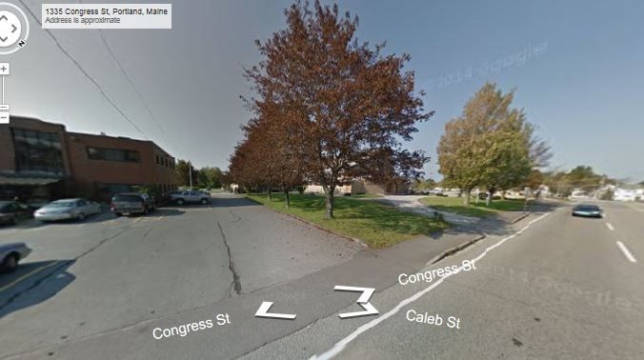

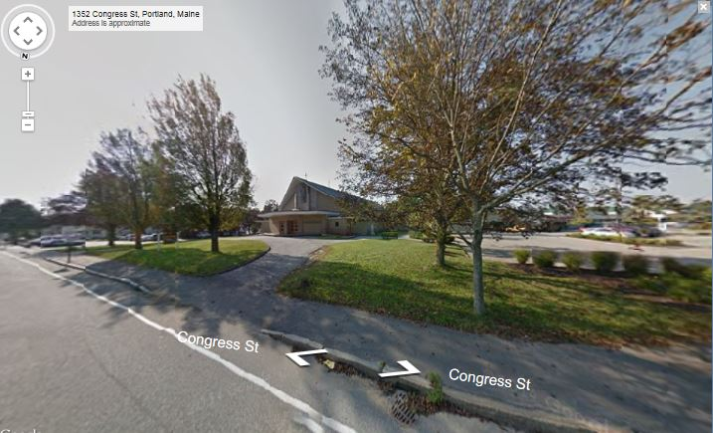
The existing St Patricks Church faces Congress Street with a looped drop off drive to the door.

The Westgate Plaza parking lot hugs the western edge of the site, and there is a shared access driveway that links the Plaza and the rear part of the church site. It is understood that the owners of the Plaza are willing to formalize the continued shared use (Att G).

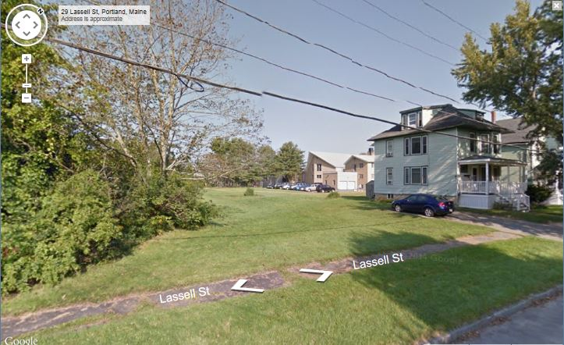

The triangular site includes a large area of grass at the rear (with some edge vegetation) and is bounded on the east by 5 properties: a commercial dental office and four residential buildings that front Lassall Street. Two of the residential owners are concerned about the fencing of the grassed area that connects to Lassall Street (see right).

- Proposed Development
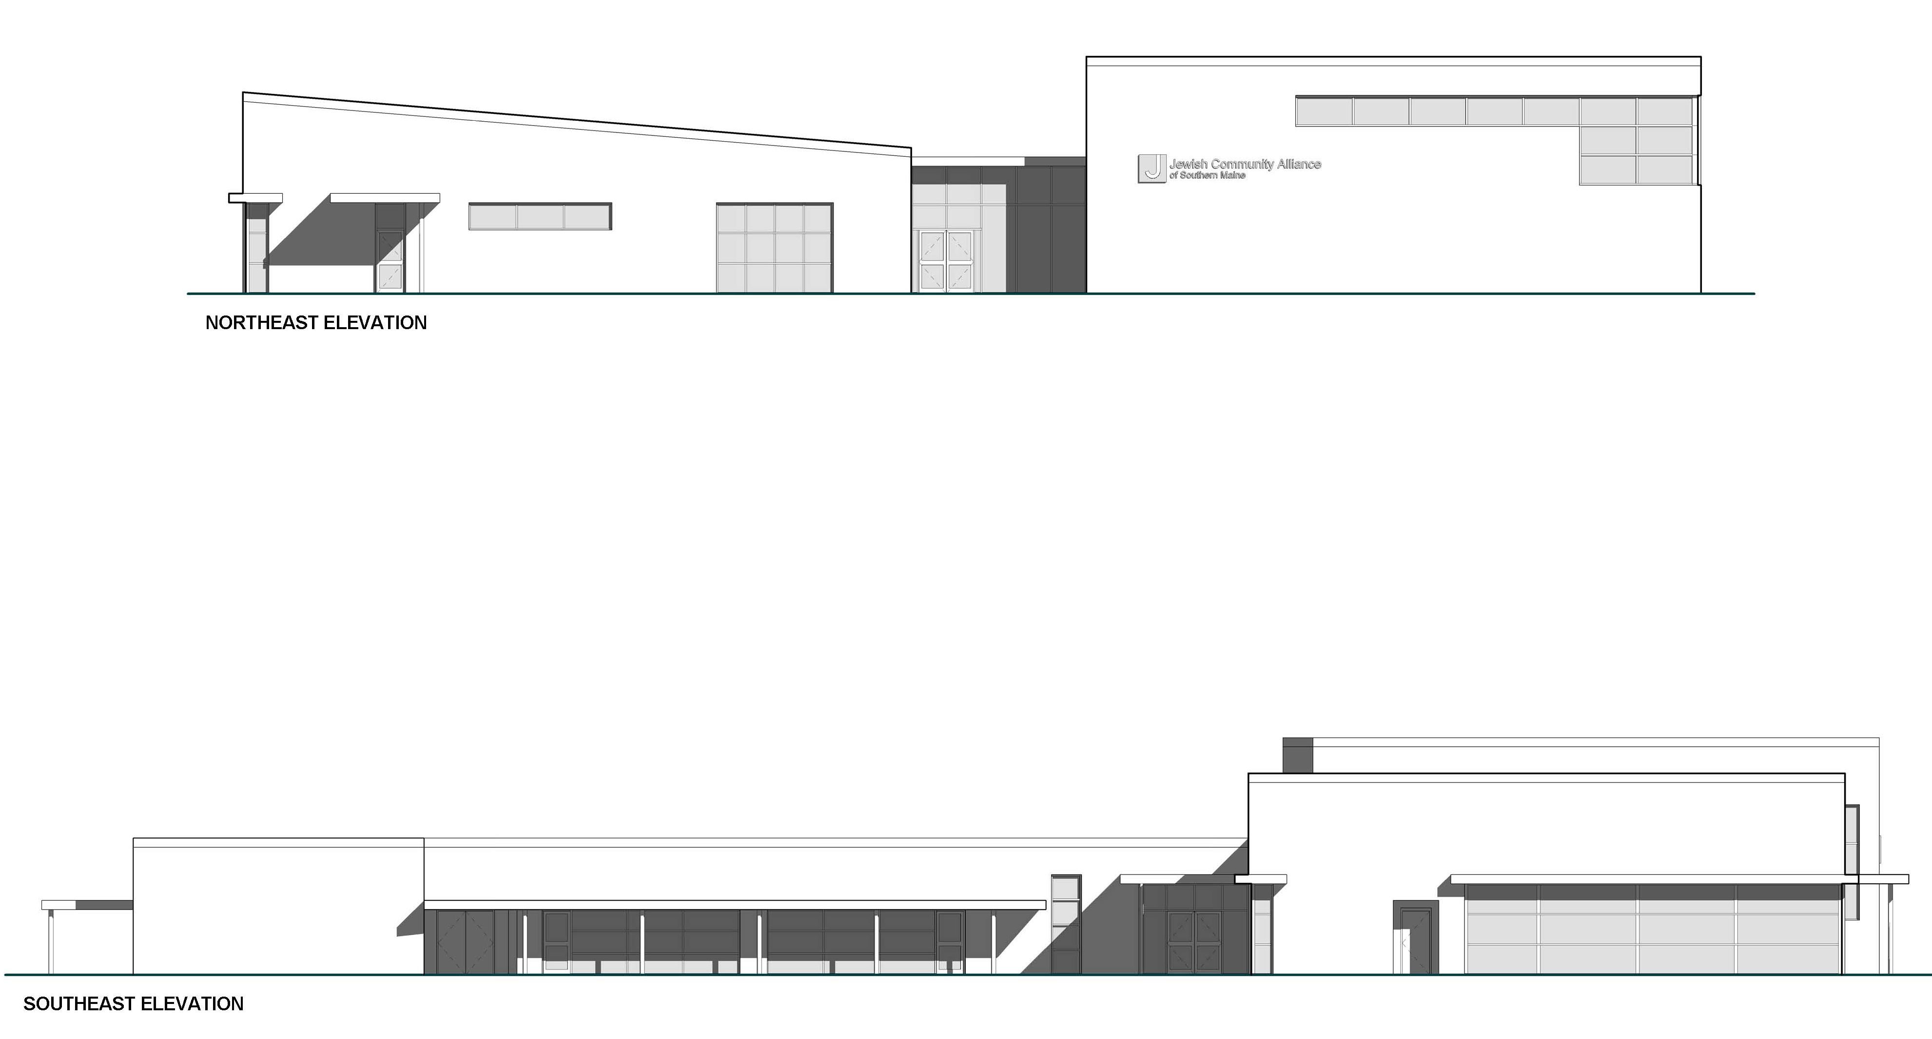
The applicant proposes to demolish the existing church building and construct a new single story building with a larger footprint (19,300 sq ft) to accommodate a neighborhood center and day care facility (described in Attachment A and shown in Plans P3 to P12).

The upper elevation shown right (and in Plan P12) is the proposed new building as viewed from Congress Street; the lower is as viewed from the east (dental offices) and shows the rear day care “wing”.

The neighborhood center is at the front of the building and falls under the ordinance definition (14-47) of a neighborhood center:

Neighborhood Center: A building or portion of a building used for recreational, artistic, social, educational, health, culture, or similar activities and services, usually owned and operated by a public or nonprofit group or agency. A neighborhood center is 10,000 square feet or less.

The floor plan helps to understand how the site will work in terms of pedestrian and vehicle access, and play areas for the children. In the floor plan (right) Congress Street is to the right and:

- Orange: Approx 4000 sq ft assembly area
- Blue: Offices
- Green: Day care

The Site Plan below (and in Plans P3 and P4) includes:

- Two drives (drop off loop at front removed)
- Parking lot for 49 -50 vehicles
- Two play areas, both fenced
- Lighting in the rear part of the site
- Snow storage around parking lot
- Stormwater management
- Stockade fence along the two sides of the rear boundary to enclose the existing grassed area down to Lassall Street (note: detail shows chain link fence)

A Landscape Plan is included in Plan P10 but does not include tree planting along the side facing the dental offices where 5 large trees have been removed. It is not clear how servicing vehicles will be handled, but a fire truck turning template was submitted (Plan P8).
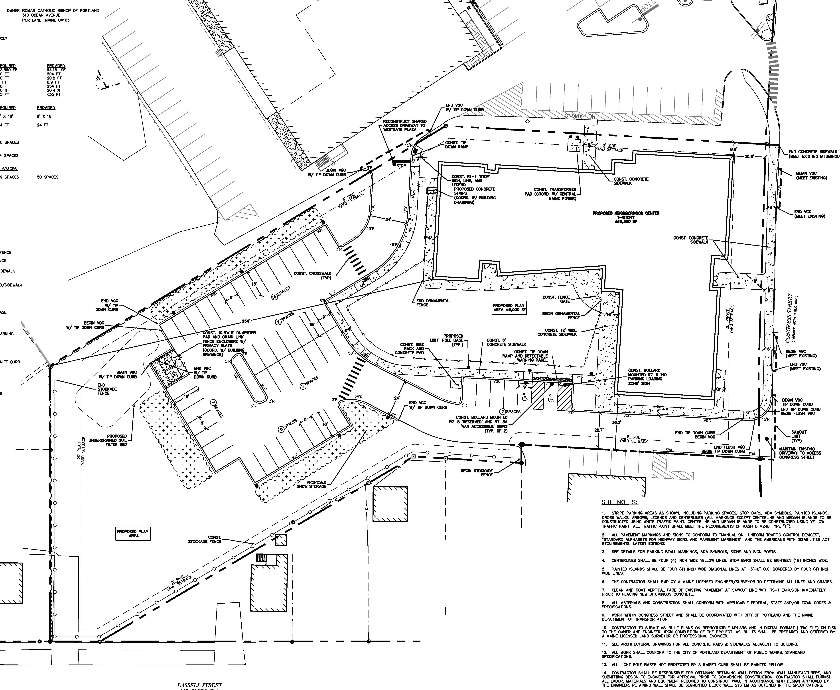

- STAFF REVIEW
- Zoning AssessmenT
The site is located in the R5 residential zone and the submitted site plan includes a zoning assessment in respect of dimensions, and the proposal meets these zoning requirements. The day care is a conditional use in this zone (14-118) and is being reviewed by the ZBA for compliance with standards that include the following requirements that overlap with site plan standards:
c. Outdoor play areas shall be screened and buffered from surrounding residences with landscaping and/or fencing to minimize visual and noise impacts.
d. Solid waste shall be stored in covered containers. Such containers shall be screened on all four (4) sides.

The ZBA also would apply section 14-474 which include standards regarding traffic and other impacts. The traffic review comments as they relate to the day care part of the proposal will be brought to the attention of the ZBA at their 5.21.2015 ZBA.

- CONDITIONAL USE REVIEW
The site was previously a religious place of assembly and is now proposed as a neighborhood center with a large day care facility. The day care use is a ZBA conditional use review. The proposed neighborhood center is approximately 6500 sq ft (according to the data on the site plan (Plan P4) and comprises an assembly room of about 4000 sq ft and offices and conference rooms in the wing nearest Congress Street. The applicant’s cover letter partially addresses the conditional use standards what require a substantive response (Attachment A).

Per 14-118 (b) 3, the Planning Board are the reviewing authority for the Neighborhood Center which is classified as a Place of Assembly, as defined:

Place of assembly: A building or portion of a building used as a community hall, neighborhood center, private and fraternal organization or place of religious assembly. This definition shall not include buildings or portions of buildings used as a community hall, neighborhood center, private and fraternal organization or place of religious assembly where fifteen (15) or fewer people, not including the permanent residents of a single family dwelling, assemble.

The ordinance standards and staff comments are listed below (ordinance text is in italics):

Sec. 14-118. Conditional uses.
The following uses shall be permitted only upon the issuance of a conditional use permit, subject to the provisions of section 14-474 (conditional uses) and any special provisions, standards or requirements specified below:
(b) Institutional: Any of the following conditional uses provided that, notwithstanding section 14-474(a) (conditional uses) of this article, or any other provision of this Code, the Planning Board shall be substituted for the board of appeals as the reviewing authority:
3. Places of assembly;
Such uses shall be subject to the following conditions and standards in addition to the provisions of section 14-474:
a. In the case of expansion of existing such uses onto land other than the lot on which the principal use is located, it shall be demonstrated that the proposed use cannot reasonably be accommodated on the existing site through more efficient utilization of land or buildings, and will not cause significant physical encroachment into established residential areas; and
Staff comment: The proposal is replacing a religious place of assembly with a neighborhood center place of assembly with no expansion.

b. The proposed use will not cause significant displacement or conversion of residential uses existing as of June 1, 1983, or thereafter; and

Staff comment: The proposal does not displace any residential uses.

c. In the case of a use or use expansion which constitutes a combination of the above-listed uses with capacity for concurrent operations, the applicable minimum lot sizes shall be cumulative; and

Staff comment: The day care facility is not considered an institutional use and therefore there is just the neighborhood center to be considered.

d. Article V (site plan) sections 14-522 and 14-523 notwithstanding, in the case of places of assembly the proposed use shall be subject to the requirements of article V (site plan) of this chapter; and

Staff comment: The applicant has submitted a level III site plan application which is being reviewed concurrently.

The following standards apply to all conditional uses:

2. Standards. The Board shall, after review of required materials, authorize issuance of a conditional use permit, upon a showing that the proposed use, at the size and intensity contemplated at the proposed location, will not have substantially greater negative impacts than would normally occur from surrounding uses or other allowable uses in the same zoning district. The Board shall find that this standard is satisfied if it finds that:

- The volume and type of vehicle traffic to be generated, hours of operation, expanse of pavement, and the number of parking spaces required are not substantially greater than would normally occur at surrounding uses or other allowable uses in the same zone; and

Staff comment: The site is in the R5 zone which allows schools, hospitals, colleges and universities, most of which would have greater traffic generation and parking requirements than the proposed use. It is located immediately adjacent to the B2 zone, which allows a range of business uses (eg restaurants, theatres and performance halls) as well as the institutional uses allowed in the R5 zone.

b. The proposed use will not create unsanitary or harmful conditions by reason of noise, glare, dust, sewage disposal, emissions to the air, odor, lighting, or litter; and

Staff comment: The proposal would not create harmful conditions. The lighting would need to be carefully designed to avoid any impacts on abutters and that would be addressed in the site plan review.

c. The design and operation of the proposed use, including but not limited to landscaping, screening, signs, loading, deliveries, trash or waste generation, arrangement of structures, and materials storage will not have a substantially greater effect/impact on surrounding properties than those associated with surrounding uses or other allowable uses in the zone.

Staff comment: The place of assembly use is similar to the former church, with gatherings generally occurring at off-peak hours and with potentially less traffic (due to the proposed assembly room areas being smaller - see details in the Traffic Memo in Attachment F). Larger gatherings will be accommodated with on-site parking and shared use parking at the adjacent shopping center, with similar or fewer impacts than those associated with surrounding uses or other allowable uses in the zone. The associated day care use introduces some different impacts that are being closely reviewed under the ZBA conditional use review and the Planning Board Level III site plan review.

DEVELOPMENT REVIEW (Site Plan Standards in Section 14-526)
The applicant has provided a comprehensive application and additional comments in response to staff reviews (Atts A-K). The proposed development has been reviewed by staff for conformance with the relevant review standards of Portland’s site plan ordinance and applicable regulations, and meets the standards except for several areas where staff have requested further consideration and potential revisions. The comments below focus on the areas where staff have not been able to confirm compliance with the site plan standards.

      - Transportation Standards
Impact on Surrounding Street system
The proposed neighborhood center and day care would utilize the two main existing drives which currently serve about a dozen parking spaces. The proposed site plan shows that these drives would be providing access to 50 space parking spaces, which would be used regularly for dropping off and picking up children from the day care part of the use. There are two issues:
- The number of vehicles likely to be entering and leaving via the unrestricted drive directly from Congress Street; and
- The question of whether cars accessing that drive to drop off or pick up children might stop in the drive and cause back ups onto Congress Street or noise/pollution for nearby residents.

The applicant has submitted the following:
- An initial Traffic Study (Attachment F);
- Responses to the Traffic Reviewer Tom Errico’s comments below (Attachment J); and
- Further traffic data (Attachment K).

Tom Errico, Traffic engineering reviewer has commented (Attachments 2 and 3) regarding the traffic generation (below), but the “Response” and data in Attachments J &K could not be reviewed in time for inclusion in this Memo as it arrived recently; an update will be provided at the meeting:
- Maine Traffic Resources conducted a Trip Generation Analysis for the project and concludes that the proposed Jewish Community Center will generate less traffic as compared to St Patrick’s Church. The applicant should provide an estimated comparison between the former Church use and the proposed project during the weekday AM and PM peak hours. My general sense in that during the AM peak hour the net change may not be significant given weekday morning Church services. During the weekday PM peak hour, I suspect the Church did not have regular weekday activities, while the proposed use will add traffic in conjunction with the day-care use.
- I’m concerned that the ITE data is not a good source for estimating traffic for the proposed project. I would suggest that the applicant conduct traffic counts/surveys at existing facilities to better estimate traffic levels. I would also like to get a better understanding on historic traffic activity at St. Patrick’s Church. I recognize that traffic volumes are not likely to be available, but information on daily services and other event details would be helpful for my review and understanding of project impacts. The applicant should attempt to provide specific church service information, if available. (Traffic Engineering Reviewer, Attachments 2 and 3)

The second concern relates to the management of the Congress Street drive when children are being dropped off and picked up. The information submitted (Attachments F and K) suggest that pickups will be staggered, but further discussion is suggested. Mr Errico’s comments are: (Attachments 2 and 3):

  - The pick-up and drop-off of daycare and others will need to be carefully managed. Accordingly, the applicant should provide specific details on how this process will take place. This should include what building entrances will be used, sidewalk facilities between parking spaces and the noted entrance, etc. I would note that the pick-up/drop-off program must be managed such that vehicles are not parking along the driveway off Congress Street.

Related to this issue is the proposed pedestrian circulation within the site. It is understood that parents dropping off and picking up young children from the day care will need to park and come into the day care to drop off or collect their child. However, the pedestrian routes between the parking lot and what appears to be the day care entrance appear circuitous (Site Plan in Plan P4) and further information and discussion is necessary to confirm that direct access is provided. This is important, as if this walking distance is long and inconvenient, parents will be more likely to stop and wait in the drive access or near one of the paths into the day care rather than park.

Access and circulation
The Congress Street driveway is proposed to be improved and extended to serve the new project and the 50 space parking lot, and will incorporate 6 parking spaces along it. This drive is along the boundary with the dental offices parking area and along the rear boundary of two of the residential properties on Lassall Street.

As shown in the photograph (right), there currently is no delineation between the access drive and the parking lot for the dental offices. Mr Errico recommends (in addition to several other detailed design comments in Attachments 2 and 3) that some formal delineation should be made at the Congress Street interface. This suggestion is reinforced by the City Arborist’s suggestion (see below) that the delineation could be combined with street trees/landscape feature to compensate for the loss of the existing trees along the drive.

DPS has confirmed that the existing concrete sidewalk along the front of the site is in good condition (Attachment 4). Further comments from DPS arrived too late for inclusion in this Memo (largely technical comments) and will be circulated at the workhop.

The project also relies for some access on the other driveway (west side) connecting to the shopping plaza. The applicant has submitted a letter from the owners of Westgate Plaza (Charter Westgate LLC; Att. G) that confirms they are willing to formalize an agreement to maintain this shared access. Given its importance to the project, staff recommends that a formal agreement be in place before the proposed new development is considered at a Planning Board hearing. Mr Errico comments (Attachment 2):

- I find the vehicular connection to Westgate Shopping Center to be an excellent access management strategy that will allow traffic from the Community Center to utilize the traffic signal at Stevens Avenue. I would note that this connection can also serve traffic from the abutting medical office building and traffic from Lassell Street. Accordingly, I would suggest that access use rights be provided. While I would prefer that the connection to the Westgate Shopping Center to be more direct, given the potential for vehicle/pedestrian conflict, the proposed plan appears acceptable. The applicant should provide a response on this issue and how they see traffic circulation interacting with site activity.

Parking: The Site Plan (Plan P4) shows 49 spaces on the plan, but the zoning assessment on that plan (in the notes) state that 50 spaces have been provided.

The ordinance Division 20 requirement requires 50 spaces, as follows:
- 30 spaces for the neighborhood center – based on 1 parking space for each 150 sq ft of floor area used for the neighborhood center, which the Zoning Administrator advises applies to the assembly room/ multipurpose rooms only (4375 sq ft; accommodating 309 people (see Att F);
- 14 spaces for the day care - based on 1 space for each of the 14 day care staff members; and
- 5 spaces for the office component- based on 2000 sq ft of offices and 1 space per 400 sq ft.

Staff are concerned that, even with 50 proposed parking spaces, that parking for the parents dropping off/collecting the 68 (+ 20 afterschool) children does not appear to have been fully addressed. Although parking for the assembly room and multi-purpose rooms would also be provided by shared –use parking in the adjacent shopping center, the dental office parking area is much closer for day care access and may be impacted if there is overflow parking. Therefore the Traffic Engineer has requested (Attachment 2):

- The applicant shall provide a Parking Supply analysis that documents parking needs both under a typical weekday scenario and during Community Center events.

      - Environmental Quality Standards
Landscape Preservation, Buffers and Parking Lot Landscaping
The Demolition Plan in Plan P2 shows the proposed removal of the 5 trees alongside the drive by the dental offices, and a considerable area of vegetation around the back of the site is also removed including near Lassall Street. A further 12 conifer trees are removed along the west boundary, which will become snow storage and parking area. The Landscape Plan in Plan P10 includes some replacement planting.

The City Arborist has reviewed the proposals and has the following comments (Attachment 7):
I have reviewed the proposed landscape plan for the Jewish Neighborhood Center on Congress Street and offer the following recommendations:
- Looking at the back property line and the graphic showing a proposed fence, which is recommended, wanted to request a fence spec. My first thought is that the fence should be wooden 6' in height or something equal.
- The project removes several mature trees on the side entranceway and does not appear to replace them. Looking at the space it appears to be wide enough that several, 3 - 4 small trees such as Magnolia, Dogwood or Cherry could be successfully planted back in this location. We have also seen good use of the several upright Oak varieties that stay very narrow but with height that could help replace the lost trees. Improving this space should be a priority.
See: http://www.jfschmidt.com/pdfs/regalprinceoak.pdf .
- Also noted that a small center landscaped island near the entranceway could be used to improve or define the drive into the site.

Overall the rest of the landscape plan appears to meet our landscape & tree standards with
recommended varieties and plant sizes.

Water quality; Stormwater Management; Erosion control:
The proposal creates an additional 12,500 sq ft of impervious surface and includes an improved stormwater management and treatment system comprising Stormtech chambers and an underdrained soil filter bed. The applicant submitted a Drainage Study as part of the original submission and revised it in response to the Peer Engineer Dave Senus comments; the revised version is included as Attachment I along with revised Plans (P2-P7). The revised proposals have been reviewed by Mr Senus and largely address the review comments, with three outstanding issues as outlined in the review comments (Attachment 1):

    - The Pre-Development Watershed Plan (WS-1) indicates that runoff from the existing building roof is part of catchments WS-1 and WS-2; however, runoff from some of these roof areas is collected in downspouts that enter into the ground and which do not appear to flow to PA-1 and PA-2. The Applicant should determine the discharge location for the building’s roof downspouts and re-evaluate the catchment areas and stormwater model based on their findings.
Update: The Applicant’s engineer has stated that they are actively working with the Owner to determine the outlet locations of the roof drains. As part of the future, final submittal, the Applicant will revise the Pre- Development Watershed Plan (WS-1) and drainage design (if needed) to account for updated roof drainage information.

    - The Applicant has proposed to discharge the majority of the site’s drainage to a new outfall located at the southwest edge of the site, adjacent to an existing drainage ditch that flows across a residential property located south of the site. Although the pre/post stormwater analysis is intended to show that the flow at this study point will not increase in the 2, 10 and 25 year storm event conditions, there will be a new outfall with a concentrated discharge at this location. We recommend that the Applicant work with the adjacent property owner to determine if there are existing concerns over drainage in this area, and based on input from that property owner, determine if improvements can or should be made to the drainage ditch as part of this project.
Update: The Applicant has acknowledged that they will work with the adjacent property owner to determine if there are any existing concerns over drainage in this area and determine if improvements are necessary. Information regarding these discussions/decisions should be provided with the final submittal.

        - The proposed Underdrained Soil Filter Bed detail refers to a Rain Garden Planting Plan for proposed plantings; however, it does not appear that this plan has been provided at this time.
Update: The Applicant has acknowledged that the Landscape Plan, Sheet L-1, will be updated to include an appropriate planting plan for the Underdrained Soil Filter with the Final Site Plan Submission.

One of the earlier concerns was that the snow storage for east edge of the parking lot would drain towards the nearby residential properties. The applicant has revised the grading in this area to include a shallow swale and Mr Senus considers this acceptable (Attachment 1).

      - Public Infrastructure and Community Safety Standards (1)
The proposal are generally acceptable in relation to these standards; the Fire Department has reviewed the fire truck turning templates and considers the access satisfactory (Attachment 6).

      - Site Design Standards
Historic Resources:
One of the public comments (PC 2) has suggested that the existing building has historic value and should not be demolished. The City’s Historic Preservation Program Manager has been consulted and she confirmed that this question was raised with her in the past and at that time she researched the building/architecture and determined that it did not meet the criteria for historic designation.
The church that is selling the property has made it a requirement of the sale that the building be demolished. Whether it should be designated historic is a decision for the Historic Preservation Program Manager and the Historic Preservation Board.

Exterior Lighting:
The proposals include lighting for the parking lot area (Plan P9) and the specifications and photometric data are generally acceptable, although there are some unacceptably high levels of light trespass onto residential neighbor’s property and some revisons are requested. There is no lighting proposed along the improved access drive from Congress Street (at the Congress Street end) nor along/ on the front of the building by the entrance from the sidewalk. Staff request additional information to evaluate the existing lighting in these areas and whether some additional lighting should be added to address safety and security in those areas.

VI NEXT STEPS
The following need to be addressed as part of the final submissions for consideration at a Planning Board hearing:

- Secure a formal agreement with the owners of Westgate Plaza for the shared drive prior to the Planning Board hearing;
- Provide additional information on traffic impacts and operation/management of the day care traffic and parking, including pedestrian links between the parking lot and the day care entrance;
- Submit a parking supply analysis;
- Develop designs to delineate the Congress Street access drive where it abuts the dental offices, to incorporate street trees/landscape and possibly lighting (and clarify re a waiver for the width of the drive);
- Revise the landscaping proposals to address the City Arborist comments (including fence specs) and the comment from the Peer Engineer regarding planting for the underdrained soil filter;
- Undertake further research and discussions with neighbors to address the two substantial concerns outlined by the Peer Engineer regarding the stormwater flow impacts;
- Revise lighting to avoid light trespass and clarify whether existing lighting is adequate along the Congress Street drive and building entrance; and
- Address any comments of the Planning Board.

ATTACHMENTS:
Memo attachments  - Peer Engineering Reviewer, Dave Senus 5.13.2015  - Traffic Eng. Reviewer Tom Errico 4.29.2015  - Traffic Eng. Reviewer, Tom Errico 5.13.2015  - Dept of Public Services re sidewalk, 5.6.2015  - Fire Dept. Keith Gautreau comments 5.6.2015  - Fire Dept. re truck turning 5.13.2015  - City Arborist comments 5.15.2015  Public Comments  PC 1 P Barnard  PC 2 P Jeffrey  Applicants submittal  A. Tighe & Bond cover letter 4.3.2015  B. Site Plan application  C. Conditional use application (Places of Assembly)  D. P&S Agreement  E. Letter of financial capacity (Key Bank) 4.2.2015  F. Traffic Memo 3.19.2015  G. Letter from Westgate plaza owners re drive 4.2.2015 | Applicants submittal, con’t  H. Tighe & Bond Response to Eng.Review comments 5.8.2015  I. Tighe & Bond Drainage Study revised 5.5.2015  J. Tighe & Bond Response to Traffic comments 5.13.2013  K. Additional Traffic Information Memo 5.13.2013  Plans  P1. Survey  P2. Existing Conditions and Demolition Plan  P3. Overall site Plan  P4. Site plan  P5. Grading, Drainage and Erosion Control Plan  P6. Utilities Plan  P7. Details (5 plans)  P8. Fire Truck Turning Plan  P9. Photometric Plan  P10. Landscape Plan  P11. Floor Plan  P12. Exterior Elevations

