PLANNING BOARD REPORT
PORTLAND, MAINE

Jewish Community Center and Preschool/Daycare 1342 Congress Street
Conditional Use & Level III Site Plan Review
Jewish Community Alliance of Southern Maine, Applicant
Project # 2015-058
CBL: 191 B-16 & 17
Submitted to: Portland Planning Board  Public Hearing Date: July 14, 2015 | Prepared by: Jean Fraser, Planner  Date: July 10, 2015

I. INTRODUCTION
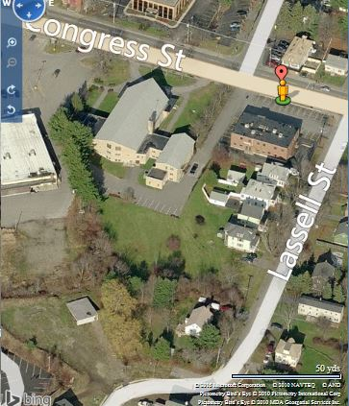
The Jewish Community Alliance of Southern Maine, as represented by Bradlee Mezquita of Tighe & Bond, has submitted a final Level III Site Plan and Conditional Use application for the construction of a single story 19,300 sq ft neighborhood center (defined as a “Place of Assembly”) and preschool/daycare on the site of the existing St. Patrick’s Catholic Church next to Westgate Shopping Center and extending back to Lassall Street behind residential properties.

The Planning Board considered this project at a Workshop on May 19, 2015 and since then the applicants have developed a comprehensive final submission that includes agreements with neighbors and addresses all of the traffic, parking and stormwater management concerns.

The existing church was closed in 2013 and its removal is a requirement in the terms of the sale (P&S Agreement in Attachment D) from the Roman Catholic Bishop of Portland. It will be demolished and a new building constructed. The existing church is not designated an historic landmark nor is within an historic district, so the demolition is not part of the current review.

The two acre site is located in the R5 residential zone where both “Places of Assembly” and “Day care facilities” are conditional uses, although in this case the Planning Board is the reviewing authority for the “Places of Assembly” aspect of the proposal, and the Zoning Board of Appeals (ZBA) has approved the preschool/daycare element of the project (Attachment 8).

Applicant: Jewish Community Alliance of Southern Maine
Consultants: Bradlee Mezquita of Tighe & Bond

II. REQUIRED REVIEWS
Applicant’s Proposal | Applicable Standards
New structure of 19, 300 sq ft | Level III Site Plan
Place of Assembly (Neighborhood Center) of 10,000 sq ft or less | Institutional Conditional Use in the R5 zone [14.118 (b) 3] (Planning Board review)
Day care facilities | Other Conditional Use in the R5 zone [14.118 (c) 3] (Zoning Board of Appeals review)

III. WAIVERS:
Waiver | Standard
Soil survey: The applicant requests a waiver for completing a soil survey, as they have undertaken soil borings as part of an earlier environmental assessment. | Technical Manual Section 7 Soil Survey Standards requires soil surveys for all Level III site plan applications. Staff support a waiver of this requirement.
Driveway Width: The applicant requests a waiver from the 24 feet width requirement to provide 22.7 foot wide drive for one section near Congress Street where it is opposite the abutters existing parking, some of which is on the applicant’s property. | Technical Manual Section 1.7.1.3 specifies that driveway access is preferred to be 24 feet wide, and a minimum of 20 feet. Staff support this waiver (Att 2)

IV. PROJECT DATA

SUBJECT | DATA
Existing Zoning | R-5 Residential
Existing Use | Vacant church
Proposed Use | Place of Assembly and Day Care (new building)
Parcel Size | 2 acres (91,146 sq ft)
Impervious Surface Area  --Existing  --Proposed  --Net Change | 36,810 sq ft  48,310 sq ft  11,500 sq ft
Total Disturbed Area | Approx 85,000 sq ft
Building Footprint  --Existing  --Proposed  --Net Change | (both are single story buildings)  14,960 sq ft  19,300 sq ft  4,340 sq ft
Parking Spaces  -Existing  -Proposed  # handicapped | 13  50  2
Bicycle parking Spaces  -Existing  -Proposed | 0  3
Estimated cost of the project | TBD

V. EXISTING CONDITIONS
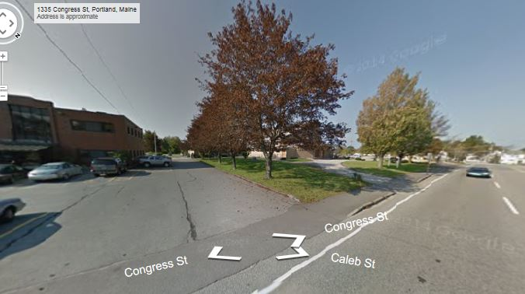
The parcel is in the R5 zone and located between the Westgate Shopping center (B2 zone) to the west and the 1330 Dental offices to the east, on the south side of Congress Street. The paved area alongside the dental building is part of the site and includes one of the existing access drives, which would be enhanced for the proposed neighborhood center. The Congress Street sidewalk is in good condition (Att 4), but the area of the drive access is not clearly defined and the proposal will remove the row of five (5) trees along the side. There is other existing peripheral vegetation that is also proposed to be removed.

The existing St Patrick’s Catholic Church faces Congress Street with a looped drop off drive to the door.

The Westgate Plaza parking lot hugs the western edge of the site, and there is a shared access driveway that links the Plaza and the rear part of the church site. The owners of the Plaza have formalized the previous shared use in a signed easement (Att J).

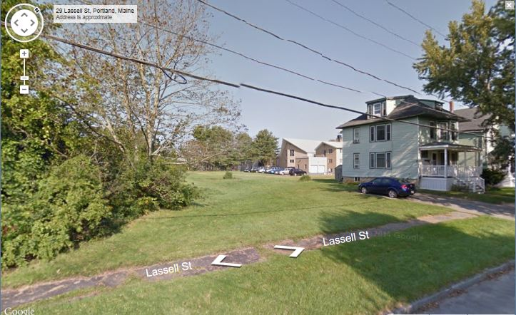
The site is triangular in shape with the southern corner on Lassall Street. It includes a large area of grass at the rear (with some edge vegetation) and is bounded on the east by 5 properties: a commercial dental office and four residential buildings that front Lassall Street. Two of the residential owners are concerned about the fencing of the grassed area that connects to Lassall Street (see right and PC 1 and 4).

V. PROPOSED DEVELOPMENT
The applicant proposes to demolish the existing church building and construct a new single story building with a larger footprint (19,300 sq ft) to accommodate a neighborhood center and daycare facility (described in Attachment A and shown in Plans P2 to P16).

The neighborhood center is at the front of the building and falls under the ordinance definition (14-47) of a neighborhood center:

Neighborhood Center: A building or portion of a building used for recreational, artistic, social, educational, health, culture, or similar activities and services, usually owned and operated by a public or nonprofit group or agency. A neighborhood center is 10,000 square feet or less.

The floor plan helps to understand how the site will work in terms of pedestrian and vehicle access, and play areas for the children. A detailed and slightly revised floorplan is in Attachment K, but this colored version helps to clarify the combination of uses: (Congress Street is to the right):

- Orange: Approx 4000 sq ft assembly area
- Blue: Offices
- Green: Day care

The Site Plan below (and in Plans P5 and P6) includes:

- Two drives (drop off loop at front removed)
- Parking lot for 50 vehicles
- Two play areas, both fenced
- Lighting in the rear part of the site
- Snow storage around parking lot
- Stormwater management
- Stockade fence along the two sides of the rear boundary

Added since the Workshop: (see comparison of plans below)
- 17 foot wide curbed landscaped island to delineate the driveway off of Congress Street
- Incorporated a barrier along west side of the main drive to prevent cars stopping to drop off
- Additional planting
- Revised lighting to reduce trespass
- Revised stormwater management and treatment
- Revised the elevations

The applicant has also arranged for 3 easements to facilitate the development and the stormwater agreements have also been submitted (Attachments J, M and N).

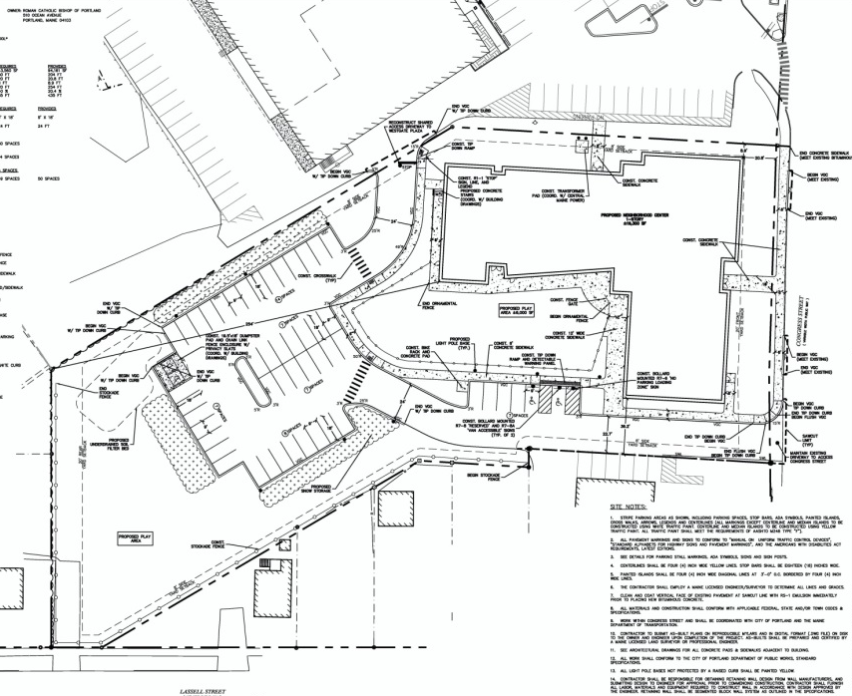
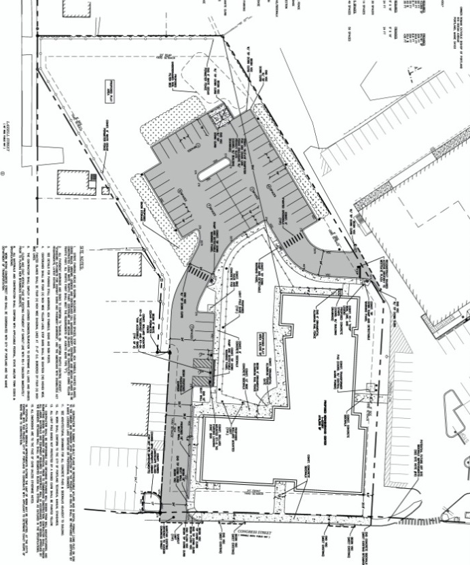
As presented to Workshop Final for hearing (see also Plan P6)

VI. PUBLIC COMMENT AND WORKSHOP DISCUSSIONS

Workshop on May 19, 2015
The preliminary site plan submission was considered by the Board to be somewhat weak because a number of issues did not appear to have been addressed, including traffic and parking safety in respect of the daycare use; how the parking demand would be addressed; and information on the scale and compatibility of the design. The applicant has submitted a final application that is very comprehensive although the design element may still be an issue.

Public comments
A total of 147 notices of this Hearing were sent to property owners within 500 feet and to interested citizens, and the notice was published in the July 3rd / 6th, 2015 editions of the Portland Press-Herald. A Neighborhood Meeting is required for this project and was held on May 5, 2015 and attended by 16 people; the notes of the meeting are included at Attachment I. As of the time of completing this Report, the Planning office has received a total of 5 public comments (Attached as PC1- PC5), of which the last two are since the Workshop. PC1 and PC4 are from Patricia Bernard who is the closest neighbor, backs onto the area nearest to the day care entrance and has a number of concerns. These are discussed within the site plan review section of this report.

The letter from the Libbytown Neighborhood Association (PC 5) raises concerns regarding the design of the new building as it faces Congress Street. There are no design standards that apply to this R5 location and the proposed front and east elevations are shown below:

AS PRESENTED AT WORKSHOP:

AS PRESENTED FOR HEARING:
(extract from Plan P2)

The applicant was requested to clarify the thinking behind the design and submitted the following (Attachment O):

We are very appreciative with the feedback provided us from the Libbytown Neighborhood Association in their letter to the Jewish Community Alliance of Southern Maine dated June 30, 2015. With respect to the concern raised regarding the elevation of the front façade of the community hall, and the desire for additional embellishment, we offer the following. The form of the community hall is being carefully designed to consider the appropriate scale at both a vehicular and pedestrian level on the north corner of the site while responding to internal program demands. Its architectural expression is principally achieved through its cladding and fenestration materials and layout as well as the graphic nature of the building’s sign, all of which are being constantly refined through the design process. The exterior elevations submitted as part of the Planning Board submission graphically represent these qualities but don’t offer the experiential perception of perspective and the relationship of this form to its context – the surrounding neighborhood and adjacent structures. We are glad to continue to update interested parties as we progress in this endeavor and are confident that this building’s expression will be an enhancement to the community.

VII. RIGHT, TITLE AND INTEREST AND FINANCIAL/TECHNICAL CAPACITY
Right, Title and Interest
The owner of the property is the Roman Catholic Bishop of Portland and a Purchase and Sale Agreement between the owner and the applicant was submitted (Attachment D). The applicant was requested to secure the rights to access from the Westgate Plaza owners prior to the hearing because the project would not be possible without it, and that was submitted in Attachment J. The City’s legal Department reviewed this easement and finds it acceptable while noting the limitations on the easement running with the land (outlined in Paragraph 5) means that the easement will no longer be in effect if the ownership or use of the property changes substantially (Attachment 6).

Financial Capacity
A letter from Key Bank dated April 2, 2015 was submitted as evidence of financial capacity (Attachment E).

- STAFF REVIEW
- Zoning AssessmenT
The site is located in the R5 residential zone and the submitted site plan includes a zoning assessment in respect of dimensions, and the proposal meets these zoning requirements. The daycare is a conditional use in this zone (14-118) and was reviewed by the ZBA on May 21, 2015 and found to be in compliance with the standards (Attachment 7).

- CONDITIONAL USE REVIEW
The site was previously a religious place of assembly and is now proposed as a neighborhood center with a large daycare facility. The daycare use is a ZBA conditional use review. The proposed neighborhood center is approximately 6500 sq ft (according to the data on the overall site plan (Plan P5) and comprises an assembly room of about 4000 sq ft and offices and conference rooms in the wing nearest Congress Street. The applicant’s cover letter addresses the conditional use standards (Attachment A).

Per 14-118 (b) 3, the Planning Board is the reviewing authority for the Neighborhood Center which is classified as a Place of Assembly, as defined:

Place of assembly: A building or portion of a building used as a community hall, neighborhood center, private and fraternal organization or place of religious assembly. This definition shall not include buildings or portions of buildings used as a community hall, neighborhood center, private and fraternal organization or place of religious assembly where fifteen (15) or fewer people, not including the permanent residents of a single family dwelling, assemble.

The ordinance standards and staff comments are listed below (ordinance text is in italics):

Sec. 14-118. Conditional uses.
The following uses shall be permitted only upon the issuance of a conditional use permit, subject to the provisions of section 14-474 (conditional uses) and any special provisions, standards or requirements specified below:
(b) Institutional: Any of the following conditional uses provided that, notwithstanding section 14-474(a) (conditional uses) of this article, or any other provision of this Code, the Planning Board shall be substituted for the board of appeals as the reviewing authority:
3. Places of assembly;
Such uses shall be subject to the following conditions and standards in addition to the provisions of section 14-474:
a. In the case of expansion of existing such uses onto land other than the lot on which the principal use is located, it shall be demonstrated that the proposed use cannot reasonably be accommodated on the existing site through more efficient utilization of land or buildings, and will not cause significant physical encroachment into established residential areas; and
Staff comment: The proposal is replacing a religious place of assembly with a neighborhood center place of assembly with no expansion.

b. The proposed use will not cause significant displacement or conversion of residential uses existing as of June 1, 1983, or thereafter; and

Staff comment: The proposal does not displace any residential uses.

c. In the case of a use or use expansion which constitutes a combination of the above-listed uses with capacity for concurrent operations, the applicable minimum lot sizes shall be cumulative; and

Staff comment: The daycare facility is not considered an institutional use and therefore there is just the neighborhood center to be considered.

d. Article V (site plan) sections 14-522 and 14-523 notwithstanding, in the case of places of assembly the proposed use shall be subject to the requirements of article V (site plan) of this chapter; and

Staff comment: The applicant has submitted a Level III Site Plan application which is being reviewed concurrently.

The following standards apply to all conditional uses:
2. Standards. The Board shall, after review of required materials, authorize issuance of a conditional use permit, upon a showing that the proposed use, at the size and intensity contemplated at the proposed location, will not have substantially greater negative impacts than would normally occur from surrounding uses or other allowable uses in the same zoning district. The Board shall find that this standard is satisfied if it finds that:

- The volume and type of vehicle traffic to be generated, hours of operation, expanse of pavement, and the number of parking spaces required are not substantially greater than would normally occur at surrounding uses or other allowable uses in the same zone; and

Staff comment: The site is in the R5 zone which allows schools, hospitals, colleges and universities, most of which would have greater traffic generation and parking requirements than the proposed use. It is located immediately adjacent to the B2 zone, which allows a range of business uses (eg restaurants, theatres and performance halls) as well as the institutional uses allowed in the R5 zone.

b. The proposed use will not create unsanitary or harmful conditions by reason of noise, glare, dust, sewage disposal, emissions to the air, odor, lighting, or litter; and
Staff comment: The proposed “place of assembly” creates different impacts as compared to the former church, in that the daycare would be operating every day and the hours and frequency of evening use are not identified in the submissions. It is therefore possible that there could be some noise impacts on the immediate neighbors (4 immediate properties in total with some multifamily) since the parking, access and building entrances are nearer to these residents. However, it is unlikely that the proposed “place of assembly” use would create more noise than a school, hospital, or college/university, which are allowed uses in the R5 zone.

If the Planning Board believes that noise may be a potential concern associated with this conditional use, staff suggest a condition of approval that defines the hours of operation to limit noise issues in the late evening. The B-1 zone, which acts as a transitional zone between residential and commercial uses, currently limits the hours of operation for retail and restaurant uses to 6:00 am to 11:00pm and could be used as a model for this project. The lighting would need to be designed to avoid any impacts on abutters and that would be addressed in the site plan review.

c. The design and operation of the proposed use, including but not limited to landscaping, screening, signs, loading, deliveries, trash or waste generation, arrangement of structures, and materials storage will not have a substantially greater effect/impact on surrounding properties than those associated with surrounding uses or other allowable uses in the zone.

Staff comment: The place of assembly use is similar to the former church, with gatherings generally occurring at off-peak hours and with potentially less traffic (due to the proposed assembly room areas being smaller - see details in the Traffic Memo in Attachment F). Larger gatherings will be accommodated with on-site parking, the agreed parking during off peak times at the abutting dental offices, and shared-use parking at the adjacent shopping center, with similar or fewer impacts than those associated with surrounding uses or other allowable uses in the zone.

DEVELOPMENT REVIEW (Site Plan Standards in Section 14-526)
The applicant has provided a comprehensive application, with additional information and easement/agreements as necessary to facilitate the project (Attachments A to O and Plans P1 to P16. The proposed development has been reviewed by staff for conformance with the relevant review standards of Portland’s site plan ordinance and applicable regulations.

      - Transportation Standards
Impact on Surrounding Street system and Access and Circulation
The proposed neighborhood center and daycare would utilize the two main existing drives which currently serve about a dozen parking spaces. The proposed site plan (Plan P5 and Plan P6) shows that these drives would be providing access to 50 space parking spaces, which would be used regularly for dropping off and picking up children from the daycare use.

At the Workshop there were a number of questions regarding the traffic generated by the daycare use and whether it was safe relative to Congress Street, plus other concerns about pedestrian safety. Since then the applicant has met with Tom Errico, Traffic engineering Reviewer, and submitted additional information to address all of the issues raised at the Workshop as described in detail in their cover letter (page 3 & 4 of Attachment A).

Tom Errico, the Traffic Engineering Reviewer, has confirmed that his comments have been addressed in full (Attachment 2) :

- Maine Traffic Resources conducted a Trip Generation Analysis for the project and concludes that the proposed Jewish Community Center will generate less traffic as compared to St Patrick’s Church. The applicant should provide an estimated comparison between the former Church use and the proposed project during the weekday AM and PM peak hours. My general sense in that during the AM peak hour the net change may not be significant given weekday morning Church services. During the weekday PM peak hour, I suspect the Church did not have regular weekday activities, while the proposed use will add traffic in conjunction with the day-care use.
Status: The applicant has submitted updated trip generation information and is estimating an increase of 50 to 60 additional PM peak hours trips as compared to the former St. Patrick’s Church. The applicant has noted that this estimate is likely high given existing facility conditions, which I agree with given my site observations. I find the trip generation estimate to be reasonable and I have no further comment.

- I find driveway conditions along Congress Street to be improved with the elimination of existing driveways.
Status: I have no further comment.

- The driveway entering the site from Congress Street is noted as having a width of 22.7 feet. This width (in the area where parking maneuvers occur) does not meet City standards and thus a formal waiver should be requested by the applicant.
Status: I find the proposed driveway width to be acceptable given that most vehicles will be passenger cars and that a secondary driveway via the Westgate Shopping Center will be provided. I support this waiver request.

- A detectible warning panel is not required at the site driveway on Congress Street.
Status: The plans have been revised and I have no further comment.

- I would suggest a tip-down curb entering the driveway on Congress Street, as currently provided.
Status: The curb ramp layout should be revised so that the ramp flare does not impact accessibility along the sidewalk route. Having a tip-down design will help to address this issue.

- I find the vehicular connection to Westgate Shopping Center to be an excellent access management strategy that will allow traffic from the Community Center to utilize the traffic signal at Stevens Avenue. I would note that this connection can also serve traffic from the abutting medical office building and traffic from Lassell Street. Accordingly, I would suggest that access use rights be provided. While I would prefer that the connection to the Westgate Shopping Center to be more direct, given the potential for vehicle/pedestrian conflict, the proposed plan appears acceptable. The applicant should provide a response on this issue and how they see traffic circulation interacting with site activity.
Status: An agreement has been provided and I have no further comment.

- The applicant shall consider the formal delineation of the driveway along the medical office property boundary, when entering from Congress Street.
Status: The site plan has been revised and I find conditions to be acceptable.

- The applicant should provide specifics about how the Daycare pick-up and drop-off activity will be managed from traffic perspective.
Status: The applicant has provided the requested information and I have no further comment.

- I’m concerned that the ITE data is not a good source for estimating traffic for the proposed project. I would suggest that the applicant conduct traffic counts/surveys at existing facilities to better estimate traffic levels. I would also like to get a better understanding on historic traffic activity at St. Patrick’s Church. I recognize that traffic volumes are not likely to be available, but information on daily services and other event details would be helpful for my review and understanding of project impacts. The applicant should attempt to provide specific church service information, if available.
Status: As noted above the applicant has provided a reasonable estimate and I have no further comment.

- The pick-up and drop-off of daycare and others will need to be carefully managed. Accordingly, the applicant should provide specific details on how this process will take place. This should include what building entrances will be used, sidewalk facilities between parking spaces and the noted entrance, etc. I would note that the pick-up/drop-off program must be managed such that vehicles are not parking along the driveway off Congress Street.
Status: I have reviewed existing JCA activity at their current Portland site and I have recommended that a barrier be constructed that prevents pedestrians from accessing the building entrance near Congress Street. The applicant has revised the site plan to include a 18” sitting wall along the curb. While the height of the wall in mountable by pedestrians, I do believe the physical presence of the wall will deter drop-off and pick-up activity near Congress Street. Accordingly, I find conditions to be acceptable.

Parking: The Site Plan (Plan P5) shows 50 spaces on the plan and this meets the zoning requirement of 49 spaces that is based on:
- 30 spaces for the neighborhood center – based on 1 parking space for each 150 sq ft of floor area used for the neighborhood center, which the Zoning Administrator advises applies to the assembly room/ multipurpose rooms only (4375 sq ft);
- 14 spaces for the day care - based on 1 space for each of the 14 day care staff members; and
- 5 spaces for the office component- based on 2000 sq ft of offices and 1 space per 400 sq ft.
The on-site provision did not address the demand for special events, and the applicant has provided additional information on the expected parking demand (Attachment A and F) and secured a parking license for about 40+ parking spaces in the dental offices parking lot immediately abutting the site and accessible from the same drive (Attachment N).
Mr Errico has confirmed (Attachment 2):
- The applicant shall provide a Parking Supply analysis that documents parking needs both under a typical weekday scenario and during Community Center events.
Status: The applicant has provided an analysis of event parking demand and estimates a need for approximately 50 vehicles. I find this estimate to be generally reasonable and given agreements for use of abutting parking lots, I find the projects parking supply to be acceptable. I have no further comment.

      - Environmental Quality Standards
Landscape Preservation, Buffers and Parking Lot Landscaping
The Demolition Plan in Plan P4 shows the proposed removal of the 5 trees alongside the drive by the dental offices, and a considerable area of vegetation around the back of the site is also removed including near Lassall Street. A further 12 conifer trees are removed along the west boundary, which will become snow storage and parking area. The City Arborist expressed concern about the loss of the trees and also suggested the incorporation of a landscaped island at Congress Street (Attachment 5)

The Landscape Plan (Plan P16) was revised to include additional planting and a 17 foot wide landscaped island between the parking in the dental offices site and the widened drive into the neighborhood center.

At the time of completing this report the City Arborist has not provided final comments and these will be circulated to the Board at the hearing. The creation of the new island is welcomed.

The nearest neighbor (Pat Bernard, see PC 4) is concerned about the height of the stockade fence but is on vacation and there has not been an opportunity to discuss this with her. The applicant has noted her concern in their response letter (Attachment O) and are open to lowering the fence, as is the City Arborist. A suggested condition of approval addresses this unresolved issue of boundary treatment for the nearest neighbor.

Water quality; Stormwater Management; Erosion control:
The proposal creates an additional 11,500 sq ft of impervious surface and includes an improved stormwater management and treatment system comprising Stormtech chambers and an underdrained soil filter bed. The applicant submitted a Drainage Study as part of the original submission and revised it prior to the Workshop in response to the Peer Engineer Dave Senus’s comments. At that time there were three outstanding issues (roof discharge; upgrade and responsibility for the southern outfall, and planting plan for the rain garden) and these have now been addressed to the satisfaction of the Peer Engineering Reviewer (Attachment 1).

The final arrangements involve a temporary easement with the abutter and a stormwater agreement with the abutter as well as the applicant, and these have been drafted and are included in Attachment M. A suggested condition of approval requires these to be executed prior to the issuance of a building permit.

      - Public Infrastructure and Community Safety Standards (1)
Consistency with Master Plans and Public Safety and Fire Prevention
The proposals are generally acceptable in relation to these standards; the Fire Department has reviewed the fire truck turning templates and considers the access satisfactory (Attachment 4).

Public Utilities
The capacity to serve letters have been submitted in respect of all utilities except wastewater disposal (Attachment G); a suggested condition of approval relates to that being submitted prior to the issuance of a building permit.

      - Site Design Standards
(note: there are no design standards that apply to this site)

Historic Resources:
One of the public comments (PC 2) has suggested that the existing building has historic value and should not be demolished. The City’s Historic Preservation Program Manager has been consulted and she confirmed that this question was raised with her in the past and at that time she researched the building/architecture and determined that it did not meet the criteria for historic designation.
The church that is selling the property has made it a requirement of the sale that the building be demolished. Whether it should be designated historic is a decision for the Historic Preservation Program Manager and the Historic Preservation Board.

Exterior Lighting:
The lighting plan has been revised since the Workshop to address earlier concerns regarding trespass (Plan P15). At the Workshop staff had requested further lighting information regarding the area along the improved access drive from Congress Street (at the Congress Street end) and on the front of the building by the entrance from the sidewalk, as the earlier plan did not show any lighting for these areas. Staff requested additional information to evaluate the existing lighting in these areas and whether some additional lighting should be added to address safety and security in those areas. This has not been received, so a suggested condition requests this information.

Noise and Vibration:
There are no anticipated impacts, but the ordinance standards have been reinforced in a suggested condition of approval.

IX. STAFF RECOMMENDATION
Subject to the proposed motions and conditions of approval listed below, Planning Division staff recommends that the Planning Board approve the proposed day care center and neighborhood center as proposed by Jewish Community Alliance of Southern Maine. The suggested conditions of approval are largely minor, although staff request guidance from the Board regarding a possilbe conditional use condition regarding the hours of use for the neighborhood center element of the project (see discussion in VIII B).

- MOTIONS FOR THE BOARD TO CONSIDER

- Waivers
On the basis of the application, plans, reports and other information submitted by the applicant; findings
and recommendations contained in the Planning Board report for the public hearing on March 24, 2015 for application #2014-054 (Conditional Use) and #2013-248 (Site Plan) (709-713 Congress Street), relevant to Portland’s Technical and Design Standards and other regulations; and the testimony presented at the Planning Board hearing:

- Driveway width:
The Planning Board (waives/does not waive) Technical Design Standard Section 1.7.1.3 to allow the proposed driveway to be 22.7 feet wide for one section near Congress Street as shown on the Site Plan in Plan P6;

- Soil survey
The Planning Board (waives/does not waive) Technical Design Standard Section 7 Soil Survey Standards that require a soil survey as the applicant has previously taken soil borings as part of an earlier environmental assessment.

B. Conditional Use
On the basis of the application, plans, reports and other information submitted by the applicant, findings and recommendations contained in the Planning Board Report for the public hearing on July 14, 2015 for application #2014-058 (Conditional Use and Site Plan) (1342 Congress Street), relevant to Portland’s Conditional Use Standards and other regulations, and the testimony presented at the Planning Board hearing:

The Planning Board finds that the proposed conditional use for place of assembly at 1342 Congress Street as described in the application does / does not meet the standards of Section 14-474 and the standards of Section 14.118 (b) 3 for the R5 zone, subject to the following conditions:

- The Jewish Neighborhood Center shall be limited to hours of operation from 6:00 am to 11:00 pm.
- Site Plan
On the basis of the application, plans, reports and other information submitted by the applicant, findings and recommendations contained in Planning Board Report for the public hearing on July 14, 2015 for application
#2014-058 (Conditional Use and Site Plan) (1342 Congress Street), relevant to the Site Plan Ordinance and other regulations and the testimony presented at the Planning Board hearing:

The Planning Board finds that the plan is / is not in conformance with the site plan standards of the land use code, subject to the following conditions:

- That the recorded easement with Charter Westgate, regarding use of the shared drive, shall be submitted to the Planning Authority prior to the issuance of a building permit; and

- That the Parking License (for use of the abutting dental offices lot) and the Drainage Improvements and Temporary Construction Easement (abutters to south) shall be executed and submitted to the Planning Authority prior to the issuance of a building permit; and

- That the applicant revise the curb ramp layout at Congress Street in accordance with the comments of Tom Errico dated June 26, 2015, with revised plans to be reviewed and approved by the Planning Authority prior to the issuance of a building permit; and

- That the height of the boundary fence along the eastern boundary and associated buffer treatment be the subject of further discussion with the City Arborist, Planning Authority and nearest neighbor (P Bernard) and any agreed revisions be shown on a revised Site Plan/Landscape Plan for final approval prior to the issuance of a building permit; and

- That the final comments of the Department of Public Services shall be addressed to the satisfaction of the Planning Authority prior to the issuance of a building permit; and

- That the outstanding utility letter be submitted to the Planning Authority prior to the issuance of a building permit; and

- The developer/contractor/subcontractor must comply with conditions of the submitted and approved stormwater management plan and sediment and erosion control plan and associated inspection and maintenance manual, based on City standards and state guidelines. The owner/operator of the approved stormwater management system and all assigns shall comply with the conditions of Chapter 32 Stormwater including Article III, Post Construction Stormwater Management, which specifies the annual inspections and reporting requirements. The two maintenance agreements (one for the applicants site and one for the abutters site) for the stormwater drainage system shall be submitted, signed and recorded with a copy to the Planning Division and Department of Public Services prior to the issuance of a building permit; and

- That additional lighting information shall be submitted in respect of the widened drive access and building entrance nearest to Congress Street to show that the site lighting meets the City Technical Standards, and any deficiencies shall be addressed in a revised lighting plan for review and approval prior to the issuance of a building permit; and

- That all heating, ventilation and air conditioning shall be screened and located away from abutting residential properties.

[Attachments on next page]

ATTACHMENTS:
Report attachments  - Peer Engineering Reviewer, Dave Senus comments  - Traffic Eng. Reviewer Tom Errico comments  - Dept of Public Services comments  - Fire Dept. Keith Gautreau comments  - City Arborist comments 5.15.2015  - Legal Dept comments re Plaza easement  - ZBA Determination re Day Care Cond. Use  Public Comments  PC 1 P Barnard  PC 2 P Jeffrey  PC 3 P Jeffrey  PC 4 P Bernard  PC 5 Libbytown Neighborhood Association  Applicants submittal  A. Tighe & Bond cover letter 6.24.2015  B. Final Site Plan application  C. Final Conditional use application (Places of Assembly)  D. P&S Agreement  E. Letter of financial capacity (Key Bank) 4.2.2015  F. Traffic Analysis 3.19.2015; 3.13.2015 and 6.4.2015  G. Utility letters  H. Fire Dept Checklist & Wastewater application | Applicants submittal, con’t  I. Neighborhood Meeting documents  J. Charter Westgate Easement Agreement  K. Floor Plan  L. Drainage Study  M. Stormwater agreements  N. Parking license re dental lot  O. Response to public comments 7.8.2015  Plans  P1. Survey  P2. Exterior elevations  P3. Cover Page  P4. Existing Conditions and Demolition Plan  P5. Overall site Plan  P6. Site plan  P7. Grading, Drainage and Erosion Control Plan  P8. Utilities Plan  P9. Erosion Control Notes and Details  P10. P13. Details  P14. Offsite Drainage  P15. Site Lighting Plan  P16. Landscape Plan

