Proposed Drainage System
By owner, Cameron Thompson
54 Alba Street Portland, Maine 04103

Hello,

The property slopes down several feet from the front to back. However, the foundation is below street level and there isn't much of a grade away from either side of the structures. There also aren't any gutters on the hip-roof. During large rain events and during the spring melt water pools in the driveway, and the soil on both sides of the house becomes saturated. Ultimately water infiltrates the basement at the foundation footing. A Sump pump prevents flooding, but the basement remains wet.

The figures depict the current layout with the indicated viewpoint of the accompanying reference pictures.

Proposed Drainage System
I plan to install a French drain on both sides of the foundation at a depth of 18-24 inches. Water will drain through buried pvc pipes to 2 50 gallon dry wells in the backyard, the exact location of which will depend on the root system of two large trees bordering the property at the backyard line. The Dry Wells will be at least 12’ away from the property line. The Soil type is (WmB) Windsor loamy sand, with 0 to 8 percent slope; the drainage class is “Somewhat excessively drained”; the water capacity is 6 to 20 in/hr and the water table is below 80 inches.
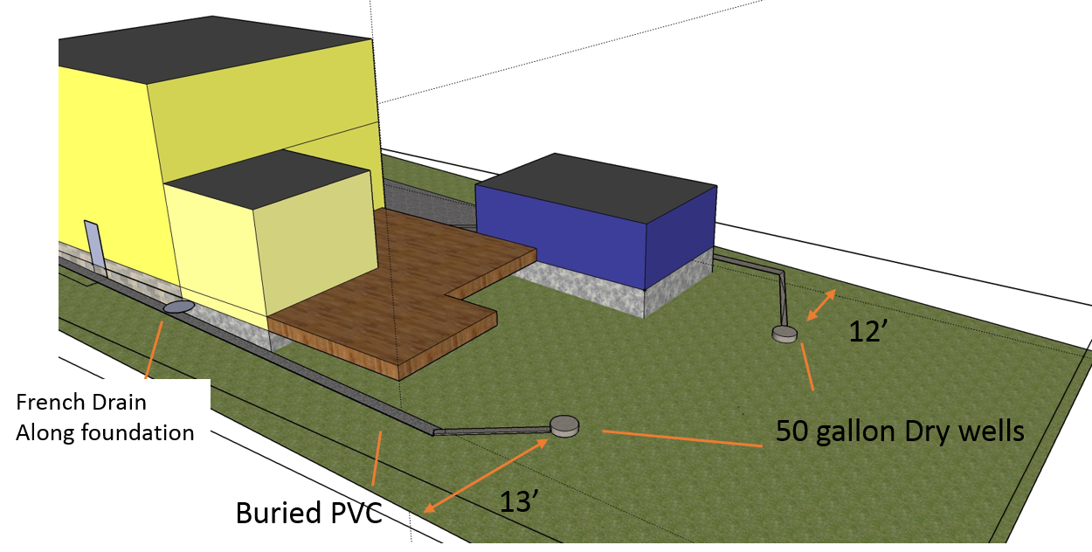

On the East side of the house is the gravel driveway and garage. Along with the French drain I will install a drain grate perpendicular to the drive, just above the garage. This will lead into a French drain that follows along the garage foundation. Buried PVC pipes will lead the water into the dry well in the backyard.
Altogether I'm estimating 75' of French drain, an additional 25-50' of buried PVC pipe, and 2 50 gallon dry wells. The East dry well will accept water from an impervious area of 156 sq ft, and the West will accept water from 216 sq ft. This will not impact any neighboring properties since the water will be captured and diverted to the dry well in the backyard, and these wells are more than 10’ from the property line.

Reference photos below:

