Inspection Services Department of Urban Development
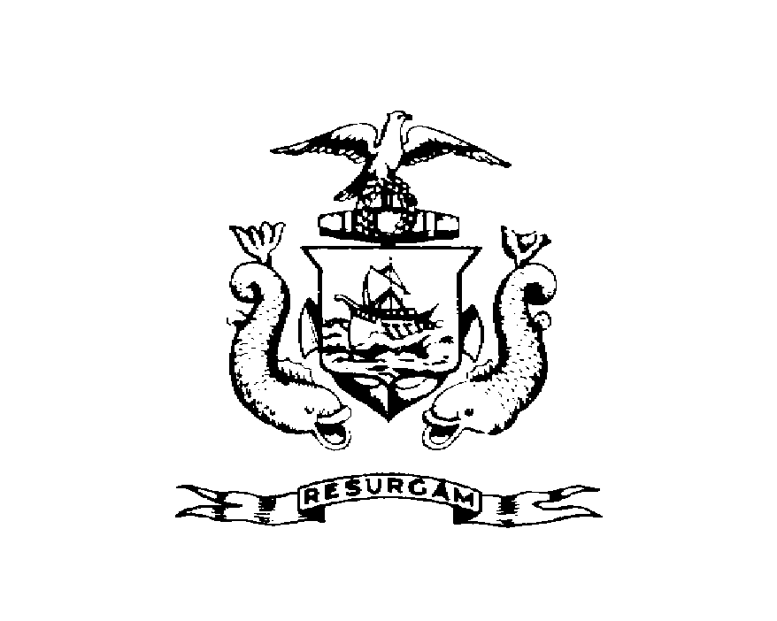
Michael J. Nugent Joseph E. Gray, Jr.
Manager Director

CITY OF PORTLAND

March 31, 2000

Jonathan Mailman
17 West Kidder Street
Portland, ME 04103

RE: 17 West Kidder Street
CBL: 168-J-002
CERTIFIED MAIL RECIPT: Z 275 867 926

Dear Mr. Mailman;

An evaluation of your property at 17 West Kidder Street on 3/29/2000 revealed that the premises fails to comply with Section 12.19 of the Garbage and Solid Waste Removal Code of the City of Portland.

Following is a description of the violations:

Trash in yard must be cleaned up/removed.

This is a notice of violation pursuant to Section 12-30 of the Code. All referenced violations shall be corrected within 30 days of the date of this notice. A re-inspection of the premises will occur on May 1, 2000 at which time compliance will be required. Failure to comply will result in this office referring the matter to the City of Portland Corporation Counsel for legal action and possible civil penalties, as provided for in Section 1-15 of the Code and in Title 30-A-M.R.S.A. Ss 4452. Please feel free to contact me at 874-8702, if you wish to discuss the matter or have any questions.

Sincerely,

Jon Reed
Code Enforcement Officer

CC: Central File

