Order 98-04/05
Given first reading: 11/1/04 Postponed on 11/15/04
Public hearing, Amended & Passage 11/29/04 9-0
NATHAN H. SMITH (MAYOR)(3)  WILLIAM R. GORHAM (1)  KAREN A. GERAGHTY (2)  CHERYL A. LEEMAN (4)  JAMES I. COHEN (5) | CITY OF PORTLAND  IN THE CITY COUNCIL | PETER E. O’DONNELL (A/L)  JAMES F. CLOUTIER(A/L)  JILL C. DUSON (A/L)  NICHOLAS M. MAVODONES (A/L)

ORDER AUTHORIZING AMENDMENT TO CITY CODE
SEC. 14-49 (ZONING MAP AMENDMENT)
RE: CONDITIONAL REZONING FOR PROPERTY
IN THE VICINITY OF
MORRILL’S CORNER/ALLEN AVENUE

ORDERED, that the Zoning Map of the City of Portland, dated December 2000 as amended and on file in the Department of Planning & Development, and incorporated by reference into the Zoning Ordinance by Sec. 14-49 of the Portland City Code, is hereby amended to reflect a conditional rezoning as detailed below.

CONDITIONAL ZONE AGREEMENT
PACKARD DEVELOPMENT, LLC

AGREEMENT made this ___ day of _____________, 2004 by PACKARD DEVELOPMENT, LLC a Delaware limited liability company with a mailing address of One Wells Avenue, Newton, Massachusetts 02159, and its successors and assigns (hereinafter “ PACKARD”).

W I T N E S S E T H
WHEREAS, PACKARD seeks to develop property located at and in the vicinity of 33 Allen Avenue in the City of Portland and identified on the City of Portland on the Assessor’s maps at Map 435, Block G, Lots 10-12, 21, 22, and 26; Map 151A, Block A, Lots 12 and 13; Map 152, Block C, Lots 2 and 5; and Map 435, Block D, Lots 15, 16, 17 and 18 (hereinafter referred to as the “PROPERTY”)(See Exhibit A); and

WHEREAS, PACKARD proposes to develop the PROPERTY as a mixed use development, including residential units, a community shopping center with a grocery store, other retail uses, restaurants, offices, and a boxing club/ gym facility; and

WHEREAS, the PROPERTY is currently located in three different zoning districts, R-5, B-2 and I-L; and

WHEREAS, the purpose of this contract rezoning is to provide for a mixed use development, including a community shopping center, residential units, offices and a boxing and fitness facility; and

WHEREAS, substantial public improvements will be required to support any redevelopment of the PROPERTY, including but not limited to traffic improvements in the Morrills Corner area; and

WHEREAS, PACKARD has developed a traffic improvement plan, which plan has been reviewed by the CITY; and

WHEREAS, the Planning Board of the City of Portland, pursuant to 30-A M.R.S.A. § 4352(8) and Portland City Code §§ 14-60 to 14-62, and after notice and hearing and due deliberation thereon, recommended the rezoning of the PROPERTY, subject, however, to certain conditions; and

WHEREAS, the CITY by and through its City Council has determined that said rezoning would be and is pursuant to and consistent with the CITY’S comprehensive land use plan and will establish uses that are consistent with the uses in the original zones and the surrounding areas; and

WHEREAS, the CITY has determined that the proposed development will be designed and operated so that it will prevent undue adverse environmental impacts, substantial diminution of the value or utility of neighboring structures, or significant hazards to the health or safety of neighboring residents by controlling noise levels, emissions, traffic, lighting, odors, and any other potential negative impacts of the proposal through the design and implementation of significant public traffic improvements, stormwater drainage improvements, landscaping and buffering; and

WHEREAS, the CITY has determined that because of the unusual nature and unique location of the proposed development and the need for significant public improvements it is necessary and appropriate to have imposed the following conditions and restrictions in order to ensure that the rezoning is consistent with the CITY’S comprehensive land use plan; and

WHEREAS, on ______, 2004, the CITY authorized amendment to its Zoning Map based upon the terms and conditions contained within this Agreement, which terms and conditions become part of the CITY’s zoning requirements; and

NOW, THEREFORE, in consideration of the rezoning, PACKARD covenants and agrees as follows:

1. Effective thirty days from the affirmative vote of the City Council on rezoning the PROPERTY, by Council Order No. ____, the City amends the Zoning Map of the City of Portland, dated December 2000, as amended and on file in the Department of Planning and Urban Development, and incorporated by reference into the Zoning Ordinance by § 14-49 of the Portland City Code, by adopting the map change amendment for the PROPERTY shown herein.

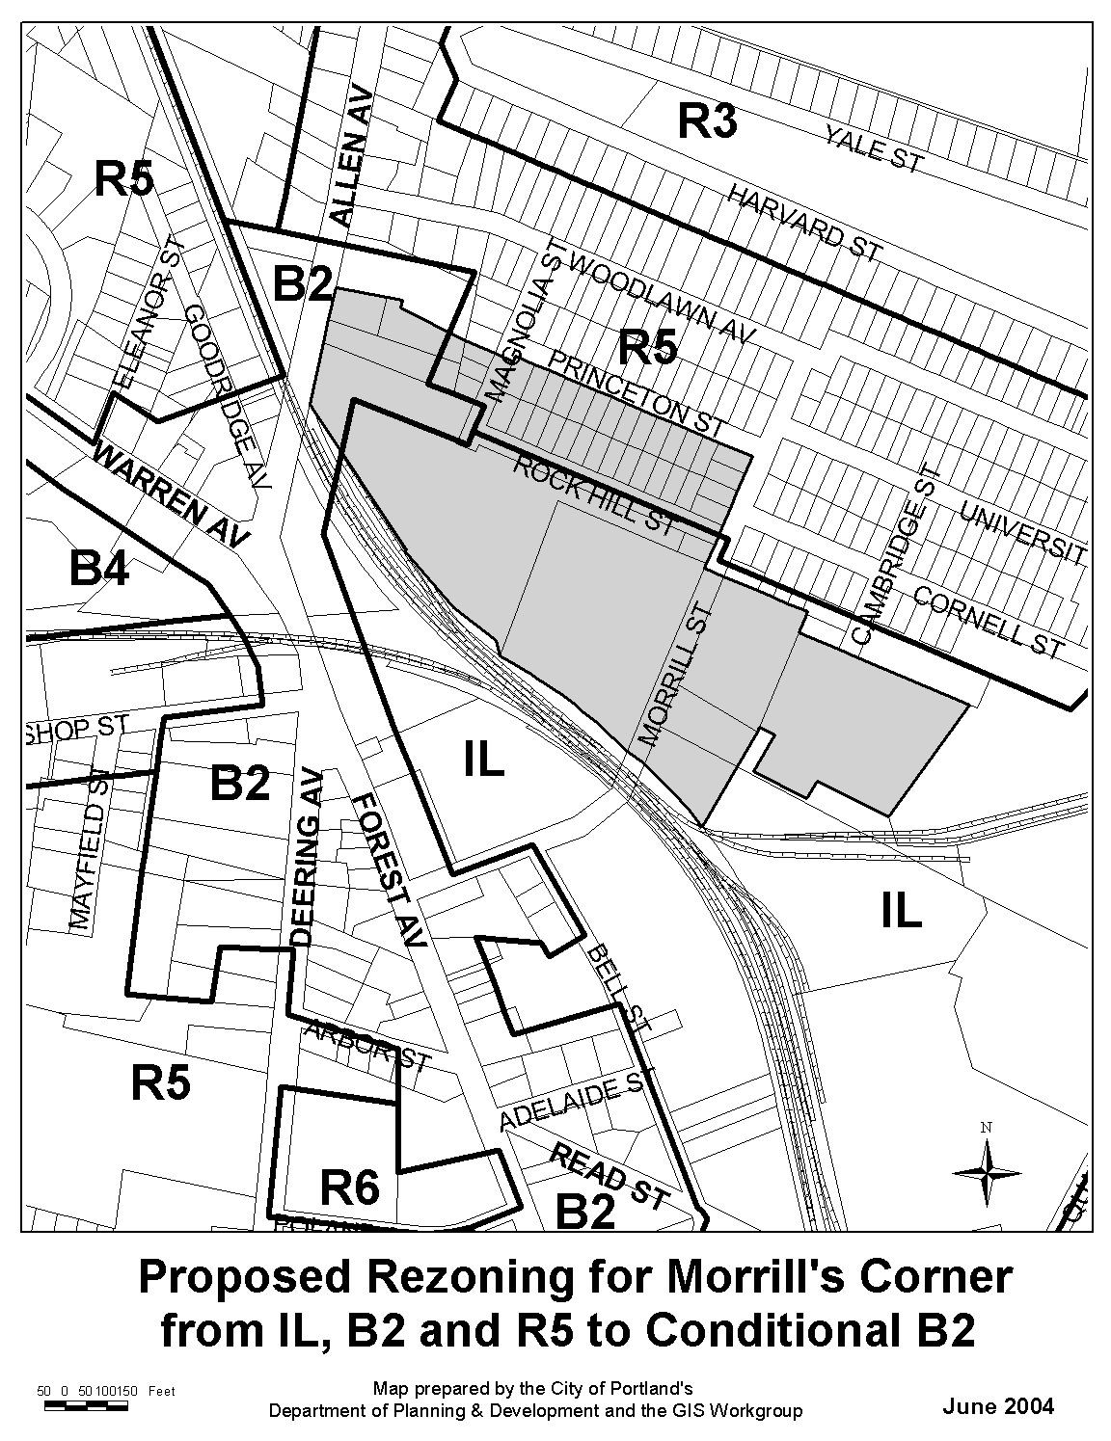

This conditional rezoning shall become null and void and the PROPERTY shall revert to the existing R-5, B-2 and I-L zones in the event that PACKARD fails to record deeds transferring title ownership or long-term leases from White Chapel, LLC; Paul G. and Jonathan White; the City of Portland, except as otherwise provided in Section 6.G of this Agreement; James E. Darling, Jr.; Madeline F. and Jack Adams; and Allen Avenue Plaza, LLC to PACKARD within one year from the date of the Council vote. This one-year period shall be extended up to an additional one year period if:

a. PACKARD has applied for all required approvals but has not received all required approvals within the one-year period;

b. Any other event beyond the control of PACKARD has occurred which will delay the closing on some or all of the parcels and PACKARD has notified the CITY of such event and the projected time period for resolution of the event.

If any required approval, including the approval of the conditional rezoning, has been appealed, then this conditional rezoning shall become null and void and shall revert if PACKARD fails to commence construction of Phase I within one (1) year from the final disposition of such appeal.

2. The following plans and documents are attached and incorporated into this Agreement:
Exhibit A: PARCEL
Exhibit B: Site plan and signage plan

Exhibit C: Minimum off site traffic improvements

Exhibit D: Architectural renderings

Exhibit E: Phasing plan

Exhibit F: Potential lot divisions/long term leases
3. The PROPERTY shall be developed substantially in accordance with the Site Plan shown on Exhibit B (including the layout of the buildings, pedestrian and vehicular circulation plan, open space, drainage, and landscaping) and the architectural renderings shown on Exhibit D, provided, however, that each Phase, whether classified as a major or minor development, shall be subject to site plan review by the Planning Board, and if applicable, subdivision review by the Planning Board. Any site plan review applications shall fully comply with the Site Plan attached as Exhibit B, and the architectural renderings shown on Exhibit D, and the application requirements contained in article V (site plan) of the Land Use Code. The Planning Board may permit minor deviations from the Site Plan, as long as the deviations are consistent with the purposes of this Agreement. The structure labeled “Existing Boxing/Proposed Expansion” in the northeasterly corner of Exhibit B shall be built with architecture similar to and compatible with that in Exhibit D for the other structures associated with this project.

4. The CITY shall not issue PACKARD any building permits for the project until PACKARD has 1) acquired the PROPERTY in accordance with the requirements of Section 1 of this Agreement and 2) has received all necessary federal, state and CITY permits.

5. Permitted Uses. PACKARD shall be authorized to establish and maintain the following uses on the PROPERTY:
a. Retail establishments, restaurants, business services and personal services, all as defined by Portland City Code § 14-47. Drive through restaurants, gasoline sales and major and minor service stations shall not be permitted on the site.

b. Professional and business offices occupying no more than 25,000 square feet.
c. Day care facilities and adult day care facilities.
d. Exercise and fitness centers, and health clubs, including but not limited to a boxing and fitness facility. Any boxing facility shall comply with the following restrictions:

- Any event at a boxing club located on the PROPERTY with ticket sales or attendance numbers in excess of three hundred (300) hundred shall be limited to twelve (12) times per year; and
- the days of the week such events may be held may be limited by the City, in its discretion, based on concerns of traffic conditions, other events around the City or any other reason deemed to negatively impact public health, welfare or safety; and
3. PACKARD shall notify the CITY’S parking division four (4) weeks in advance of such event.
4. PACKARD shall provide an annual parking management plan to handle the requirements for parking at said events.
5. PACKARD shall include in the annual parking management plan appropriate provisions for prohibiting parking on streets neighboring the property.

The initial plan shall be submitted for review as part of the site plan review for the boxing facility. The plan must include provisions for off site parking and shuttle bus transportation to the PROPERTY. Thereafter, the parking management plan shall be updated annually and shall be reviewed and approved on an annual basis by the City’s Planning Authority and Parking Division, in its discretion . In any case, parking for daily use and for normal boxing club events shall be met on site.

e. Dwellings, as specified herein:

1. There shall be no fewer than ten (10) apartments (which may be combined live/work spaces) located in the building delineated on the Site Plan as “Proposed Mixed Use: Office/Prof. Service/ Retail/ Residential and “Proposed Retail”). The same and their associated parking shall be built in Phase I of the project. These units may serve as the replacement units for housing units to be displaced by construction of Phase I of the development in accordance with the requirements of the City’s Preservation and Replacement of Housing Units Ordinance, § 14-483 et seq. if approved by the City during site plan review. Replacement units shall be available for occupancy before a certificate of occupancy may be issued for the new construction on the original site.

2. There shall be no fewer than 18 or more than 24 townhouses located adjacent to Princeton Street and shown on Exhibit E as Phase II. The same and their associated parking shall be built in Phase II of the project. No temporary or permanent certificate of occupancy shall be granted for the grocery store building until all municipal approvals have been obtained for the Phase II townhouse development and a building permit has been issued for the first townhouse units. Building permits for at least 18 townhouses shall be obtained within 2 years of the commencement of construction of Phase II. PACKARD shall post a performance guarantee in the amount of $50,000.00 per dwelling unit for the 18 townhouses required under this condition (hereinafter referred to as the “Housing Guarantee”), in a form acceptable to the CITY. The Housing Guarantee shall be reduced in amount for every six (6) townhouses built and certificates of occupancy issued for such units. In the event that PACKARD fails to complete any or all of the 18 required townhouses, the CITY shall have the right to all funds remaining in the Housing Guarantee at the time of default. The CITY may utilize the funds in the Housing Guarantee for any housing project or housing-related purpose that it deems appropriate. Notwithstanding any contrary provision of this Agreement, PACKARD’s completion of the 18 townhouse unit development or the CITY’S call of the Housing Guarantee for any or all of the 18 required units shall satisfy PACKARD’s obligations under this subsection to provide 18 dwelling units in Phase II. The Housing Guarantee shall be separate from the performance guarantee required for site improvements on the townhouse site.

3. PACKARD may also construct up to 24 additional units in the area designated on Exhibit B as "Area Reserved for Potential Residential Development" (hereinafter referred to as Phase III) subject to prior subdivision and site plan review. Such development shall comply with the setback and height requirements established for the R-5 zoning district. Pending development of Phase III, the Area Reserved for Potential Residential Development shall be loamed and seeded as part of Phase I of the redevelopment of the site, as required by Section 6. Should PACKARD fail to develop or cause to be developed Phase III within seven (7) years after the date of issuance of the final certificate of occupancy for Phase I, PACKARD shall offer to sell and/or assign to the CITY PACKARD'S interest in the area labeled "Area Reserved for Potential Residential Development" for $100, which offer must be accepted by the CITY within 60 days of its receipt. In the event that the CITY does not accept the offer within the 60 day period, PACKARD shall retain its interest in the Area Reserved for Potential Residential Development, subject to the limitations as set forth in this paragraph. Should the CITY accept PACKARD'S offer, its use of the property shall be limited to development of up to 24 units of housing, subject to subdivision and site plan review.

f. Accessory uses, including, but not limited to, public trails, parking facilities and structures, utility services, stormwater management systems, community meeting center, and site amenities. The uses listed in this subparagraph f shall be functionally related, physically oriented, and complementary to the principal uses of the site.

6. The uses on the PROPERTY will be within multiple buildings, which shall be constructed in phases as specifically set forth on Exhibit E. All sections of Phase I and Phase II are required to be developed. Phase II shall be constructed in accordance with the schedule requirements set forth in Paragraph 5 e.

The following improvements must be constructed during Phase I: no fewer than 10 housing units in compliance with Portland City Code § 14-483 et seq., minimum off-site traffic improvements as shown on Exhibit C, the trail network shown on Exhibit B and E (except for that area labeled “Proposed Pedestrian Way in Princeton Street Right of Way” which shall be constructed as part of Phase II), the construction of the multi-purpose field and the Area Reserved for Residential Development shall be loamed and seeded. No certificate of occupancy at this site will be issued for any purpose, unless and until such improvements are completed. Trails shall be constructed with bituminous surface or another surface approved by the City and complying with trail construction specifications of Portland Trails.

If the PROPERTY is constructed in Phases, in addition to the requirements contained in the Portland City Code, PACKARD nonetheless will be required at the outset to post a performance guarantee to cover all of the following improvements regardless of the Phase:

- Landscaping for approved portions of the plan and any temporary landscaping or screening determined necessary by the Planning Authority, in its discretion, to buffer the adjacent residential zone
- At minimum, the traffic improvements as shown on Exhibit C
- Trail amenities
- Stormwater system

7. Development Standards. All site plans in conformance with Exhibit B and Exhibit D (architectural renderings) may be approved by the Planning Board only if, in addition to the dimensional requirements of paragraph 9 and the applicable provisions of article IV (subdivisions) and article V (site plan), the development meets the following additional development standards:

a. Landscaping: Development proposals shall include a landscape program that is consistent with the landscaping plan shown on Exhibit B. All land areas not covered by structures, parking areas, bus facilities or circulation facilities shall be landscaped and maintained. In order to soften the visual impact of large expanses of pavement in parking lots, vegetation shall be planted or retained in islands or planting strips as shown on Exhibit B. Development proposals shall include appropriate fencing and/or berming and planting treatment of a dense and continuous nature in order to buffer parking lot visibility from adjacent properties.

b. Vehicular access. Vehicular access to the Phase I portion of the site shall be from the signalized access as shown on Exhibit B and shall be coordinated with other minimum off-site traffic improvements as shown on Exhibit C. A gated emergency access shall be provided at the terminus of Morrill Street as shown on Exhibit B. Vehicular access to Phase II shall be as shown on Exhibit B, with the location of the access to the Area Reserved for Potential Residential Development to be established during site plan and subdivision review of such development.
c. Signs: Development proposals shall identify all proposed signage. Building signage shall be designed in proportion and character with the building facades. A pylon sign including tenant signage shall be located as depicted on Exhibit B. All signs shall be constructed of permanent materials and shall be coordinated with the building and landscaping design through the use of appropriate materials and finishes. Signage for the development shall meet the standards established in Section 14-369 for multi-tenant lots in the B-2 zoning district, except as otherwise approved pursuant to Section 14-526(a)(23).

d. Traffic improvements: PACKARD shall be responsible for the design and installation of, at minimum, the off-site traffic improvements shown on Exhibit C, which improvements shall be made at PACKARD'S sole expense, following review and approval by the CITY. Such traffic improvements may include, but not be limited to, roadway widening, signal modifications, installation of a new traffic signal, provisions for bicycle facilities, bus stops, esplanades with street trees, railroad preemption upgrades and pedestrian facilities (e.g. sidewalks, crosswalks). In addition, within twelve (12) months after issuance of the final certificate of occupancy for Phase I, PACKARD shall undertake a post-development traffic study of the unsignalized intersections identified within the scope of the MDOT traffic movement permit. In the event that this study demonstrates that the impact from traffic attributable to the development is materially different than what was approved as part of the project's MDOT traffic movement permit, the CITY may require PACKARD to fund mitigation measures to address those impacts, to the extent that such mitigation is technically and economically feasible. As well, the applicant shall be obligated to mitigate impacts created by the development, to the extent technically and economically feasible, which result in a degradation of traffic service at said intersections.

e. Open space improvements: In addition to the trail and other open space amenities delineated on Exhibit B, PACKARD shall be responsible for improving the parcel currently owned by the CITY and located in the vicinity of Cambridge Street (Tax Map 151A-A-13). PACKARD shall be responsible for the remediation of the site and for grading a level surface, installation of loam and seed or sod, installation of associated parking, creation of appropriate drainage, and installation of irrigation equipment appropriate to create a multi-purpose field. PACKARD shall also be responsible for providing those funds necessary to purchase the playground and similar equipment necessary to improve the multi purpose field to similar condition to the multi-purpose field similar to the CITY’S Fox Street multipurpose field as it exists as of June 8, 2004. PACKARD shall work with the CITY’S Department of Parks and Recreation in determining the design and construction standards for the multipurpose field. In the event that ownership of this parcel will remain with the CITY or will be reconveyed to the CITY after the completion of improvements PACKARD shall be granted or shall retain an easement for its stormwater facilities, which shall be located and incorporated on this site in a manner as to allow the construction and use of the multi-purpose field. The open space in this area shall remain accessible to the users of the PROPERTY, as well as the general public, by use of the walking trails and any other available access.

PACKARD shall deed to the CITY a public recreational easement on and over the “Recreation/Open Space” area, the “Proposed Walking Trail,” the sidewalk traversing the site, as well as the “Proposed Pedestrian Way in Princeton Street Right of Way” as delineated on Exhibit B. PACKARD shall be responsible for installing the “Proposed Walking Trail” as part of Phase I, as shown on Exhibit B and E, of the development. PACKARD shall grant a public recreational easement to the CITY for the trail or other recreational improvements. PACKARD shall also be responsible for construction of the multi-purpose field as set forth above in Phase I unless, after PACKARD has expended all reasonable efforts, permitting by the Maine DEP is held up or delayed for any reason beyond the control of PACKARD. In such case, PACKARD shall have an additional one (1) year from the issuance of required DEP permits in which to install the multipurpose field.

8. Phasing: PACKARD shall be authorized to develop the PROPERTY in multiple phases. These phases shall occur in accordance with the phasing plan attached hereto as Exhibit E. As specified in paragraphs 4 and 5, all sections of Phase I and Phase II are required to be developed. The Area Reserved for Future Residential Development shall be loamed and seeded or constructed for parking/green space as otherwise approved during site plan review.

9. CSO contribution: PACKARD shall be required to contribute up to $100,000.00 to the CITY’S Fall Brook Combined Sewer Overflow project, as determined by Public Works Authority.

10. Dimensional Requirements. The dimensional standards established in Section 14-185 for the B-2 zoning district, as further modified by this Agreement or by Exhibit B, shall apply to the PROPERTY as a whole, and not additionally to individual lots (if any) within the PROPERTY. For purposes of front yard setbacks, the front yard for each office or retail building developed on the PROPERTY shall have as the front yard the area between the building and Allen Avenue. The potential lot divisions for residential development and areas to be subject to long-term ground leases are delineated on Exhibit F. These locations may be changed as part of the subdivision review process. Amendments to these locations, once approved, may occur after Planning Board review and approval of the proposed amendments.

11. PACKARD, and its successors and assigns shall maintain the PROPERTY and the perimeter of the PROPERTY in order to ensure litter and other garbage is not spread/ blown to adjacent properties/neighborhood. PACKARD shall provide to the CITY a Maintenance Agreement which, in the event PACKARD or its successor fails to maintain the PROPERTY, would give the CITY the right to enter the property for purposes of cleaning up litter and debris, and charge PACKARD for its costs. The Property Maintenance Agreement shall include a retrieval program for shopping carts that have been removed from the PROPERTY.

The provisions of this Agreement, including the permitted uses listed in paragraph 2, are intended to replace the uses and requirements of the existing R-5 and I-L zones and to limit and supplement the requirements of the existing B-2 zone as set forth in this Agreement , except that the conditional uses included within Portland City Code § 14-483 are specifically excluded.
The above stated restrictions, provisions, and conditions, including all Exhibits to this Agreement, are an essential part of the rezoning, shall run with the PROPERTY, shall bind and benefit PACKARD, any entity affiliated with PACKARD that takes title to the PROPERTY, their successors and assigns, and any party in possession or occupancy of said PROPERTY or any part thereof, and shall inure to the benefit of and be enforceable by the CITY, by and through its duly authorized representatives. PACKARD shall record a copy of this Agreement in the Cumberland County Registry of Deeds, along with a reference to the Book and Page locations of the deeds for the PROPERTY.

If any of the restrictions, provisions, conditions, or portions thereof set forth herein is for any reason held invalid or unconstitutional by any court of competent jurisdiction, such portion shall be deemed as a separate, distinct, and independent provision and such determination shall not affect the validity of the remaining portions hereof.

Except as expressly modified herein, the development, use, and occupancy of the subject premises shall be governed by and comply with the provisions of the Land Use Code of the City of Portland and any applicable amendments thereto or replacement thereof.

In the case of any issue related to the PROPERTY which is governed by this section, neither PACKARD nor its successors or assigns may seek relief which might otherwise be available to them from Portland's Board of Appeals by means of a variance, practical difficulty variance, interpretation appeal, miscellaneous appeal or any other relief which the Board would have jurisdiction to grant. Nothing herein, however, shall bar the issuance of stop work orders.

This conditional rezoning agreement shall be enforced pursuant to the land use enforcement provisions of state law (including 30-A M.R.S.A. § 4452) and City Ordinance. Following any determination of a zoning violation by the Court or the Zoning Administrator, the City Council, after recommendation of the Planning Board, may amend, modify or rescind its conditional rezoning of the site.

WITNESS: PACKARD DEVELOPMENT, LLC

________________________________ By_________________________________

Its: _____________________________

COMMONWEALTH OF MASSACHUSETTS
MIDDLESEX, ss. __________________________, 2004

Personally appeared before me the above-named ___________________, in his/her capacity as __________________________, and acknowledged the foregoing instrument to be his/her free act and deed in his/her said capacity and the free act and deed of Packard Development, LLC.

Before me,
___________________________________
Notary Public/Attorney at Law

/tmp/in/input.doc

