Spaulding Engineering and Construction Services, Inc.
24 Common Street ~ Waterville, Maine 04901
Phone (207) 861-9923 ~ Fax (207) 861-9923

WEEKLY CONSTRUCTION REPORT

Report # 1

Project: | CMP Portland Service Center – 5’-6” East  Truck Bay Addition |  | Date: 09-26-11
Location: | Portland, Maine
Contractor | H.E. Callahan Construction Company
Client: | Central Maine Power Company
From: | Jack Belyeu | SECS-Technician
To: | Bob Meader

Work Completed This Week: | (W/E) 09-23-11

DAYS ON SITE: (4)
- Removed all pavement and gravel in the building addition area.
- Discovered higher rock in the bay 2 - 6 areas. Brought in hoe-ram and removed rock to 2 feet below finished grade. Completed mechanical rock removal on Wednesday, 9-21.
- Completed approximately 45% of concrete demolition on the existing slab to allow tie-in of the new slab. Concrete work was halted on Friday due to office noise issues. H.E. Callahan was directly to complete the remaining demolition on Saturday 9/24.
- Installed all formwork and reinforcing for the entire new addition wall. Formwork and reinforcing was inspected by J. Belyeu on 9-23-11 prior to concrete placement. Modifications to reinforcing and concrete footing stepping due to the rock was discussed and approved by D.E. Spaulding P.E. Formwork and reinforcing was also inspected by Nick Adams of the city of Portland on 9-23.
- 18 cubic yards of concrete was placed for the entire addition footings on Friday 9-23-11
- Demolition of the existing concrete slab to allow tie-in of the new concrete slab was completed on Saturday 9-24.

5 | Days worked this week | 1 | Day(s) lost due to inclement weather.

Manpower

H.E. Callahan Construction |  | Varied 1-2
Colex |  | 2
Williams |  | Varied 3-4

Project Status

5% |  | Complete |  | Scheduled Completion Date | 11/30/11

X |  | on schedule | or | _______ days/weeks ahead/behind schedule

Work Planned for Next Week:

- Remove footing forms.
- Form and place entire addition walls and pier concrete.

Problems/Issues:

- Rock in bays 2-6 was encountered in several locations higher than the minimum 2’ depth required. Colex brought in hoe-ram was brought in and rock was removed by mechanical methods. Work completed in one day on Wednesday 9-21.
- Demolition of existing building concrete slab for the new slab tie-in caused too much noise for the office staff above the work area. Concrete demolition work was stopped and H.E. Callahan was directed to complete the concrete removal on Saturday, 9-24.

Visitors:
Dan Spaulding, SECS – Tuesday 9-20
Nick Adams, City of Portland – Friday 9-23
Jack Belyeu, SECS – Tuesday 9-20 & Friday 9-23

Other:

- Change Order #1 for mechanical rock removal was issued and approved.
- Change Order #2 for Saturday concrete demolition was issued and approved.

Signature _____________________
Jack Belyeu

CC: Marc Geaumont, CMP
Steve Willette, CMP
Tom Daniels, CMP
Dave Lepage, HEC
Phil DiPierro, City of Portland
Jonathan Blanchard, HEC

Attachments: Photos

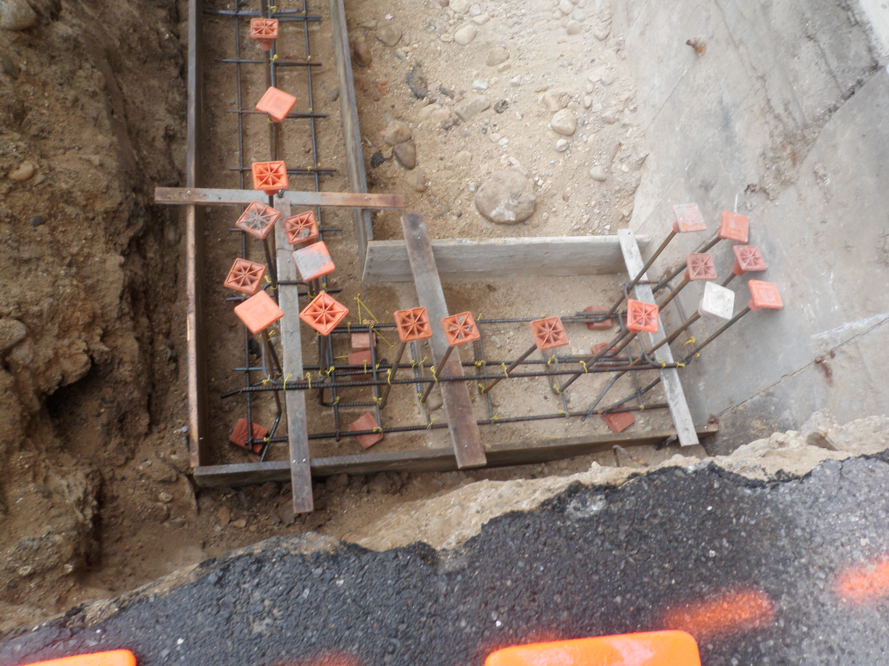
09-20-11 Forming and reinforcing for new addition footing.
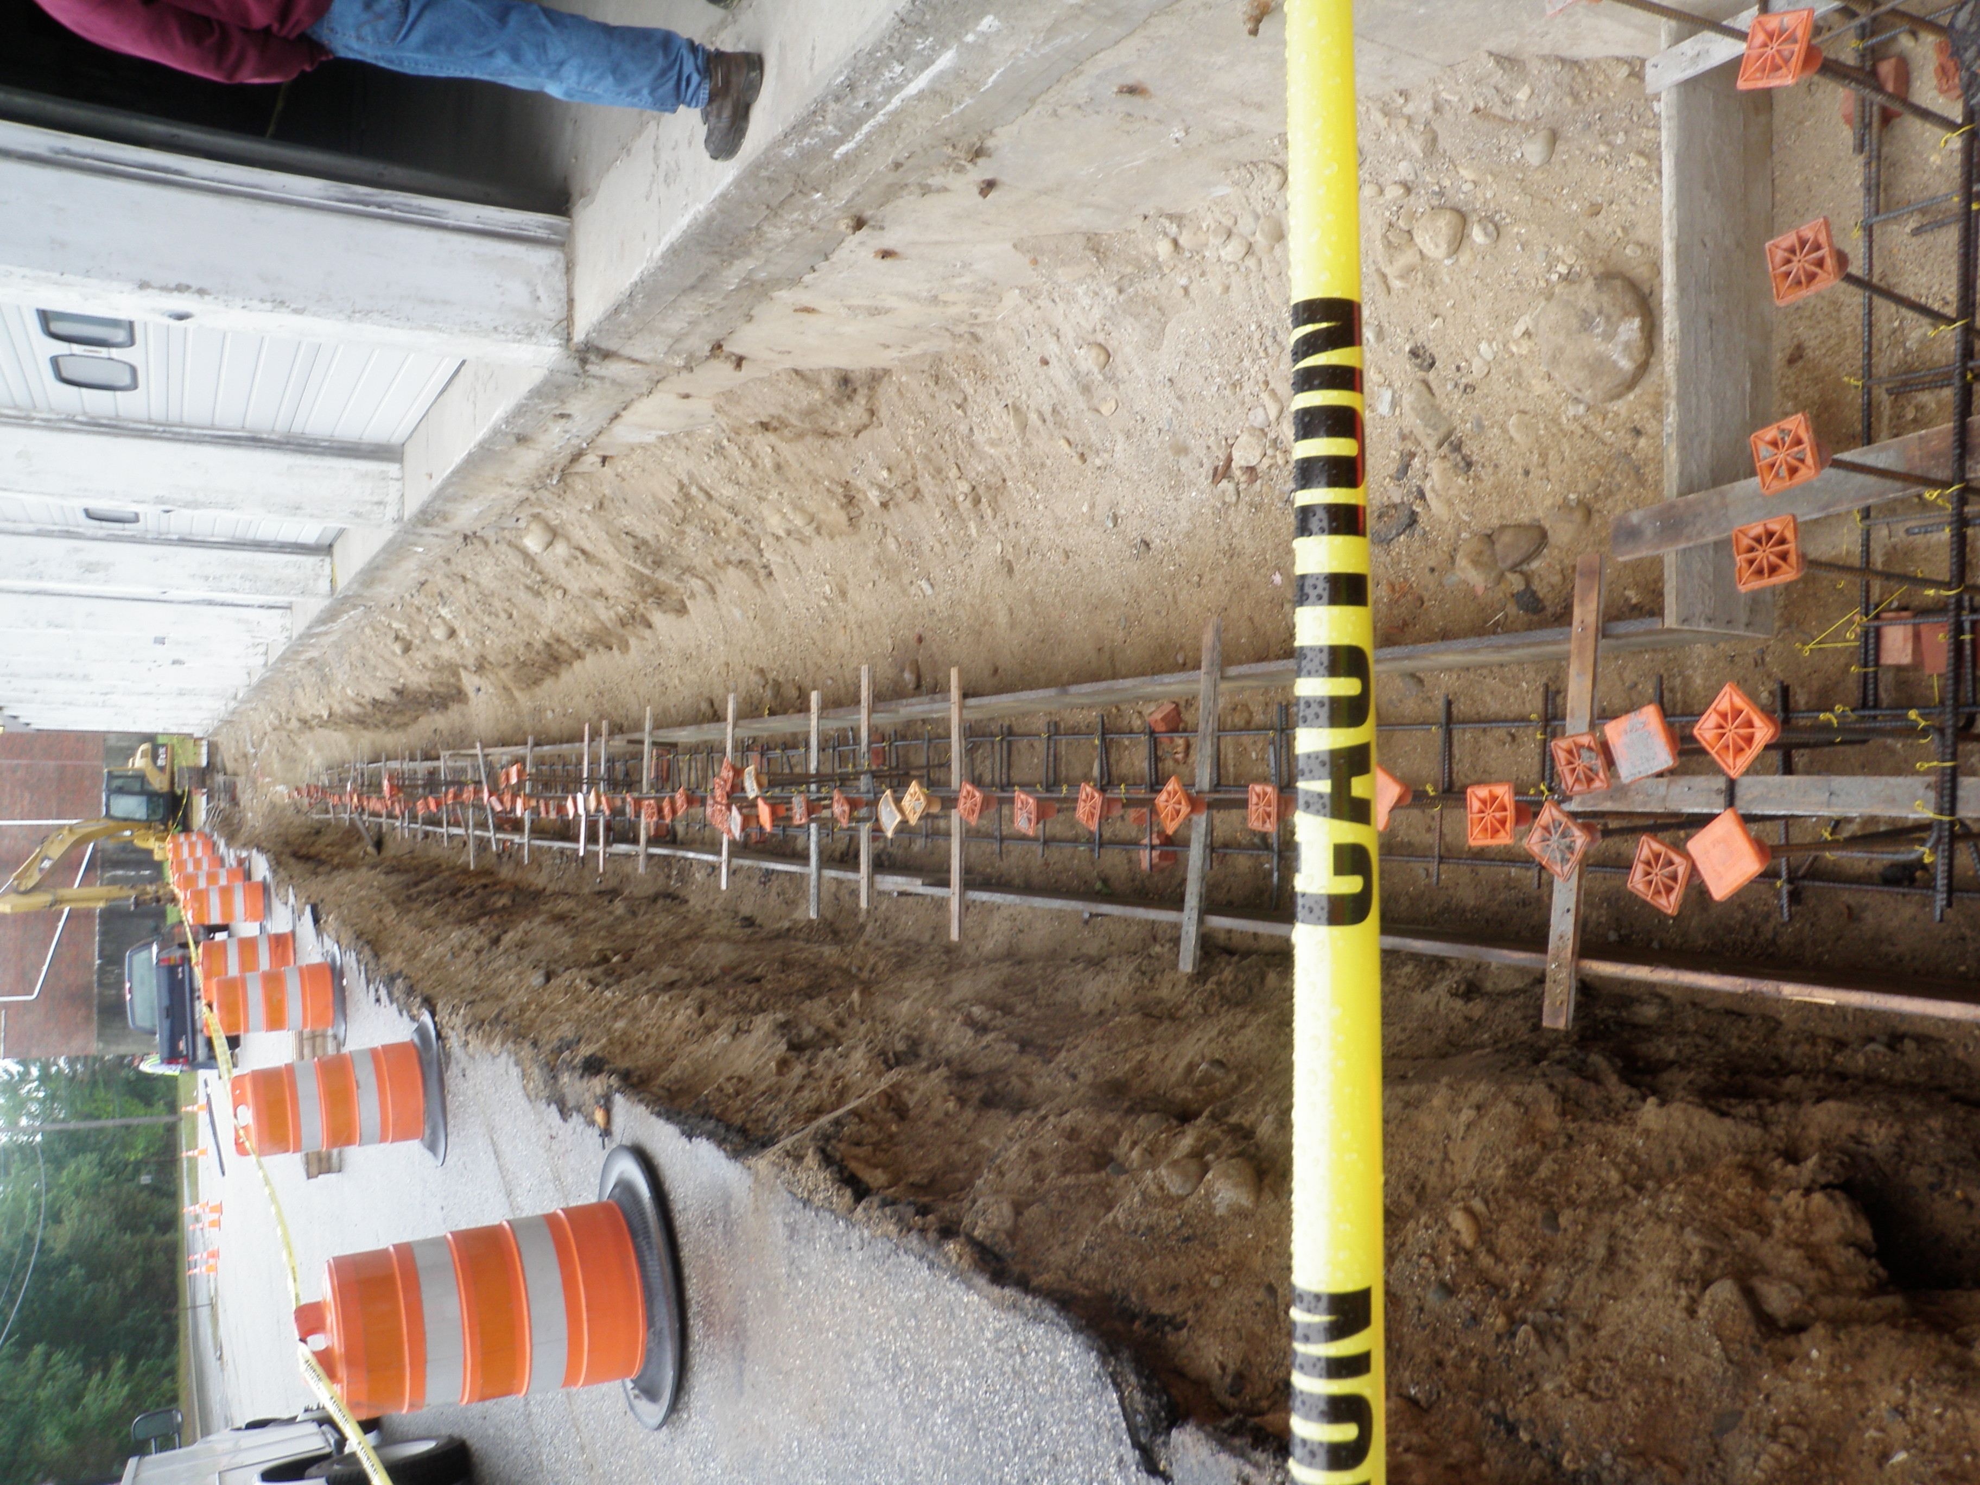
09-20-11 Forming and reinforcing for new addition footing.

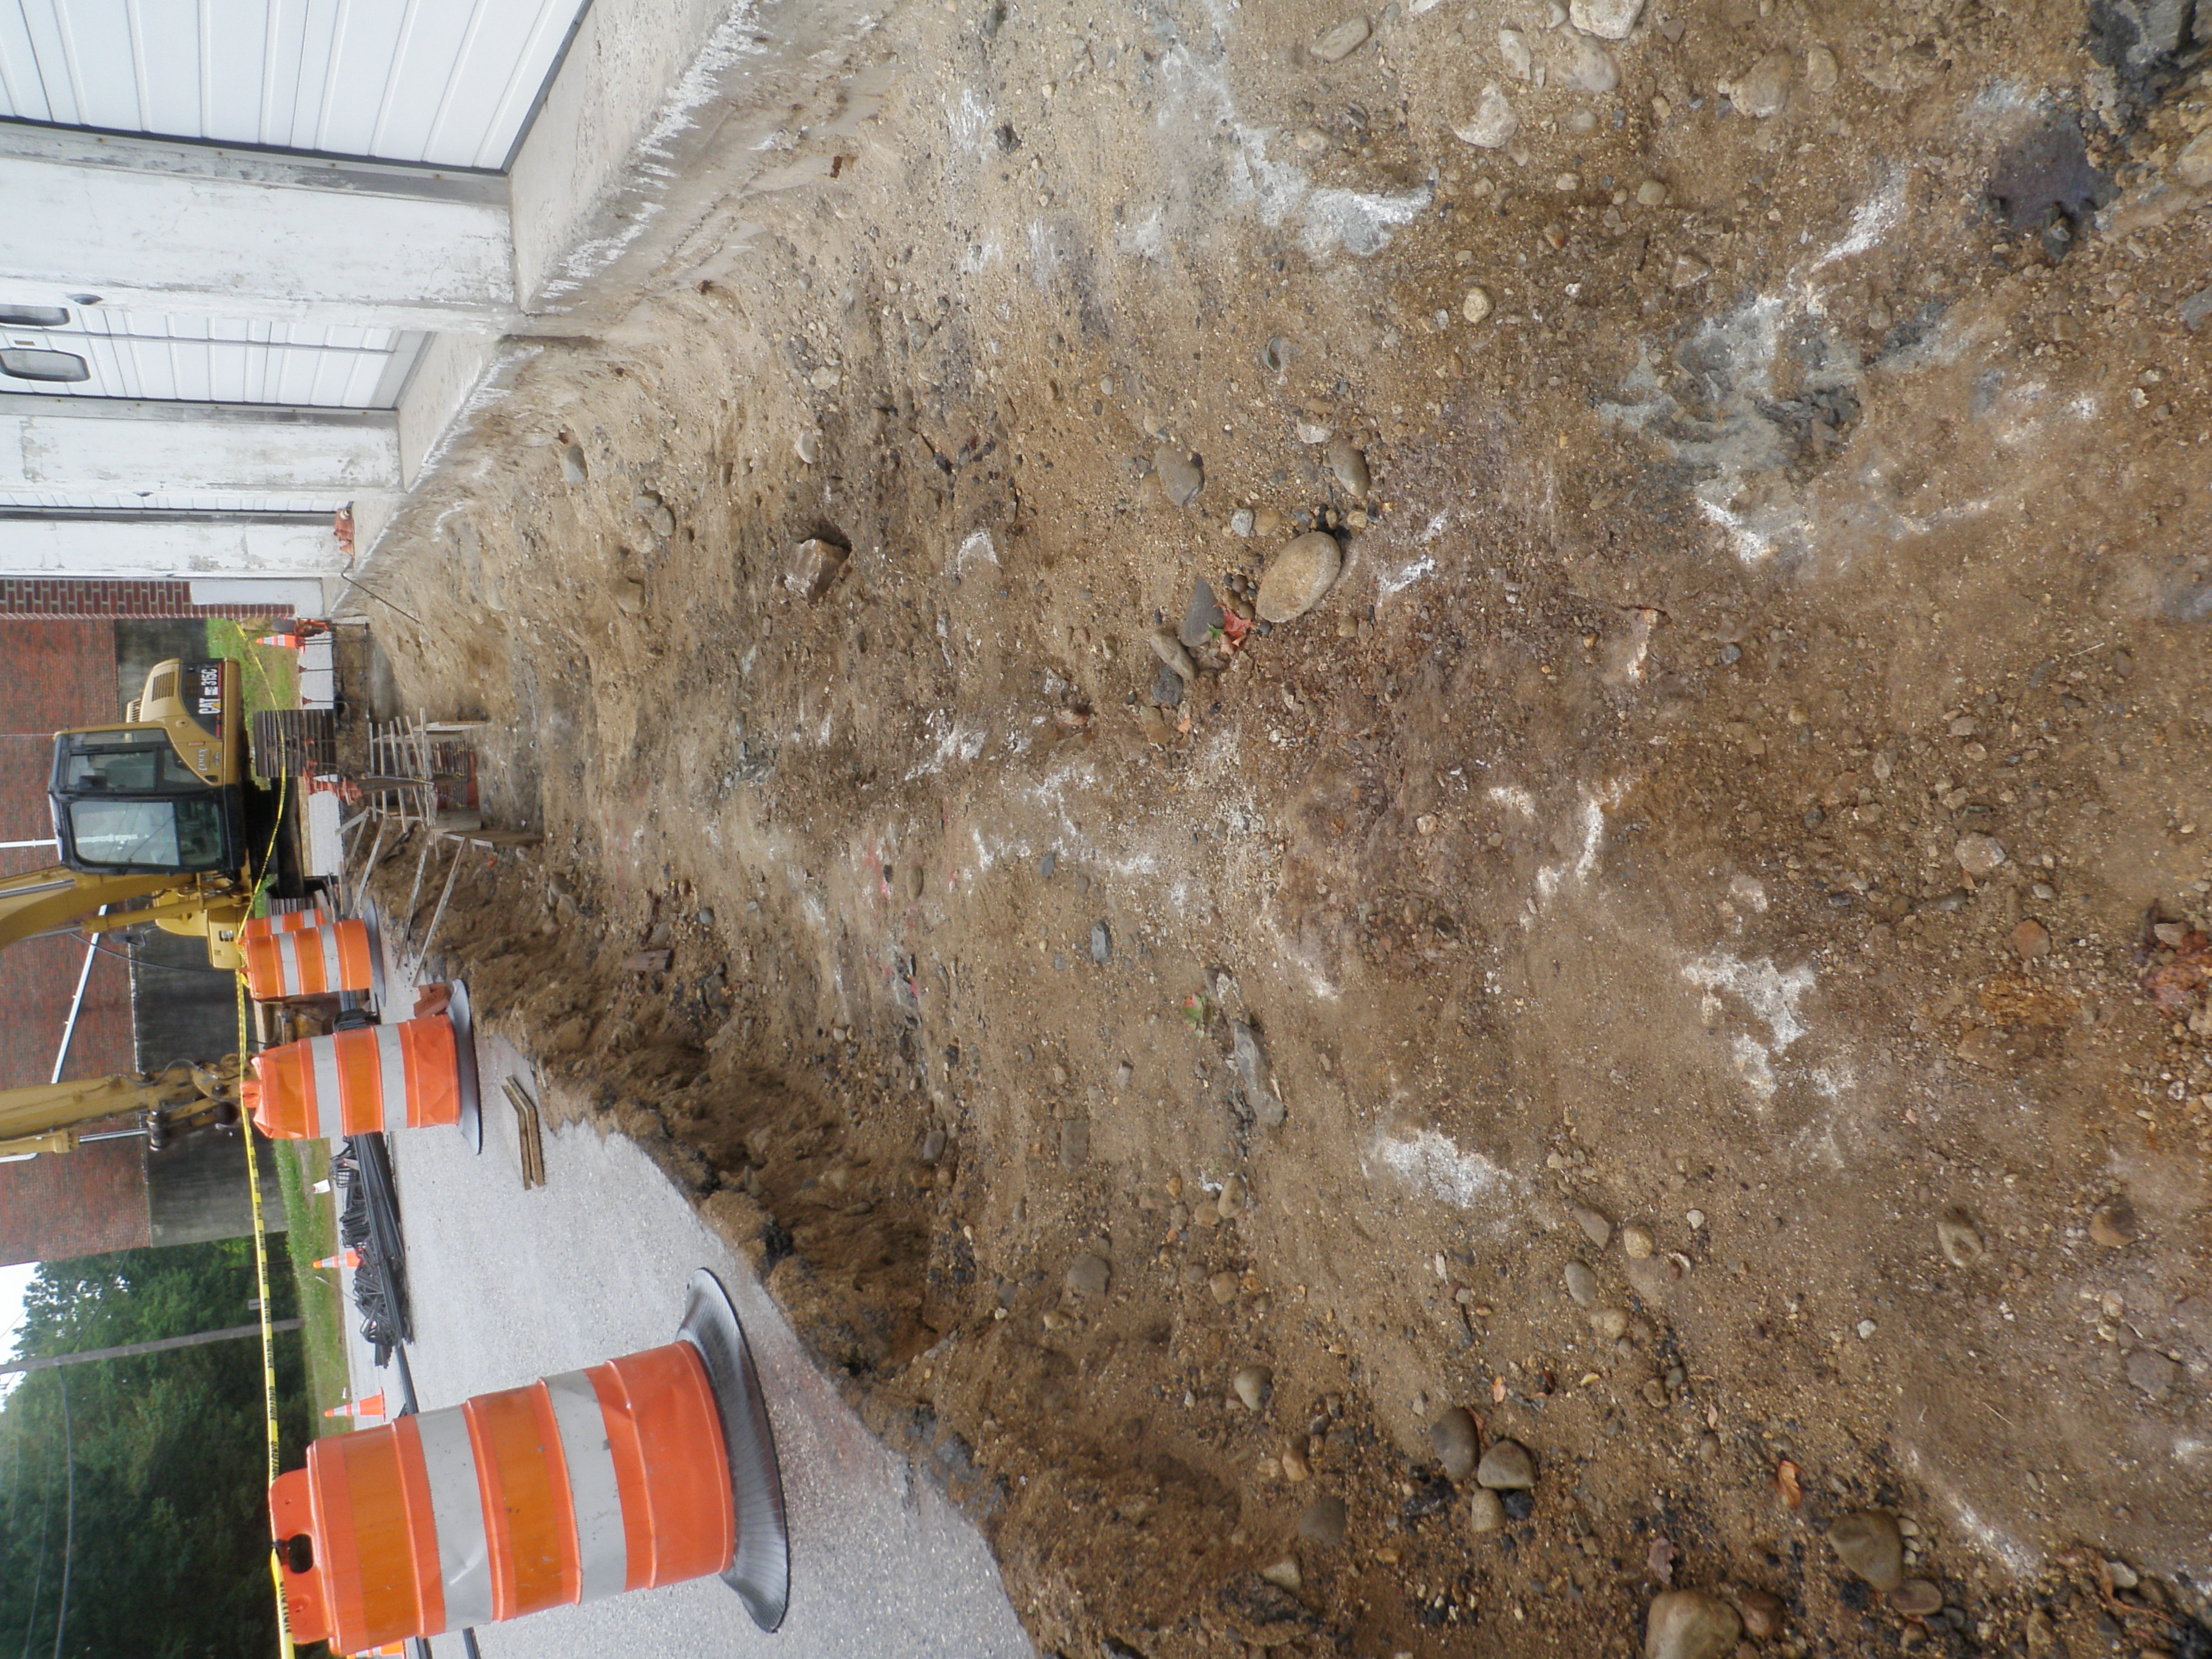
09-20-11 High rock between bays 2-6. Mechanical hoe-ram was used to remove.
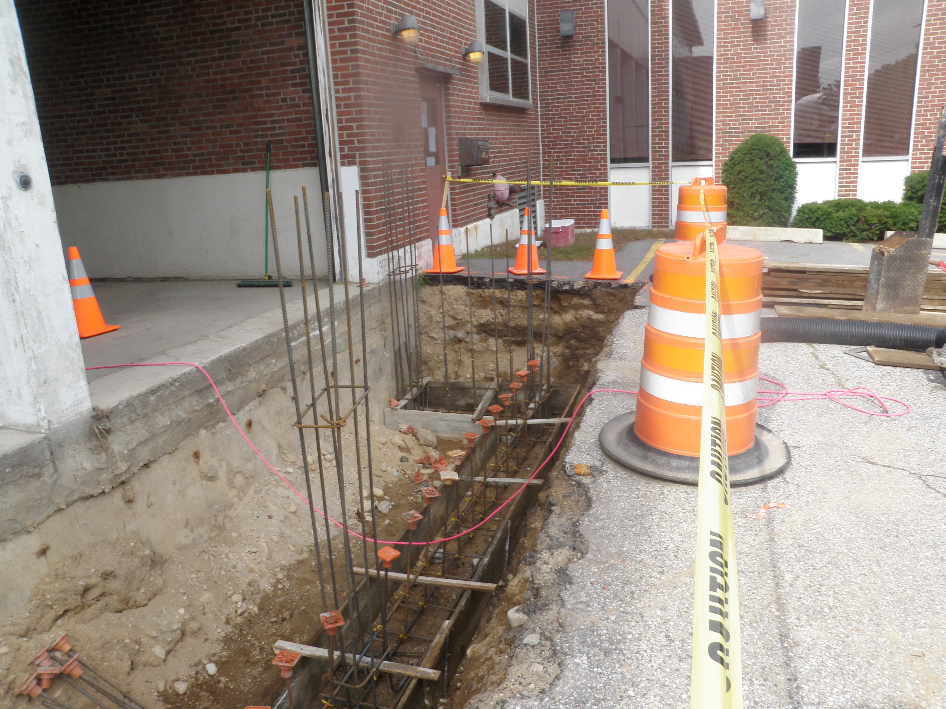
09-23-11 Forms and reinforcing in-place ready for concrete placement.

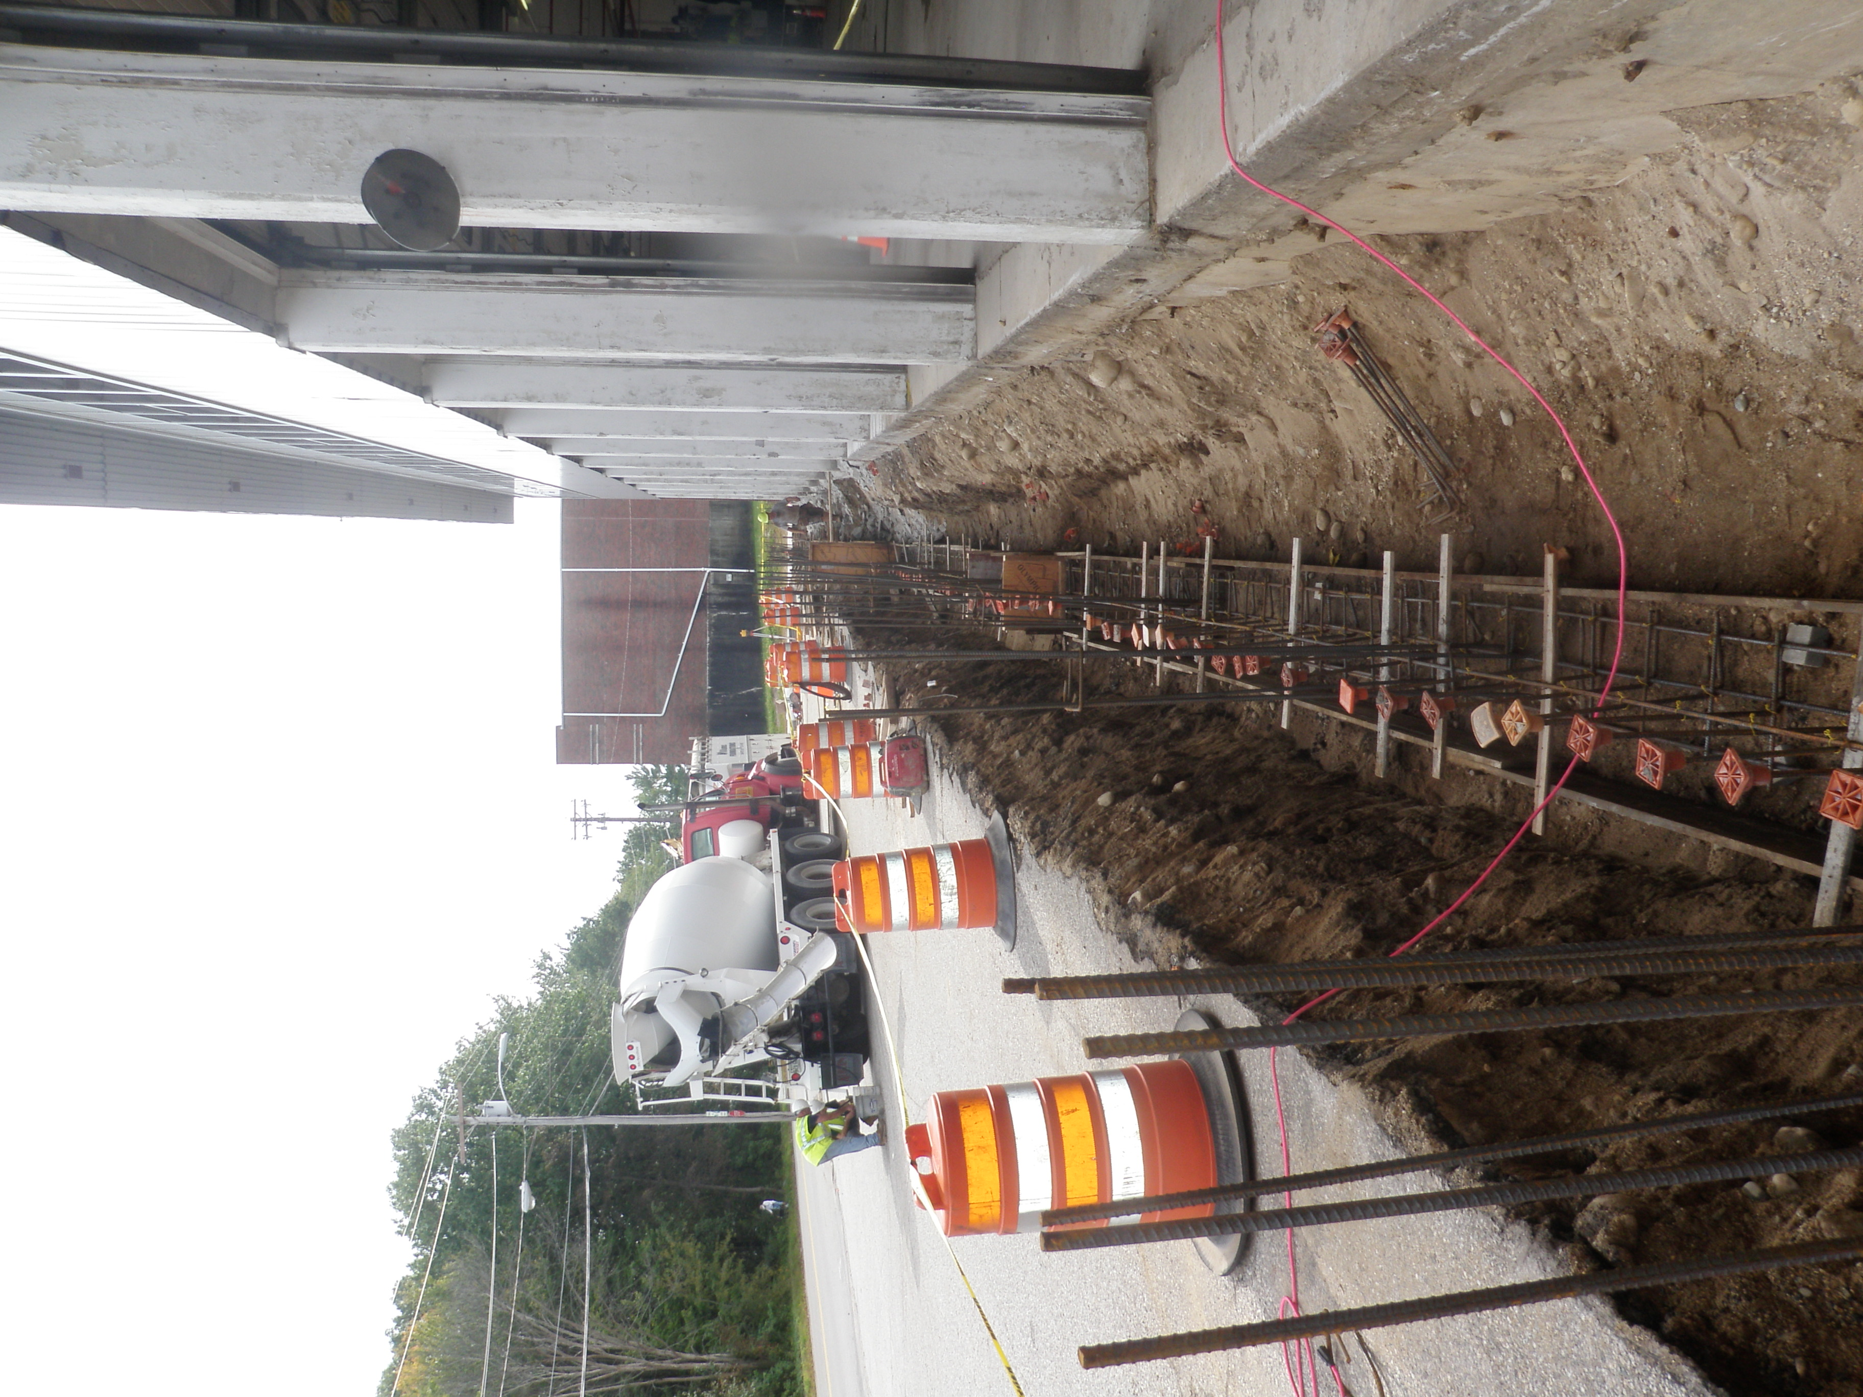
09-23-11 Forms and reinforcing in-place ready for concrete placement.
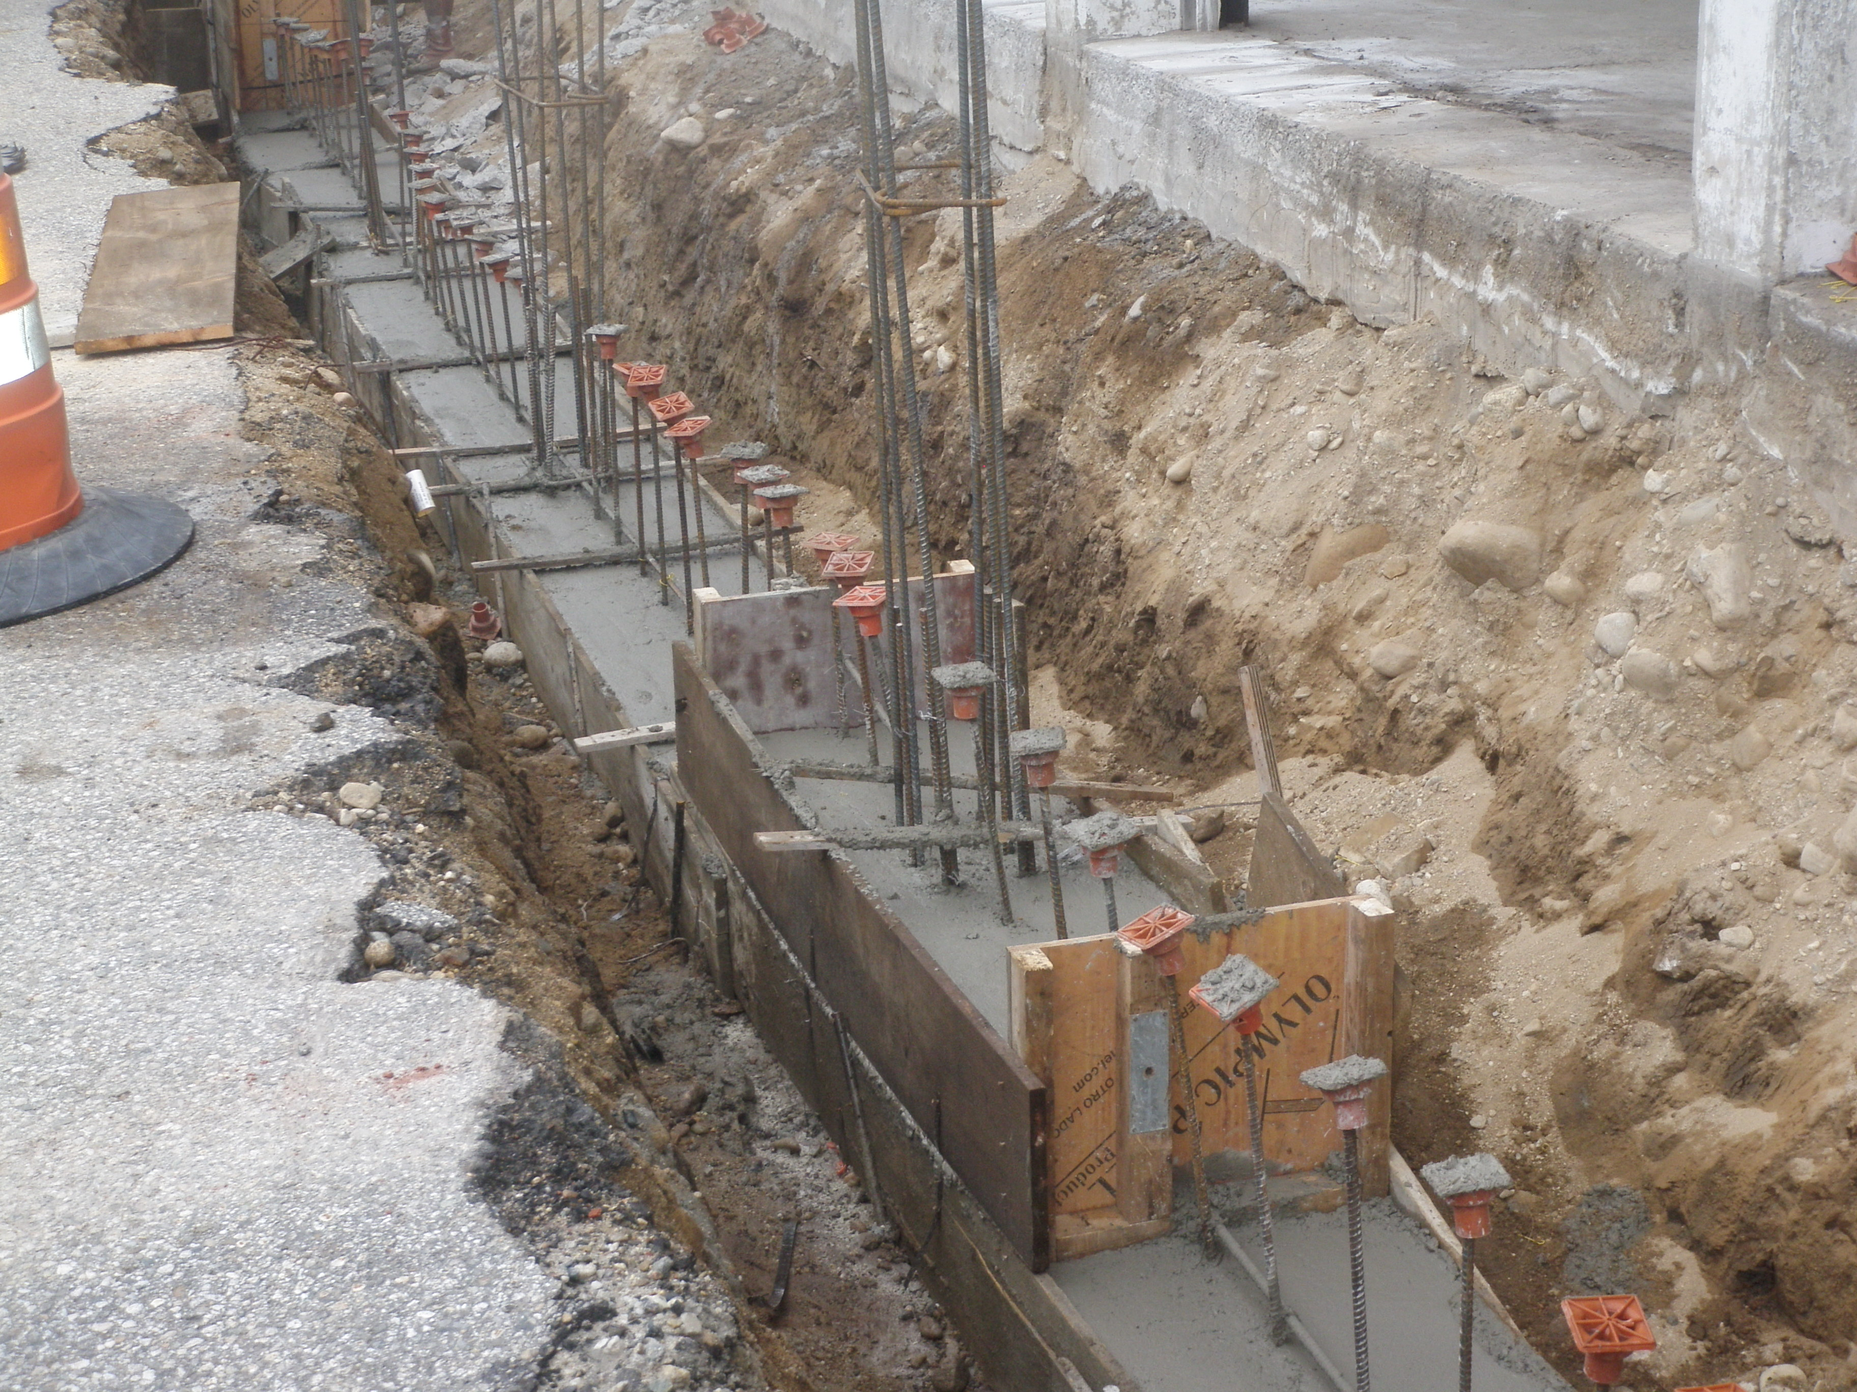
09-23-11 Concrete footing placed.

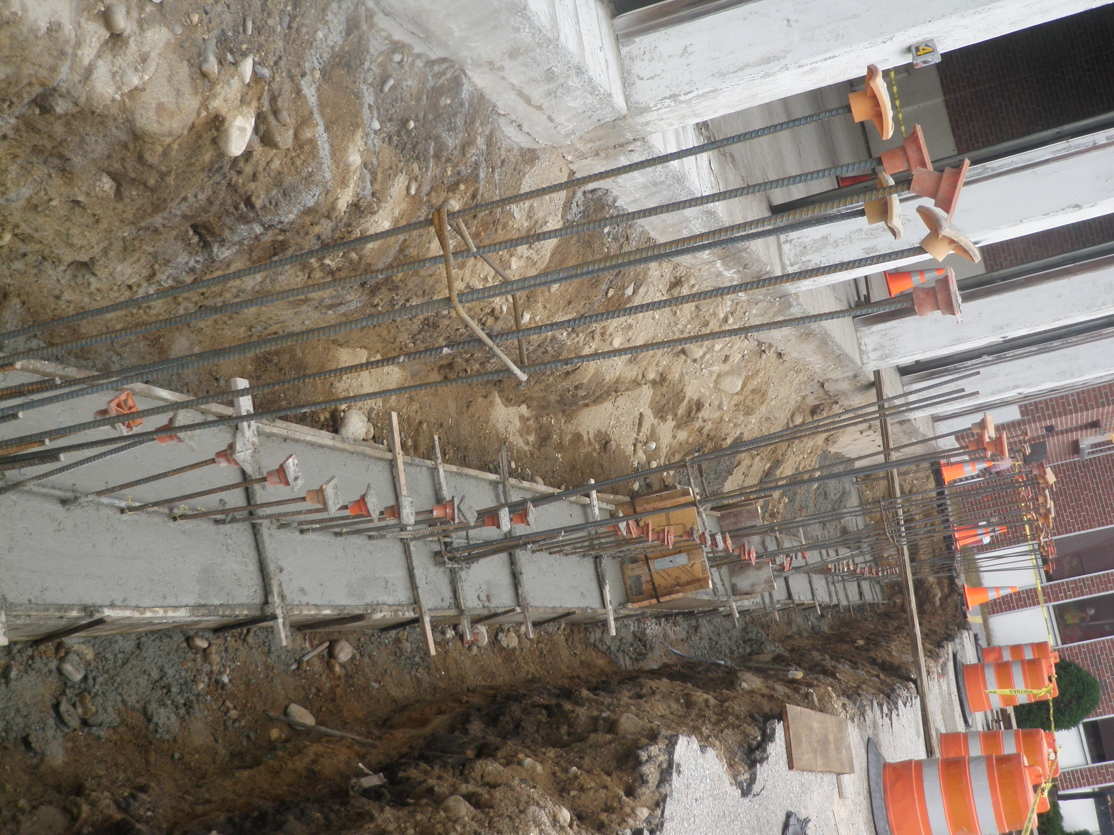
09-23-11 Concrete footing placed.

