June 30, 2014

Ms. Barbara Barhydt
Development Review Services Manager
City of Portland
389 Congress Street
Portland, Maine 04101

Re: Park Danforth
777 Stevens Avenue
Request for Map Change
And Text Amendment

Dear Barbara,

On behalf of The Park Danforth we are pleased to submit the following application for a zone map change and text amendments for the properties identified as Tax Map 146 Chart C Lots 6-9, 11, 12 & 14 situated between Stevens and Forest Avenues. The Park Danforth is an elderly residential housing entity that has been in existence for over 130 years in the city of Portland. The proposed map change and text amendments are being proposed to address an expanded housing program and site enhancement to offer a quality environment for an aging population.
History
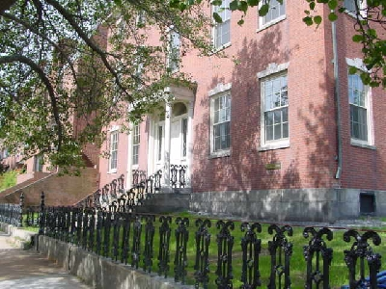
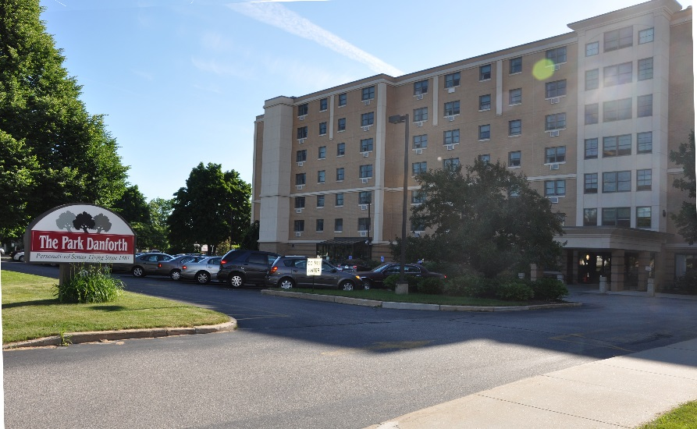
The Park Danforth, a not-for-profit corporation, has been in existence for over a 130 years, evolving from the “Mercantile Home for Aged Men” located at the corner of Park and Danforth Streets. During the mid - 1970’s the facility model was expanded to provide a larger state-licensed and Medicaid supported residential care program coupled with internal subsidies as well. With financial pressures changing from both state reimbursements and increasing pressure for subsidies from its investments, The Park Danforth considered its options to continue its mission while remaining financially solvent. Making a bold move, The Park Danforth sold its program and property to 75 State Street – another strong not for profit provider – and moved its operations to the current 777 Stevens Avenue location in 1985 with 70 Section 8 apartments and 36 market rate residential apartments for the elderly in the mix. In 1999, to further its mission of service, The Park Danforth expanded the facility to provide 18 new apartments and 36 Assisted Living studios. The current makeup of The Park Danforth today consist of 124 apartments classified by the city as Special Needs Independent Living Units and 36 Assisted Living studios classified by the city as Intermediate Care units, 3 of which are licensed for double occupancy units.
Mercantile Home for the Aged Men
Current location at 777 Stevens Avenue

Mission Statement
“The Park Danforth is a not-for-profit corporation dedicated to providing high quality housing and services to those 60 years of age or older. Our Mission is to provide housing and services to enhance a person’s quality of life, respect personal dignity, and accommodate the need for privacy and self-determination. In doing so, we aim to respond to the individual’s changing needs brought about through aging.”
Existing Conditions
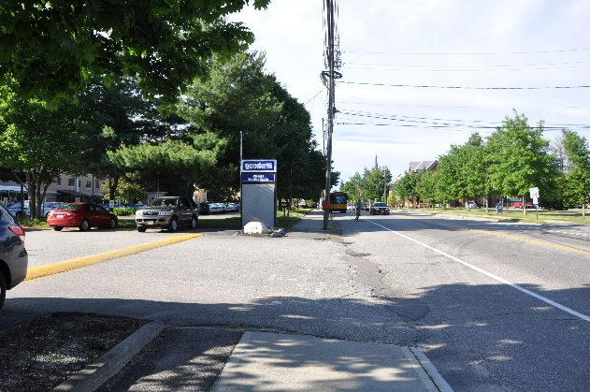
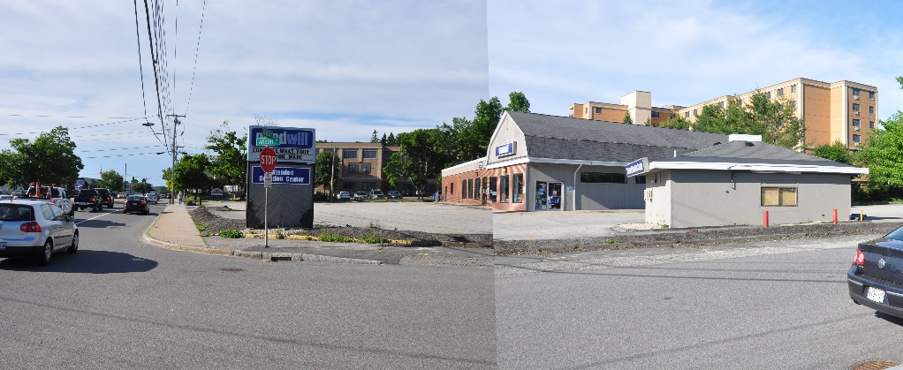
The Park Danforth properties consist of 8 parcels identified on the Assessors maps as Map 146, Chart C, Lot’s 5-12 & 14. Over the past 5 years, The Park Danforth has negotiated the purchase of the adjacent parcels that include the Goodwill properties along Forest Avenue extending to Stevens Avenue and two existing residential properties along Arbor Street and presently own an entire city block with the exception
Goodwill Property, Forest Ave. & Arbor St.
Goodwill entrance: view Stevens Ave south

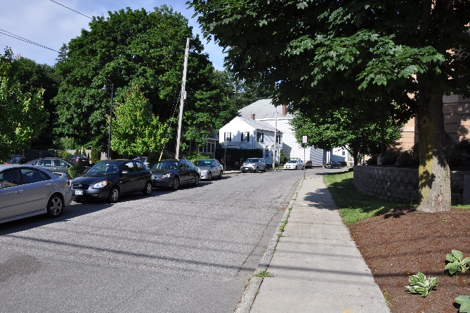
of one residential property, 24 Arbor Street, identified as lot 13. They have been in discussions with the property owner to purchase however due to health issues discussions are temporally on hold. Further discussions will continue when appropriate.
Poland Street
Arbor Street
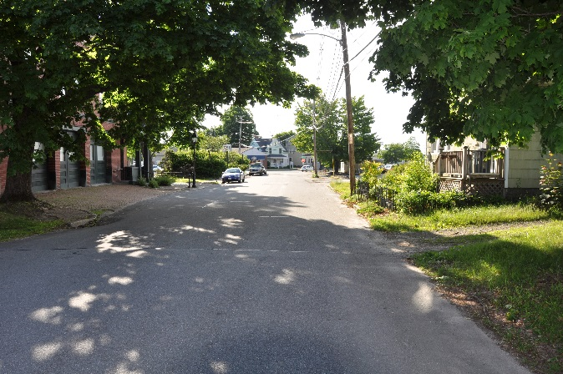
The properties are bound by Stevens Avenue, Poland Street, Forest Avenue and Arbor Street. Of the existing property held by The Park Danforth, Map 146, lot 5 & 10 are presently zoned R6. Lots 6-9 and a portion of 14, held by The Park Danforth, are presently zoned R5 and Lots 11, 12 and a portion of 14, “Goodwill” operation, are zoned B2. Not included in the application is Lot 13, 24 Arbor Street, is also in the R5 zone. The total parcel area of The Park Danforth campus is 179,546 SF or 4.12 acres. The Goodwill site is almost entirely impervious (95% +/-) consisting of two buildings and paved parking, with a lot area of 60,798 +/-SF or 1.40 acres. Of the two Arbor Street properties acquired, one has an existing single family residence and the second parcel is presently vacant.
Proposed Map Change
The Park Danforth is currently developing a master development plan to expand their opportunities for providing elderly housing to include “independent elderly housing” for a younger aging population including those that do not require assistance with daily living but who are looking for housing that provides opportunities for an interactive senior community with amenities and services for their choosing. The target market is 75 years of age plus.
The map change request is intended to include the entire city block as an R6 to reach the density necessary to achieve a successful project. As indicated above, with exception of one residential property on Arbor Street, The Park Danforth owns all of the land within the city block. While the owners of the Arbor Street property have not been contacted to request a letter of support for reasons previously mentioned, they have been informed of The Park Danforth’s intensions. The requested change from the R5 to the R6 designation will have no adverse impact upon the remaining residence.

R5 (Residential) to R6 (Residential)
Chart 146 Block C Lots 6-9 and portion of 14
B2 to R6 (Residential)
Chart 146 Block C Lots 11, 12 and portion of 14
Proposed Development
The Park Danforth currently consist of a seven-story building along Stevens Avenue, and a three-story building along Poland Street. With the acquired parcels along Arbor Street and Forest Avenue, The Park Danforth seeks to build a new structure along Arbor Street and Forest Avenue comprised of 46 new “Independent Living” units on four and five floors with one level of underground parking for approximately 40 cars. The building will be approximately 64,000 SF. excluding the parking level, and 55 feet tall at its highest point.
The majority of the building will be four-stories along Forest Avenue and Arbor Streets with a five-story element at the corner. The interior of the building that faces the existing Park Danforth building will be five-stories. The new building will connect to the existing seven-story building with a one-story structure at the new turn-around. The building will feature varied window sizes, balconies, and materials, to coordinate and complement the existing Park Danforth building.
The proposed campus Master Plan addresses functional open spaces, provides an opportunity to enhance the street presence, address pedestrian and vehicular circulation and safety. The total land area of the parcels making up The Park Danforth Campus is 179,546 +/-SF or 4.12 acres. Current residents and emergency service vehicles will continue to access by the Stevens Avenue-Poland Street entry, circulation will remain as one-way, exiting from a modified existing driveway that will be two-way, providing access to new parking and the new visitor entry. An existing curb cut along Forest Avenue serving the Goodwill is to be eliminated. A reconfigured drive on Arbor Street will be identified as the primary access to the new visitor entrance and for the proposed new elderly independent living units. The Forest Avenue service entrance will be modified to accommodate for enhanced open space garden court yards and to diminish the visual presence from Forest Avenue. Parking will be accommodated for by well distributed parking areas and proposed parking garage to minimize the presence of large areas of paved parking.
Site improvements will include enhanced street presence along Arbor Street and Forest Avenue through extensive plantings and site features including retaining walls, fencing, and lighting, buffering, and parking distributed in small lots. The campus will include two interior court yard gardens to provide safe and functional open space for the varied skill levels of the elderly resident population.

Conformance with Comprehensive Plan
The proposed expansion, density and target market support the goals set-forth in the City’s Comprehensive Plan “Portland’s Goals and Policies for the Future”. The proposed expansion of The Park Danforth provides for the density and mix of housing opportunities identified in the following sections of the Comprehensive plan. The Park Danforth campus will provide for a strong transition between business community along Forest Avenue, with the residential community along Poland Street and the changing UNE campus along Stevens Avenue.

STATE GOAL A: To encourage orderly growth and development in appropriate areas of each community, while protecting the State's rural character, making efficient use of public services and preventing development sprawl;
I. HOUSING: SUSTAINING PORTLAND’S FUTURE – Nov. 18, 2002
Goal
Portland’s Comprehensive Plan encourages a manageable level of growth that will sustain the city as a healthy urban center in which to live and work and to achieve a shared vision for Portland. Portland should encourage sustainable development patterns and opportunities within the city by promoting efficient land use, conservation of natural resources, and easy access to public transportation, services, and public amenities.
Policies
- Encourage growth in Portland that strives for a dynamic balance of the essential elements of the city, such as excellent schools, diverse housing choices, proximity to services and employment, increased public transit usage, expanded economic base, high quality services, and an affordable tax rate.
- Target Portland to achieve and maintain a 25% share of Cumberland County’s population.
- Maximize development where public infrastructure and amenities, such as schools, parks, public/alternative transportation, sewer lines, and roads, exist or may be expanded at minimal costs.
- Create new housing to support Portland as an employment center and to achieve an improved balance between jobs and housing.
- Encourage neighborhood business centers throughout the city to reduce dependence on the car and to make neighborhood life without a car more practical.
- Locate and design housing to reduce impacts on environmentally sensitive areas.
- Design housing to use new technologies and materials that reduce costs and increase energy efficiency.

The expansion of Park Danforth will provide the opportunity, for an aging population, a choice for residents of Portland and Greater Portland to remain in the city and have access to services, transportation and cultural activities. The property is in the heart of a diverse vibrant university community that provides for life-long learning opportunities through adult education programs and UNE offerings. Shopping and services are within walking distance of the campus.
The proposed expansion will incorporate new building technologies and sustainability.

III. A TIME OF CHANGE: PORTLAND TRANSPORTATION PLAN - July 1993

Transportation Plan Guiding Principle
Provide maximum mobility in a balanced transportation system, which encompasses all modes, to support the economic vitality and quality of life of the Portland community.

Land Use and Transportation Link
Link the transportation plan with land use planning policies in the City and region to guide decision-making for development and infrastructure investment.
- Ensure that future growth does not foster auto dependency.

Transportation Policies
- Vibrant neighborhoods include nearby, small-scale commercial areas that provide both convenient service and natural meeting places. Provide routine, daily services within walking distance of residents of all neighborhoods, as long as the businesses providing the services are small-scale, are designed compatibly with residences, and fit into the fabric of the neighborhood.
- Allow development along transit corridors and near community commercial centers to evolve at a density sufficient to make public transit, walking, and biking viable options.

Public transportation is available along Stevens and Forest Avenue with bus stop locations on both street frontages. The property is within walking distance of neighborhood services.

STATE GOAL D. To encourage and promote affordable, decent housing opportunities for all Maine citizens:

I. HOUSING: SUSTAINING PORTLAND’S FUTURE- Nov.18, 2002

Goal
Ensure that an adequate supply of housing is available to meet the needs, preferences, and financial capabilities of all Portland households, now and in the future.

Policies
- Ensure the construction of a diverse mix of housing types that offers a continuum of options across all income levels, which are both renter and owner-occupied, including but not limited to the following:
  - Affordable housing, including starter homes;
  - Housing units for decreasing household size, such as young professionals, empty nesters, single-parent households, and senior citizens;
  - Housing for special markets, such as SRO’s, student or dormitory housing, group homes, and artist housing including live/work opportunities;
  - Higher density housing, such as row houses, small lots, reuse of nonresidential buildings, and mixed use buildings;
  - Housing development that encourages community, such as co-op housing;
  - Housing with a range of services and medical support for the elderly and special needs population, including assisted living, congregate care, group homes and nursing homes; and
- A variety of housing choices should be available such that no one should have to spend more than 30% of their income for housing.
- Encourage higher density housing for both rental and home ownership opportunities, particularly located near services, such as schools, businesses, institutions, employers, and public transportation.
- Increase Portland’s rental housing stock to maintain a reasonable balance between supply and demand yielding consumer choice, affordable rents, and reasonable return to landlords.
- Increase home ownership opportunities for all types of households and all income levels.

- Ensure that a continuum of housing is available for people with special needs and circumstances ranging from emergency shelters and transitional housing to permanent housing (rental and homeownership), which offer appropriate supportive services.
- Identify vacant land and redevelopment opportunities throughout the City to facilitate the construction of new housing.

The Park Danforth will provide a higher density of development and address a growing sector of population, providing for a much needed rental housing for the elderly.

Goal
Maintain and enhance the livability of Portland’s neighborhoods as the City grows and evolves through careful land use regulation, design and public participation that respects neighborhood integrity.

Policies
- While accommodating needed services and facilities, protect the stability of Portland residential neighborhoods from excessive encroachment by inappropriately scaled and obtrusive commercial, institutional, governmental, and other non-residential uses.
- Support Portland’s livable neighborhoods by encouraging a mix of uses that provide goods and services needed and are within walking distance of most residents.
- Encourage innovative new housing development, which is designed to be compatible with the scale, character, and traditional development patterns of each individual residential neighborhood.
- Encourage new housing development in proximity to neighborhood assets such as open space, schools, community services and public transportation.
- Ensure the integrity and economic value of Portland’s neighborhoods.
- Encourage Portland’s neighborhoods to address the City’s housing issues through the Neighborhood Based Planning Process.
- Encourage neighborhood populations that are economically, socially, culturally and ethnically diverse.

The Park Danforth provides an opportunity for affordable market rate elderly as well as subsidized (Section 8 HUD) housing for the aging population. A range of services provided supports the diverse needs of the aging elder population as needs increase, providing the opportunity for individuals to remain independent.

Campus improvements will enhance the character of the residential and university neighborhood providing street presence, incorporating green space and improved circulation.

To provide for the demand and growth of an aging population and maintain the sustainability of the Park Danforth Mission, the proposed master plan incorporates an expansion to include 46 elderly independent living housing units. The opportunity provided by controlling the majority of a city block, creates a campus that has a street presence along all frontages. The goal is to provide an opportunity for an active-wellness based community that provides for social interaction, functional outdoor green spaces, and addresses’ security for a wide range of elderly skill levels.
Proposed Text Amendment
Presently the city land use ordinance does not define “Elderly Independent Living Housing”. Elderly housing needs and housing opportunities have been changing significantly over the past 15 years or better to address a wider spectrum of elder housing needs. Currently, Elderly Independent Living (EIL) housing is interpreted as multifamily housing and equates to a much higher parking requirement. While the ordinance, Division 20 Off-Street Parking Section 14-332.2 (c) allows the Planning Board to determine the required number of parking spaces for projects of 50,000 SF or greater based upon a parking analysis submitted by an applicant. Establishing the required parking for EIL is crucial to the development of this expanded program offering before proceeding to developing plans for Site Plan approval.
As stated above, The Park Danforth is a not-for-profit corporation whose mission is to provide dignified and quality housing to serve an aging population. There is a significant financial and economic hardship associated with development of this property without having an acknowledged defined parking requirement to base a development program on. Based upon a market study and financial evaluation, the expansion, to be financially viable, must have a minimum of 46 dwelling units. The master plan, as presented, has been developed based upon that premise.
To address this, two text amendments are being proposed, one that defines “Independent Living Housing” and one that establishes the parking requirements for “Elderly Independent Living Housing”. Based upon evaluation of industry standards and definitions we are proposing the following language to be added to Division 1 Section 14-47 Definitions:

  - Elderly Independent Living Housing; living units such as apartments, cottages, condominium units, multiplex housing, or single family unit, the occupancy of which is restricted to certain elderly residents. Elderly resident(s) must be 55 years of age or older, or in case of a couple, one who is 55 years or older, and do not require assistance with daily living activities or 24/7 skilled nursing. Such facilities may offer optional services to residents who desire them, such as dining services, basic housekeeping and laundry services, transportation to appointments, social programs and access to exercise equipment.

Division 7. R6 Residential Zone
- Amend Section 14-136. Permitted Uses, (a) Residential: to include Elderly Independent Living Housing as a permitted use as defined in Section 14-47.

- Amend Section 14-139. Dimensional Requirements, (a) 7. Maximum structure height: to include Elderly Independent Living Housing: Fifty-five (55) feet.
The Park Danforth as approved in 1982 is 65 feet tall, the addition along Poland Street is a 3 story addition with a scale that is more in keeping with the adjacent residential and mixed commercial uses. The proposed addition, provides for a transition between the existing 7 story building fronting on Stevens Avenue and mixed commercial scale uses along Arbor Street that include the former Ava Maria Gift Shop, former Arbor Street Fire Station, which is now offices, and the Po’ Boys and Pickles sandwich shop. The side of the building closest to Arbor Street and Forest Avenue will be four stories with the 5 story element located at the midpoint and a 5 story section facing toward the interior courtyard. Forest Avenue is considered a rear yard and requires a 20 FT setback and Arbor Street is considered a side setback (side street) requiring a 15 FT setback. The setback along Forest Avenue is proposed to be 45 FT +/- and the setback along Arbor Street is proposed to be 55 FT +/-.

Division 20 Off-Street Parking
An assessment of parking requirements for Elderly Independent Living Housing was undertaken to identify parking requirements that would meet with the expectations of the program being developed. Communities surrounding Portland have defined elderly housing to address a sector of the population that is constantly changing. Review of the literature and parking requirements from several surrounding communities indicate that elderly independent living communities require fewer parking spaces due to need

for fewer cars. The average number for the intended population is 1 space per dwelling unit.
Portland is fortunate to have a public transit system that is currently looking to expand its role to provide services to the urban population providing more opportunities and reduce the need for automobiles. Based upon review of the industry literature and parking requirements in surrounding communities we are proposing the following amendment to Section 14-332. Uses requiring off-street parking.
Section 14 -332 (a) Residential Structure 3. For residential development on the peninsula (area defined as southerly of I-295) and including off-peninsula R6 zoned areas.
There are only three areas zoned R6 off of the peninsula, they include the current Park Danforth campus, as permitted, Deering Pavilion (Forest Avenue) and Back Cove Apartments (off Forest Avenue). The R6 designation for both Deering Pavilion and Back Cove Apartments only encompass the entire properties.
The Park Danforth as well as Deering Pavilion provide housing for the aging population and both are on Metro bus routes. There is a Metro stop on both the Stevens and Forest Avenue frontages of The Park Danforth.
To support the parking requirement, the attached documentation has been provided:
- Parking requirements for elderly independent living for surrounding communities in the Greater Portland area,

Enclosed for your consideration are the following:
- Zone Map and Text Amendment Application
- Application Fee $3,000
- Letter of Authorization
- Technical Capacity
- Right, Title or Interest- Deeds
- Context Map
- Portland Zoning Map
- Proposed Zone Change Map
- Surrounding Community Parking Requirements
- Boundary and Topographic Survey Plan (Existing Conditions)
- Concept Master Plan A
- Massing Concept Forest Avenue
- Massing Concept Arbor Street
- Preliminary Forest Avenue Building Elevation
- Preliminary Arbor Street Building Elevation

We look forward to the opportunity to meet with you and the Planning Board to discuss the application. Should you have any questions and or comments, please do not hesitate to contact me.

Sincerely
Mitchell & Associates
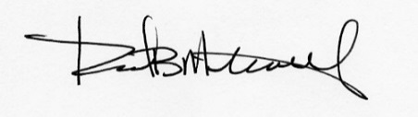
Robert B. Metcalf, Principal
Maine Licensed Landscape Architect

Enclosure

Cc Denise Vachon, CEO
William Shanahan
Melissa Murphy, Esq
Ron Norton
Joan Eagleson

