Memorandum
Planning and Urban Development Department
Planning Division

To: Elizabeth Boepple, Chair, and Members of the Portland Planning Board
From: Nell Donaldson, Planner
Date: July 21, 2016
Re: Mixed-Use Development, 23 Ocean Avenue
Project #: 2016-150 CBL: 129-G-1
Meeting Date: July 26, 2016

I. INTRODUCTION
23 Ocean Avenue Association, LLC has requested a preliminary Level III site plan and subdivision review for a mixed-use development at 23 Ocean Avenue, at the corner of Ocean Avenue and Hersey Street near Woodford’s Corner. The proposed 7,000 SF development includes approximately 2,400 SF of office space on the basement level and first floor, and four two-bedroom apartments on the second and third floors. The proposal also includes new sidewalks on Ocean Avenue and Hersey Street, 10 off-street parking spaces with a lease for additional off-site parking, landscaping, and stormwater treatment. The site is currently occupied by a former residential building which has been converted to office use and a large lawn area. This open space would be developed under the proposal. The existing office building would remain.

This development is being referred to the Planning Board for compliance with the site plan and subdivision standards of the land use code. A total of 144 notices were sent to property owners within 500 feet of the site and a legal ad ran in the Portland Press Herald on July 18 and 19, 2016.

Applicant: Steve and Roberta Cope, 23 Ocean Avenue Association, LLC
Consultants: Kevin Moquin Architects, Ransom Consulting, Carroll Associates

II. REQUIRED REVIEWS
Waiver Requests | Applicable Standards
Aisle width – to allow 21 foot aisle in parking area | Technical Manual, Section 1.14. Aisle width for right-angle parking be 24 feet per Figure I-27.
Flooding standard – pertaining to peak flows of discharge from the site | Technical Manual Section 5/Maine DEP Chapter 500
Review | Applicable Standards
Site Plan | Section 14-526
Subdivision | Section 14-497

III. PROJECT DATA
Existing Zoning | B-1/R-3
Existing Use | Office
Proposed Use | Mixed use (office and residential)
Proposed Development Program | App. 2,400 SF office ; App. 4,700 SF residential (4 2-br apartment units); App. 220 SF storage
Parcel Size | 9,519 SF
 | Existing | Proposed | Net Change
Building Footprint | 1,030 SF | 2,730 SF | 1,700 SF
Building Floor Area | 1,580 SF | 10,220 SF | 8,640 SF
Impervious Surface Area | 4,036 SF | 6,396 SF | 2,360 SF
Parking Spaces | 5 | 10 on-site and 15 off-site (14 required) | 20
Bicycle Parking Spaces | 0 | 6 | 6
Estimated Cost of Project | $1,000,000
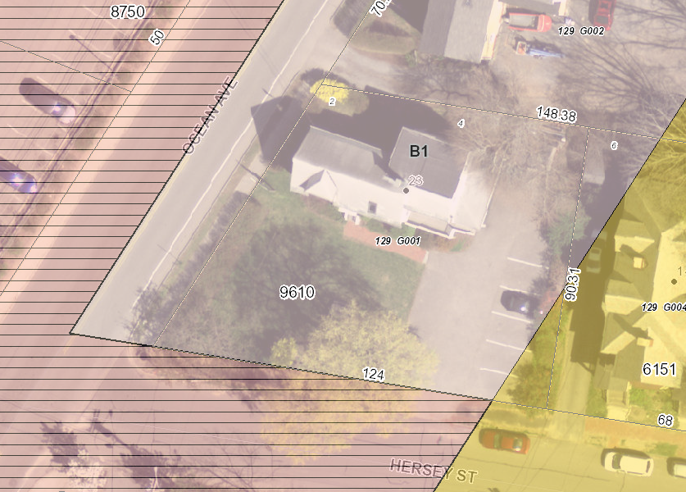
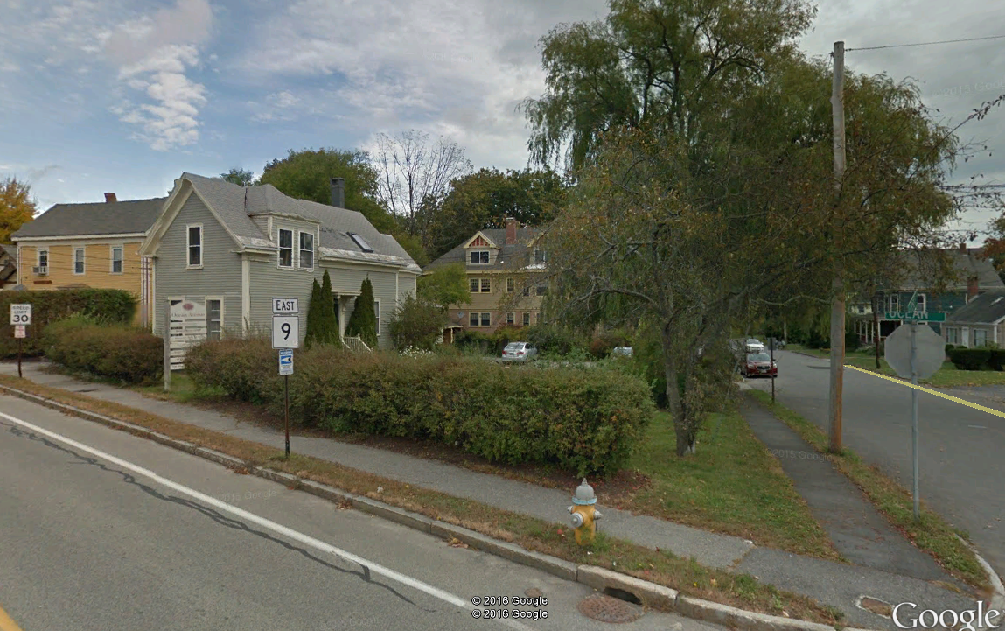
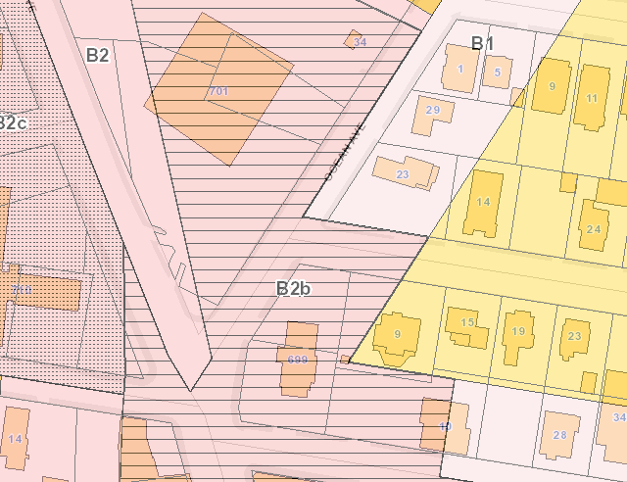
Figures 1, 2, and 3 (Clockwise from top right):
23 Ocean Avenue from above, showing existing building in office use;
Site from the corner of Ocean Ave./Hersey St.;
Zoning context
IV. BACKGROUND & EXISTING CONDITIONS
23 Ocean Avenue lies at the intersection of Ocean Avenue and Hersey Street where Woodford’s Corner meets the residential neighborhood of Back Cove. The Woodford’s Corner Rite Aid sits directly across Ocean Avenue from the site and Thurston’s Burgers lies directly to the south across Hersey Street, yet residential uses abut the site to the east and north. The site was originally developed for residential use, but the original home has since been repurposed for office. The majority of the site is zoned B-1, with a small sliver in the southeast corner lying in the R-3 zone.

Figure 4: Preliminary site plan

V. PROPOSED DEVELOPMENT
The applicant proposes to develop the existing, undeveloped portion of the lot with a 7,000 SF building including 2,400 SF of office space on the basement and first levels and four 2-bedroom apartment units on the top two floors. The main entrances for both uses would front a pervious patio courtyard area at the interior of the site, which would be shared with the existing office use. Vehicular access would be provided via an existing curb cut from Hersey Street. Ten parking spaces are proposed on site and 15 additional spaces would be leased off-site. New concrete sidewalks are proposed on Ocean Avenue and Hersey Street. The plans also include landscaping around the proposed building. Stormwater treatment would be managed through rain gardens near the parking area. Utilities are generally proposed to and from Hersey Street, with the gas and electrical connections to Ocean Avenue.

VI. PUBLIC COMMENT
The Planning Division has received no public comments on the submittal. The applicant is not required to host a neighborhood meeting, since only four residential units are proposed.

VII. RIGHT, TITLE, & INTEREST
The applicant’s submittal includes a deed as evidence of right, title, and interest (Attachment E). A license is proposed for encroachments into the right-of-way for the purposes of footings and cornices. A public access easement will also be necessary for areas of sidewalk which are depicted on private property on the site.

VIII. FINANCIAL & TECHNICAL CAPACITY
The estimated cost of the development is approximately $1 million. The applicant has not provided evidence of financial capacity at this time. This documentation will be required at the time of final review.
IX. ZONING ANALYSIS
The applicant has provided a zoning analysis documenting that the plans meet the dimensional requirements of the B-1 zone, including the front yard maximum of 10 feet and the maximum height of 35 feet (Attachment D). It should be noted that the elevations show a stair tower extending above the roofline of the building, and above the permitted height limit. Stair towers are permitted to extend beyond the height limit per Section 14-430 of the city code.

X. SITE PLAN SUBMISSION REQUIREMENTS (Section 14-527) and SUBDIVISION PLAT
AND RECORDING PLAT REQUIREMENTS (Section 14-496)
Per the city’s land use ordinance, the following materials should be included in the final plan submission:
- A subdivision plat meeting all plat requirements as noted in Section 14-496, depicting all proposed easements and licenses, zone lines, and references to the proposed stormwater management features and associated maintenance agreement.

The draft plat has been reviewed by William Clark, the city’s surveyor, who has provided a markup (Attachment 1) and made the following comments:

1. The sidewalk at corner of Ocean Ave and Hersey St shows as being constructed on the private property. Currently the sidewalk is within the City street ROW limits for Ocean Ave and Hersey St. If it is expanded onto the private property the City will need a public easement for that area and a detail on the plan showing bearings, distances, and curve data for the easement metes and bounds description.

2. The proposed aerial licenses in Ocean Ave and Hersey St will need bearings, distances, and curve data added to the plan for the license metes and bounds descriptions. The vertical clearance in the license areas will also need to be stated.

- Final plan submittal requirements as noted in Sections 14-527(e) and (f), including a site plan stamped by a licensed engineer.

XI. SUBDIVISION REVIEW (14-497(a). Review Criteria)
The proposed development has been reviewed by staff for conformance with the relevant review standards of the City of Portland’s subdivision ordinance. Staff comments are below.

1. Water, Air Pollution
Lauren Swett, consulting civil engineer, has reviewed the plans relating to stormwater runoff and water quality (Attachment 2). Her comments are discussed in detail under site plan review below. No detrimental water or air quality impacts are anticipated.

2 & 3. Adequacy of Water Supply
The plans show water service from an existing 8-inch main in Hersey Street. The applicant has provided evidence of water capacity (Attachment J).

4. Soil Erosion
No unreasonable soil erosion or reduction in the capacity of the land to hold water is anticipated.

5. Impacts on Existing or Proposed Highways and Public Roads
The applicant has not provided traffic analysis in their preliminary submittal. Tom Errico, the city’s consulting traffic engineer, has provided comments on potential traffic impacts, which are discussed in detail under site plan review below.

6. Sanitary Sewer/Stormwater Disposal
One 6-inch sewer line is proposed to service the building; this line would outlet to Hersey Street. The applicant has submitted a wastewater capacity application to the Department of Public Services (Attachment J). Verification of capacity will be required at the time of final plan review.

As noted above, a stormwater management plan has been provided. Ms. Swett’s comments on the proposed plan are discussed in detail under site plan review below.

7. Solid Waste
The applicant has proposed curbside trash and recycling. No dumpster is proposed. The applicant writes that “[t]enants will be informed of collection day and appropriate interim on-site storage of waste and recycling” (Attachment D). Staff has requested that the applicant identify the location of interim on-site storage.

8. Scenic Beauty
This proposal is not deemed to have an adverse impact on the scenic beauty of the area.

9. Comprehensive Plan
The applicant’s narrative argues that the project would achieve a number of goals of the city’s Comprehensive Plan, including goals related to housing and neighborhood stability and integrity. The applicant also cites the Woodford’s Corner Public Improvement Plan and Transforming Forest Avenue, which called for improvements that “promote livability, economic vibrancy, and mobility in Woodford’s Corner” (Attachment D).

10. Financial and Technical Capacity
As noted above, evidence of financial capacity will be required at the time of final review.

11. Wetland/Water Body Impacts
There are no wetlands or water bodies on or immediately proximate to the site.

12. Groundwater Impacts
There are no anticipated impacts to groundwater supplies.

13. Flood-Prone Area
Per the city’s existing flood maps, the site is not located in a flood zone.

XII. SITE PLAN REVIEW
The proposed development has been reviewed by staff for conformance with the relevant review standards of the City of Portland’s site plan ordinance. Staff comments are below.

- Transportation Standards
- Impact on Surrounding Street Systems
As noted above, the applicant has not provided an analysis of the potential traffic impacts of the proposed development. Mr. Errico has reviewed the plans and writes,

The applicant should provide a summary of the anticipated trip generation increase expected during the AM and PM peak hours following project completion. While I do not expect the project to significantly impact the public street system, I do believe documentation of traffic volumes changes is necessary.

The applicant should provide a review of safety data in the immediate vicinity of the project.

- Access and Circulation
The plans include new concrete sidewalks on the length of the site’s Hersey Street frontage and the majority of the site’s Ocean Avenue frontage. Mr. Errico writes,

The plans do not include full replacement of the sidewalk on Ocean Avenue along the entire property frontage. The applicant should either include full sidewalk replacement or document justification for the current proposal.

The applicant has proposed to provide a new detectable warning panel and “improved/realigned crosswalk” across Hersey Street at the Ocean Avenue intersection as well. Mr. Errico writes,

Further review of the sidewalk ramp configuration is required. I would suggest that a fully ADA compliant ramp be provided on the opposite side of Hersey Street.

The major building entrances are proposed from Ocean Avenue via a patio at the interior of the site, which sits below the sidewalk elevation and thus is accessible via stair. Staff has requested that the applicant provide evidence of accessibility to building entrances.

The preliminary plans show continued use of an existing curb cut from Hersey Street. Mr. Errico has reviewed this driveway location and writes,

I find the driveway location and configuration to be acceptable given existing site conditions. A detail for the driveway shall be provided that notes that the crossslope shall not exceed 2%.

Regarding vehicular circulation on the site, however, he writes,

I would prefer that backing maneuvers onto Hersey Street not be required and thus the applicant should either provide a layout that allows for onsite vehicle circulation – for headout egress, or supporting documentation on the proposed circulation condition.

The applicant has requested a waiver for parking lot aisle width. Mr. Errico writes,

The applicant is requesting a waiver for parking lot aisle width (21 feet versus the City standard of 24 feet). The applicant should provide documentation that supports the waiver request.

- Public Transit Access
No accommodation for public transit is required.

- Parking
Division 20 of the land use ordinance requires parking for residential uses at a ratio of two/unit off-peninsula and one/ 400 SF of usable area for office uses. At these ratios, 14 parking spaces are required. The applicant has proposed 10 of these spaces in a surface parking area on site. For the remainder, it has provided a lease at the Woodford’s Club, 1,200 feet distant and across Woodford’s Corner (Attachment I). Technically, this is permissible per Section 14-334 of the city’s ordinance, which allows the Planning Board to approve off-street parking within 1,500 feet upon presentation of a lease agreement. Mr. Errico has not yet reviewed this lease. Of the parking arrangement in general, he writes,

The applicant is proposing to meet parking demand needs via leased parking spaces off Woodford Street west of Forest Avenue. Given on street parking regulations, it is my professional opinion that occupants of the project site will park on Hersey Street given parking availability and convenience. Recognizing this factor, the applicant should provide a detailed parking demand and supply management plan that realistically proposes parking conditions. I would note that I’m open to the idea of shared parking given site uses, if it works from a management perspective. Further coordination and review on this subject is needed.

- Transportation Demand Management
A transportation demand management plan is not required.

2. Environmental Quality Standards
- Preservation of Significant Natural Features
There are no known significant natural features on the site.

- Landscaping and Landscape Preservation
The applicant’s landscape plans show a mix of evergreens, grasses, and deciduous shrubs along the Ocean Avenue and Hersey Street frontages, as well as climbing hydrangeas to screen the under-building parking and assorted perennials on the eastern property line. Staff has requested that the applicant consider more robust planting on the eastern property line, where the site abuts a residential zone and use. Jeff Tarling, the city’s arborist, writes,

[P]arking lot on Hersey Street should have a 4' buffer with plant material at back of sidewalk. A smaller 3' or 2' buffer might not make it. Ideally like to see woody shrub planting but could do ornamental grasses. Wood guardrail on the parking lot side is needed to protect this space from vehicles, snow etc. Without protection plant material would likely be damaged. This buffer on the residential side is more important then the more commercial Ocean Avenue side. Add a couple of trees on the parking lot edge to buffer parking lot from next door residential use. See photos (Attachment 4).

The applicant has also proposed five street trees in the esplanade on Ocean Avenue and four in the esplanade on Hersey Street, more than sufficient to meet the street tree requirement. Of these, Mr. Tarling writes,

The existing esplanade width is problematic just too narrow to support Street trees on both sides, Ocean & Hersey Street. I checked the entire length of Ocean Avenue and no existing street trees, also this is a busy truck / commercial vehicle route and tree canopy even on an upright tree would unlikely to survive. Snow storage in winter along with deicing salts, this sidewalk route is on our priority school walk route and we plow so we need as much space as possible. Thus we would like to see 'setback' tree planting in available spaces.

- Water Quality/Storm Water Management/Erosion Control
The site is currently occupied by a residential structure which has been converted to office use, a surface parking lot, and a landscaped lawn area. The project will disturb approximately 7,170 SF of the parcel and result in a total impervious area of approximately 6,400 SF, or an increase of 2,360 SF. As such, the applicant has provided a stormwater management plan outlining their approach for managing and treating stormwater on the site (Attachment H). Portions of the proposed parking lot and existing building roof are proposed to drain to a rain garden within the parking area on the site’s eastern property line. The entire roof of the proposed building and half of the roof of the existing building, as well as the new building’s foundation drain, would be piped into an underdrain which daylights to another rain garden in the parking area along Hersey Street. The underdrain in this rain garden is proposed to connect to the existing combined sewer in Hersey Street. Pervious pavers are proposed in the patio and driveway apron.

Ms. Swett has reviewed the design of this system and provided the following comments,

Plans, notes, and details should be provided to address erosion and sediment control requirements, inspection and maintenance requirements, and good housekeeping practices in accordance with Appendix A, B, & C of MaineDEP Chapter 500. The applicant has provided details, and notes indicating erosion control requirements, but we recommend the addition of erosion and sedimentation control locations on the plans and additional notes on inspection and maintenance requirements should be added to the plans to be in conformance with the standards.

The project is required to include stormwater management features for stormwater quality control. The Applicant is proposing to install rain gardens, pervious pavers, and underdrained roof drain collection systems on the site.
  - The proposed systems are anticipated to provide acceptable stormwater treatment, but the Applicant is required to provide calculations and additional design information verifying compliance with the Maine DEP Chapter 500 and City of Portland Technical Standards Section 5.
  - The proposed rain gardens do not appear to have any overflow structures or bypass outlets. Applicant should provide model and information indicating the peak water elevations within these systems during storm events, as well as information on infiltration rates at these sites.
  - The Applicant should provide comment on the potential for these systems to overflow during storm events, and the impact that this may have on their site and adjacent properties.

The project is required to include stormwater management features to control the rate or quantity of stormwater runoff from the site. The Applicant has requested a waiver of the flooding standard. The project will result in the creation of greater than 1,000 square feet of new impervious surface, which cannot be considered as a de minimus increase. Additional information, including stormwater calculations and verification of downstream infrastructure capacity to handle any increases in flow, is required before we can consider a potential waiver of the flooding standard.

The Applicant has requested that the outlet from one of the proposed rain gardens on the site be
connected to the City of Portland combined sewer system in Hersey Street. Per Section 2 of the City of
Portland Technical Manual, “the introduction of non-contaminated water such as rain water, non-contact cooling water, groundwater from foundation drains, sump pumps, surface drains or any other sources of inflow shall not be allowed to discharge into a sewer which conveys sanitary waste unless approved by the City Engineer.” A waiver of this requirement may be considered when no other alternative exists. Before a waiver can be considered for this project, additional information on the anticipated flow quantities must be provided.

3. Public Infrastructure and Community Safety Standards
- Consistency with Related Master Plans
As noted above, the project is generally deemed consistent with related master plans.

- Public Safety and Fire Prevention
The applicant has provided a life safety summary for review by the city’s Fire Prevention Bureau (Plan 16). Per this summary, the building would be fully sprinklered and accessible from two sides. Assistant Fire Chief Keith Gautreau has reviewed the plans and indicated that he has no comments (Attachment 5).

- Availability and Capacity of Public Utilities
As noted above, at the time of final site plan review, the applicant will need to present evidence that there is sufficient sewer capacity to service the office and residential units on the site. Ms. Swett writes,

The Applicant has submitted a City of Portland Wastewater Capacity Application. The Applicant should note that they will be required to provide evidence of capacity to serve and approval of the proposed design from the City of Portland.

The applicant has proposed to connect to existing water and sewer lines in Hersey Street and to provide gas via a line in Ocean Avenue. Electrical service would be provided from an existing overhead line in Ocean Avenue. Staff has advised the applicant that overhead electrical is not permitted, and the applicant will need to coordinate with CMP on the placement of underground utilities. Staff has also requested that the applicant pursue the removal of an existing utility pole on Hersey Street which will no longer be necessary with the removal of overhead lines to the existing building on site. Ms. Swett has reviewed the plans and notes,

The Applicant has indicated on their plans that they will be extending gas and electrical services from meters to be installed on the existing building to remain. The Applicant should provide verification from both Unitil and CMP that the ability to serve exists, and that the configuration will be acceptable to each utility.

The proposed underground gas and electric utilities will be located beneath an existing hedge located along Ocean Avenue. The site preparation plan notes that the hedge is to remain, and the landscaping plan does not provide any new plantings in this area. The Applicant should comment on the plan for maintaining this existing landscaping with the proposed utility installation

4. Site Design Standards
- Massing, Ventilation, and Wind Impact
The bulk, location, or height of the building is not likely to result in health or safety problems from a reduction in ventilation to abutting structures. However, staff has requested information on the location of HVAC systems.

- Shadows
The project will not result in shadow impacts to publicly accessible open spaces.

- Snow and Ice Loading
The project is not likely to result in snow or ice loading impacts.

- View Corridors
The project does not lie on a protected view corridor.

- Historic Resources
There are no historic resources within 100 feet.

- Exterior Lighting
The applicant has provided a photometric plan and lighting cut sheets which meet the standards of the Technical Manual (Plan 17 and Attachment K). Staff is coordinating with current work in Woodford’s Corner on the need for street lights.

- Noise and Vibration
As noted above, staff has requested information on the location of HVAC equipment.

- Signage and Wayfinding
One sign is depicted on the site plan near the patio entrance. This sign is intended to serve both buildings on the site. The sign will be subject to separate sign permits, and is not being reviewed at this time.

- Zoning-Related Design Standards
Projects within the B-1 zone are subject to design review, as are all multi-family buildings. The applicant has provided a brief narrative responding to the design guidelines (Attachment D). Caitlin Cameron, the city’s urban designer, has provided preliminary comments from a design review (Attachment 6). These comments raise several concerns about the building design, including the treatment of building entrances, windows, and materials. Ms. Cameron writes,

B-1 Commercial Business Zones
- Standard (1) c. Building Entrances – We’re concerned about visibility of entries from street – can office entrance be located closer to or on one of the streets? If not, visual cues from the street are needed, especially from the corner approach and indicating ADA route.
- Standard (1) d. Windows – Façade character of the office portion of the building places fenestration with wrong emphasis – why are the largest windows at the stair instead of the
active spaces? Corner approach should be made more open or active with fenestration. The office fenestration pattern versus the residential is not distinct enough – the upper floor residential should have consistent alignment and have a different character than the office.
Figures 5 and 6: Rendering of proposed building from corner of Ocean Ave./Hersey Street (top) and Ocean Avenue (bottom).

- Standard (1) e. Façade Character – Street-facing facades are oriented to and/or adjacent to public sidewalk. The office use should have a more distinctive façade character whether through floor delineation, fenestration patterns/sizes, and/or materials.
- Standard (1) g. Building Materials – Metal siding is not found in either the residential or commercial context. Revise the material selection – fiber cement clapboard is recommended.

Appendix 2: Development in the B-1, B-1b, B-2, B-2b
- Standard 1: Building Location and Form – Met – Building matches surrounding context in its relationship to the street which contributes positively to the streetscape. Building contributes to the street wall with its position, form, and height. See comments above regarding fenestration patterns. Some window proportions also not consistent with predominant residential character
- Standard 3: Orientation of Buildings and their Entrances to the Street – Entries to commercial spaces can be made more prominent with the use of features such as signage, canopies, or lights. Alternatively, entrance could be moved to face a street.

Two-family, Special Needs Independent Living Units, Multiple-Family, Lodging Houses, Bed and Breakfasts, and Emergency Shelters
- Standard 1 – The street-facing façades provide a high level of fenestration and visual interest with façade variation, changes in materials, and projecting balconies. The form, scale, and roof line are consistent with and complement the surrounding residential context. Adjust fenestration on corner approach to distinguish office from residential uses. Window proportions could be adjusted to reflect context.

XIII. NEXT STEPS
- Applicant to address staff comments and additional comments of the Planning Board;
- Applicant to prepare final plan submission, including subdivision and site plan submittal requirements as included in 14-496(a) and (b) and 14-527(e) and (f) for review by the Planning Authority and Planning Board; and
- Hold final Planning Board Hearing.

XIV. ATTACHMENTS
Planning Board Report Attachments
- City Surveyor review (memo from Bill Clark, 7/11/16)
- Traffic Engineer review (memo from Thomas Errico, 7/13/16)
- Civil Engineer review (memo from Lauren Swett, 7/14/16)
- City Arborist review (memo from Jeff Tarling, 7/12/16)
- Fire Prevention Bureau review (memo from Keith Gautreau, 7/11/16)
- Design review (memo from Caitlin Cameron, 7/8/16)
- Planning review (memo from Nell Donaldson)

Applicant’s Submittals
- Cover Letter
- Application
- Project Data
- Application Narrative
- Right, Title, and Interest
- Construction Management Plan
- Fire Department Checklist
- Stormwater Management Plan
- Parking Lease
- Capacity Letters
- Lighting Cut Sheets

PLANS
- Subdivision Plat
- Existing Conditions
- Site Preparation
- Site Plan
- Materials and Layout Plan
- Grading Plan
- Stormwater/Utility Plan
- Landscape Plan
- Landscape Details
- Details
- Details
- Details
- Details
- Floor Plans
- Elevations and Sections
- Code Review Plans
- Photometric Plan

