PLANNING BOARD REPORT
PORTLAND, MAINE

Mixed-Use Development
23 Ocean Avenue
Level III Site Plan and Subdivision Review
23 Ocean Avenue Association, LLC

Submitted to: Portland Planning Board  Date: October 21, 2016  Public Hearing Date: October 25, 2016 | Prepared by: Nell Donaldson, Planner  CBL: 129-G-1  Project #: 2016-120

I. INTRODUCTION
23 Ocean Avenue Association, LLC has requested a final Level III site plan and subdivision review for a mixed-use development at 23 Ocean Avenue, at the corner of Ocean Avenue and Hersey Street near Woodford’s Corner. The proposed 7,000 SF development includes approximately 2,400 SF of office space on the basement level and first floor, and four two-bedroom apartments on the second and third floors. The proposal also includes new sidewalks on Ocean Avenue and Hersey Street, nine off-street parking spaces with a lease for additional off-site parking, landscaping, and stormwater treatment. The site is currently occupied by a former residential building which has been converted to office use and a large lawn area. This open space would be developed under the proposal. The existing office building would remain.

This development is being referred to the Planning Board for compliance with the site plan and subdivision standards of the land use code. A total of 144 notices were sent to property owners within 500 feet of the site and a legal ad ran in the Portland Press Herald on July 18 and 19, 2016.

Applicant: Steve and Roberta Cope, 23 Ocean Avenue Association, LLC
Consultants: Kevin Moquin Architects, Ransom Consulting, Carroll Associates

II. REQUIRED REVIEWS
Waiver Requests | Applicable Standards
Aisle width – to allow 21 foot aisle in parking area | Technical Manual, Section 1.14. Aisle width for right-angle parking be 24 feet per Figure I-27.
Review | Applicable Standards
Site Plan | Section 14-526
Subdivision | Section 14-497

III. PROJECT DATA
Existing Zoning | B-1/R-3
Existing Use | Office
Proposed Use | Mixed use (office and residential)
Proposed Development Program | App. 2,400 SF office ; App. 4,700 SF residential (4 2-br apartment units); App. 220 SF storage
Parcel Size | 9,519 SF
 | Existing | Proposed | Net Change
Building Footprint | 1,030 SF | 2,730 SF | 1,700 SF
Building Floor Area | 1,580 SF | 10,220 SF | 8,640 SF
Impervious Surface Area | 4,036 SF | 6,188 SF | 2,152 SF
Parking Spaces | 5 | 9 on-site and 4 off-site | 13
Bicycle Parking Spaces | 0 | 6 | 6
Estimated Cost of Project | $1,000,000
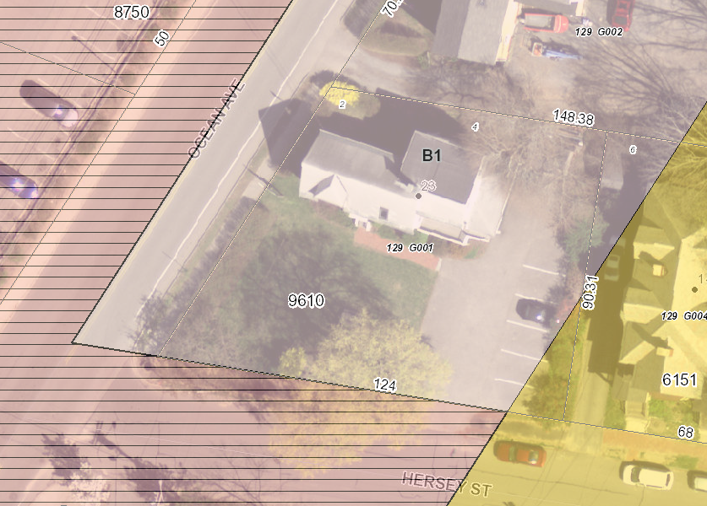
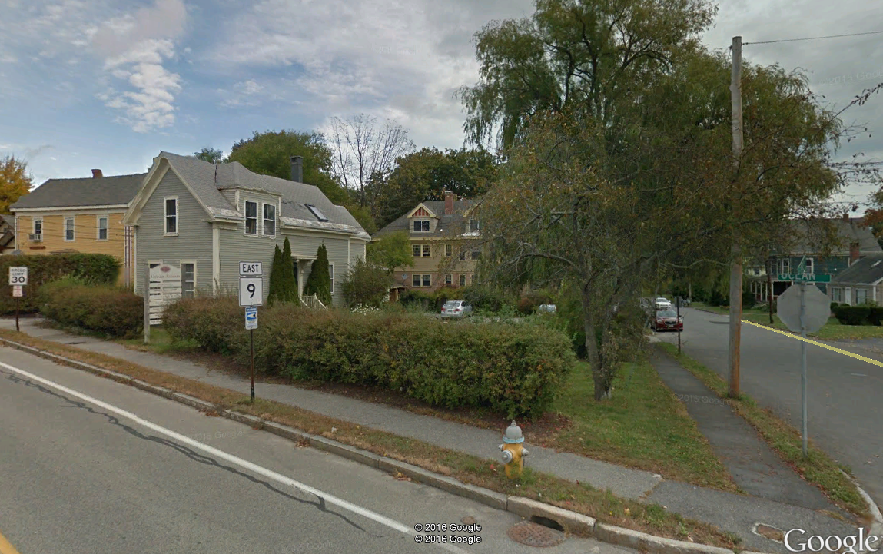
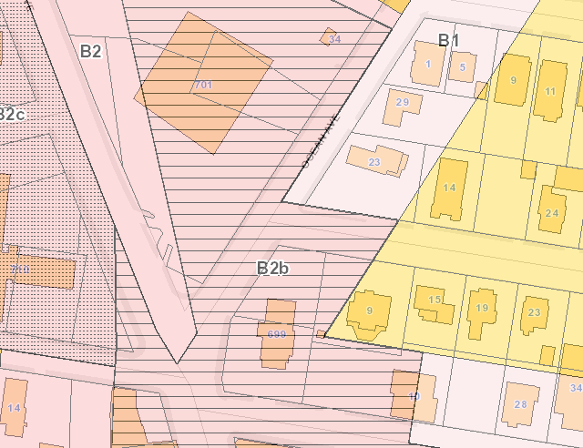
Figures 1, 2, and 3 (Clockwise from top right):
23 Ocean Avenue from above, showing existing building in office use;
Site from the corner of Ocean Ave./Hersey St.;
Zoning context
IV. BACKGROUND & EXISTING CONDITIONS
23 Ocean Avenue lies at the intersection of Ocean Avenue and Hersey Street, where Woodford’s Corner meets the residential neighborhood of Back Cove. The Woodford’s Corner Rite Aid sits directly across Ocean Avenue from the site and the former Thurston’s Burgers lies directly to the south across Hersey Street, yet residential uses abut the site to the east and north. The site was originally developed for residential use, but the former home has since been repurposed for office. The majority of the site is zoned B-1, with a small sliver in the southeast corner lying in the R-3 zone.

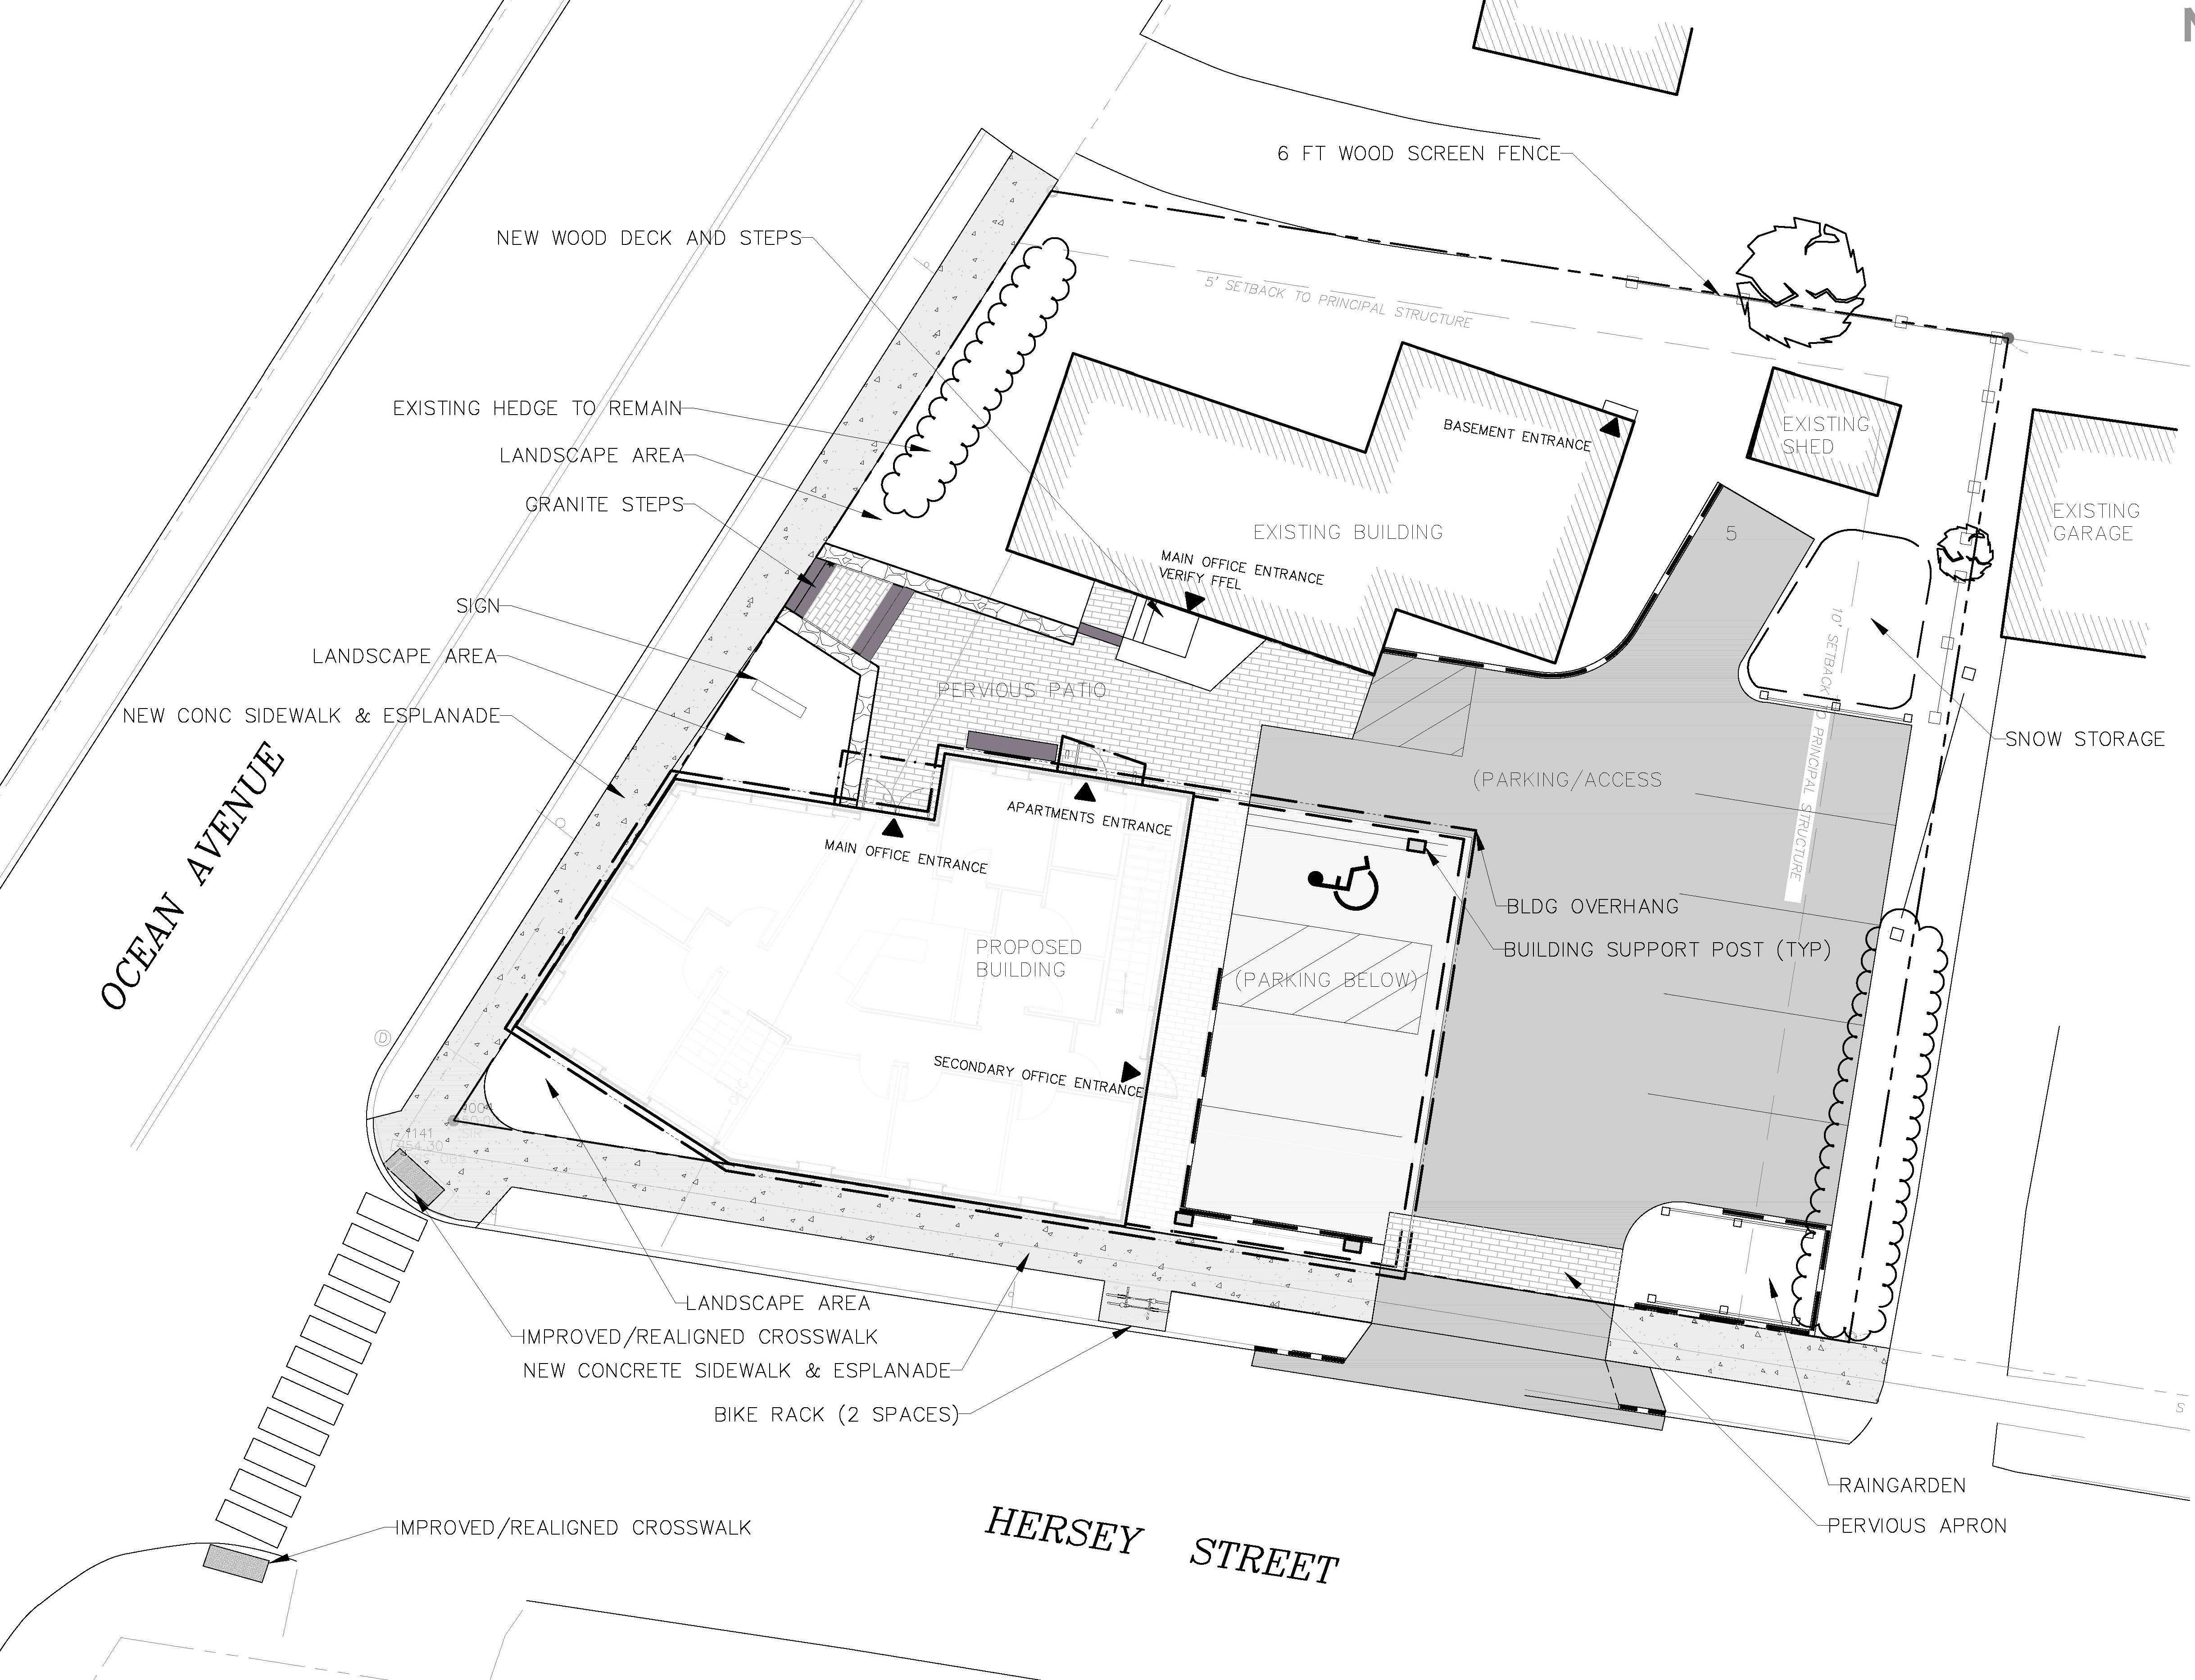
Figure 4: Final site plan

V. PROPOSED DEVELOPMENT
The applicant proposes to develop the existing, undeveloped portion of the lot with a 7,000 SF building including 2,400 SF of office space on the basement and first levels and four 2-bedroom apartment units on the top two floors. The main entrances for both uses would front a pervious patio courtyard area at the interior of the site, which would be shared with the existing office building. Vehicular access would be provided via an existing curb cut from Hersey Street. Nine parking spaces are proposed on site and six additional spaces would be leased off-site at a property on Vannah Avenue. New concrete sidewalks are proposed on Ocean Avenue and Hersey Street. The plans also include landscaping around the proposed building. Treated stormwater runoff from the roof of the new building would drain into the existing catch basin at Ocean Avenue and Hersey Street; the remainder of the site would drain to Hersey Street via a rain garden near the driveway entrance. Utilities are proposed to and from Hersey Street.

VI. PUBLIC COMMENT
The Planning Division has received a number of public comments on the proposal (Attachments PC-1-5). These comments raise questions about:
- The stormwater and utility plans, noting that Hersey Street experiences flooding during periods of heavy rain, and raising concerns about the impact of any additional stormwater runoff on the combined sewer in Hersey Street;
- The proposed parking supply as it relates to the demand analysis, and particularly the shared parking analysis, which neighbors have described as unsubstantiated and argued should be reviewed by the Zoning Board of Appeals;
- The use of off-site parking to meet projected parking demand and the potential for spillover impacts to Hersey Street;
- The trip generation analysis, which neighbors have criticized for failing to include actual counts from the existing office use;
- Traffic safety around the project site;
- The design and its lack of relationship to the residential context; and
- The construction management plan and potential impacts of truck traffic and contractor parking on Hersey Street.
The applicant is not required to host a neighborhood meeting, since only four residential units are proposed. No neighborhood meeting was held.

VII. RIGHT, TITLE, & INTEREST
The applicant’s submittal includes a deed as evidence of right, title, and interest (Attachment E). A license is proposed for encroachments into the right-of-way for the purposes of footings and cornices. A public access easement will also be necessary for areas of sidewalk which are depicted on the site. This license and easement are proposed as conditions of approval.

VIII. FINANCIAL & TECHNICAL CAPACITY
The estimated cost of the development is approximately $1 million. The applicant has provided a letter from Biddeford Savings Bank attesting to the applicant’s financial capacity (Attachment H).

IX. ZONING ANALYSIS
The applicant has provided a zoning analysis documenting that the plans meet the dimensional requirements of the B-1 zone, including the front yard maximum of 10 feet and the maximum height of 35 feet (Attachment D). It should be noted that the elevations show a stair tower extending above the roofline of the building, and above the permitted height limit. Stair towers are technically allowed to extend beyond the height limit per Section 14-430 of the city code.

X. SITE PLAN SUBMISSION REQUIREMENTS (Section 14-527) and SUBDIVISION PLAT
AND RECORDING PLAT REQUIREMENTS (Section 14-496)
The applicant has submitted a subdivision plat meeting the requirements of Section 14-527 of the city’s land use code. This plat has been reviewed by William Clark, the city’s surveyor (Attachment 1). A final recording plat, including all recording plat requirements, has been included as a condition of approval.

The applicant has submitted a draft construction management plan (Attachment F). Staff have forwarded several comments on this draft plan to the applicant, including a request that the applicant identify an off-street location for contractor parking, address concerns about truck traffic, and identify phasing. The applicant has requested that these comments be resolved as a condition of approval once a contractor has been selected for the project. A condition of approval has been suggested.

XI. SUBDIVISION REVIEW (14-497(a). Review Criteria)
The proposed development has been reviewed by staff for conformance with the relevant review standards of the City of Portland’s subdivision ordinance. Staff comments are below.

1. Water, Air Pollution
Lauren Swett, consulting civil engineer, has reviewed the plans relating to stormwater runoff and water quality (Attachment 3). Her comments are discussed in detail under site plan review below. No detrimental water or air quality impacts are anticipated.

2 & 3. Adequacy of Water Supply
The plans show domestic and fire water service from an existing 8-inch main in Hersey Street. The applicant has provided evidence of water capacity (Attachment J).

4. Soil Erosion
No unreasonable soil erosion or reduction in the capacity of the land to hold water is anticipated.

5. Impacts on Existing or Proposed Highways and Public Roads
The applicant has provided traffic analysis in the final submittal. Tom Errico, the city’s consulting traffic engineer, has provided comments on potential traffic impacts, which are discussed in detail under site plan review below. No detrimental impacts to existing roads are anticipated.

6. Sanitary Sewer/Stormwater Disposal
One 6-inch sewer line with backflow preventer is proposed to service the building; this line would outlet to the combined sewer in Hersey Street. The applicant has not provided evidence of wastewater capacity from the Department of Public Services at this time. As such, this letter has been included as a condition of approval. As noted above, a stormwater management plan has been provided. Ms. Swett’s comments on the proposed plans for stormwater and sewer are discussed in detail under site plan review below.

7. Solid Waste
The applicant has proposed curbside trash and recycling. No dumpster is proposed. The applicant writes that “[t]enants will be informed of collection day and appropriate interim on-site storage of waste and recycling” (Attachment D). Storage of office waste is proposed in the basement.

8. Scenic Beauty
This proposal is not deemed to have an adverse impact on the scenic beauty of the area.

9. Comprehensive Plan
The applicant’s narrative argues that the project would achieve a number of goals of the city’s Comprehensive Plan, including goals related to housing and neighborhood stability and integrity. The applicant also cites the Woodford’s Corner Public Improvement Plan and Transforming Forest Avenue, which called for improvements that “promote livability, economic vibrancy, and mobility in Woodford’s Corner” (Attachment D).

10. Financial and Technical Capacity
As noted above, the applicant has provided evidence of financial capacity (Attachment H).

11. Wetland/Water Body Impacts
There are no wetlands or water bodies on or immediately proximate to the site.

12. Groundwater Impacts
There are no anticipated impacts to groundwater supplies.

13. Flood-Prone Area
Per the city’s existing flood maps, the site is not located in a flood zone.

XII. SITE PLAN REVIEW
The proposed development has been reviewed by staff for conformance with the relevant review standards of the City of Portland’s site plan ordinance. Staff comments are below.

- Transportation Standards
- Impact on Surrounding Street Systems
At the request of Tom Errico, the city’s traffic engineer, the applicant has provided a trip generation analysis in the final submittal (Attachment 2). The trip generation analysis, which is based on ratios from the Institute of Traffic Engineers, estimates a total of six additional trips during the AM peak hour and seven additional trips during the PM peak hour, for a total of nine AM and PM peak hour trips from the site (including the existing office use on site, which the applicant’s traffic engineer has estimated at three AM trips and two PM trips). The applicant writes, “this minimal level of new traffic would not be expected to have any significant impact off-site on traffic operations” (Attachment L). Mr. Errico has reviewed the analysis and writes,

The applicant has provided an estimate of trip generation. As noted the project is expected to
generate 6 new peak hour trips in the morning peak hour and 7 new peak hour trips during the afternoon peak hour. This level of trip generation is not expected to impact traffic operations and safety and therefore I have no further comment.

The applicant has also provided a safety analysis in the final submittal. This analysis finds, based on data from the Maine Department of Transportation, that although the segment of Ocean Avenue between Forest Avenue and Hersey Street has a “higher than expected accident rate,” this location fails to qualify as a high crash location since only two accidents occurred in this segment in the most recent three-year period. All other segments and intersections in the immediate vicinity of the project have lower than expected accident rates, and none qualify as high crash locations. Mr. Errico has also reviewed this analysis and writes,

A review of crash data was conducted by the applicant and that analysis indicated that there are no High Crash Locations in the vicinity of the project site. I have no further comment.

- Access and Circulation
The plans include new concrete sidewalks on the length of the site’s frontage on both Hersey Street and Ocean Avenue. The applicant has proposed to provide a new detectable warning panel and a new crosswalk across Hersey Street at the Ocean Avenue intersection. Final details related to the design of this intersection are yet to be resolved, as there are right-of-way constraints on the property opposite the site. Mr. Errico writes,

The applicant shall upgrade the sidewalk ramp on the opposite side of Hersey Street to meet ADA requirements. The applicant shall submit plans to the City for review and approval. I would note that the City recognizes the right-of-way limitations at the subject corner and will assist the applicant in design development.

A condition of approval has been drafted to address this ramp.

The major building entrances are proposed via a patio at the interior of the site, with access from Ocean Avenue. This patio sits below the sidewalk elevation and thus is accessible via stair. ADA access to the major entrance of the proposed building would be provided from Hersey Street. In the final submittal, the applicant has noted that the proposed plan shows “accessible grades along the sidewalk connecting to the main office entrance and the accessible parking space” (Attachment K).

The final plans show continued use of an existing curb cut from Hersey Street for vehicular access. In the final plans, the applicant has reconfigured the parking area and reduced the number of proposed parking spaces by one as a means of eliminating the need for backing maneuvers to Hersey Street. The applicant has provided turning templates as documentation of the adequacy of the parking area design (Plan 21). The applicant has requested a waiver for parking lot aisle width. Mr. Errico writes,

The applicant has provided information that demonstrates onsite circulation can be accommodated.

Following a review of vehicle turning template information and revisions to the parking lot layout, I support a waiver from the City’s Technical Standards.

- Public Transit Access
No accommodation for public transit is required.

- Parking
Division 20 of the land use ordinance requires parking for residential uses at a ratio of two/unit off-peninsula and one/ 400 SF of usable area for office uses. At these ratios, eight parking spaces are required for the residential units and six spaces are required for the office space, for a total of 14 parking spaces for the proposed mixed-use building. Four additional parking spaces are required for the existing office building, bringing the total parking requirement for the site to 18 parking spaces. It should be noted that, in their final submittal, the applicant has provided a parking analysis that cites parking ratios from the Institute of Traffic Engineers, and estimates a total parking demand of six spaces for the residential uses and 13 spaces for the office uses, for a total of 19 parking spaces (Attachment M).

Recognizing the opportunity for shared parking in this context, where residential and office uses are apt to experience offset peak parking demand, the applicant’s parking narrative includes some shared use analysis, based again on data from the Institute of Traffic Engineers (Attachmnet M). The city’s code permits shared use parking under Section 14-343, stating,

the Board of Appeals may approve the joint use of a parking facility by two (2) or more principal buildings or uses where it is clearly demonstrated that the parking facility will substantially meet the intent of the requirements by reason of variation in the probable time of maximum use by patrons or employees among such establishments… The Planning Board may be substituted for the Board of Appeals only where an applicant is otherwise before the Planning Board for site plan approval.

The applicant has based their shared parking analysis on shared use factors developed by the Institute of Traffic Engineers. By applying these factors to both the residential and office uses in their off-peak hours, the applicant arrives at total estimated daytime and nighttime parking demand figures which allow for some overlap in use. The analysis estimates a peak daytime demand of 10-13 parking spaces for the office and two-three for purposes of the residential use, or a total of 12-15 spaces. (The range cited here is a function of differing sources, with the former number a product of applying the shared use factors to the parking supply numbers as required by code and the latter a product of applying the factors to the ITE-derived demand figures.) The applicant argues that, at night, while the residential use will generate its peak demand of six to eight spaces, the office use will not generate any demand at all.

With nine spaces proposed on site, then, the applicant argues that they meet their nighttime peak demand requirement of six to eight spaces. The proposed on-site parking is not sufficient, however, to accommodate the peak daytime demand, which again has been estimated at 12-15 parking spaces. For this reason, the applicant has submitted a letter of intent from the property owner at 28 Vannah Avenue indicating their agreement to lease six parking spaces to the applicant (Attachment M), which, when added to the nine on site, would bring the total parking supply to 15 (Figure 5). Technically, this is permissible per Section 14-334 of the city’s ordinance, which allows the Planning Board to approve off-street parking within 1,500 feet upon presentation of a lease agreement. 28 Vannah Street lies approximately 500 feet from the site by lines of public access and contains sufficient parking (15 spaces) to lease six parking spaces and remain conforming with respect to its own parking requirement under Division 20 of the land use code.

In their final submittal, the applicant has provided a parking management plan which speaks to how on-site and off-site parking would be managed so as to ensure the shared parking arrangement functions as designed (Attachment M). This plan identifies a number of tools, including signage, lease restrictions for office tenants, incentives for use of the off-site parking, and monitoring as means of managing the shared parking. Mr. Errico has reviewed the shared parking analysis and the parking management plan and writes,

I generally find the parking generation analysis to be reasonable and would expect a parking demand of 18 to 21 vehicles, without the consideration of shared parking.

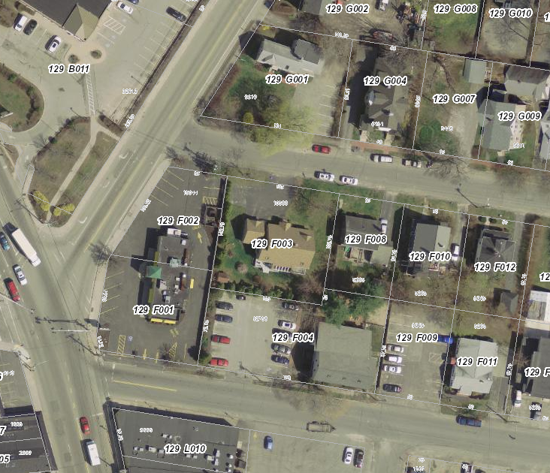

Figure 5: Proposed off-site parking at 28 Vannah Avenue, with missing sidewalk link highlighted.
28 Vannah Ave.

I support the concept of shared parking for this project and thereby a reduced parking supply given proposed land uses. Based upon the information provided by the applicant and information from the Urban Land Institute, I would estimate a peak parking demand of 16 to 18 parking spaces. The applicant is providing 9 parking spaces onsite and has an agreement in place for up to 6 parking spaces on Vannah Avenue, for a total of 15 parking spaces. I would suggest that the applicant conduct a monitoring study at the time of full occupancy and determine if 15 spaces is sufficient. If parking demand is greater than expected, the applicant shall provide additional offsite parking that meet actual demand. I would suggest that the Woodford Club site, as originally proposed, be formally agreed to as a backup site.

I support the location of the offsite parking lot on Vannah Avenue. For it to be fully accessible by pedestrians to and from the site, the applicant shall construct a missing sidewalk section on the north side of Vannah Avenue near the proposed parking lot. The applicant shall submit plans to the City for review and approval.

The applicant has provided a parking management plan for the site. I am concerned that implementation will not be easily enforced, particularly as it related to early morning and late afternoon time periods when the residential and office uses are likely to conflict. I would note that the applicant has noted that TDM will likely impact trip and parking generation (for which I agree), but it is also likely that the residential uses may leave their cars all day, while walking or biking to work destinations. I would therefore suggest that the monitoring study also include a review of the parking management plan and necessary adjustments. I would suggest that the monitoring study be closely coordinated with the Planning Authority.

A final copy of an off-site parking lease, written to including a five-year term as required by the land use code, has been included as a condition of approval. Improvements to the sidewalk on the north side of Vannah Street to close the sidewalk gap between the off-site parking location and the site have also been included as a condition of approval. Last, a monitoring study has been suggested as a condition of approval.

It should be noted that the applicant stresses in their parking analysis that TDM will be employed at the site in an effort to reduce car-dependency on site. The applicant writes, “the building will provide interior bike lockers for both resident and office uses to encourage bicycle commuting” and notes that METRO provides service within a block of the site (Attachment M).

- Transportation Demand Management
A transportation demand management plan is not required.

2. Environmental Quality Standards
- Preservation of Significant Natural Features
There are no known significant natural features on the site.

- Landscaping and Landscape Preservation
At the request of Jeff Tarling, the city’s arborist, the applicant has revised the landscape plans to show two zelkovas on the Ocean Avenue frontage, three Armstrong maples in the esplanade on Hersey Street, and a cherry tree at the corner of Ocean Avenue and Hersey Street. Collectively, these trees meet the city’s street tree requirement of one per unit. It should be noted that staff has recommended a condition of approval to address a potential conflict between the cherry tree and a stormwater treatment unit proposed for the Ocean Avenue/Hersey Street corner.

Elsewhere on the site, the applicant shows a mix of perennials and sumac in the rain garden, a combination of juniper and lilacs on the eastern property line to create a buffer where the site addresses residential neighbors, and a mix of day lilies at the corner of Ocean Avenue and Hersey Street. Ferns, climbing hydrangeas, bayberries, fountain grass, and rhododendrons are also proposed for the site. Mr. Tarling has reviewed the revised plans and verbally indicated that they meet the landscaping requirements of the land use code.

- Water Quality/Storm Water Management/Erosion Control
The site is currently occupied by a residential structure which has been converted to office use, a surface parking lot, and a landscaped lawn area. The project will disturb approximately 7,170 SF of the parcel and result in a total impervious area of 6,188 SF, or an increase of 2,152 SF. As such, the applicant has provided a stormwater management plan outlining their approach for managing and treating stormwater on and from the site (Attachment J).

At the Department of Public Works’ request, the applicant has modified their final drainage plan to direct runoff from the proposed building’s roof to an existing catch basin in Ocean Avenue, which, as a product of future city plans, would ultimately be connected to a new separated stormwater system. This runoff would be treated with a roof drain cartridge filter. The remainder of the site, including the existing building roof and the parking area, would drain to a rain garden, which would outlet to the combined sewer in Hersey Street and overflow to a pervious paver system in the driveway apron. The applicant writes that, under the proposed plan, “the peak flow rates discharging to Hersey Street will decrease for all storm events. This is because both the total area and impervious area draining to Hersey Street are proposed to decrease [under the post-development condition]” (Attachment J).

Ms. Swett has reviewed the design of this system and provided the following comments,

The project is required to include stormwater management features to control the rate or quantity of stormwater runoff from the site. The Applicant will be discharging a portion of the site’s stormwater to the combined sewer in Ocean Avenue. The site does not discharge to this location in the existing condition; however, the Applicant has discussed this condition with Public Works, and the connection will be allowed. Stormwater from the site will be collected as part of a future City sewer separation project. As a result of this connection, the stormwater discharge to Hersey Street will be reduced, providing an improvement over the existing condition on Hersey Street.

It should be noted that Ms. Swett has determined that a waiver from the flooding standard is not required in this instance.

3. Public Infrastructure and Community Safety Standards
- Consistency with Related Master Plans
As noted above, the project is generally deemed consistent with related master plans.

- Public Safety and Fire Prevention
The applicant has provided a life safety summary for review by the city’s Fire Prevention Bureau (Plan 16). Per this summary, the building would be fully sprinklered and accessible from two sides. Assistant Fire Chief Keith Gautreau has reviewed the plans and indicated that he has no comments (Attachment 4).

- Availability and Capacity of Public Utilities
As noted above, the applicant has proposed to connect to existing water and sewer lines in Hersey Street, and has provided evidence of water capacity (Attachment I). Evidence of sewer capacity has been included as a condition of approval. Underground electrical service would be provided from an existing pole on the opposite side of Hersey Street. With respect to the capacity of the combined sewer on Hersey Street, as noted above, the city’s consulting civil engineer has noted that stormwater runoff to Hersey Street will be reduced under the post-development condition, “providing an improvement over the existing condition.” The development is not anticipated to overburden existing public infrastructure.

4. Site Design Standards
- Massing, Ventilation, and Wind Impact
The bulk, location, or height of the building is not likely to result in health or safety problems from a reduction in ventilation to abutting structures. In the final submittal, the applicant has indicated that HVAC equipment will consist of six rooftop condensers.

- Shadows
The project will not result in shadow impacts to publicly accessible open spaces.

- Snow and Ice Loading
The project is not likely to result in snow or ice loading impacts.

- View Corridors
The project does not lie on a protected view corridor.

- Historic Resources
There are no historic resources within 100 feet.

- Exterior Lighting
The applicant has provided a photometric plan and lighting cut sheets which meet the standards of the Technical Manual (Plan 17 and Attachment K).

- Noise and Vibration
Mechanical equipment is proposed at the interior of the site and generally screened from view. HVAC cut sheets will be required as a product of the building permit review.

- Signage and Wayfinding
One sign is depicted on the site plan near the patio entrance. This sign is intended to serve both buildings on the site. The sign will be subject to separate sign permits, and is not being reviewed at this time.

- Zoning-Related Design Standards
Projects within the B-1 zone are subject to design review, as are all multi-family buildings. In response to comments on the preliminary plans, the applicant has revised the design to accentuate the building entrances; employ materials to distinguish the lower floor (which would be occupied by office uses) from the upper floor residential; align windows to provide more rhythm on the street-facing facades; and accentuate the Ocean Avenue/Hersey Street corner through a change in roofline and material (Attachment K). Caitlin Cameron, the city’s urban designer, has provided final comments from the B-1 design review, finding that the final design meets the design standards (Attachment 5).

Figures 6 and 7: Final architecture from the corner of Hersey Street and Ocean Avenue (top) and Ocean Avenue looking south

Figure 8: Hersey Street building entrance

XIII. STAFF RECOMMENDATION
Subject to the proposed motions and conditions of approval listed below, Planning Division staff recommends that the Planning Board approve the proposed mixed-use development at 23 Ocean Avenue.

XIV. PROPOSED MOTIONS
- WAIVERS
On the basis of the application, plans, reports and other information submitted by the applicant; findings and recommendations contained in the Planning Board report for the public hearing on
October 25, 2016 for application 2016-120 relevant to Portland’s technical and design standards and other regulations; and the testimony presented at the Planning Board hearing:

- The Planning Board finds/does not find, based upon the consulting transportation engineer’s review, that extraordinary conditions exist or undue hardship may result from strict compliance with the Technical Manual standard (Section 1.14) which requires that aisle width for right-angle parking be 24 feet per Figure I-27, that substantial justice and the public interest are secured with the proposed variation in this standard, and that the variation is consistent with the intent of the ordinance. The Planning Board waives/does not waive the Technical Manual standard (Section 1.14) to allow a 21 foot wide aisle in the parking area.

- SUBDIVISION
On the basis of the application, plans, reports and other information submitted by the applicant; findings and recommendations contained in the Planning Board report for the public hearing on October 25, 2016 for application 2016-120 relevant to the subdivision regulations; and the testimony presented at the Planning Board hearing, the Planning Board finds that the plan is/is not in conformance with the subdivision standards of the land use code, subject to the following conditions of approval, which must be met prior to the signing of the plat:

      - The applicant shall finalize the subdivision plat for review and approval by Corporation Counsel, the Department of Public Works, and the Planning Authority; and

      - The applicant shall submit:
        - A license agreement for foundation footings and cornice proposed to encroach on the city’s right-of-way and
        - A public pedestrian access easement for areas of sidewalk proposed to encroach on private property
for review and approval by the Department of Public Works and Corporation Counsel.

      - The applicant shall submit a final sewer capacity letter for review by the Planning Authority;

- DEVELOPMENT REVIEW
On the basis of the application, plans, reports and other information submitted by the applicant; findings and recommendations contained in the Planning Board Report for the public hearing on October 25, 2016 for application 2016-120 relevant to the site plan regulations; and the testimony presented at the Planning Board hearing, the Planning Board finds that the plan is/is not in conformance with the site plan standards of the land use code, subject to the following conditions of approval that must be met prior to the issuance of a building permit, unless otherwise stated:

- The applicant shall submit a final construction management plan, including provisions for pedestrian access, contractor parking, truck deliveries, and phasing, for review and approval by the Department of Public Works and the Planning Authority;

- The applicant shall submit final details for the reconstruction of the ramp on the south side of Hersey Street to meet ADA requirements for review and approval by the Department of Public Works;

- Prior to certificate of occupancy, the applicant shall provide evidence of a lease for use of off-site parking spaces under Section 14-334 for review and approval by the Planning Authority and Corporation Counsel;

- Prior to certificate of occupancy, the applicant shall submit final details for the reconstruction of the missing sidewalk link on the north side of Vannah Street between the proposed off-site parking and the site and construct this sidewalk segment for review and approval by the Department of Public Works;

- Within six months of certificate of occupancy, and on an annual basis thereafter for a period of five years, the applicant shall provide an analysis of parking demand, the efficacy of the parking management plan, and neighborhood impacts for review and approval by the Department of Public Works and the Planning Authority. Should the analysis indicate that parking demand is not adequately met with the approved shared parking and off-site parking arrangement, the applicant shall submit and implement a revised parking plan to address deficiencies for review and approval by the Department of Public Works and the Planning Authority; and

- The applicant shall provide revised plans to address the conflict between the proposed cherry tree and stormwater treatment unit at the corner of Ocean Avenue and Hersey Street for review and approval by the City Arborist and the Planning Authority.

XIV. ATTACHMENTS
Planning Board Report Attachments
- City Surveyor review (memo from Bill Clark, 10/13/16)
- Traffic Engineer review (memo from Thomas Errico, 10/21/16)
- Civil Engineer review (memo from Lauren Swett, 10/21/16)
- Fire Prevention Bureau review (memo from Keith Gautreau, 7/11/16)
- Design review (memo from Caitlin Cameron, 9/28/16)

Applicant’s Submittals
- Cover Letter
- Application
- Project Data
- Application Narrative
- Right, Title, and Interest
- Construction Management Plan
- Fire Department Checklist
- Evidence of Financial Capacity
- Evidence of Utility Capacity
- Stormwater Management Narrative
- Response to Staff Comments
- Trip Generation and Safety Analysis
- Parking Analysis
- Site Lighting Cut Sheets
- Siding Examples

PLANS
- Subdivision Plat
- Existing Conditions
- Site Preparation
- Site Plan
- Materials and Layout Plan
- Grading Plan
- Landscape Plan
- Landscape Details
- Stormwater/Utility Plan
- Details
- Details
- Stormwater Pre-Development Plan
- Stormwater Post-Development Plan
- Hersey Ocean View Rendering
- Ocean Courtyard View Rendering
- Ocean Hersey Gateway
- Streetscape Elevations
- Elevations and Sections
- Floor Plans
- Photometric Plan
- Turning Movement Plan

PUBLIC COMMENT
- Levine letter (7/21/16)
- Levine letter (7/25/16)
- Haskell letter (7/25/16)
- Dombek letter (8/1/16)
- Levine letter (10/20/16)

