Arrow 10 ft. x 8 ft.-9 ft. Floor Foundation Kit

Model # FB109 Internet # 100044222

Store SO SKU # 514274

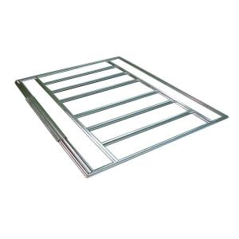

PRODUCT OVERVIEW
Protect your stored items from sitting on the ground with the Arrow Floor Frame Kit for Arrow Storage Sheds. This steel frame is great for use with a plywood floor (not included) and offers simple setup.

- Helps keep stored items off the ground
- Fits 8 ft. x 8 ft., 10 ft. x 7 ft., 10 ft. x 8 ft., 10 ft. x 9 ft. and 10 ft. x 10 ft. storage buildings
- Made from hot-dipped galvanized steel
- Great for use with a plywood floor (not included)
- Easy to assemble
- MFG Model # : FB109
- MFG Part # : FB109

SPECIFICATIONS
Assembled Depth (in.) | 0 in | Assembled Height (in.) | 0 in
Assembled Width (in.) | 0 in | Manufacturer Warranty | N/A
Product Depth (in.) | 0 | Product Height (in.) | 0
Product Type | Accessory Kit | Product Weight (lb.) | 20
Product Width (in.) | 0 in | Returnable | 90-Day

