Arrow Dallas 10 ft. x 8 ft. Vinyl-Coated Steel Storage Building

HOME DEPOT: Model # VD108 Internet # 100660031

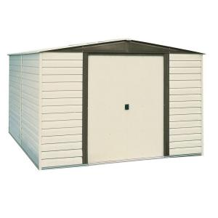

PRODUCT OVERVIEW
Enhanced with a thick vinyl coating that offers high durability, the Arrow Dallas 10 ft. x 8 ft. Vinyl-Coated Steel Storage Building is constructed of steel and has a tall wall height that creates plenty of headroom. Accessing your stored items is easy thanks to the building's 2 doors, which have a wide opening that accommodates lawn equipment and other large objects. The building's horizontal panels have drop-in-place features for speedy assembly.

- Steel building is sturdy
- Thick vinyl coating for enhanced durability
- Tall wall height for lots of headroom
- 470 cu. ft. storage capacity helps you store a large number of items
- Horizontal panels have drop-in-place features for speedy assembly
- Gable roof provides space to work in and hang tools
- 2 doors give you easy access to your stored items
- Wide door opening for easy storage of large lawn and garden equipment
- Door lock enhances the safety of your stored items
- Beige color complements your landscape
- MFG Model # : VD108
- MFG Part # : VD108

SPECIFICATIONS
Approximate Shed Depth (ft.) | 8 | Approximate Shed Width (ft.) | 10
Assembled Depth (in.) | 95.25 in | Assembled Height (in.) | 82.13 in
Assembled Width (in.) | 123.25 in | Assembly Required | Yes
Door Opening Width (ft.) | 4 | Lockable Door/Gate Latch | Yes
Manufacturer Warranty | 15 year limited | Number of Doors | 2
Number of Windows | 0 | Product Depth (in.) | 95.25
Product Height (ft.) | 6.8 | Product Height (in.) | 82.125
Product Weight (lb.) | 248 | Product Width (in.) | 123.25 in
Returnable | 90-Day | Roof Color Family | Beige/bisque
Shed Door Type | Sliding | Shelving Included | No
Sidewall Height (in.) | 71.25 | Siding Color Family | Beige/bisque
Storage Capacity (cu. ft.) | 470

