**Arrow Concrete Anchor Kit for Storage Building**

**Model # AK100**

**Internet # 100062646**

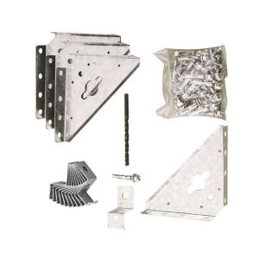

#### PRODUCT OVERVIEW

Anchor your Arrow building to concrete with the AK100 anchor kit. The kit includes 4 steel corner gussets, clips and a 1/4 in. masonry drill bit. The clips lag bolt the floor frame directly to the concrete slab. Simple to install. Provides the protection your storage building needs against strong winds.

* Includes four steel corner gussets & clips
* Lag bolts directly to concrete slab
* Fits any arrow building
* 1/4 in. Masonry drill bit included
* MFG Model # : AK100
* MFG Part # : AK100

#### SPECIFICATIONS

| Assembled Depth (in.) | 2 in | Assembled Height (in.) | 6 in |
| --- | --- | --- | --- |
| Assembled Width (in.) | 5 in | Manufacturer Warranty | 12 year limited |
| Product Depth (in.) | 0 | Product Height (in.) | 0 |
| Product Type | Accessory - Shed Anchor | Product Weight (lb.) | 2 |
| Product Width (in.) | 0 | Returnable | 90-Day |