Temporary Certificate of Occupancy
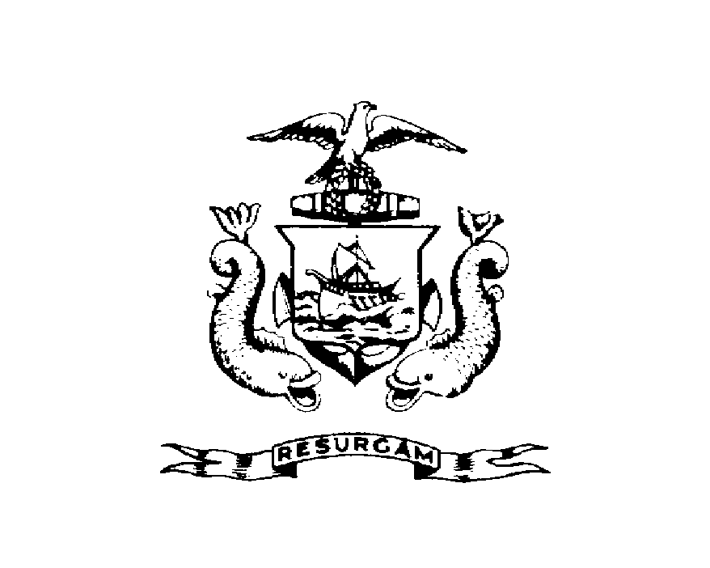CITY OF PORTLAND, MAINE
Department of Planning and Urban Development Building Inspections Division
Location 96 FALMOUTH ST CBL 114A A001001
Issued to UNIVERSITY OF MAINE Date Issued August 25, 2011
This is to certify that the building, premises, or part thereof, at the above location, built-altered-changed as to use under Building Permit NO. 2011-04-932, has had a final inspection, has been found to conform substantially to the requirements of the Building Code and the Land Use Code of the City of Portland, and is hereby approved for occupancy or use, limited or otherwise, as indicated below.
PORTION OF BUILDING OR PREMISES APPROVED OCCUPANCY
1st and 3rd Floor Simulation Labs Use Group B, Type 2B IBC 2009
Limiting Conditions: Temporary Occupancy expires September 24, 2011
Approved:

(Date) Inspector Inspections Division Director
Notice: This certificate identifies the legal use of the building or premises, and ought to be transferred from owner to owner upon the sale of the property.

