Elevations
Bangor Savings Bank
20 Marginal Way, Portland, Maine

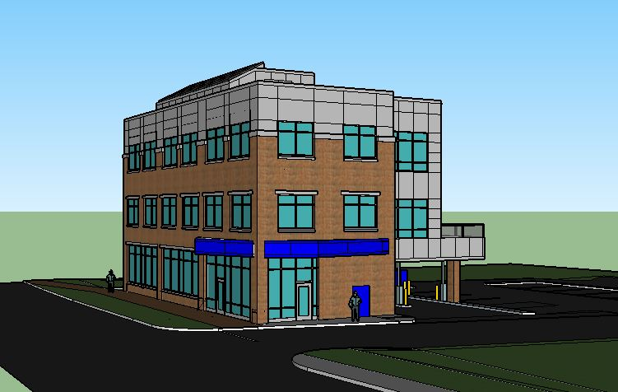
Marginal Way and East Elevation
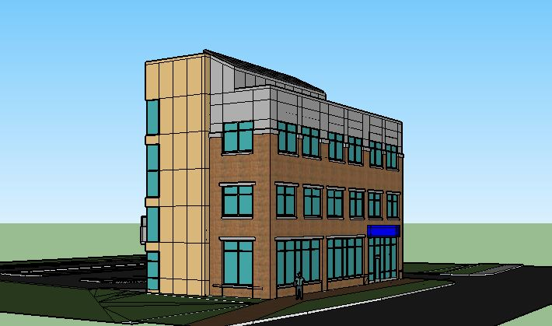
Marginal Way and West Elevation

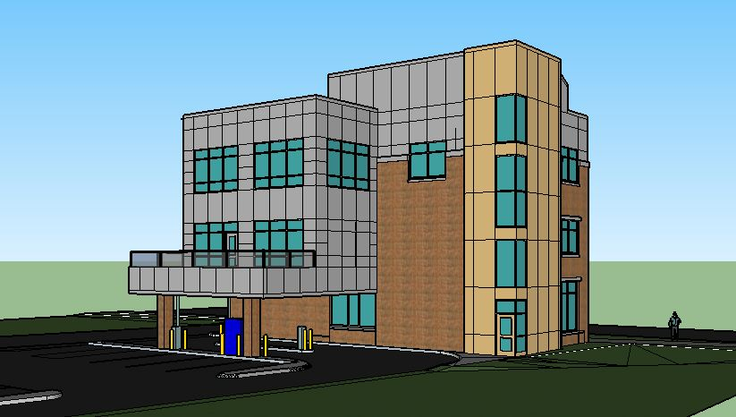
Rear and West Elevation

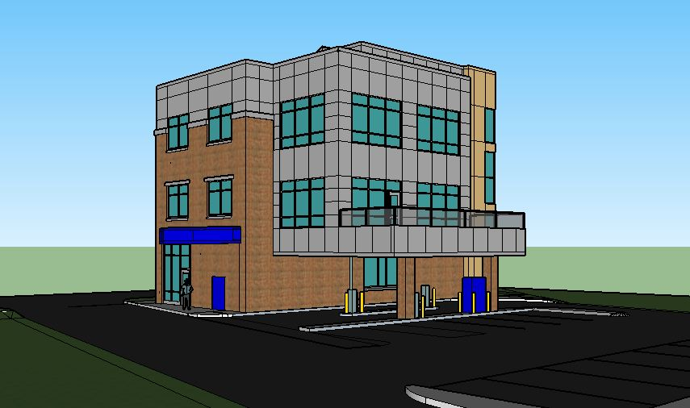
Rear and East Elevation

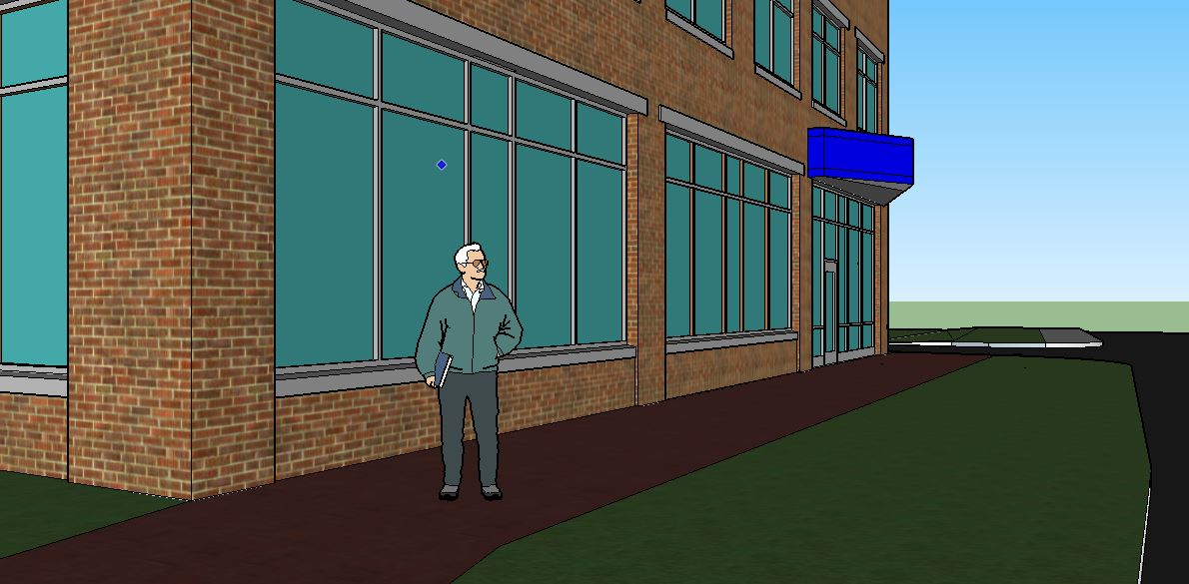
Pedestrian Oriented Streetscape Along Marginal Way Frontage

