CITY OF PORTLAND, MAINE

PLANNING BOARD
Stuart O'Brien, Chair
Elizabeth Boepple, Vice Chair
Sean Dundon
Dave Eaton
Bill Hall
Carol Morrissette
Jack Soley

July 22, 2015

Wendy Durrah  Bangor Savings Bank  99 Franklin Street  Bangor, ME 04401 | David Latulippe  C J Developers, Inc  35 Primrose Lane  Freeport, ME 04032 | Gorrill-Palmer  PO Box 1237  Gray, ME 04039

Project Name: Bangor Savings Bank Bank/Office building with two lane drive-through
Project ID: #2015-080
Address: 20 Marginal Way CBL: 113 A 025001
Applicant: Wendy Durrah, Bangor Savings Bank
Planner: Jean Fraser

Dear Ms Durrah:

On July 14, 2015, the Planning Board considered your application for a three story bank and office development with a two lane drive through at 20 Marginal Way. The Planning Board reviewed the proposal for conformance with the standards of the Conditional Use Review and Site Plan Ordinances of the Land Use Code. The Planning Board voted 7-0 to approve the application with the following waivers and conditions as presented below.

Waivers
On the basis of the application, plans, reports and other information submitted by the applicant, findings and recommendations, contained in the Planning Board Report for the public hearing on July 14, 2015 for application #2015-080 (20 Marginal Way) relevant to Portland’s Technical and Design Standards, the B7 Design Guidelines and Standards and other regulations, and the testimony presented at the Planning Board hearing:

- Driveway Separation
The Planning Board voted 7-0 to waive Technical Design Standard Section 1.7.1.7 Location and spacing of driveways to allow the proposed driveway to be located as shown on Site Plan Plan 4.

- Bicycle parking dimensional standards
The Planning Board voted 7-0 to waive Technical Design Standard Section 1.15.2 which specifies a minimum of 24 inches between the bike rack and the building wall, to allow a separation of 12 inches, subject to the required bicycle parking being met on the non-building side of the rack.

- Building Signage:
The Planning Board voted 7-0 to waive B7 Mixed Use Urban District Zone Design Principles and Standard E-16: Signage to allow a total of two signs at the pedestrian level and three signs at upper levels, and to allow illuminated individual plastic letters, to address the unique circumstances of the site and the user.

Conditional Use
On the basis of the application, plans, reports and other information submitted by the applicant, findings and recommendations contained in the Planning Board Report for the public hearing on July 14, 2015 for application #2015-080 (Conditional Use and Site Plan) (20 Marginal Way), relevant to Portland’s Conditional Use Standards and other regulations, and the testimony presented at the Planning Board hearing:

The Planning Board voted 7-0 that the proposed conditional use for a bank drive-through associated with the new Bangor Savings Bank at 20 Marginal Way in the B-7 zone does meet the standards of §14-474 and the standards of §14-296(a)1(c) for the B-7 zone.

Site Plan Review
On the basis of the application, plans, reports and other information submitted by the applicant; findings and recommendations contained in Planning Board Report for the public hearing on July 14, 2015 for application #2015-080 (Conditional Use and Site Plan) (20 Marginal Way), relevant to the site plan regulations; and the testimony presented at the Planning Board hearing; the Planning Board voted 7-0 that the plan is in conformance with the site plan standards of the land use code, subject to the following conditions of approval:

- That this approval is subject to the Zoning Text Amendments relating the bank drive-throughs in the B7 zone, as recently approved by the City Council, taking effect without delays such as an appeal; and

- That the Planning Board has established that the maximum level of parking is 24 parking spaces; and
- That the applicant shall reconsider the window design, including transparency, color, and size, in consultation with the City’s Urban Designer, to meet the intent of the B-7 Design Principles and Standards. The final design to be reviewed and approved by the Planning Authority prior to the issuance of a building permit; and
- That the applicant shall submit a revised Landscape Plan, for review and approval by the City Arborist and the Planning Authority prior to the issuance of a building permit, that adds one tree to be planted in the rear right side traffic island and adds vegetation to the proposed rear curbing area to address the City Arborist comments dated 7.2.2015; and

- That the developer/contractor/subcontractor must comply with conditions of the construction stormwater management plan and sediment and erosion control plan submitted May 2015 based on City standards and state guidelines. The owner/operator of the approved stormwater management system and all assigns shall comply with the conditions of Chapter 32 Stormwater including Article III, Post Construction Stormwater Management, which specifies the annual inspections and reporting requirements; and

- That the applicant shall submit a copy of the ability to serve (water supply and wastewater) letters prior to the issuance of a building permit; and

- That the applicant shall address the Department of Public Services comments dated 7.2.2015 to revise the notes on the Site Plan prior to the issuance of a building permit; and

- That the applicant shall submit, for review and approval by the Planning Authority prior to the issuance of a building permit, a revised photometric plan for the rear parking lot area that includes the lighting fixture specification, reduces trespass along the eastern boundary to meet Technical Standards, and increases the lighting levels in the vicinity of the drive-through; and

- That separate permits are also required for all new signs, including those on the building, and for HVAC systems, which require submission of dBA levels to confirm compliance with the maximum sound limits of the ordinance.

The approval is based on the submitted plans and the findings related to conditional use and site plan review standards as contained in Planning Report for application #2015-080 which is attached.

Standard Conditions of Approval
Please note the following standard conditions of approval and requirements for all approved site plans:

- Develop Site According to Plan The site shall be developed and maintained as depicted on the site plan and in the written submission of the applicant. Modification of any approved site plan or alteration of a parcel which was the subject of site plan approval after May 20, 1974, shall require the prior approval of a revised site plan by the Planning Board or Planning Authority pursuant to the terms of Chapter 14, Land Use, of the Portland City Code.

- Separate Building Permits Are Required This approval does not constitute approval of building plans, which must be reviewed and approved by the City of Portland’s Inspection Division.

- Site Plan Expiration The site plan approval will be deemed to have expired unless work has commenced within one (1) year of the approval or within a time period up to three (3) years from the approval date as agreed upon in writing by the City and the applicant. Requests to extend approvals must be received before the one (1) year expiration date.

- Performance Guarantee and Inspection Fees A performance guarantee covering the site improvements, inspection fee payment of 2.0% of the guarantee amount and seven (7) final sets of plans must be submitted to and approved by the Planning Division and Public Services Department prior to the release of a building permit, street opening permit or certificate of occupancy for site plans. If you need to make any modifications to the approved plans, you must submit a revised site plan application for staff review and approval.

- Defect Guarantee A defect guarantee, consisting of 10% of the performance guarantee, must be posted before the performance guarantee will be released.

- Preconstruction Meeting Prior to the release of a building permit or site construction, a pre-construction meeting shall be held at the project site. This meeting will be held with the contractor, Development Review Coordinator, Public Service's representative and owner to review the construction schedule and critical aspects of the site work. At that time, the Development Review Coordinator will confirm that the contractor is working from the approved site plan. The site/building contractor shall provide three (3) copies of a detailed construction schedule to the attending City representatives. It shall be the contractor's responsibility to arrange a mutually agreeable time for the pre-construction meeting. (If applicable)

- Department of Public Services Permits If work will occur within the public right-of-way such as utilities, curb, sidewalk and driveway construction, a street opening permit(s) is required for your site. Please contact Carol Merritt at 874-8300, ext. 8828. (Only excavators licensed by the City of Portland are eligible.)

- As-Built Final Plans Final sets of as-built plans shall be submitted digitally to the Planning Division, on a CD or DVD, in AutoCAD format (*,dwg), release AutoCAD 2005 or greater.

The Development Review Coordinator must be notified five (5) working days prior to the date required for final site inspection. The Development Review Coordinator can be reached at the Planning Division at 874-8632. All site plan requirements must be completed and approved by the Development Review Coordinator prior to issuance of a Certificate of Occupancy. Please schedule any property closing with these requirements in mind.

If there are any questions, please contact Jean Fraser at (207) 874-8728 and via jf@portlandmaine.gov .

Sincerely,

Stuart O'Brien, Chair
Portland Planning Board

Attachments:
- City Arborist Review comments dated 7.2.2015
- DPS comments dated 7.2.2015
- B7 Design Review comments 7.8.2015
- Planning Board Report
- City Code Chapter 32
- Sample Stormwater Maintenance Agreement
- Performance Guarantee Packet

(continued)

Electronic Distribution:
Jeff Levine, AICP, Director of Planning and Urban Development  Barbara Barhydt, Development Review Services Manager  Jean Fraser, Planner  Philip DiPierro, Development Review Coordinator, Planning  Caitlin Cameron, Urban Designer, Planning  Ann Machado, Zoning Administrator, Inspections Division  Tammy Munson, Inspections Division Director  Jonathan Rioux, Inspections Division Deputy Director  Jeanie Bourke, Plan Reviewer/CEO, Inspections Division  Lannie Dobson, Administration, Inspections Division  Brad Saucier, Administration, Inspections Division  Michael Bobinsky, Public Services Director  Katherine Earley, Engineering Services Manager, Public Services  Bill Clark, Project Engineer, Public Services  David Margolis-Pineo, Deputy City Engineer, Public Services  Doug Roncarati, Stormwater Coordinator, Public Services | Greg Vining, Associate Engineer, Public Services  Michelle Sweeney, Associate Engineer  John Low, Associate Engineer, Public Services  Rhonda Zazzara, Field Inspection Coordinator, Public Services  Mike Farmer, Project Engineer, Public Services  Jane Ward, Administration, Public Services  Jeff Tarling, City Arborist, Public Services  Jeremiah Bartlett, Public Services  Keith Gautreau, Fire Department  Jennifer Thompson, Corporation Counsel  Thomas Errico, P.E., TY Lin Associates  David Senus, P.E., Woodard and Curran  Rick Blackburn, Assessor’s Department  Approval Letter File

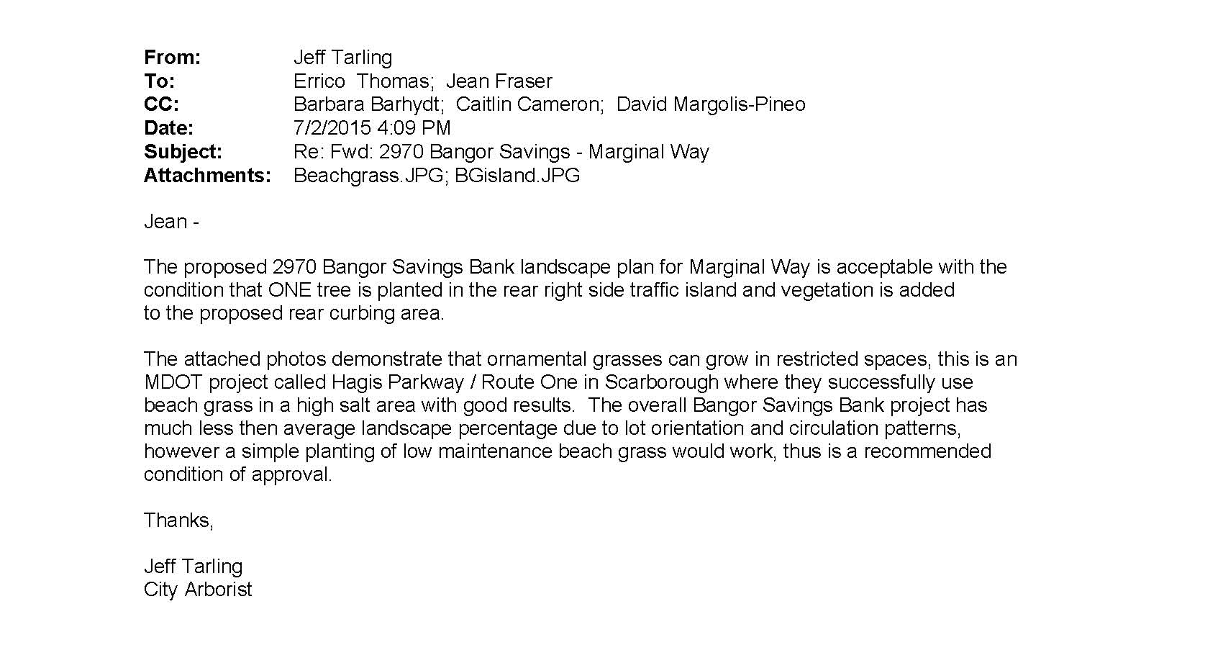
Attachment 1

Attachment 2

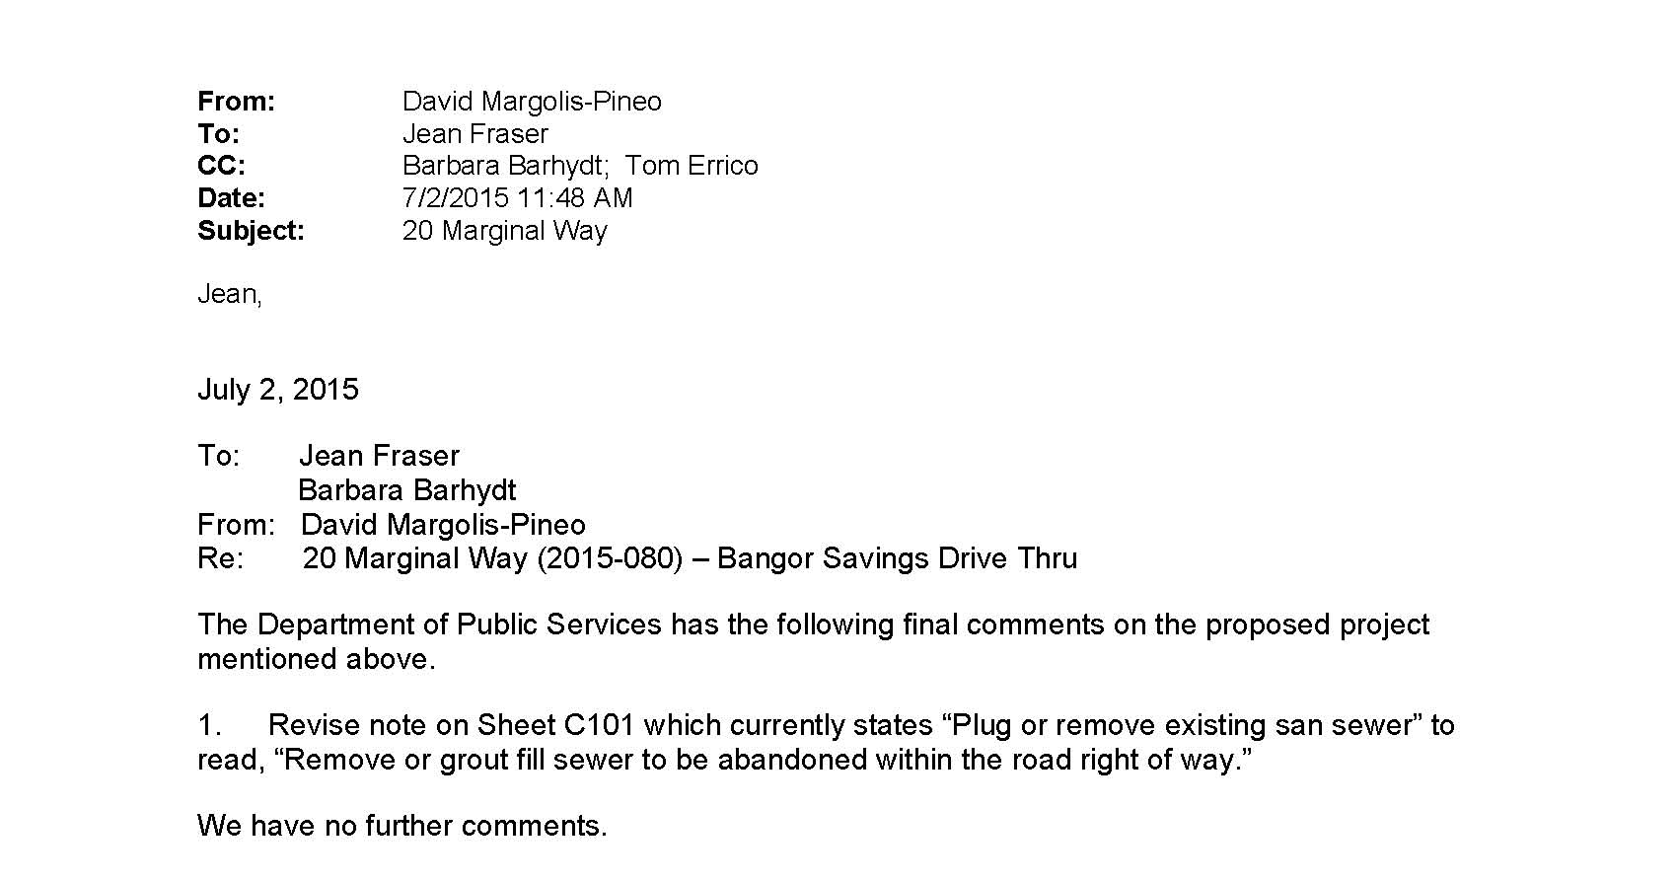

Attachment 3

