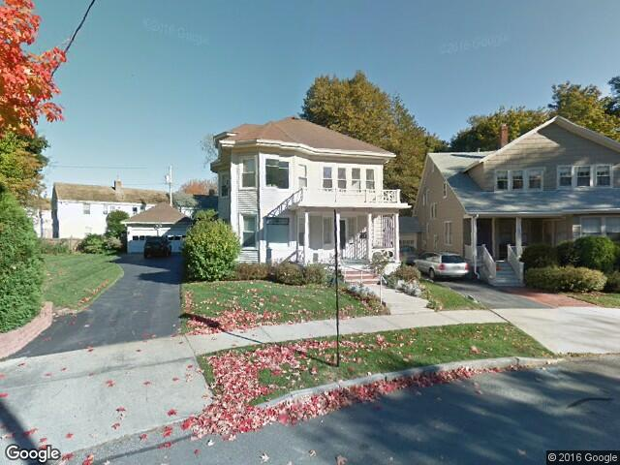

This is a street view of the house. Parking will be provided in the driveway on the left. For more information, please see this link: http://www.realtor.com/realestateandhomes-detail/85-Deerfield-Rd_Portland_ME_04101_M32869-21104.

85 Deerfield Rd Portland, ME 04101

Property Details

Overview
85 Deerfield Rd is a Multi-family located in Oakdale, ME, in Cumberland county. The median price for this area is 349900. The 6 assigned schools for this property are located in Portland Public School District. There are currently 1,020 similar properties for sale within 10-mile radius, ranging from $139,900 - $1,375,000.

Key Facts
- Multi family
- Year built: 1926
- Price/Sq Ft: $134

Public Records
- Beds: 6
- Rooms: 13
- House size: 3,278 sq ft
- Stories: 2
- Lot size: 9,862 sq ft
- Cooling: Unknown
- Year built: 1926
- Property type: Multi family
- Style: Old Style
- Date updated: 03/22/2016
- Units: 2

