**37 & 90 Ballfield Road**

**088 I006 (and associated lots) and 088 J006**

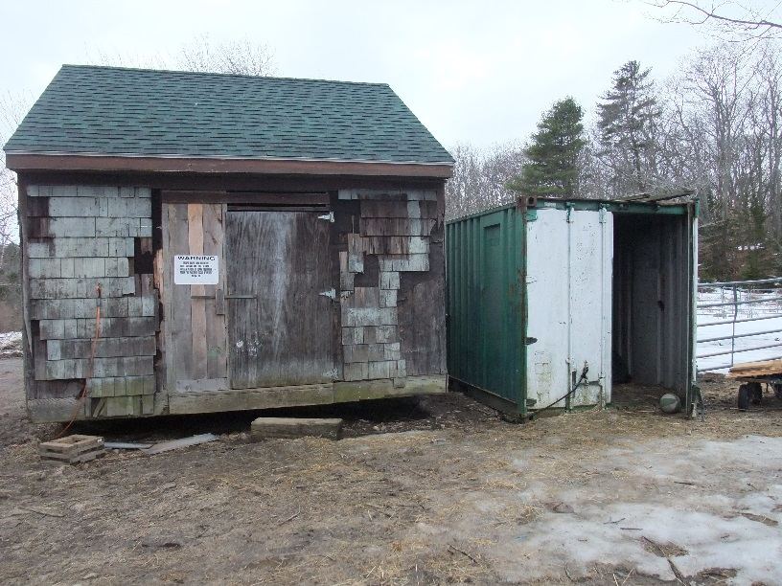

Shed #1 (left) – 15’ by 15’

Shipping Container (right) – 8’ by 20’

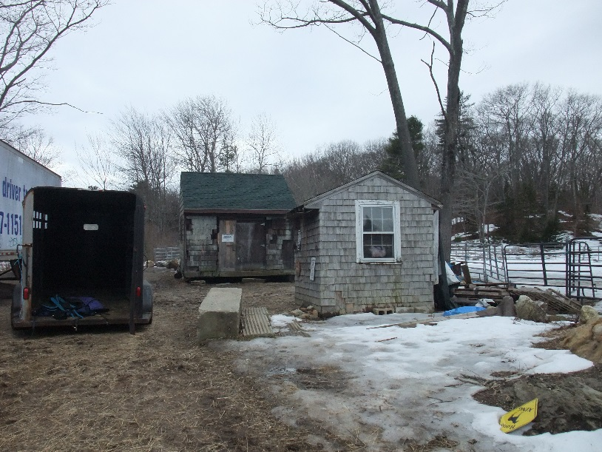

Shed #2 (front) – 8’ by 8’

Shed #1 is visible in rear

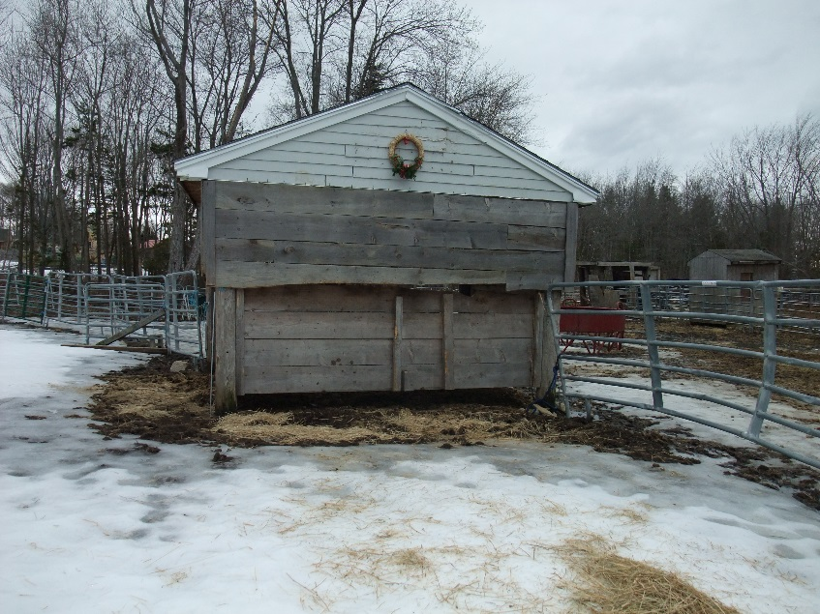

Shed #3 – approx. 12’ by 8’

**37 & 90 Ballfield Road**

**088 I006 (and associated lots) and 088 J006**

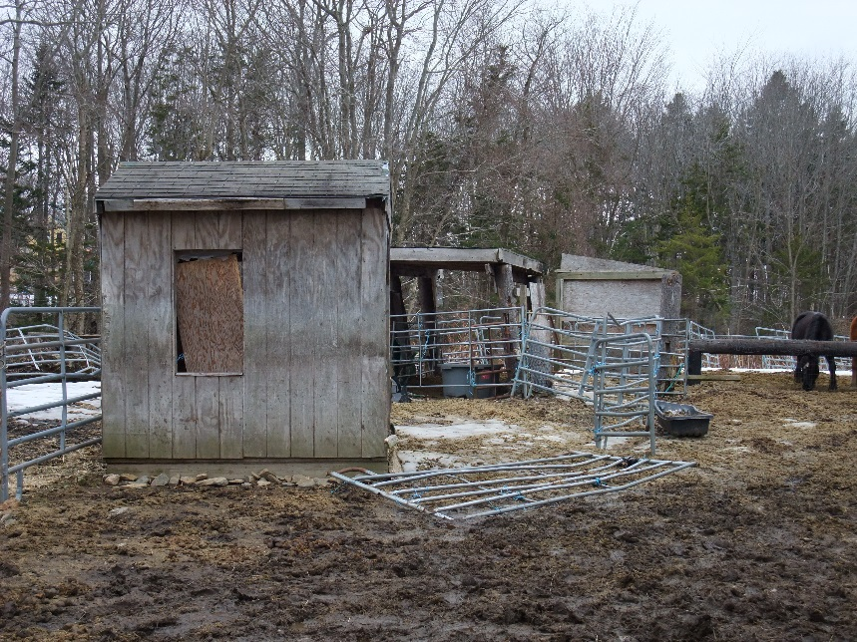

Shed #4 (front) – approx. 4’ by 6’

Shed #5 (rear) – approx. 8’ by 16’

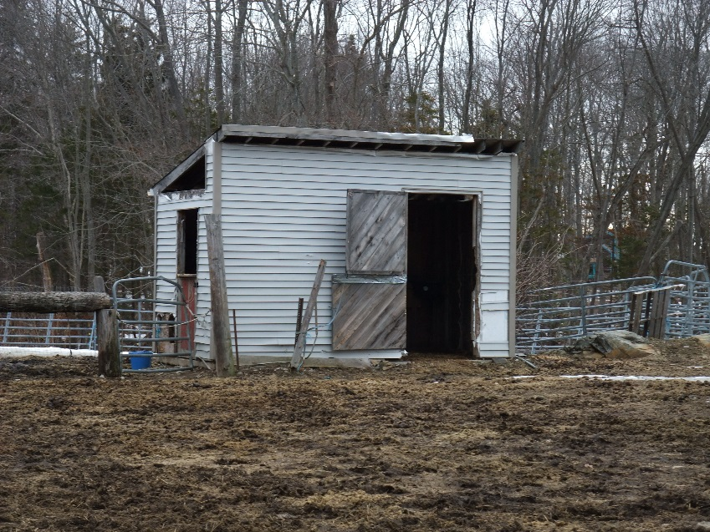

Shed #6 – approx. 6’ by 12’

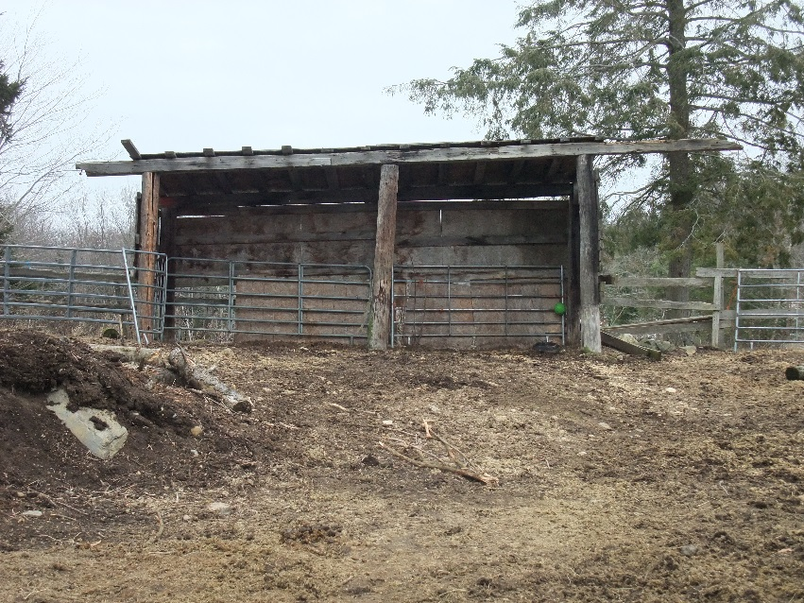

Shed #7 – approx. 6’ by 20’

**37 & 90 Ballfield Road**

**088 I006 (and associated lots) and 088 J006**

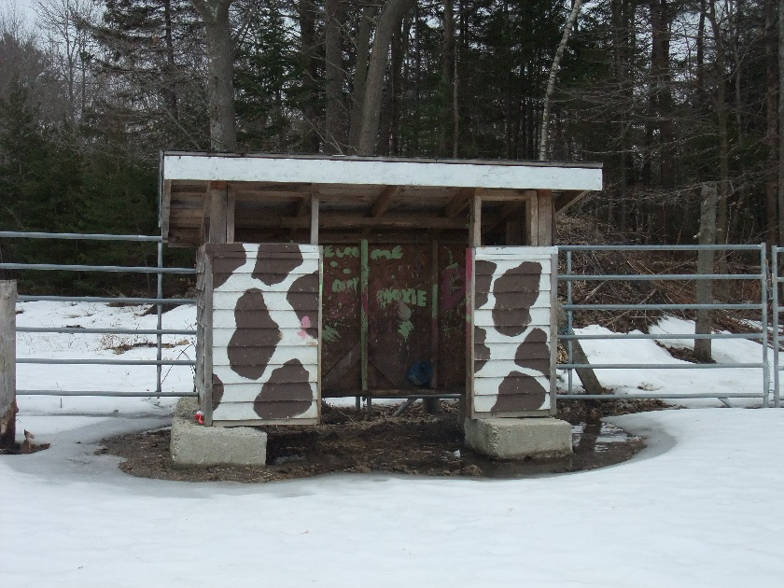

Shed #8 – approx. 4’ by 8’

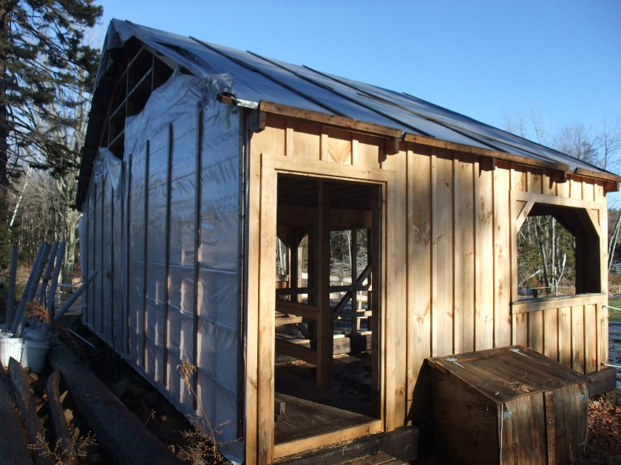

Shed #9 – 16’ by 24’

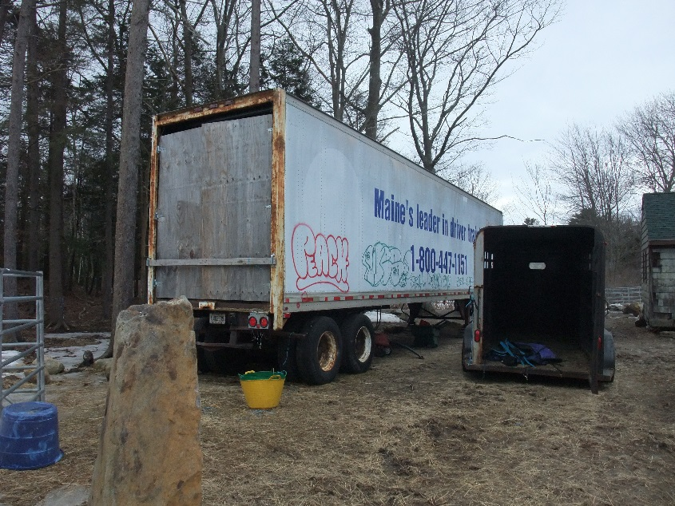

Unregistered trailer