IMPORTANT NOTICE FROM THE CITY OF PORTLAND - PLANNING DIVISION

To residents and property owners in the vicinity of
118 SUNSET AVENUE (GREAT DIAMOND ISLAND)

To Residents and Property Owners: The Portland City Council will hold a public hearing to consider a proposed conditional zone by Dinosaur Enterprises, Ltd. for a fuel distribution service at 118 Sunset Avenue on Great Diamond Island. The proposal would allow an existing fuel distribution business to continue its operations. The existing underlying zoning of the property (IR-2 Residential) does not permit such uses. The size of the property and zone change is 21,643 sq. ft. The proposal would allow two fuel delivery trucks and a dispensing gasoline tank mounted on a pick-up truck parked on the site. Conditional zoning provisions include but are not limited to, applicant to demonstrate compliance with federal, state and local permits, licenses and other requirements; restriction on uses on the site; and termination of agreement if Dinosaur or its successor discontinues business for at least 12 months. Public comments will be taken at this meeting.

The meeting will be held:
Monday, October 7, 2013 ** 7:00 p.m. ** City Hall, Council Chambers, 2nd Floor

The proposed Conditional Zone Agreement is available for viewing in the Portland Planning Division, 4th Floor, City Hall. If you wish to submit written comments, address them to Rick Knowland, Senior Planner, Planning Division, City Hall, 4th Floor,
389 Congress Street, Portland, ME 04101; contact by phone at (207)874-8725 or e-mail at rwk@portlandmaine.gov
Please visit http://misc.portlandmaine.gov/current.pdf for current memos and reports.

IMPORTANT NOTICE FROM THE CITY OF PORTLAND - PLANNING DIVISION

To residents and property owners in the vicinity of
118 SUNSET AVENUE (GREAT DIAMOND ISLAND)
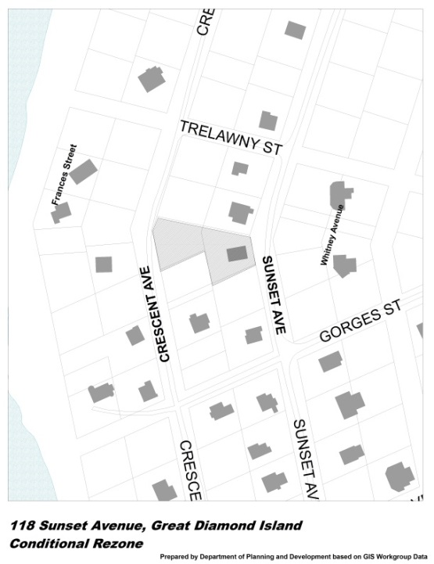
To Residents and Property Owners: The Portland City Council will hold a public hearing to consider a proposed conditional zone by Dinosaur Enterprises, Ltd. for a fuel distribution service at 118 Sunset Avenue on Great Diamond Island. The proposal would allow an existing fuel distribution business to continue its operations. The existing underlying zoning of the property (IR-2 Residential) does not permit such uses. The size of the property and zone change is 21,643 sq. ft. The proposal would allow two fuel delivery trucks and a dispensing gasoline tank mounted on a pick-up truck parked on the site. Conditional zoning provisions include but are not limited to, applicant to demonstrate compliance with federal, state and local permits, licenses and other requirements; restriction on uses on the site; and termination of agreement if Dinosaur or its successor discontinues business for at least 12 months. Public comments will be taken at this meeting.

The meeting will be held:
Monday, October 7, 2013 ** 7:00 p.m. ** City Hall, Council Chambers, 2nd Floor

The proposed Conditional Zone Agreement is available for viewing in the Portland Planning Division, 4th Floor, City Hall. If you wish to submit written comments, address them to Rick Knowland, Senior Planner, Planning Division, City Hall, 4th Floor,
389 Congress Street, Portland, ME 04101; contact by phone at (207)874-8725 or e-mail at rwk@portlandmaine.gov
Please visit http://misc.portlandmaine.gov/current.pdf for current memos and reports.

