Inspection Services Department of Urban Development
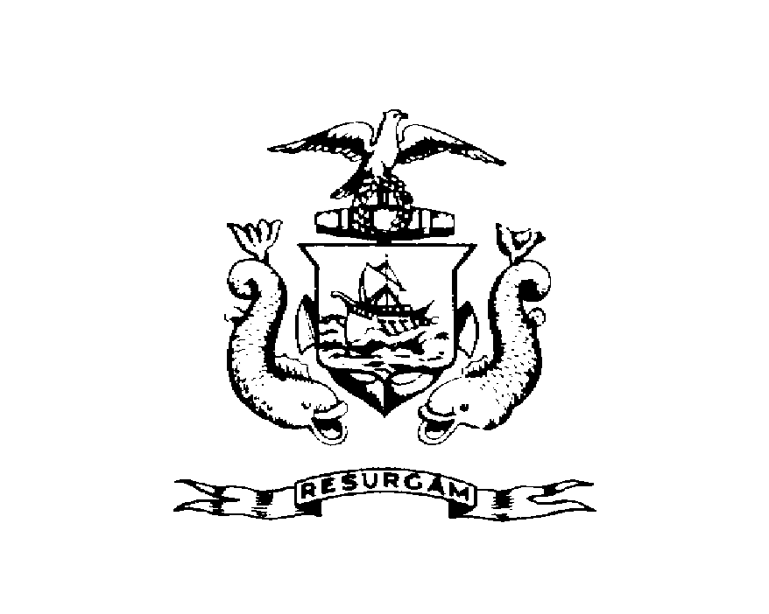
Michael J. Nugent Joseph E. Gray, Jr.
Manager Director

CITY OF PORTLAND
NOTICE OF VIOLATION

September 15, 1999

Helen K Pappas
1519 Forest Ave
Portland ME 04103

RE: 21 Devonshire St
CBL: 082-B-023
DU: 3

Certified Mail Receipt # Z 434 206 681

Dear Ms. Pappas

An evaluation of your property at 21 Devonshire St on September 14, 1999 revealed that the structure fails to comply with Section 12-79 of the Garbage, Waste & Junk Ordinance of the City of Portland.

Junk Car VIN# CGR2597113116

This is a notice of violation pursuant to Section 12-79 of the Ordinance. All referenced violations shall be corrected within 30 days of the date of this notice. A reinspection of the premises will occur on October 14, 1999 at which time compliance will be required. Failure to comply will result in this office referring the matter to the City of Portland Corporation Counsel for legal action and possible civil penalties, as provided for in Section 1-15 of the Code and in Title 30-A M.R.S.A. ss 4452.

This constitutes an appealable decision pursuant to Section 12-80 of the Code. Please feel free to contact me at 874-8693, if you wish to discuss the matter or have any questions.

Sincerely

Tom Markley
Code Enforcement Officer
cc/Central File

