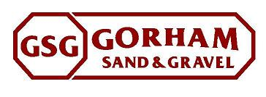
Commercial Street Snow Dump

- The site has existing berms to contain any runoff as the snow melts
- The site preparation will include general clean up and some tree removal
- The CSO area’s will be clearly identified and kept clear of all snow from the snow dump. The cso’s are not in conflict with the proposed snow dumps.
- Once the snow melts GSG will clean up all the debris and remove from site to return to existing condition.
- The Maine DEP has approved this site as a snow dump.
- In case of flooding we will contain the water with additional berms.
The Water will be pumped into a discharge area built of hay bales, grade stakes and geotextile fabric.

